Summary
Lesson Title:
I’ll Gladly Sell You Some Swampland in Florida

Lesson Summary (1-3 sentence summary):
Students will analyze the text, context, and subtext of four primary source documents from the early 1900s to answer the question: How did early 1900’s Everglades development impact the United States on a whole?

Key words (e.g. Language Arts, Math, Science, Social Studies/History, Art, Music, etc.):

Primary Source Analysis, American/Florida History, Jigsaw, Common Core Speaking
Intended Audience/Grade Level:  Grade 9 |  | Time Frame:  Approximate time: 3 hours
Standards and Purpose
Standards:
SS.912.A.5.12: Examine key events and people in Florida history as they relate to United States history.

RH.9-10.4: Cite specific textual evidence to support analysis of primary and secondary sources, attending to such features as the date and origin of the information

WHST.9-10.2: Write informative/explanatory texts, including the narration of historical events, scientific procedures/experiments, or technical processes.
Text or Text (s):
Florida Everglades Development Timeline (See Attachments)
http://ufdc.ufl.edu/FI07050811/00001
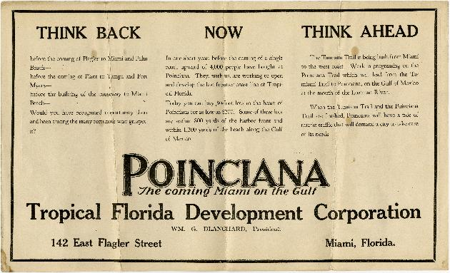
http://ufdc.ufl.edu/UF00004013/00001
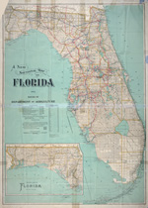

http://ufdc.ufl.edu/UF00055198/00001 (See cover and pages 4-5)
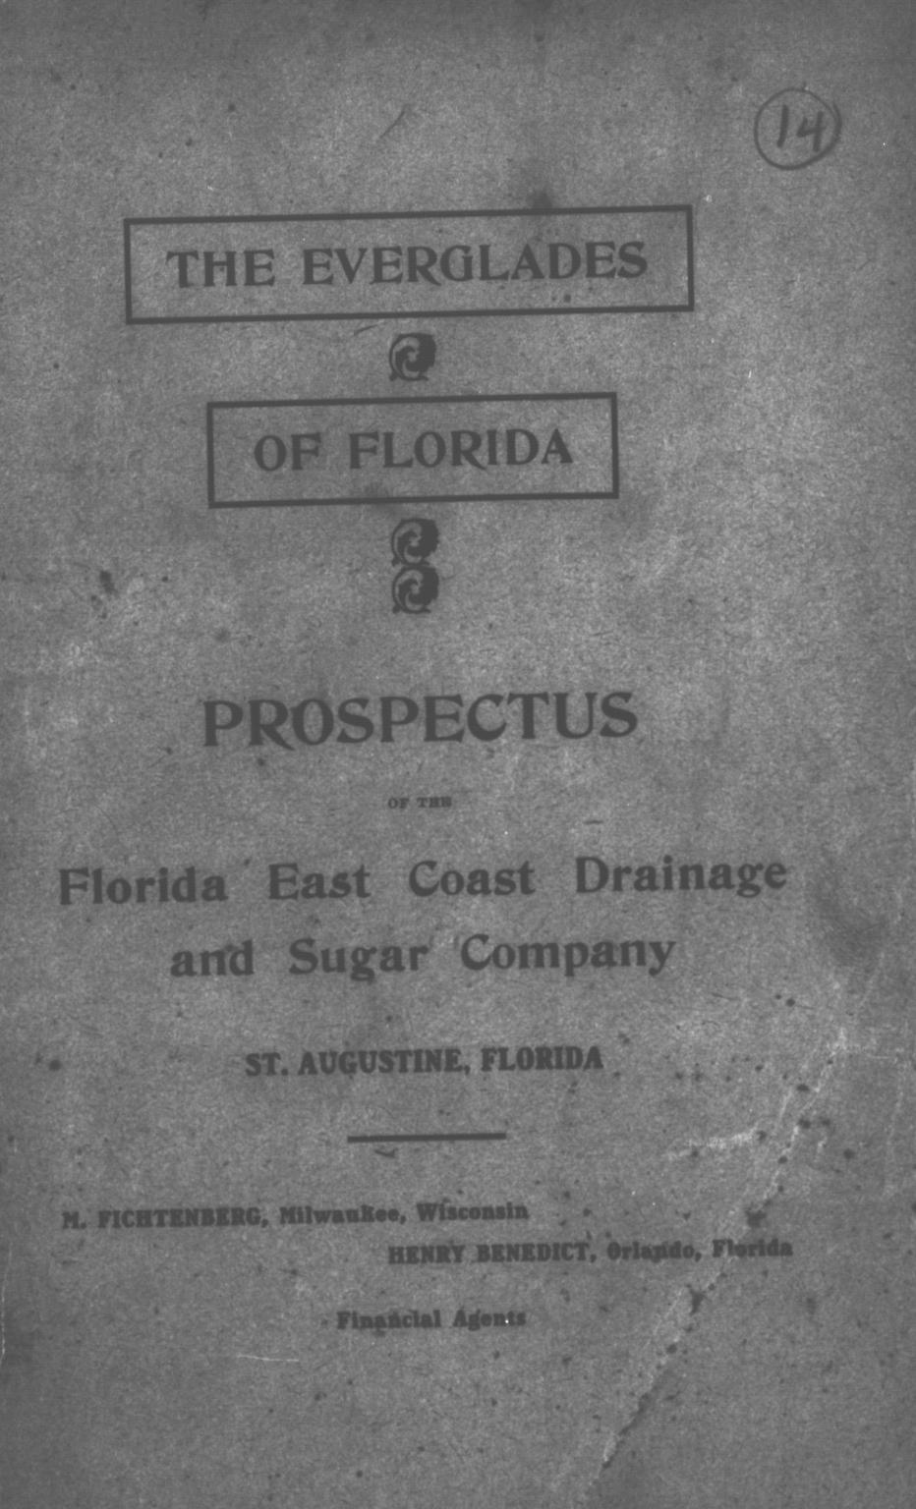

http://ufdc.ufl.edu/FI05140108/00001
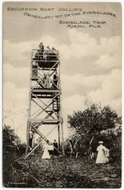
Essential Question (s):  How did early 1900’s Everglades development impact the United States on a whole? |  | Objectives:  Students will write a primary source analysis for text, context, and subtext.  Students will share a primary source analysis with evidence from that primary source and a secondary source with a group.  Groups will present an organized response to an inferential question to an audience.  Students will write an informational essay that integrates findings from class presentations to answer an inferential/inquiry question.
Assessment (how will data be collected on student performance?)
Formative:  Individual written responses to primary source analysis on Analysis Template.  Group presentation of integrated findings. |  | Summative:  Individual essay answering the inquiry question utilizing evidence from the group presentations.
Teaching Phase (step by step narrative guide to instruction)
Activate/Build Prior knowledge:
A common phrase to imply someone gullible is to “sell them swampland in Florida.” But this blind purchase of our “river of grass” doesn’t apply when we consider how the Everglades were developed.

QUICK WRITE: (See attachments) What do the Everglades look like?
Based on:
1. Personal experience: Have you visited the Everglades, (or any swamplands in Florida)?
2. Viewing pictures listed below.:
http://ufdc.ufl.edu/UF00094632/00001
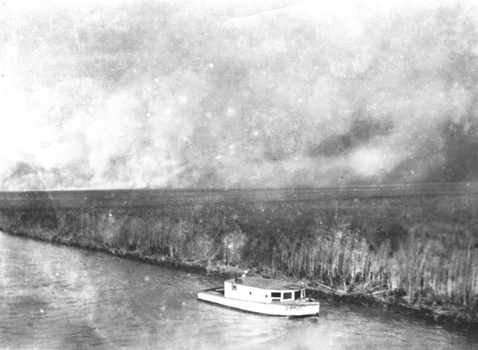

The Everglades and Royal Palm State Park, Photos from the 1920s and 1930s

http://www.nps.gov/ever/index.htm

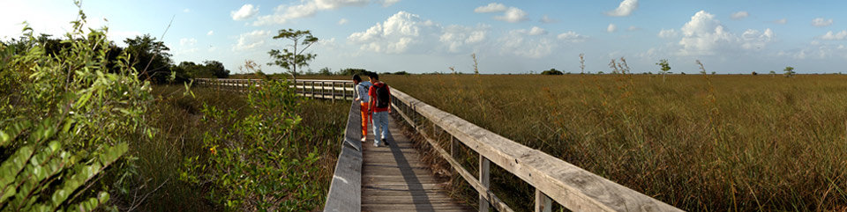

Direct Instruction:
- In this lesson, you are going to view primary sources to establish how development of the Everglades impacted the United States of America. Show essential question (or have students write in their journal).
- Whole Group discussion from Quick Write.
- Teacher led instruction about Everglades history to build background knowledge. Possible topics and resources to use.
  - The Everglades is a protected area of South Florida that originally spanned our state from Lake Okeechobee to the south tip. Through development, that area is much smaller.
  - http://www.nps.gov/ever/index.htm
  - Google earth of the everglades now.
  - Review timeline. (See attachments). Fill in context and explain the dates without addressing the factors aligned with the essential question.
  - National Park Service: http://www.nps.gov/history/history/online_books/bisc/hrs/chapter3.pdf - Suggested reading for homework: Reading to Build Content Knowledge. Text mark.
  - Reclaiming the Everglades: http://everglades.fiu.edu/reclaim/timeline/timeline6.htm

Guided Practice:
Let’s review how to analyze a primary source: Return to the original picture (Primary Source Analysis page 1 of Analysis Template)
http://ufdc.ufl.edu/UF00094632/00001
Independently write what the text, context (highlight within the timeline), and subtext are. Model zooming into the picture and viewing the citation.

Text: List what the source clearly shows and says.
Context: Looking at the timeline and the background readings, circle the events that directly relate to this source.
Subtext: Identify: who is the author, what is the purpose, what is the audience?

How does this source answer the question:
How did early 1900’s Everglades development impact the United States on a whole?
Cite specific details from the source.

Review the answers whole group.
Independent Practice:
Students will be divided into groups of four. Each student receives one of the four sources. Independent:
- View the source in UFDC’s database. Be sure to read the description for more information.
- List the text, circle the context, and identify the subtext of source. (Primary Source Analysis page 1 of Analysis Template)
- Using this source as evidence, answer the inquiry question “How did early 1900’s Everglades development impact the United States?”
Discuss
- Share your source with the group in a discussion format, not reading directly from your notes. “My source is…”
- Share your response and evidence for the inquiry question. Other group members record notes on Jigsaw of Sources from each member.
Organize
- Review the four perspectives to the inquiry question and organize into a presentation to the class. Determine each person’s role in the presentation. All students must participate in some fashion. Reference the images on the projected computer for evidence.
Present:
- Groups present their responses to the inquiry question.
- Students add on to their Jigsaw of Sources page.
Write
- Individually write an essay response to the inquiry question citing information from the four sources and from the background information presented at the lesson’s start.

Closure:
Teacher reviews the responses and the strengths of the evidence. I like how this group….

Reading strategies (describe strategies in detail):  - Highlight- Text mark National Park Service Chapter 3 background reading  - Primary Source Analysis handout for viewing primary source | Writing strategies (describe strategies in detail):  - Quick Write  - Jigsaw of Sources handout as a prewriting source |  | Speaking and listening strategies (describe strategies in detail:  - Students come to the group prepared with homework reading and source analysis  - jigsaw organization  - group presentations  - Jigsaw of Sources as a listening guide
Accommodations
ESE students:  For students who have accommodations such as a peer buddy, use two grouping techniques. In the first group, (or pairs), students all have the same source to analyze together. Then they jigsaw into the groups of four. |  | ELL students:  As needed, circle and review vocabulary in the timeline, source, and citation.
Extensions
Re-Teaching:  Students should have many opportunities to analyze primary sources for text, context and subtext. Analysis skills will develop with experience. |  | Enrichment:  Students create a prezi where the path zooms into the specific detail within each source used as evidence.
Materials
Special materials/preparation needed:  Have links to the images in a folder or file so that students can easily access the digital versions to allow zooming in and viewing of the citation.  Print sources (color when possible) if computers are not available for student use.  Include links to the sources used for the timeline if students would like to research more information:  National Park Service: http://www.nps.gov/history/history/online_books/bisc/hrs/chapter3.pdf  Reclaiming the Everglades: http://everglades.fiu.edu/reclaim/timeline/timeline6.htm |  | Suggested technology:  Student computers  Teacher computer with projector for Direct Instruction and Guided Practice.
Attachments
Quick Write description
Timeline
Analysis Template: Includes Primary Source Analysis and Jigsaw of Sources handouts
Notes
Additional Recommendations:

