University of Florida Digital Collection – Teacher Resource Collection
Politics are a Beach: Tools to Analyze Political Cartoons
helenjd@leeschools.net
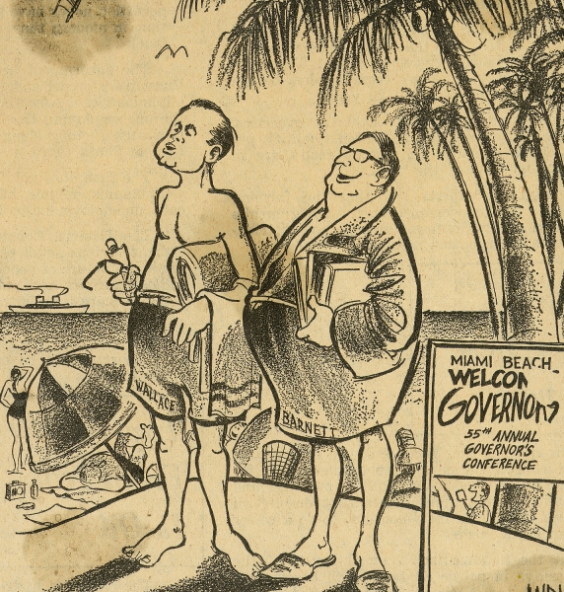
Observe |  | Reflect |  | Question
Role | Audience |  | Format |  | Topic
News anchor | Citizens of Miami |  | News Report |  | Announce who is coming to the convention, what they will discuss, when the convention is taking place, where it is happening, and why Wallace and Barnett’s attendance might be controversial.

