Dia De Muertos Skeletons (Also attached):
http://www.thecolor.com/Category/Coloring/Dia%20De%20Los%20Muertos.aspx
http://www.coloringcastle.com/diadelosmuertos_coloring_pages.html
EXIT QUESTION: Why do people in Mexico go to the graveyard and are happy and sing and dance, when in America people cry and are sad at the graveyards?
Chinese New Year Papers-
- Get red construction paper or red A-4 paper
- Any stickers that indicate what students may desire or may want to be good at
- Black crayons or markers to write their material wishes and luck wishes. Gold is good too if you can obtain a good marker or crayon
EXIT QUESTION: Why do people and China write things on these red papers and put them all over their house??
Songkran Paste-
- In a bowl, mix about 2 parts gold bond powder (or talc or baby powder) to 1 part water- Add additional water/powder until consistency is equal to peanut butter
- Spread on face and arms (supposed to be on each other but use with caution).
EXIT QUESTION: What is the purpose of this paste and why does it have to be cooling and smell all clean? What is the purpose of the water?

Boxing Day Boxes-
- Have one shoe box per table. Over the course of the week, have students bring in anything they have a surplus of and can live without (clothes, toys, candy, pencils, etc.). For students that may not have the means to provide these things, allow them to make letters and/or color pictures
- After the week, take box and send/give to the most appropriate recipient.

EXIT QUESTION: Why do people in Australia and Canada put a bunch of their stuff in boxes and give it away after Christmas?

Paper Santa Lucia crowns and hats
http://kiddley.com/2006/12/13/paper-santa-lucia-crowns-and-hats/
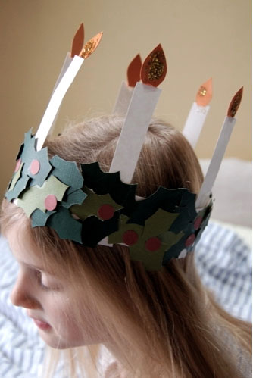
You can read more about how Santa Lucia is celebrated in Scandinavia here. We decided to create our own versions of the candle crown traditionally worn by the eldest daughter as well as a star hat like those worn by boys in Santa Lucia processions.
You will need:
White card stock or heavy paper for crown and candles.
Green craft paper cut into leaf shapes (depending on the age of the child, you may want to cut out the leaf shapes ahead of time).
Red craft paper cut or punched into small circles for berries.
Orange/yellow craft paper cut into flame shapes.
Glitter.
Glue.
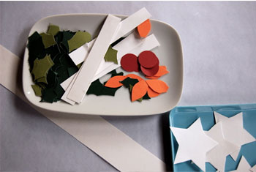
Santa Lucia Crown
1. Cut a two inch wide strip of paper long enough to wrap around the child’s head. Have child glue leaf shapes to cover the crown and decorate with red berries.
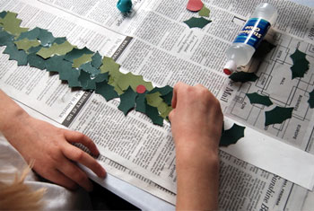
2. Add glitter to flame shapes. Cut strips of white card stock as candles (we made six candles for our crown). Glue flame to candle and candles to crown.
3. Fit crown around head and fasten at back with glue or staples.
4. Play Santa Lucia!
Boy’s Lucia Procession Hat
1. Create a tall cone hat from white card stock. Glue or staple closed.
2. Cut star shaped from card stock and decorate with silver or gold glitter.
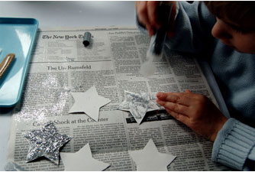
3. Glue stars to hat.
4. Ta-da!
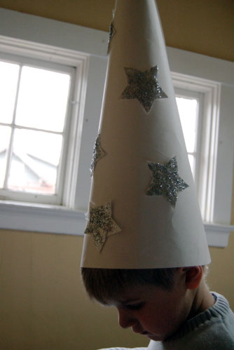

EXIT QUESTION: What do children do for St. Lucia day that is different than what you do for Christmas?

DIA DE LOS MUERTOS
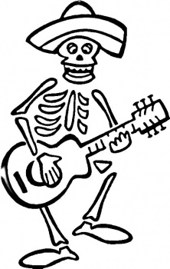
DIA DE LOS MUERTOS
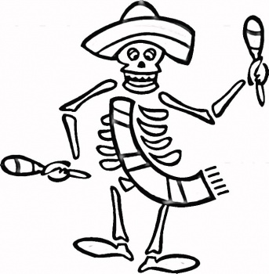
DIA DE LOS MUERTOS
