*HOLIDAYS: Here, There, and Everywhere!* Name: _________________________
- Draw a line matching the holiday with the symbol  - HALLOWEEN  - SONGKRAN  - DIA DE LOS MUERTOS  - CHRISTMAS  - CHINESE NEW YEAR  - THANKSGIVING | 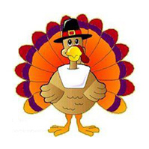  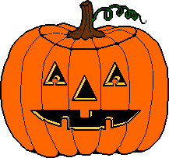  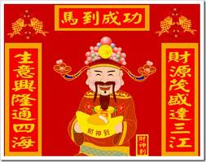  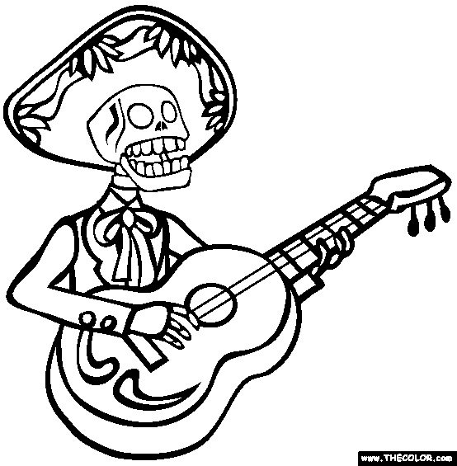

- What was your favorite international holiday: _______________________________________________

Why was this your favorite? (write words, draw a pictures, or raise your hand and tell your teacher the answer)

- What United States holiday and International holiday were VERY similar? ________________ and _________________

Give reasons why: (write words, draw a pictures, or raise your hand and tell your teacher the answer)

- What United States holiday and International holiday were VERY different? ________________ and _________________

Give reasons why: (write words, draw a pictures, or raise your hand and tell your teacher the answer)

CREATED BY: Jason Schipper, Cassie Wucher, & Emma Dewalt

