Digital Library of the Caribbean (dLOC)
Scholar Update, June 2014

Welcome to the dLOC Scholar Update

The dLOC Newsletter (http://dloc.com/UF00102954) covers new collections, partners, partner projects, technical updates, training resources and recent training activities, and related highlights.

The dLOC Scholar Update started in June 2014 as a complement to the dLOC Newsletter because of the wealth and wide variety of dLOC activities and projects with scholars for research and teaching. The dLOC Scholar Update covers new scholarship projects and activities, teaching with dLOC, scholarly collaborators, publications about and featuring dLOC, and more. Projects highlighted in this dLOC Scholar Update show the wealth of complementary collaborative activities with dLOC partners and with scholars around the world.

Call for Contributions to Future Issues, and Note

For this first issue, many projects are not yet included or covered. Please forgive any omissions for this first issue, and please help us by contributing entries for future issues. Please contact Laurien@ufl.edu to contribute to the next issue.

In this Issue:
- New Collaborations
  - Early Caribbean Digital Archive
- New Digital Scholarship Projects
  - Haiti: An Island Luminous
  - Stereographs from the Panama Canal
- Teaching with dLOC
  - Panama Silver, Asian Gold DOCC (A Distributed Online Collaborative Course), Amherst College, University of Miami, and University of Florida
  - Syllabi, Assignments, Video Lectures, and More
  - Teaching and Archival Research in Cuba
- New Collaborative Opportunities
  - Discussions on Regional Florida/Caribbean Digital Humanities Collaborative
  - Caribbean Digital: a small axe event
  - dLOC Scholarly Advisory Board
- Publications & Presentations About and Featuring dLOC

New Collaborations
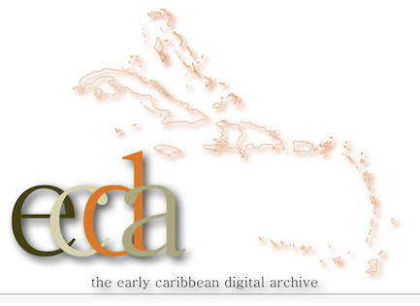
The Early Caribbean Digital Archive (ECDA)

The Early Caribbean Digital Archive (ECDA) is housed in Northeastern University’s NULab for Texts, Maps, and Networks (NULabTMN, http://nulab.neu.edu/), and ECDA has partnered with dLOC. ECDA is a highly interactive digital scholarly lab for the collaborative research and study of pre-C20 Caribbean literature.

The ECDA is identifying texts for digitization and digitized texts, collecting these as a research set with the materials hosted in dLOC and with the ECDA at Northeastern’s NULab. With the NULab, the ECDA is developing innovative tools that build from the digitized texts and enable users—both scholars in the interdisciplinary study of the Caribbean as well as undergraduate and graduate students— to view the materials as networks of related texts. The goal is to build and manage an open-access interface, what we are calling a digital text analytics lab, for providing interested publics access to both texts of the Caribbean and our analytical and visual tools.

The ECDA invites contributions and collaborators. Contact the ECDA for more on collaborative opportunities, including transcribing, the Idea Wall, Workbench, exhibits, and investigations and continued study of the ways in which scholars and students collaborate and interact with each other and the materials in the archive for collaboration on developing and designing digital research platform and project development spaces.

ECDA Scholar Commons: http://omekasites.neu.edu/ECDA/digital-scholars-commons
ECDA collections in dLOC: http://www.dloc.com/ecda

New Digital Scholarship Projects

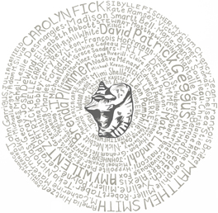
Haiti: An Island Luminous

Created by historian Adam M. Silvia and hosted online by Digital Library of the Caribbean, Haiti: An Island Luminous is designed to help readers learn about Haiti’s history and to access rich historical materials. Haiti: An Island Luminous combines rare books, manuscripts, and photos scanned by archives and libraries in Haiti and the United States with scholarly commentary.
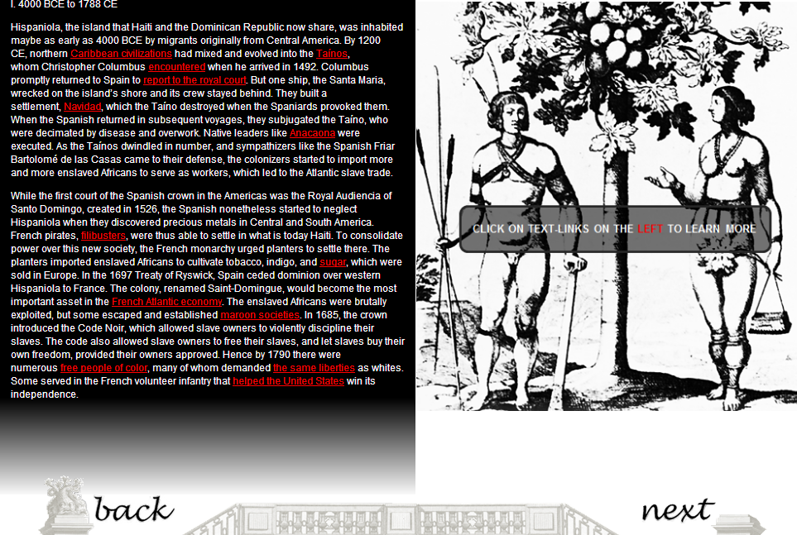
Haiti: An Island Luminous, first page
Haiti: An Island Luminous is perhaps best described as an online exhibit and an annotated edited collection because it includes commentary by over 100 scholars and the scholarly commentary links to relevant historical materials in dLOC. Users can thus read and explore Haiti: An Island Luminous for a rich and broad sense of Haitian history and culture, and can click on linked full text and image items to see historical artifacts and understand the significance of these materials within the larger context of a particular historical moment and in relation to the full history of Haiti.

See and explore Haiti: An Island Luminous: http://www.dloc.com/exhibits/islandluminous

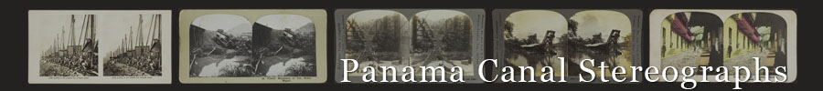

The Panama Canal Related Stereographs Collection includes 200 stereographs of the Panama Canal from the Keystone View Company, Underwood and Underwood, and E. and H.T. Anthony Company. The Panama Canal Related Stereograph Collection is a pilot project for creating a model for digitizing resources from the Panama Canal Museum while leveraging the talents of an eager group of knowledgeable student volunteers for record creation. The project seeks to promote use and interest in the collection by various academic departments through the construction of a variety of educational and teaching resources.

See the over 200 stereographs from the Panama Canal: http://www.dloc.com/ps/all

Teaching with dLOC

Many scholars, teachers, students, and learners around the world benefit from the important intellectual, creative, research, historical, and other materials in dLOC. In addition to teaching with dLOC as a location and source for materials, scholars are embedding dLOC in the research and teaching practices. Doing so creates opportunities for undergraduate and graduate student research that makes a contribution to Caribbean Studies by enriching existing resources in dLOC and creating new works that are shared through dLOC. This section highlights recent teaching collaborations with dLOC.

Panama Silver, Asian Gold: Migration, Money, and the Making of the Modern Caribbean
DOCC (A Distributed Online Collaborative Course): Amherst College, University of Miami, and University of Florida (Fall 2013); Spring 2014 Version, University of Florida

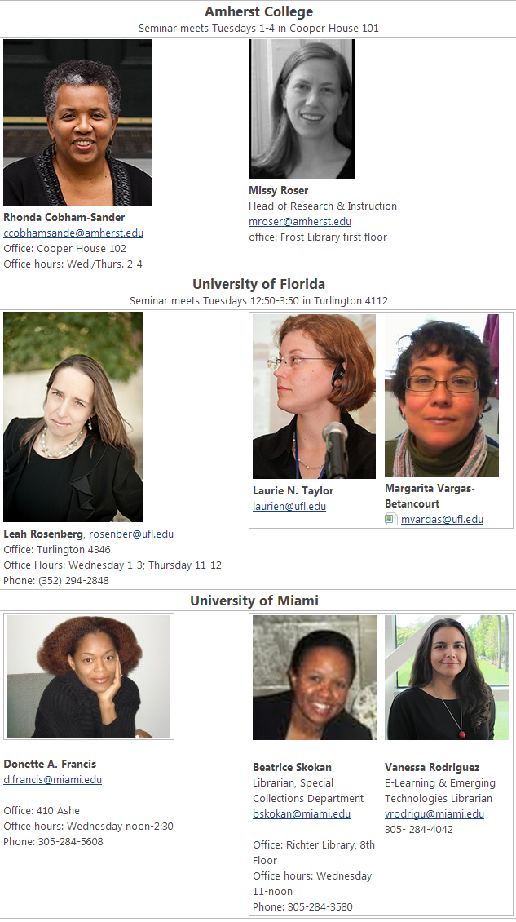
Course Wiki Page: Faculty and Librarians (not
pictured: Judith Roberts, Instructional Designer,
UF Libraries)
Rhonda Cobham-Sander (Amherst College), Donette Francis (University of Miami), and Leah Rosenberg (University of Florida) collaboratively created and taught a course, Panama Silver, Asian Gold: Migration, Money, & the Making of the Modern Caribbean, in fall 2013 at all three institutions. The course faculty, librarians and instructional designers at each institution, and all three classes of students collaborated together on the course. The collaboration enriched the courses for all involved as well as enlarging available resources with each professor successfully requesting funding to bring in guest speakers.

The course content covers two often overlooked labor migrations that profoundly affected the emergence of modern Caribbean literature: The immigration of indentured laborers from India and China into the West Indies and the emigration and return of the Afro-Caribbean workers who built the Panama Canal. The course sought to illuminate:
- Relationship the migration of indentured workers from India and China to the Caribbean and of West Indians to Panama and the rise of the Caribbean middle class, nationalism, and national literatures.
- Limitations and biases of colonial and imperial archival materials
- Techniques used by Caribbean scholars and writers to employ and extend these colonial historical sources to illuminate the experience of indentured Asian immigrants and West Indians working in Panama
- Challenges of the digital archive: How can we not reproduce the colonial structure of existing historical archival materials?

Course Assignments, Activities, & Products
The course was designed to help build dLOC as academic infrastructure for Caribbean Studies:
- Making course materials (syllabus, exercises, guest lectures, hands-on assignments, presentation slides, guides to digital humanities tools, etc.) available in dLOC
- Increasing dLOC’s holdings in two key areas: West Indians in Panama; Indenture: Indo- and Chinese in the Caribbean
- Providing assignments as opportunities for student-produced research contributions, including: finding guides for historical documents, guides to the cultural and historical references in contemporary novels, digital humanities projects on the two migrations

Resources Now Available
- All materials (currently, with more in process): www.dloc.com/contains/?t=%22Course+materials+for+Panama+Silver+Asian+Gold%22&f=SU
- Syllabi for all three institutions: http://dloc.com/AA00013935
- Video: Victor Chang reading his short stories: www.dloc.com/AA00022041/00001/video
- Student project (more are being added): www.dloc.com/AA00021180/00001

The course is the first of many in a broader initiative to support teachers and scholars in using archival materials for Caribbean Studies.

Teaching and Archival Research in Cuba

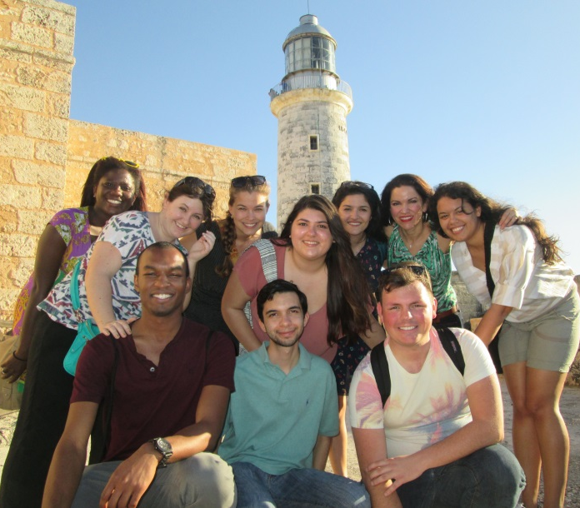
Lillian Guerra, UF Professor of Cuban History, recently collaborated with institutions of Cuba and has now shared her research materials including transcriptions and photographs of archival materials from the National Library of Cuba (www.dloc.com/AA00019994/) and the Archivo Nacional, Museo de la Educación, and others (www.dloc.com/AA00019995/). Guerra led students on a recent research trip to Cuba, with writing and presenting on the research trip (http://ufhistorydepartment.wordpress.com/2014/05/16/una-nuevo-dias-en-los-cubano-estudios-beginning-this-spring/). Many ongoing activities are underway in collaboration with institutions in Cuba for access and preservation of library materials, teaching, and research activities.
New Collaborative Opportunities

Digital Humanities Collaborative Network
At the 2014 THATCamp-Florida conference, the University of Central Florida began a discussion on statewide Digital Humanities collaboration in Florida. The model discussed is based on the NYC DH Collaborative Portal (http://nycdh.org/) and discussions on it with Alex Gil at Columbia University. See the draft portal for the possible Florida Digital Humanities collaboration: http://fldh.org/

The conversation continued at the THATCamp-Gainesville conference in April 2014. Participants discussed the possibility of expanding to a regional Digital Humanities collaboration including any interested institutions in the Caribbean, possibly having multiple, complementary collaborative groups with one for Florida and another or others for the larger Caribbean based on interest. More recent conversations with scholars from the University of Puerto Rico and University of Maryland demonstrate interest in collaboration from Puerto Rico for a larger regional Caribbean Digital Humanities collaborative group.

Discussions are still in an exploratory phase and are ongoing.

Please email Laurien@ufl.edu if you may be interested in the collaboration or are interested in participating in the evolving discussion.

The Caribbean Digital: a small axe event (5 Dec. 2014, Barnard College/Columbia Univ.)

As explained in the CFP for this event: “The transformation of the academy by the digital revolution presents challenges to customary ways of learning, teaching, conducting research, and presenting findings. It also offers great opportunities in each of these areas.” The Caribbean Digital: a small axe event will bring together scholars of the Caribbean, Digital, and other areas on adapting research and pedagogical methods in an age of information abundance. The Caribbean Digital will serve as a unique one-day public forum intended to engage critically with the digital as practice and as historicized societal phenomenon, reflecting on the challenges and opportunities presented by the media technologies that evermore intensely reconfigure the social and geographic contours of the Caribbean.

In addition to activities during the public forum, selected proceedings will be published in the inaugural issue (September 2015) of sx:archipelagos – an interactive, born-digital, print-possible, peer-reviewed Small Axe Project publication.

See the CFP for more: http://caribbean.commons.gc.cuny.edu/2014/04/01/the-caribbean-digital/
For more, contact Kaiama L. Glover and Kelly Baker Josephs at archipelagos@smallaxe.net

dLOC Scholarly Advisory Board

In collaborating with scholars, dLOC provides hosting for materials for preservation and access. Perhaps most importantly, dLOC also provides the socio-technical or the human infrastructure supports, including various forms of assistance to practical advice and technological training to help faculty and students bring together their resources to produce new knowledge for the field.

The dLOC Scholarly Advisory Board currently consists of seven representatives, skilled in relevant academic disciplines, in curriculum development, and/or in technical issues. The Scholarly Advisory Board initially provided guidance focused on collections to the dLOC Executive Committee (reviewing proposals for collections, nominating collections for inclusion, reviewing standards developed by subcommittees and assisting with future funding sources).

The role of the dLOC Scholarly Advisory Board and other scholars collaborating with dLOC has greatly expanded with many existing and new collaborations among scholars and support for various activities, including:
- Reviewing individual and collected materials to ensure a balance of perspectives
- Identifying priority materials for digitization and digital acquisition
- Supporting intellectual access: selecting, digitizing, curating, and supporting curation activities
- Helping to make sense of materials and clarifying their significance
- Helping to get permissions for materials
- Providing pedagogical and teaching support
- Providing support to instructors teaching Caribbean subject matter, particularly dLOC materials
- Encouraging libraries and other institutions with Caribbean holdings to join as dLOC content-contributing partners and those interested in Caribbean materials as fiscally-supporting members

Community Building for Caribbean Studies through Academic Infrastructure
Much as the Caribbean is fragmented geographically, linguistically, Caribbean studies and scholars are fragmented among departments and disciplines. Many live and work with few, if any, colleagues in the field at their local institution. dLOC can provide a place for scholars to meet, share knowledge and resources, create knowledge and resources, make resources available to others, and thus enable others to continue the process of producing knowledge and resources for the far-flung, interdisciplinary community of Caribbean scholars—and the general public interested in the Caribbean.

Materials in dLOC are available to anyone with internet access and are available in perpetuity. Thus, what is in dLOC and how it is presented will shape the understanding of Caribbean culture and history now and long into the future. Scholars have the opportunity for identifying gaps and working to fill them.

As dLOC collaboration with scholars continues to grow in various areas, the role of the dLOC Scholarly Advisory Board is expected to grow as well, and may include:
- Bringing people from different institutions and countries together to pool knowledge & resources
- Bringing faculty and students together to produce knowledge for everyone with internet access
- Collaborating and planning to provide invaluable context to make sense of these diverse materials
- Collaborating, planning, identifying, and helping ameliorate critical gaps in the collection

Publications & Presentations About and Featuring dLOC

Recent Publications
- Putnam, Lara. (2014). "The Transnational and the Text-Searchable: Digitized Sources and the Shadows They Cast." http://d-scholarship.pitt.edu/20882/1/PutnamDigitalShadowsPrePrint.pdf
- Ramdathsingh, Krystel. (2014). "Does U.S. Counter-drug Policy Affect Nationalism in the Anglophone Caribbean? A Comparative Study on the Impact of Counter-drug Policy on Nationalism in Jamaica and Trinidad and Tobago." FIU Electronic Theses and Dissertations. Paper 1257. http://digitalcommons.fiu.edu/etd/1257
- Nixon, Angelique V. and Rosamond S. King. (2013). "Embodied Theories: Local Knowledge(s), Community Organizing, and Feminist Methodologies in Caribbean Sexuality Studies." Caribbean Review of Gender Studies (7): http://www2.sta.uwi.edu/crgs/december2013/journals/CRGS%20_7_NixonKing.pdf
- Cobham-Sander, Rhonda. (2013) "Going with the Flow," Anthurium: A Caribbean Studies Journal (10: 2): http://scholarlyrepository.miami.edu/anthurium/vol10/iss2/14
- Francis, Donette A. (2013) "Intellectual Formations: Locating a Caribbean Critical Tradition." Anthurium: A Caribbean Studies Journal (10: 2): http://scholarlyrepository.miami.edu/anthurium/vol10/iss2/1
- Taylor, Laurie N., Brooke Wooldridge, Lourdes Santamaría-Wheeler, Mark V. Sullivan, Benjamin Hebblethwaite, & Megan Raitano. (2013). "Scholarly Publishing in the Digital Library of the Caribbean (dLOC)." Library Publishing Toolkit: http://opensuny.org/omp/index.php/IDSProject/catalog/book/25 and http://www.dloc.com/AA00016370/00001/pdf

Please email laurien@ufl.edu with publications to include.

Recent & Upcoming Presentations

- Rosenberg, Leah. (2015). "Teaching using digital textual scholarship in the classroom." Modern Language Association Convention.
- Taylor, Laurie N. (June 2014). “Collaboratively Developing Data Curation Literacy with the Digital Library of the Caribbean (dLOC).” ACURIL Conference 2014: http://www.dloc.com/AA00020051/00001/pdf
- Sullivan, Mark V. and Laurie N. Taylor. (June 2014). "SobekCM’s Community Ecosystems & Socio-Technical Practices with dLOC." Open Repositories 2014: http://dloc.com/AA00019927/00001/pdf
- Rosenberg, Leah. “The Pedagogy of the Archive as Intervention.” THATCamp-Gainesville (April 2014): Abstract on page 8: http://ufdc.ufl.edu/AA00021146/00011/pdf
- Szok, Peter. (March 2014). “Blackness and Popular Art in Twentieth-Century Panama.” UF Center for Latin American Studies: 63rd annual conference: “Panama Considered: Remembering the Past, Embracing the Future" (http://www.latam.ufl.edu/news-events/annual-conference): http://www.dloc.com/AA00020388/00001
- Vargas-Betancourt, Margarita. (2013). “Finding the Silver Voice: Afro-Antilleans in the Panama Canal Museum Collection at the University of Florida.” 13th International Conference on Caribbean Literature (ICCL)—Panama in the Caribbean: The Caribbean in Panama. University of Panama, Panama City: http://www.dloc.com/IR00003593/00001/
- Rosenberg, Leah. (June 2013). “Teaching On-Library and Why Scholars need to Partner with Each Other and Digital Libraries.” The 38th Annual Conference of the Caribbean Studies. Grand Anse, Grenada.
- Wooldridge, Brooke, Laurie N. Taylor, Judith C. Russell, and Lillian Guerra. (2013). "Digital Library of the Caribbean (dLOC)." THATCamp Caribe 2, Havana, Cuba: http://www.dloc.com/AA00017957/00001/pdf
- Taylor, Laurie N., Margarita Vargas-Betancourt, and Brooke Wooldridge (2013). “The Digital Library of the Caribbean (dLOC): Creating a Shared Research Foundation.” Scholarly and Research Communication (4: 3): http://src-online.ca/src/index.php/src/article/view/114/246

Please email laurien@ufl.edu with presentations to include.

