DRAFT: dLOC New Features Handout , 2014
New Features and Enhancements
- Curator Tools
  - The new Curator Tools allow easy online access to statistics (usage, and items for each workflow status), online editing for collection web pages, and fully online workflow support for digital curation.
  - dLOC’s Training Series for Curators & Collection Managers of 4 recorded webinars is available: www.dloc.com/IR00003545 and www.youtube.com/user/sobekcm
  - Guide to the Curator Dashboard & Curator Tools: www.dloc.com/AA00016133
- Linked Data support with Schema.org microdata
  - Schema.org microdata enables search engines and other systems to better find, index, and connect to site resources. Microdata powers semantic web functionality.
- HTML5 update for all header, navigation, footer, and item viewers
- Multi-file upload through the online interface
- Search functionality update for easily refining searches (part of SobekCM 4.0)
  - Like the search facets which narrow a search, this functionality expands search results by allowing users to click the X to easily remove a search term.
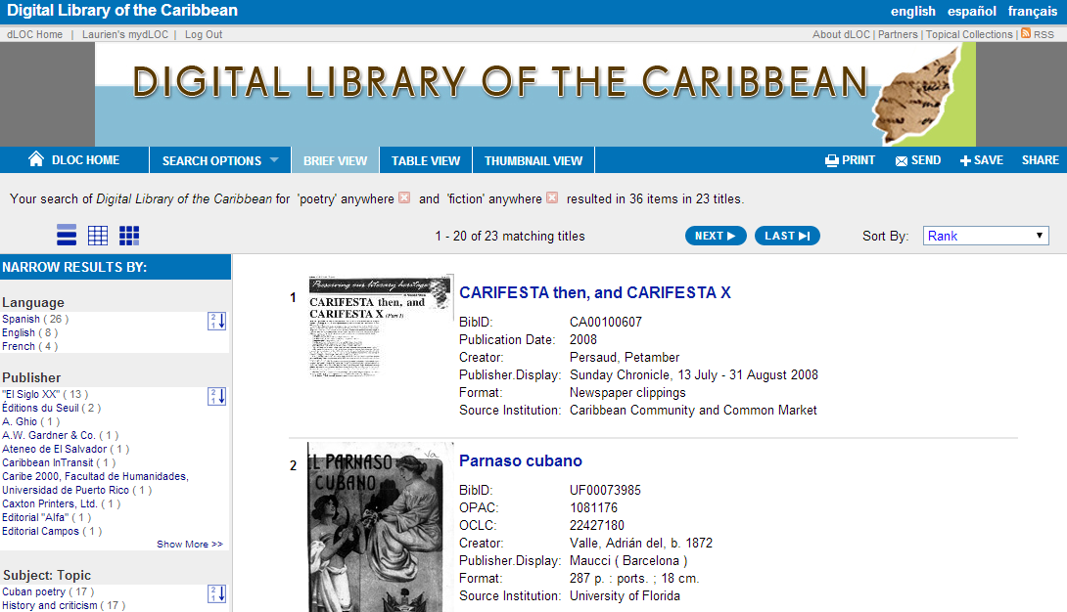
- Dataset support for data and database curation (Prototype)
  - Functional prototype support for datasets, and a grant proposal has been submitted for expanded support. For more, see: http://dloc.com/AA00017907/00001/pdf
- Updated METS editor, with additional mappings supported through the spreadsheet importer
- Online QC (Online Quality Control) Full Release
  - Online QC allows users to create chapters, name pages, swap pages, and more directly in online interface, allowing anyone to easily create structural metadata for an item.
- Workflow Guides
  - dLOC Advanced Training Institute Presentations & More: www.dloc.com/AA00016149
  - Filenaming for Digital Production & Curation: www.dloc.com/AA00016465/
  - Adding Publications as Records with Excerpts: www.dloc.com/l/AA00016039
  - Enhancing Metadata and Creating Context: www.dloc.com/AA00016041

Enhancements Underway:
- Djatoka and Open Layers
- EAD enhancements released in 2013, and additional enhancements underway
- Searching by date (and date facets by decade, year, and date)
- Ability to add coordinates by placing markers on a Google Map display
- Authority system integration, for linking and referencing other authority systems (Virtual International Authority File, ORCID and other researcher IDs, and more)

About the SobekCM Software
dLOC is powered by the SobekCM open source software, which was created for dLOC and with collaboration among dLOC partners.
- Recent SobekCM software enhancements: http://sobekrepository.org/
- SobekCM email list for SobekCM and tools: SOBEKCM-DISCUSS@googlegroups.com

