Mia Gettenberg, Featured Scholar
Journal of Undergraduate Research

The ultimate aim is to leave the place better than you found it. – Mia Gettenberg
A music enthusiast and avid guitar player from South Florida, Mia Gettenberg came to UF to pursue an environmentally focused major. Along the way, criminology and philosophy captured her attention, causing her to refocus her interests. “Philosophy can really open your eyes to so many things and make you truly appreciate the world,” she says. However, this field of study can also highlight “defects and make you think critically and analytically.” At the other end of the discipline spectrum, she finds criminology and the law to “reflect the tangible way of implementing ideas.” Put them together and they form the basic foundation for Mia’s research and illustrate a deeper understanding of her drive for social transformation.
Mia is outstanding. She not only has a drive to implement change, but she also realizes the time, energy and commitment it takes to tackle some of society’s deeply rooted problems—namely those surrounding education. Her research investigates Common Core Standards within Florida’s public schools: “I understand education can be a hot topic, but it feels like a lot of complaints and not enough practical solutions especially with Common Core. Everyone either loves it or hates it.” She set out to uncover what Florida’s Common Core Standards consist of and why they garnered such polarizing views, choosing to focus her work on two levels.
On a broad level, she looks at the standards themselves and the debate that has ensued since their most recent implementation. In a local sense, she draws from teacher interviews as well as secondary research, like school wide surveys, to find the philosophical underpinnings of Common Core State Standards. While her results were mixed, ultimately Mia discovered that the theory and practice surrounding Florida’s Common Core Standards did not add up. “It’s not like the intentions of common core are bad,” she says, “In theory, Common Core national standards are good but a lot of it seemed like no one really asked the teachers. Or if they did there was some kind of disconnect.”
Her main concern was this gap between teachers and policy makers: “There’s still a problem if the teachers are responding with ‘I don’t feel adequately trained for this;’ ‘I understand the theory but I don’t get the practice;’ ‘I understand the motivations but I don’t get them being carried out.’”
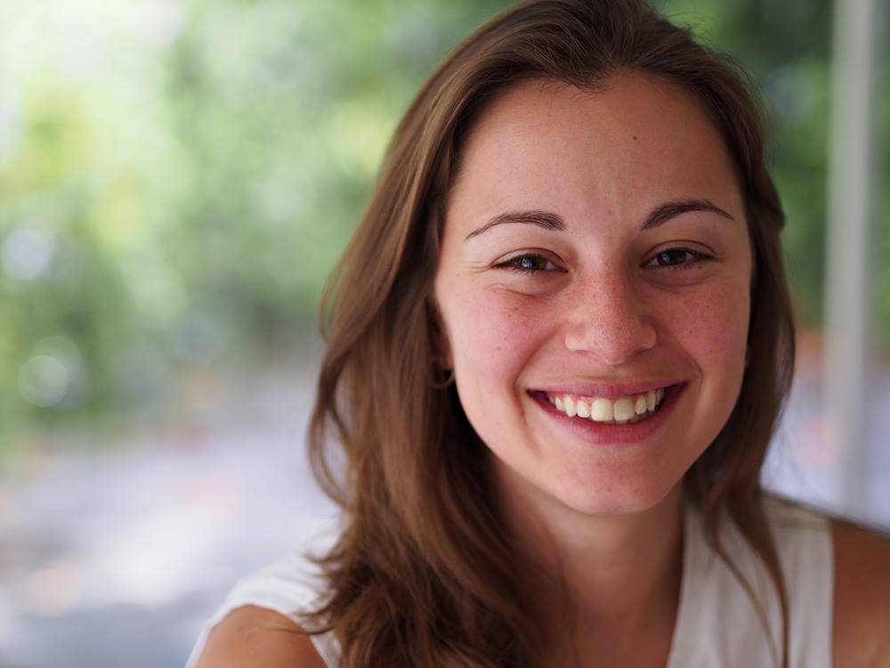
Mia is not naïve about the reality of this problem. Since sophomore year, she has worked closely with Mentor GNV, aiding some of Gainesville’s most disadvantage students. Working predominately in East Gainesville, Mia has engaged kids on a wide range of levels—everything from afterschool supervision to homework help to one-on-one reading. Pairing her service work with her research allows Mia to see the inequalities on both personal and systemic levels. In this respect, Mia recognizes the cynical approaches to Common Core. However, she says, “At the end of the day, I think we should do the best for our teachers and students.” Her solution is to go directly to the educators inquiring, “’What do you need for your classroom to succeed. What kind of things do you see students failing in? How can we provide for that?”
It is this holistic approach to education where Mia finds the most solace. For her, “education has the potential to not just teach us math and science and language arts but also greater empathy and compassion and diversity and the importance of diversity.” Again, she’s far from a reductionist about the position of K-12 learning institutions in the U.S., noting, “That’s a hefty goal for public schools and for teachers, who I think they are a very undervalued and underappreciated part of our workforce. But I know that my public-school experience contributed to those larger goals for me. I like to think that made me a better person and expanded the way I think about the world.” For Mia, education should move beyond preexisting boundaries. Indeed, she adds, “The worst thing an education can do is make you think like you’re done learning.”
It was her K-12 public education that unleashed this drive to pursue systemic change. Over the years, many teachers stand out to Mia, perhaps most notable was her high school AP Literature teacher who reinforced the value of working for the future. She explains, “When you graduate, when you move on to the next chapter, you want to leave the place better than you found it. and that has stuck with me for a long time. You don’t have to do everything. I think it’s overwhelming to think you have to fix every little thing you run into.” Though the issue of educational reform and implementing a more equitable learning system is a lot to tackle, Mia recognizes the crucial aspect of small victories, as she continues to draw on her own experience and those of the students she with whom she closely works.
So, what’s next for this UF senior? Mia spent the Fall applying to law schools. She has already heard back from some of her top choices and the responses have provided her with a wide range of possibilities, as she has already been accepted to both the University of Chicago and NYU. “The ultimate career goal is public interest law,” she says, “something that benefits children and families. Education is my number one right now. It’s an integrated problem with integrated solutions.”
Mia is excited to take on these complex problems, hoping to join the legal workforce through the public sector, public interest firms or even in government working in conjunction with the Department of Education. Regardless of where she ends up, her direction is strong and her passion contagious: “The underlying passions I hope are what will carry me through to the ultimate end goal.”
With her stunning smile, she declares, “It’s good to have that big picture idea but it’s also good to not get stuck in the little things along the way. Keep moving, don’t forget to have fun. Don’t forget this is all about other people.”
--Victoria Machado

