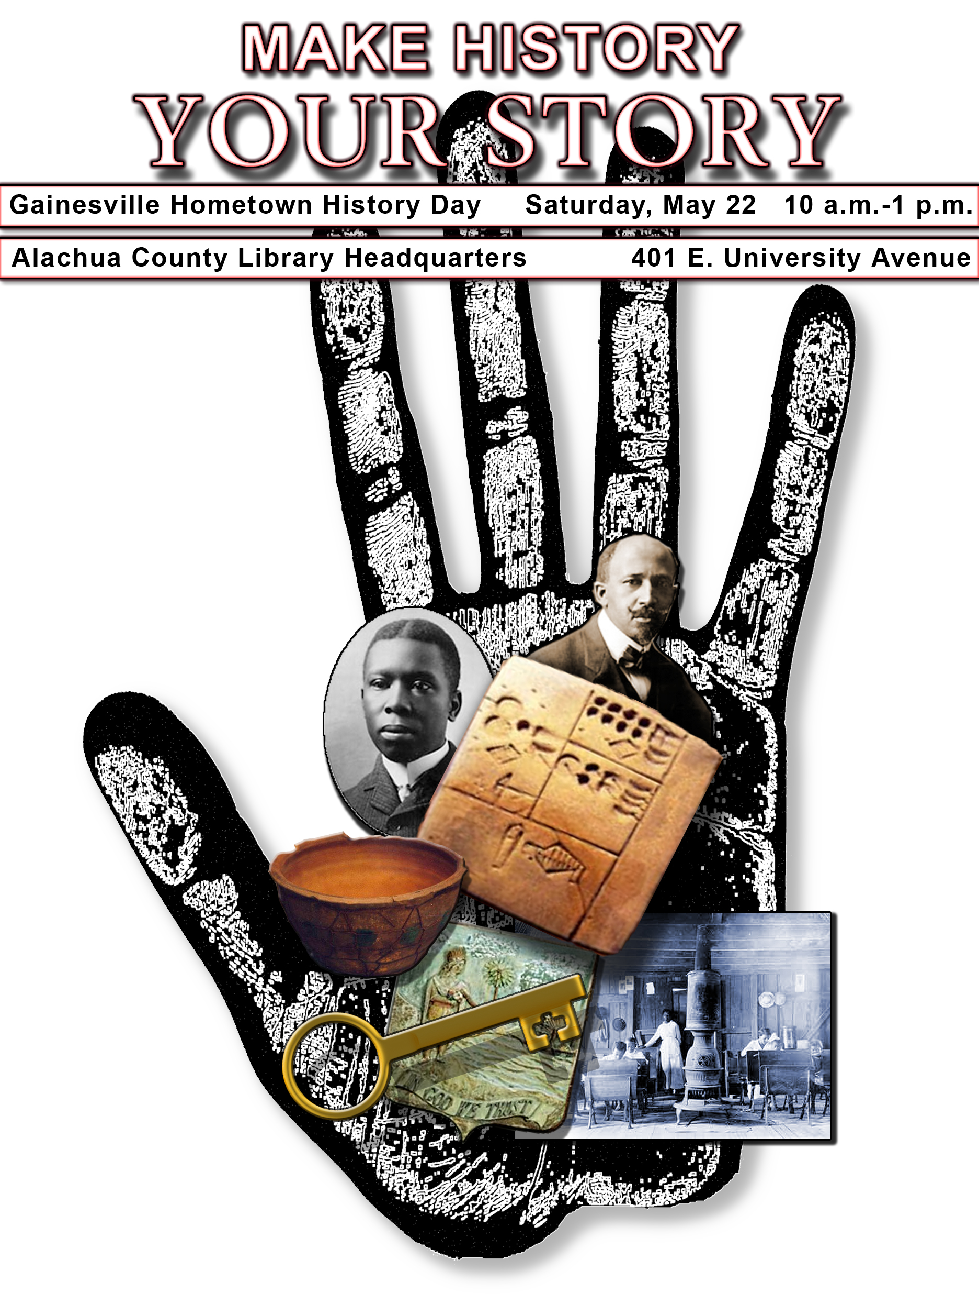
Help us recreate Gainesville for the years 1880–1910. Bring in objects, toys, tools and memorabilia to be photographed for an historical digital archive of our town. Then join us at the EPHEMERAL CITIES website… http://www.uflib.ufl.edu/digital/collections/EphemeralCities/

For more information, call (352) 378-2280

Sponsored by the Alachua County Library District, Matheson Museum, University of Florida, and the Alachua County Ancient Records Office.
Help us recreate Gainesville for the years 1880–1910. Bring in objects, toys, tools and memorabilia to be photographed for an historical digital archive of our town. Then join us at the EPHEMERAL CITIES website… http://www.uflib.ufl.edu/digital/collections/EphemeralCities/

For more information, call (352) 378-2280

Sponsored by the Alachua County Library District, Matheson Museum, University of Florida, and the Alachua County Ancient Records Office.

