Margarita Vargas-Betancourt
University of Florida
George A. Smathers Libraries
October 2013

Paper to be presented at the the 13th International Conference on Caribbean Literature (ICCL)—Panama in the Caribbean: The Caribbean in Panama. University of Panama, Panama City, November 13-16, 2013.

“Finding the Silver Voice: Afro-Antilleans in the Panama Canal Museum Collection at the University of Florida”

The purpose of this paper is to discuss how archivists and librarians have approached the challenge of finding manuscripts and artifacts that document Afro-Antilleans’ life and work in the Panama Canal Museum Collection (PCMC) at the University of Florida (UF). In 1999, Canal Zone residents that retired to Florida opened the Panama Canal Museum in Seminole. Their objective was “to preserve the history of the American Era of the Panama Canal (1904-1999).” The collection consists of artifacts, publications, and manuscripts that American Canal Zone residents or their descendants donated to the museum. In 2012, the Panama Canal Museum closed its doors and transferred its holdings to the UF libraries. This has enriched UF’s Latin American Collection and has made it one of the leading repositories of material related to the Panama Canal. Although the transfer took place recently, it has already yielded a variety of academic projects at UF and elsewhere. One is an exhibit on diversity in the Panama Canal (UF, August 2014), and the other, the class “Panama Silver, Asian Gold: Migration, Money, and the Making of the Modern Caribbean” taught simultaneously at UF, Amherst College, and the University of Miami (Fall 2013) by the other members of this panel. Even though the collection highlights the perspective of the American residents, it is possible to find the presence and the impact of Afro-Antilleans in the construction of the Canal. As archivists and librarians locate this material, they are incorporating it to the Digital Library of the Caribbean (dLOC) to create a public archive of Afro-Antilleans in Panama. This effort was recognized in 2011 when the George A. Smathers Libraries were nominated for UNESCO’s Memory of the World Register as one of the institutions that serves as repository for records that document the presence of Afro-Antilleans in the Panama Canal project.
The acquisition of Latin American material related to the Caribbean began in the 1930s with the creation of the Institute for Inter-American Affairs by UF’s president John J. Tigert. Tigert believed that the University of Florida had a special role because of its immediacy to the Caribbean. In 1948, U.S. librarians developed the Farmington Plan, a collaborative agreement among select U.S. libraries in which each would be asked to specialize in a specific region. Recognizing the strength of UF’s Latin American Collection, in 1951, the Farmington Plan assigned UF as the repository for Caribbean material. Since then, the Latin American Collection has worked to fulfill this task. At the same time, the Latin American Collection, as part of the George A. Smathers Libraries, has the mission to support the needs of faculty, students, and the rest of the University of Florida community.
Because of UF’s Libraries broader purpose, the transfer of the PCMC to UF has brought about the challenge to expand its content in order to fulfill the mission of UF’s Latin American Collection as the most important repository of Caribbean material in the U.S. and of the George A. Smathers Libraries to support the needs of faculty and students. This paper explores the challenges that librarians faced to support the specific needs of the faculty and students who are participants in the class on Panama Silver. The first task of this quest was to find relevant material within the PCMC; the second, to acquire materials that capture the voices that are absent, and the third, to upload the selections into dLOC.
In the first decade of the twentieth century, people from all over the world began to migrate to the Panama Canal Zone for work. The U.S. government had established labor recruiting offices in the Caribbean and in Europe. At first the islands of the Caribbean were their main target, especially Barbados. Approximately, twenty thousand Barbadians signed contracts to work in the Canal, and thousands more went without a contract. Barbadians migrated to the Canal because, due to the sugar plantation economy, they had no hope of overcoming impoverishment. They also used the opportunity of going to Panama to demand better wages from plantation owners back at home. With or without a contract, men also migrated to Panama from Grenada, Martinique, St. Lucia, Trinidad, and Jamaica. At first only male workers migrated. Later women followed, too; they found work providing services. The Panama Canal project became a magnet for Afro-Antilleans. Consequently, their stories are an essential part of the history of the Canal.
Along with their manuscripts and artifacts, the PCMC is now an integral part of the UF Digital Collections (UFDC) website. This database has been extremely useful in providing access to the collection. However, it has a drawback: it does not use standard Library of Congress Subject Headings. To find material related to the Afro-Antilleans, it was necessary to use one’s imagination and to play with search words, such as "West Indian," "worker," "laborer," "silver," "Antilles," "negro," "black," etc. The results were for the most part the expected: numerous photographs of workers next to huge machinery. In many of these images, the machines are the protagonists, while the workers blend into the landscape (see Figs 1-3).
Another type of object documents the system of segregation in which white U.S. citizens were paid with gold currency, whereas Afro-Antilleans, eventually African American U.S. citizens, and other ethnic groups were paid with silver currency. One of the most interesting items is a manuscript on errors in the 1915 gold payroll which states that there are no corrections for the silver roll because that information was easier to keep (see Fig. 4). Another is a photograph of the commissary with two separate doors, each marked “silver” and “gold.” In front of the former, there is a group of Afro-Antillean workers, and of the latter, a group of white officials (see Fig. 5). Still another photograph portrays the crew of a U.S. dredge sandpiper standing in the deck (see Fig. 6). White crew members are numbered and named at the bottom of the picture, the Afro-Antillean workers are only identified with the caption “The rest of crew are blacks.” Like the photographs of the machines, these photographs describe the stereotypical story of oppressors versus oppressed: nameless individuals who were even less important than the machinery they handled. Nonetheless, some of the photos tell a different perspective of such narrative.
A photograph with the inscription “Interior view of restaurant showing proprietress” probably from the early 20th century shows a black woman in a rustic dining hall. Behind her a sign reads “Board $7.00 per week; 30.00 per month” (see Fig. 7). The woman is in the center of the photograph, and she is looking directly at the camera. She is obviously the focal point, and so is the sign next to her. Whatever the motivation of the photographer, this is not a picture of the oppressed. West Indian women followed men in their migration to Panama. Unlike men, they did not have a place in the official construction, but they thrived in the informal economy by selling board and food, or working as maids. Another photograph depicts a parade. Again despite the motivation of the photographer, the Afro-Antilleans in this photograph appear as a united cohesive group. The men in the front of the parade wear ties and hats; they seem to be proud leaders of their community (see Fig. 8). Although scarce, these photographs provide a presence to the Afro-Antilleans in the PCMC, but not a voice.
The PCMC includes numerous texts such as letters, testimonials, newsletters, pamphlets, booklets, flyers, yearbooks, in addition to oral history, that document the stories of white U.S. residents of the Panama Canal Zone, but not of the Afro-Antilleans. Given the provenance, this is not surprising. After all, the museum was created to celebrate the American presence in the Canal. But, as stated before, the mission of the PCMC is now embedded in that of UF’s Latin American Collection and of UF’s Libraries in general. For this reason, it is necessary that we include the other voices that also make up the legacy of the Panama Canal. As part of this mission, the three instructors of the course Panama Silver identified the book Isthmian Historical Society. Letters from Isthmian Canal Construction Workers in a bibliography that Rhonda Frederick had included in the article “Mythographies of Panamá Canal Migrations: Eric Walrond’s ‘Panama Gold’.” They requested Laurie Taylor, UF’s Digital Humanities Librarian, to find and digitize the book to be uploaded into dLOC. However, Laurie Taylor could not locate the book. Rhonda Frederick indicated that she had found this book in Panama City on the shelves of the Afro-Antillean Museum’s library. This exchange of information took place in the spring of 2013, before a visit that Judy Russell, Dean of University Libraries, and Rachel Schipper, Associate Dean, were going to make to Panama. During this visit, the library deans asked Glenroy James, President of SAMAAP (Sociedad de Amigos del Museo Afro-Antillano de Panamá) to see if the National Library of Panama would digitize the one copy of the book available. Deans Russell and Schipper had visited the National Library during their travels, and had been encouraged by the significant amount of historic material the library had digitized. Panama’s National Library agreed to digitize the book, and it is now available in dLOC.
The anthology Isthmian Historical Society. Letters from Isthmian Canal Construction Workers was a product of a 1963 contest which the Isthmian Historical Society organized in order to obtain stories that documented the lives of non-U.S. citizens during the construction of the Canal. Despite the storytellers’ agenda (in addition to publication, there was a cash incentive for the best stories), this text seemed fundamental to capture the voice of Afro-Antillean workers. African-American and Afro-Antillean former residents of the Panama Canal have also expressed the need of including the silver voice in the PCMC at UF. In 2013, Emilio Collins went to Seminole to visit the Panama Canal Museum, only to discover that the museum had closed and its holdings had been transferred to UF. Emilio, an African-American former resident of the Panama Canal who is a descendant of Afro-Antilleans, came to UF to see the PCMC. He was shocked to find that despite having a great assortment of school yearbooks, the PCMC did not include the Afro-Antillean schools that existed in the Zone. He explained that since the 1930s there were two schools where the Afro-Antilleans could study: on the Atlantic side, Silver City Occupational High School (later known as Rainbow City Occupational High School); and, on the Pacific side, La Boca High School (later known as Paraíso). At first these schools only extended to middle grades, for there was an explicit effort to retain Afro-Antilleans at a worker rather than a professional level. With time this changed. However, segregation in the Panama Canal Zone schools did not end until 1978, long after segregation had ended in the United States.
In order to fill the gaps that he had identified in the PCMC, Emilio began to contact friends, or friends of friends, who had yearbooks from these schools. Although his contacts were not willing to donate their physical copies, they were willing to lend them to UF for digitization. He also contacted the Afro-Antillean Museum and asked if they had copies that could be digitized. The museum has begun to lend copies to UF, too. Today there are fifteen digital copies of silver school yearbooks in dLOC (see Figs. 9 and 10), and Emilio’s project continues. At the same time, UF’s Libraries have undertaken the task to record and archive oral histories from Panamanian Afro-Antilleans who either lived in the Panama Canal Zone or lived in Panama but descended from people who migrated to work in the Canal. The funding for the oral history component of the project has come from a Faculty Enhancement Opportunity (FEO) that Rachel Schipper obtained in 2012, the university and the libraries, and the PCMC. This support provides evidence of a collaborative synergy to include the voice of the underrepresented group.
The efforts to find the silver voice have been tremendous, and they reveal how hidden and inaccessible this voice can be. However, the quest of this mission is fundamental not only to fulfill the Libraries’ mission and the demand by Afro-Antillean descendants, but also to identify the role that the construction of the Panama Canal had not only in U.S. history but in the history of the Caribbean. As the course entitled Panama Silver suggests, the financial and cultural impacts that Afro-Antillean workers brought back home generated the beginning of national identities. To continue this quest, inclusion of other ethnic groups that participated in the construction of the Panama Canal is needed to fully appreciate the silver voice.

Figure 1. [Concrete Mixing Plant, Gatun Locks, Nov. 1909] Panama Canal Museum Collection, Special and Area Studies Collections, George A. Smathers Libraries, University of Florida, Gainesville, Florida.
(http://ufdc.ufl.edu/AA00016431/00001)

Figure 2. [Rock Channeler at Work in Upper Miraflores Lock Site Jan. 6, 1910] Panama Canal Museum Collection, Special and Area Studies Collections, George A. Smathers Libraries, University of Florida, Gainesville, Florida.
(http://ufdc.ufl.edu/AA00016789/00001)

Figure 3. [Lidgerwood Unloader – 14% grade- Tabernilla Dumps] Panama Canal Museum Collection, Special and Area Studies Collections, George A. Smathers Libraries, University of Florida, Gainesville, Florida.
(http://ufdc.ufl.edu/AA00016788/00001)

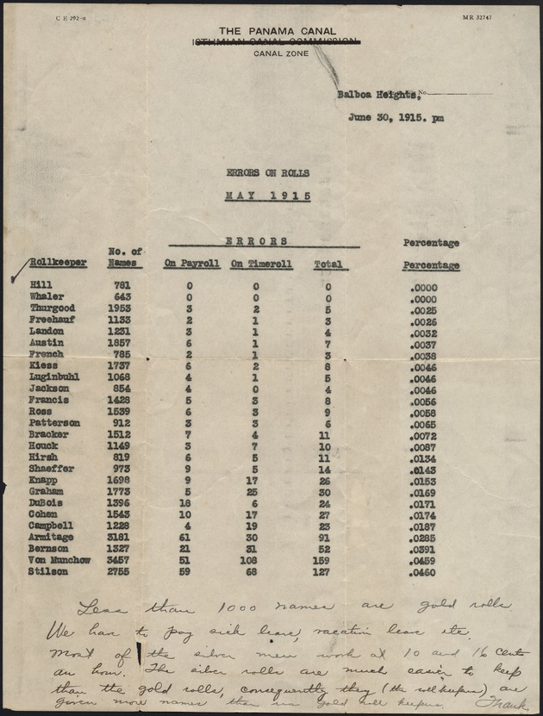

Figure 4. [Errors on the Rolls of May 1915 Panama Canal Employees] Panama Canal Museum Collection, Special and Area Studies Collections, George A. Smathers Libraries, University of Florida, Gainesville, Florida.
(http://ufdc.ufl.edu/AA00014744/00001)

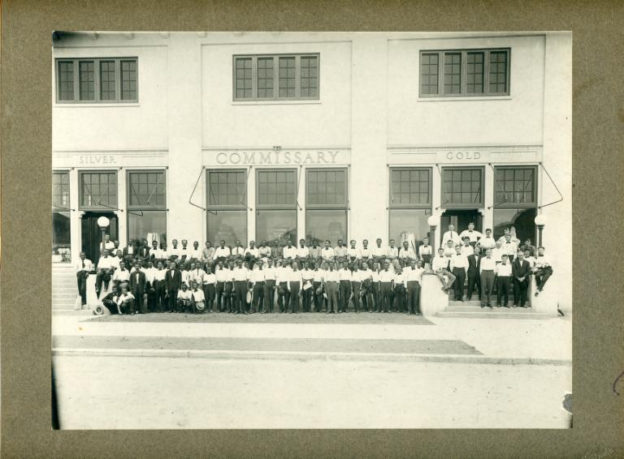

Figure 5. [Panama Canal Commissary, with personnel, showing the "silver" and "gold" entrances] Panama Canal Museum Collection, Special and Area Studies Collections, George A. Smathers Libraries, University of Florida, Gainesville, Florida.
(http://ufdc.ufl.edu/PCMI007246/00001)

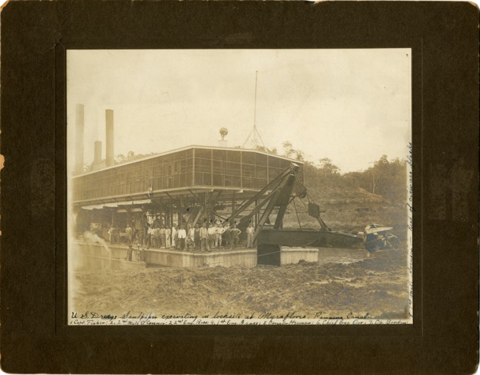

Figure 6. [U.S. Dredge Sandpiper excavating in lock site at Myraflores, Panama Canal] Panama Canal Museum Collection, Special and Area Studies Collections, George A. Smathers Libraries, University of Florida, Gainesville, Florida.
(http://ufdc.ufl.edu/AA00016121/00001)

Figure 7. [Interior view of restaurant showing proprietress] Panama Canal Museum Collection, Special and Area Studies Collections, George A. Smathers Libraries, University of Florida, Gainesville, Florida.
(http://ufdc.ufl.edu/PCMI008135/00001)

Figure 8. [1916- Parade of Afro-Antilleans] Panama Canal Museum Collection, Special and Area Studies Collections, George A. Smathers Libraries, University of Florida, Gainesville, Florida.
(http://ufdc.ufl.edu/PCMI011782/00001)

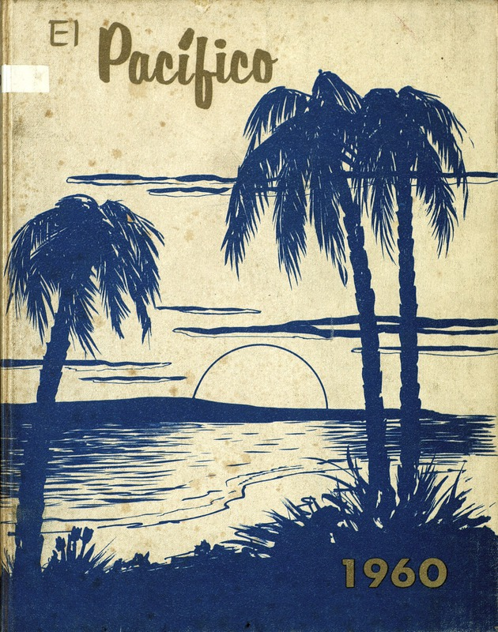

Figure 9. [Pacífico Yearbook] Panama Canal Museum Collection, Special and Area Studies Collections, George A. Smathers Libraries, University of Florida, Gainesville, Florida.
(http://ufdc.ufl.edu/AA00015058/00001)

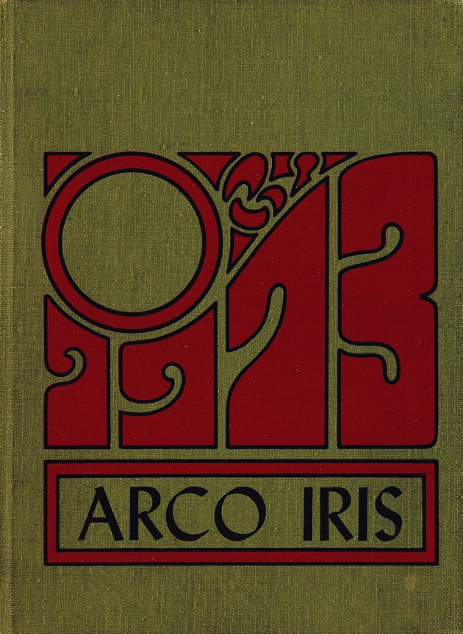

Figure 10. [Arco Iris: Rainbow City High School Yearbook] Panama Canal Museum Collection, Special and Area Studies Collections, George A. Smathers Libraries, University of Florida, Gainesville, Florida.
(http://ufdc.ufl.edu/AA00015016/00001)

Website of the Panama Canal Museum (http://cms.uflib.ufl.edu/pcm/Home.aspx).
Rhonda Cobham-Sander, Professor of Black Studies and English, Amherst College; Leah Rosenberg, Associate Professor of English, University of Florida; Donette Francis, Associate Professor of English, University of Miami.
Website for UNESCO. (http://www.unesco.org/new/fileadmin/MULTIMEDIA/HQ/CI/CI/pdf/mow/nomination_forms/Panama%20silvermen.pdf)
Website of the Center for Latin American Studies at the University of Florida (http://www.latam.ufl.edu/history).
Ralph D. Wagner, A History of the Farmington Plan (Lanhuam: Scarecrow Press, 2002), 84.
George A. Smathers Libraries. Library Directions 2006-2007. (http://www.uflib.ufl.edu/search.html?cx=002991405718492227978%3Aa-3xnpi_fuq&sa=Search&cof=FORID%3A11&q=mission)
The definition of the Caribbean for UF’s Latin American Collection is cultural more than geographic. In addition to the Antilles, it includes the Yucatan Peninsula, Central America, Colombia, the Guyanas, and Venezuela.
Julie Greene. The Canal Builders:Making America's Empire at the Panama Canal (New York: Penguin Press, 2009), 29-30.
Greene. The Canal Builders, 30-31.
http://ufdc.ufl.edu/pcmi
Thomas Orr donated the photograph to UF in the summer of 2013.
A later object is a ledger that includes the Payroll Record Silver Roll Schedule of Unpaid amounts July 1944 to June 1946 (http://ufdc.ufl.edu/PCMI005419/00001).
See http://ufdc.ufl.edu/AA00016037/00001. Rhonda Frederick, “Mythographies of Panamá Canal Migrations: Eric Walrond’s ‘Panama Gold’.” Marginal Migrations: The Circulation of Cultures within the Caribbean. Oxford: Macmillan Press—Warwick University Caribbean Studies, 2003. pp. 43-76.
Two of the interviewees are Emilio Collins and James Glenroy. The former was born and lived in Rainbow City. His father was a teacher in the zone’s Afro-Antillean schools. The latter was born and lived in Panama, and as mentioned above, is now the president of SAMAAP. Rachel Schipper’s FEO funded Glenroy’s visit to Gainesville; the university and the libraries supported the purchase of a camera, labor from several employees, and the software to videotape/edit oral histories. Finally, the PCMC funded two oral histories from two Afro-Antillean descendants recommended by Emilio (personal communication with Rachel Schipper, October 24, 2013).

