Addendum 6-1. Atala Larval Host-Plant Consumption
The fresh weights of fronds from potted coontie plants (Zamia integrifolia) were used to determine approximate food content of similarly-sized plants located in natural areas or gardens, based on the quantity of foliage consumed by larvae in a captive colony. Each frond rachis was cut from live plant material 4” above the soil line, weighed fresh (wet) and dried in the green-house. The fronds were dried in open brown paper bags in the greenhouse and stirred monthly to encourage even drying. The material was considered fully dry when the foliage contained less than 1% of its original wet weight. The dry weight was compared to the dry weight of plant material consumed by a captive E. atala colony.
Coontie cut fronds cut from live naturally growing plants were weighed (wet weight) before being presented to the larvae for food; any material remaining after consumption was dried and re-weighed for dry weight.
Each photographic record of the potted plants was taken against a backdrop of squares measuring 30 cm x 30 cm (approximately 1’ x 1’) and fronds were counted on individual plants. This will assist land managers in judging the size and potential food content of plants on their properties.
Height of the plants was measured from the ground (bottom of pot) to the top of the tallest frond. Width was measured from the furthest tips of the leaves on either side. Plants were allowed to rest naturally (fronds were not artificially extended in any photograph).
All frond length measurements are approximate. Leaf width is variable between plants, which alters the food content of the plant. The accompanying weight can be used to assess the width or rachis radius of the plants.
The nutritional quality of the plant material is highly variable depending on soil chemistry, age and potential pathogens, such as scale or fungus. The chemical constituents will vary between plants according to the plant genetics, soil elements, age and environmental factors (such as drought, flooding, fertilizers, pesticides or herbicides, sunlight, seasonal photoperiod, and other factors) (Oberpreiler 1995a; 1995b; 1995c).
Not all leaf material may be appropriate for all larval consumption; for example, younger larvae require fresher new plant growth for consumption. Larvae may ingest more food than experimentally documented in the laboratory; although the larvae were fed ad libitum, there was a routine feeding schedule that may have affected the larval feeding rates. Larvae in the laboratory captive colony consumed between 5 and 14 grams (0.2- 0.5 oz.) of plant material during their life span. This amount varied according to brood size and age (see Appendix 1). The data for these plants will allow potential food resources of similarly sized plants to be estimated for wild colonies of E. atala. (All photos by S. Koi).
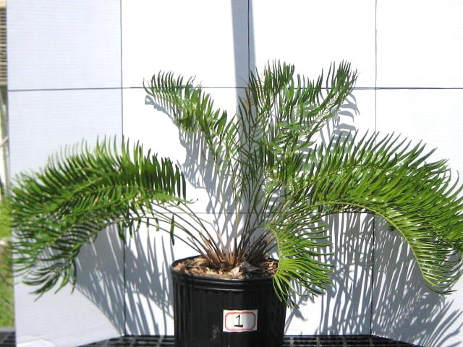

Figure 6-1. Height: ~65 cm (2.133 ft.)
Width: ~120 cm (3.937 ft.)
Fresh Wet fronds: 286.5 g. (~10.1 oz.)
Dry weight fronds: 94.7 g. (~3.3 oz.)
Number of rachides: 25
Sex: Female
Cones: None
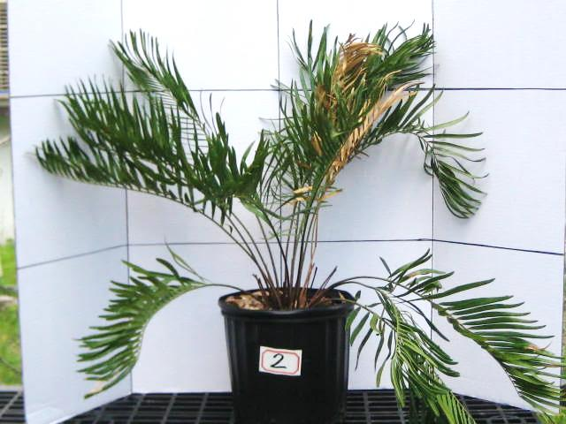

Figure 6-2. Height: ~75 cm (2.461 ft.)
Width: ~100 cm (3.280 ft.)
Fresh Wet fronds: 246.5 g. (~8.7 oz.)
Dry weight fronds: 83.5 g. (~2.9 oz.)
Number of rachides: 17
Sex: Female
Cones: None

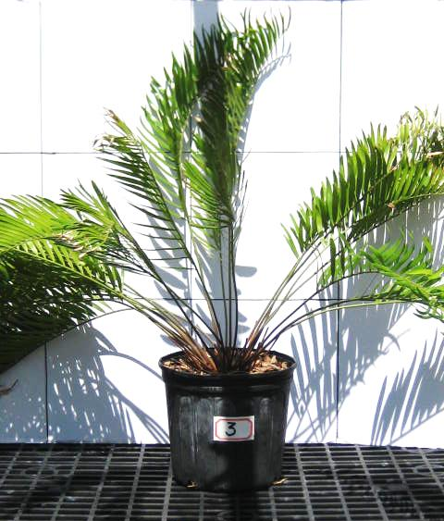

Figure 6-3. Height: ~90 cm (2.953 ft.)
Width: ~120 cm (3.937 ft.)
Fresh Wet fronds: 437.1 g. (~15.4 oz.)
Dry weight fronds: 132.5 g. (~4.7 oz.)
Number of rachides: 25
Sex: Male
Cones: One
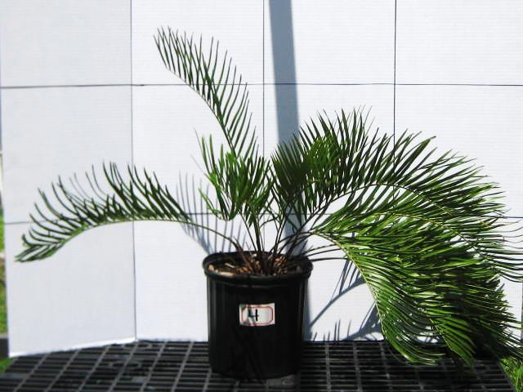

Figure 6-4. Height: ~75 cm (2.461 ft.)
Width: ~120 cm (3.937 ft.)
Fresh Wet fronds: 261.4 g. (~9.2 oz.)
Dry weight fronds: 79.5 g. (~2.8 oz.)
Number of rachides: 15
Sex: Unknown
Cones: None

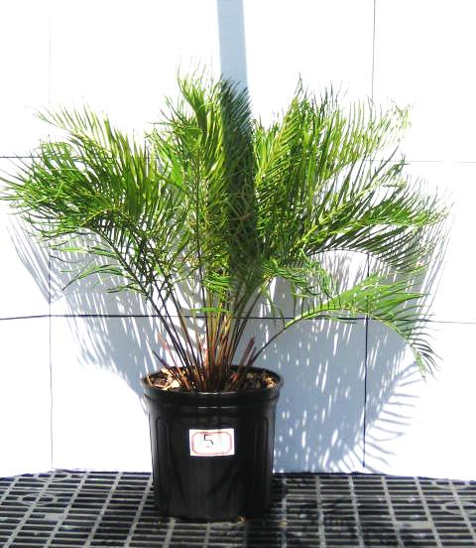

Figure 6-5. Height: ~85 cm (2.789 ft.)
Width: ~ 90 cm (2.953 ft.)
Fresh Wet fronds: 312.8 g. (~11.0 oz.)
Dry weight fronds: 95.6 g. (~3.4 oz.)
Number of rachides: 30
Sex: Unknown
Cones: None

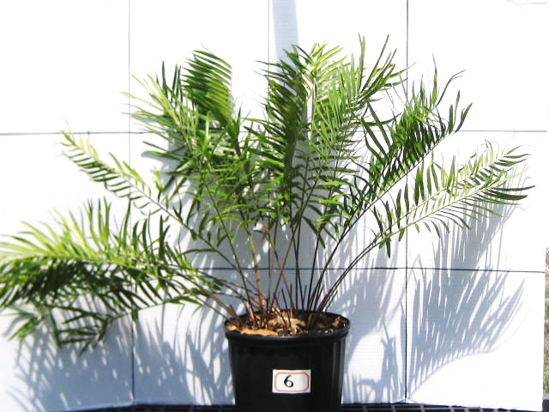

Figure 6-6. Height: ~85 cm (2.789 ft.) Width: ~120 cm (3.937 ft.)
Fresh Wet fronds: 306.4 g. (~10.8 oz.)
Dry weight fronds: 99.7 g. (~3.6 oz.)
Number of rachides: 19
Sex: Female
Cones: One

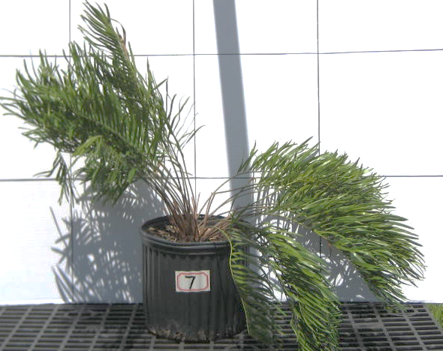

Figure 6-7. Height: ~85 cm (2.789 ft.)
Width: ~120 cm (3.937 ft.)
Fresh Wet fronds: 300.7 g. (~10.6 oz.)
Dry weight fronds: 94.3 g. (~3.3 oz.)
Number of rachides: 31
Sex: Female
Cones: One

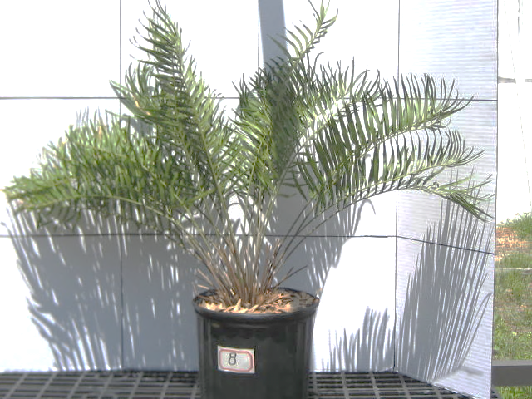

Figure 6-8. Height: ~90 cm (2.953 ft.)
Width: ~120 cm (3.937 ft.)
Fresh Wet fronds: 260.7 g. (~9.2 oz.)
Dry weight fronds: 82.0 g. (~2.9 oz.)
Number of rachides: 23
Sex: Unknown
Cones: None

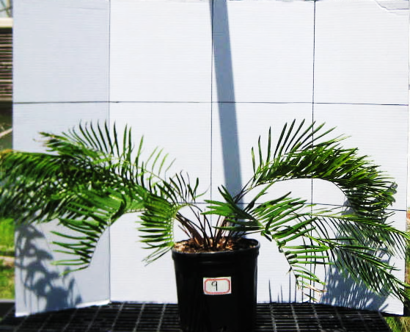

Figure 6-9. Height: ~60cm (1.969 ft.)
Width: ~150 cm (4.921 ft.)
Fresh Wet fronds: 235.3 g. (~8.3 oz.)
Dry weight fronds: 73.0 g. (~2.6 oz.)
Number of rachides: 14
Sex: Female
Cones: One

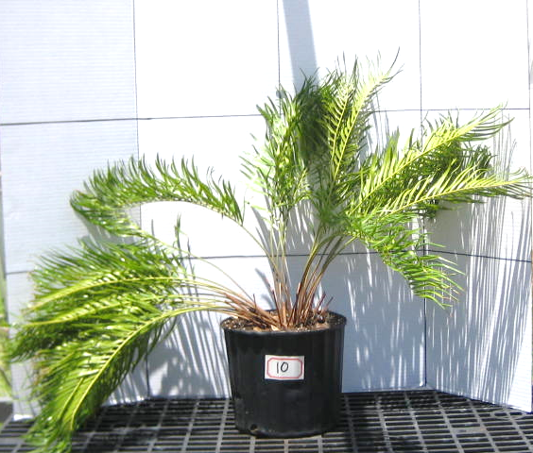

Figure 6-10. Height: ~85 cm (2.789 ft.)
Width: ~125 cm (4.101 ft.)
Fresh Wet fronds: 324.4 g. (~11.4 oz.)
Dry weight fronds: 102.7 g. (~3.6 oz.)
Number of rachides: 35
Sex: Male
Cones: One

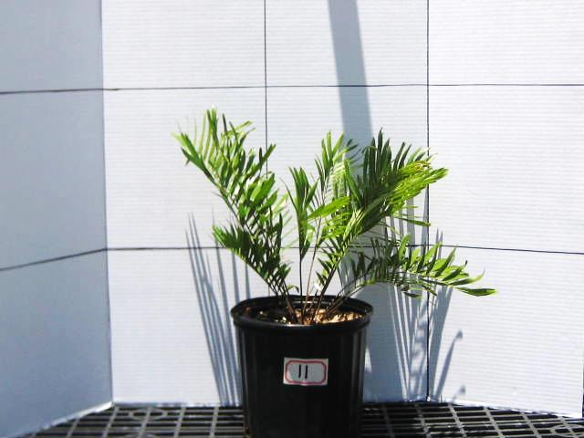

Figure 6-11. Height: ~58 cm (1.901 ft.)
Width: ~40 cm (1.312 ft.)
Fresh Wet fronds: 84.6 g. (~3.0 oz.)
Dry weight fronds: 29.0 g. (~1.0 oz.)
Number of rachides: 16
Sex: Female
Cones: One

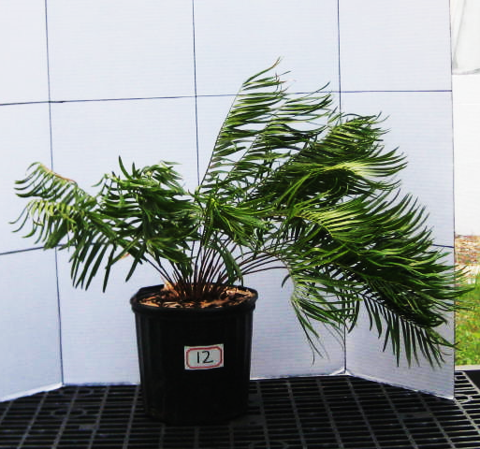

Figure 6-12. Height: ~63 cm (2.067 ft.)
Width: ~95 cm (3.12 ft.)
Fresh Wet fronds: 233.1 g. (~8.2 oz.)
Dry weight fronds: 72.8 g. (~2.6 oz.)
Number of rachides: 22
Sex: Female
Cones: One

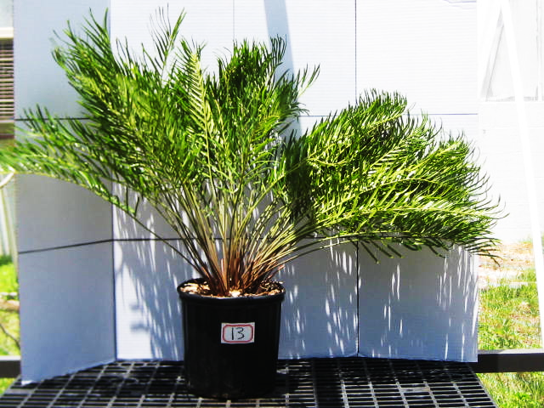

Figure 6-13. Height: ~90 cm (2.953 ft.)
Width: ~130 cm (4.265 ft.)
Fresh Wet fronds: 541.1 g. (~19.1 oz.)
Dry weight fronds: 160.8 g. (~5.7 oz.)
Number of rachides: 67
Sex: Female
Cones: One

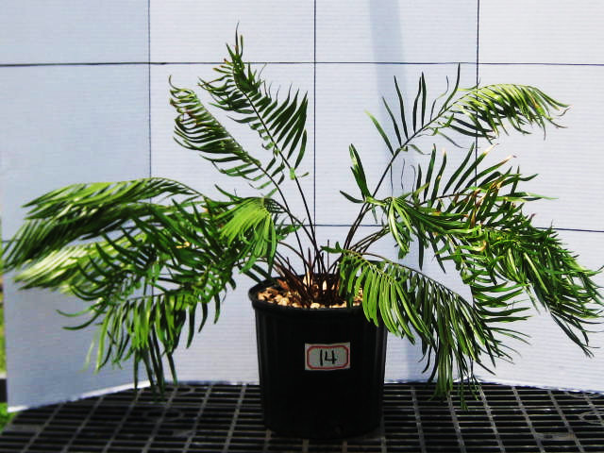

Figure 6-14. Height: ~63 cm (2.067 ft.)
Width: ~125 cm (4.101 ft.)
Fresh Wet fronds: 228.1 g. (~8.0 oz.)
Dry weight fronds: 66.3 g. (~2.3 oz.)
Number of rachides: 21
Sex: Female
Cones: One

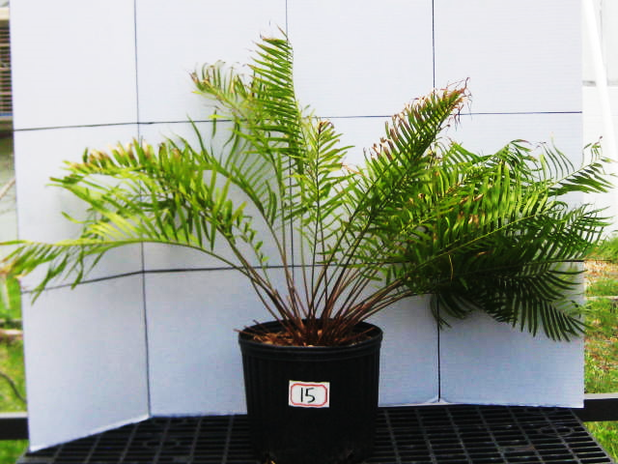

Figure 6-15. Height: ~70 cm (2.297 ft.)
Width: ~125 cm (4.101 ft.)
Fresh Wet fronds: 310.7 g. (~11.0 oz.)
Dry weight fronds: 94.6 g. (~3.3 oz.)
Number of rachides: 29
Sex: Unknown
Cones: None

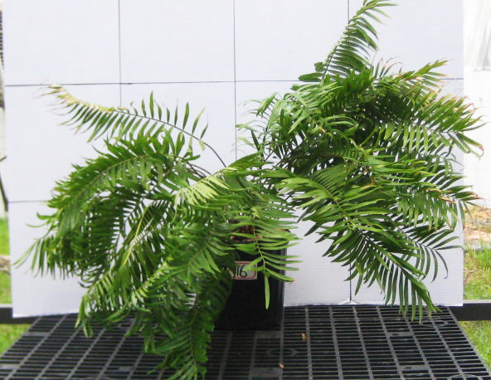

Figure 6-16. Height: ~90 cm (2.953 ft.)
Width: ~125 cm (4.101 ft.)
Fresh Wet fronds: 556.9 g. (~19.6 oz.)
Dry weight fronds: 169.6 g. (~6.0 oz.)
Number of rachides: 32
Sex: Male
Cones: One

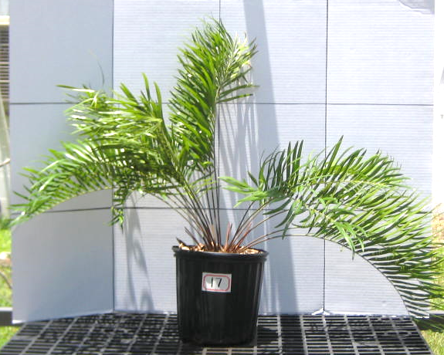
Figure 6-17. Height: ~85 cm (2.789 ft.)
Width: ~125 cm (4.101 ft.)
Fresh Wet fronds: 285.6 g. (~10.1 oz.)
Dry weight fronds: 91.2 g. (~3.2.)
Number of rachides: 18
Sex: Male
Cones: One

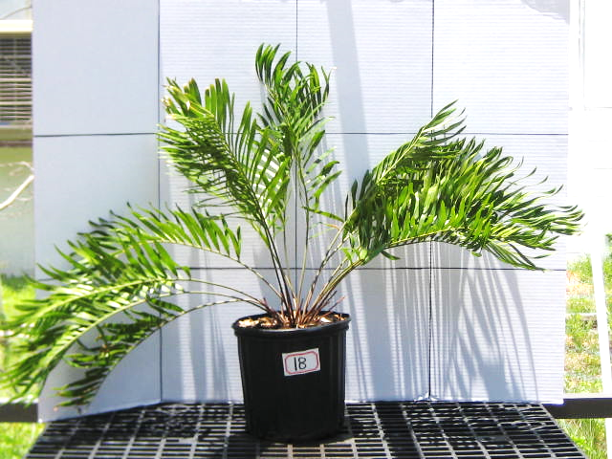

Figure 6-18. Height: ~85 cm (2.789 ft.)
Width: ~130 cm (4.265 ft.)
Fresh Wet fronds: 302.3 g. (~10.7 oz.)
Dry weight fronds: 95.2 g. (~3.6 oz.)
Number of rachides: 16
Sex: Female
Cones: One

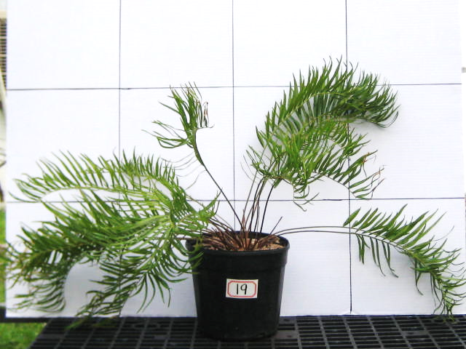

Figure 6-19. Height: ~63 cm (2.067 ft.)
Width: ~125 cm (4.101 ft.)
Fresh Wet fronds: 234.2 g. (~8.3 oz.)
Dry weight fronds: 73.4 g. (~2.6 oz.)
Number of rachides: 23
Sex: Unknown
Cones: None

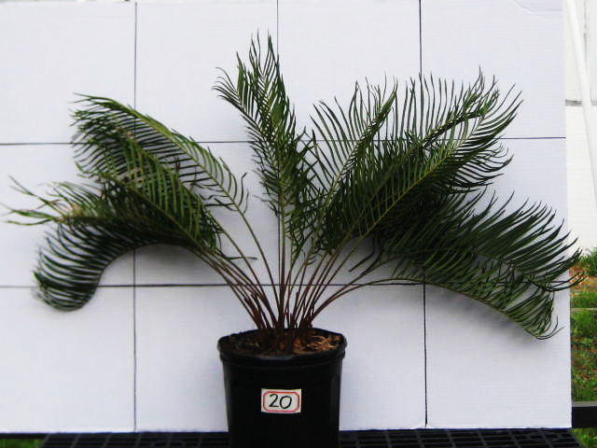

Figure 6-20. Height: ~85cm (2.789 ft.)
Width: ~125 cm (4.101 ft.)
Fresh Wet fronds: 369.9 g. (~13.0 oz.)
Dry weight fronds: 115.0 g. (~4.1 oz.)
Number of rachides: 22
Sex: Unknown
Cones: None

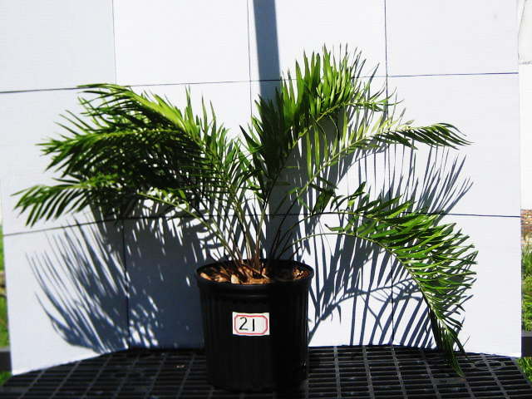

Figure 6-21. Height: ~65cm (2.133 ft.)
Width: ~95 cm (3.117 ft.)
Fresh Wet fronds: 224.0 g. (~7.9 oz.)
Dry weight fronds: 70.6 g. (~2.5 oz.)
Number of rachides: 15
Sex: Unknown
Cones: None

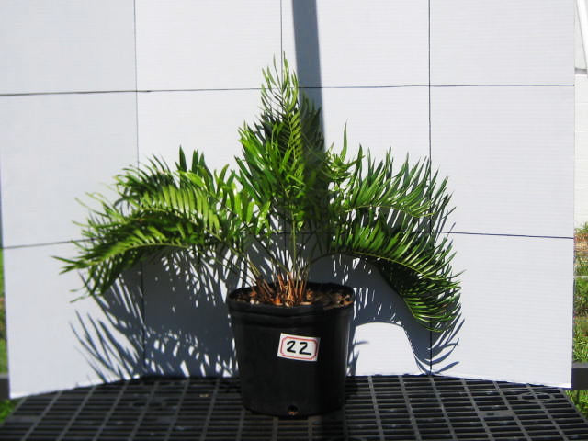

Figure 6-22. Height: ~65cm (2.133 ft.)
Width: ~85 cm (2.789 ft.)
Fresh Wet fronds: 154.9 g. (~5.5 oz.)
Dry weight fronds: 46.0 g. (~1.6 oz.)
Number of rachides: 15
Sex: Female
Cones: One

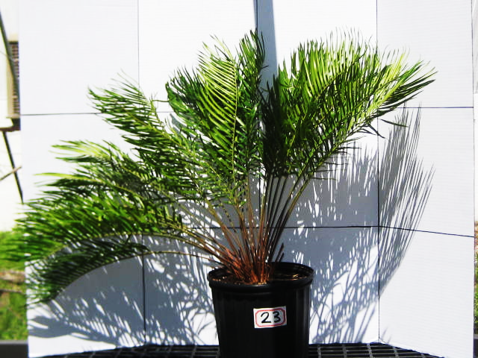

Figure 6-23. Height: ~85 cm (2.789 ft.)
Width: ~120 cm (3.937 ft.)
Fresh Wet fronds: 336.1 g. (~11.9 oz.)
Dry weight fronds: 106.7 g. (~3.8 oz.)
Number of rachides: 33
Sex: Female
Cones: One

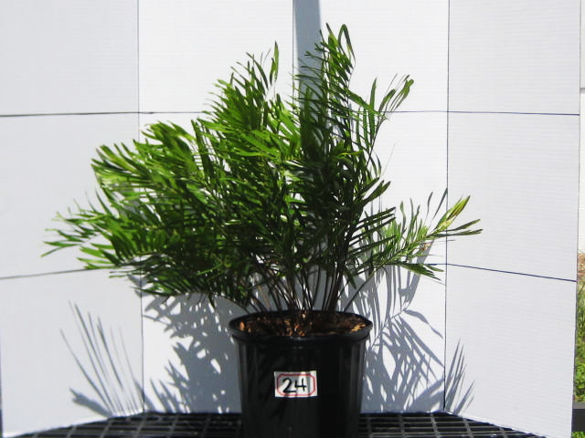

Figure 6-24. Height: ~85 cm (2.789 ft.)
Width: ~85 cm (2.789 ft.)
Fresh Wet fronds: 267.5 g. (~9.4 oz.)
Dry weight fronds: 94.6 g. (~3.3 oz.)
Number of rachides: 31
Sex: Female
Cones: Two

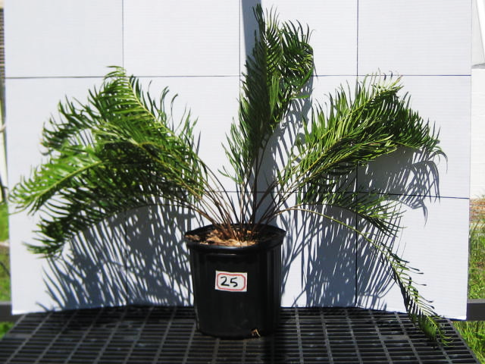

Figure 6-25. Height: ~90 cm (2.953 ft.)
Width: ~120 cm (3.937 ft.)
Fresh Wet fronds: 330.3 g. (~11.7 oz.)
Dry weight fronds: 112.1 g. (~4.0 oz.)
Number of rachides: 27
Sex: Male
Cones: None

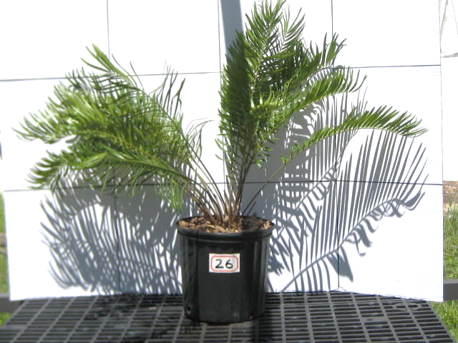

Figure 6-26. Height: ~90 cm (2.953 ft.) Width: ~110 cm (3.609 ft.) Fresh Wet fronds: 240.5 g. (~8.5 oz.)
Dry weight fronds: 76.8 g. (~2.7 oz.)
Number of rachides: 26
Sex: Female
Cones: One

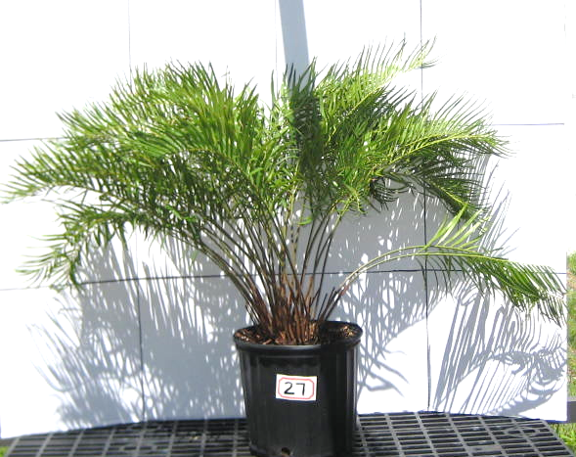

Figure 6-27. Height: ~85 cm (2.789 ft.)
Width: ~120 cm (3.937 ft.)
Fresh Wet fronds: 373.5 g. (~13.2 oz.)
Dry weight fronds: 114.5 g. (~4.0 oz.)
Number of rachides: 38
Sex: Male
Cones: One

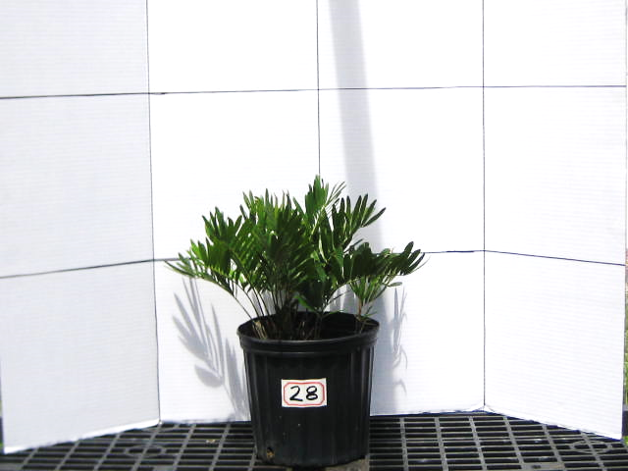

Figure 6-28. Height: ~45 cm (1.476 ft.)
Width: ~50 cm (1.640 ft.)
Fresh Wet fronds: 80.0 g. (~2.8 oz.)
Dry weight fronds: 27.0 g. (~1.0 oz.)
Number of rachides: 17 + 5 sprouts
Sex: Male
Cones: One

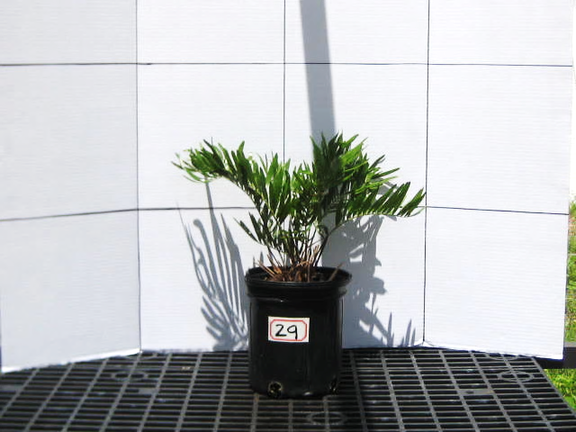

Figure 6-29. Height: ~45 cm (1.476 ft.)
Width: ~50 cm (1.640 ft.)
Fresh Wet fronds: 57.0 g. (~2.01 oz.)
Dry weight fronds: 19.6 g. (~0.7 oz.)
Number of rachides: 9
Sex: Male
Cones: One

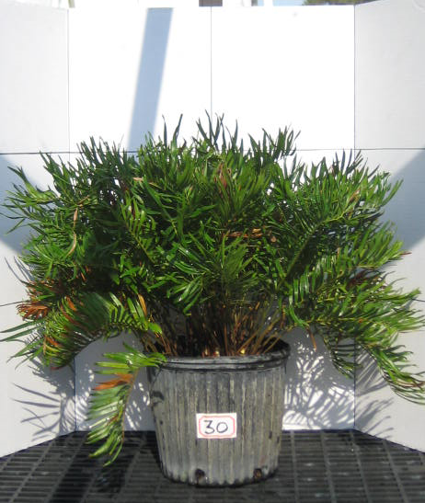

Figure 6-30. Height: ~65 cm (2.133 ft.)
Width: ~120 cm (3.937 ft.)
Fresh Wet fronds: 740.3 g. (~26.1 oz.)
Dry weight fronds: 278.1 g. (~9.8 oz.)
Number of rachides: 104
Sex: Male
Cones: Eight

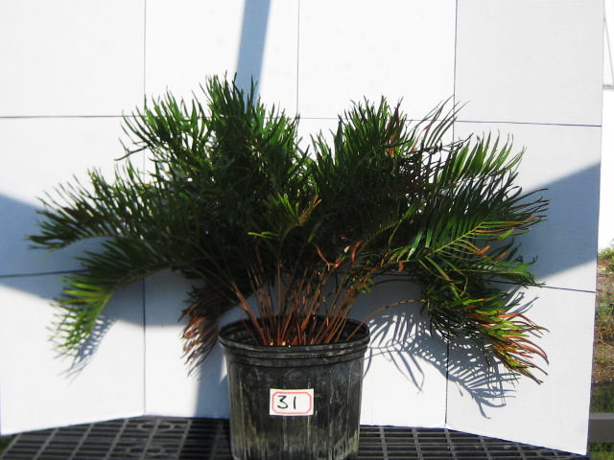

Figure 6-31. Height: ~65 cm (2.133 ft.)
Width: ~100 cm (3.281 ft.)
Fresh Wet fronds: 411.4 g. (14.5 oz.)
Dry weight fronds: 151.3 g. (5.3 oz.)
Number of rachides: 49
Sex: Female
Cones: Six

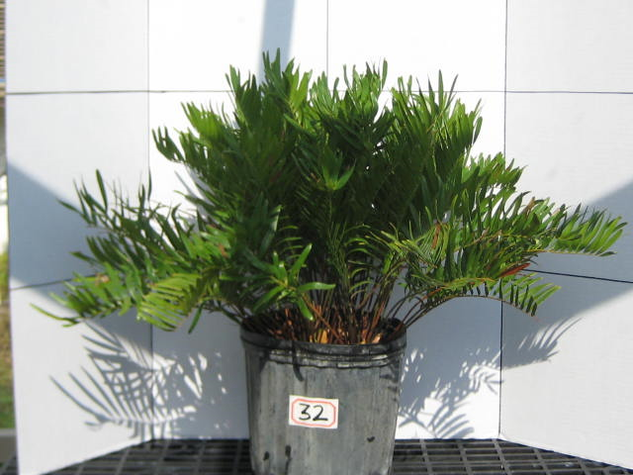

Figure 6-32. Height: ~63 cm (2.067 ft.)
Width: ~110 cm (3.609 ft.)
Fresh Wet fronds: 491.0 g. (~17.3 oz.)
Dry weight fronds: 174.3 g. (~6.1 oz.)
Number of rachides: 70
Sex: Male
Cones: Seven

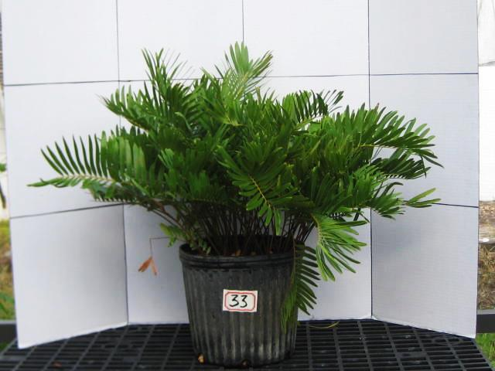

Figure 6-33. Height: ~63 cm (2.067 ft.)
Width: ~110 cm (3.609 ft.)
Fresh Wet fronds: 527.5 g. (~18.6 oz.)
Dry weight fronds: 180.7 g. (~6.4 oz.)
Number of rachides: 72
Sex: Male
Cones: Ten

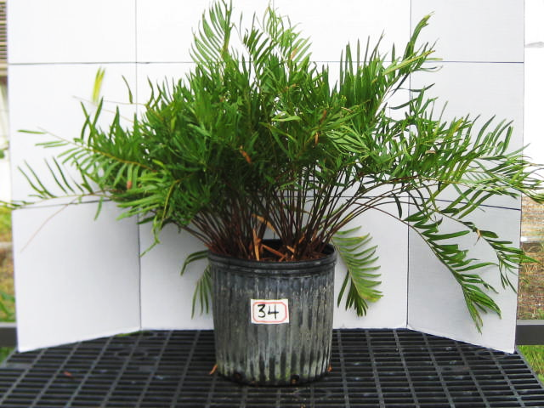

Figure 6-34. Height: ~90 cm (2.953 ft.)
Width: ~125 cm (4.101 ft.)
Fresh Wet fronds: 544.6 g. (~19.2 oz.)
Dry weight fronds: 171.5 g. (~6.1 oz.)
Number of rachides: 83
Sex: Female
Cones: Thirteen, new

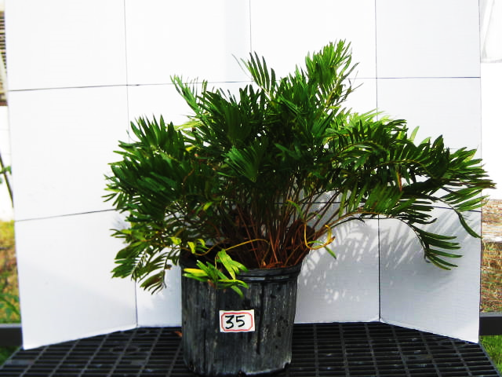

Figure 6-35. Height: ~65 cm (2.133 ft.)
Width: ~95 cm (3.117 ft.)
Fresh Wet fronds: 490.7 g. (~17.3 oz.)
Dry weight fronds: 171.5 g. (~6.1.)
Number of rachides: 62
Sex: Female
Cones: Two, mature

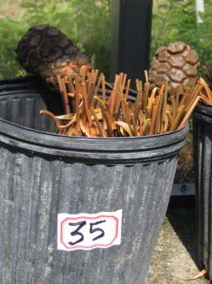
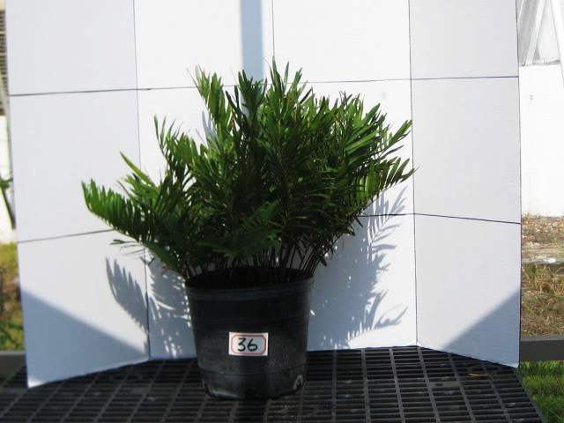

Figure 6-36. Height: ~63 cm (2.067 ft.)
Width: ~65 cm (2.133 ft.)
Fresh Wet fronds: 432.6 g. (~15.3 oz.)
Dry weight fronds: 142.0 g. (~5.0 oz.)
Number of rachides: 58
Sex: Female
Cones: Five, new

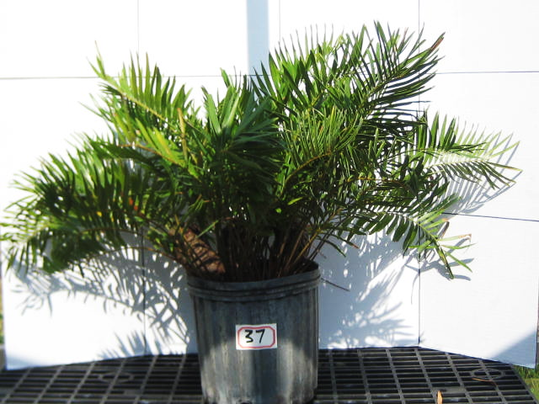

Figure 6-37. Height: ~70 cm (2.297 ft.)
Width: ~110 cm (3.609 ft.)
Fresh Wet fronds: 592.3 g. (~21.0 oz.)
Dry weight fronds: 216.8 g. (~7.7 oz.)
Number of rachides: 61
Sex: Female
Cones: Three, mature

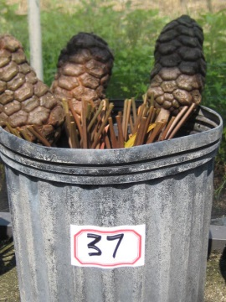
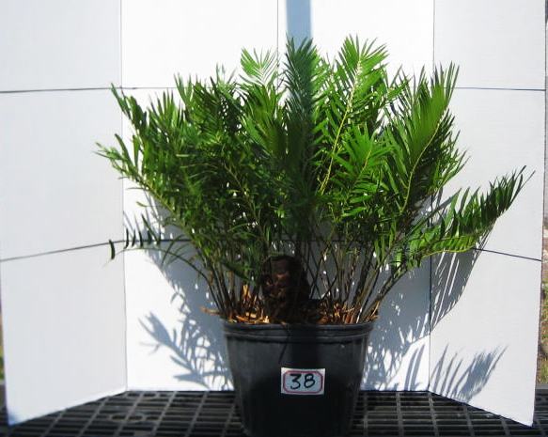

Figure 6-38. Height: ~65 cm (2.133 ft.)
Width: ~90 cm (2.953 ft.)
Fresh Wet fronds: 421.8 g. (~15.0 oz.)
Dry weight fronds: 114.1 g. (~4.0 oz.)
Number of rachides: 64
Sex: Female
Cones: Two, mature

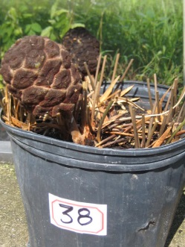
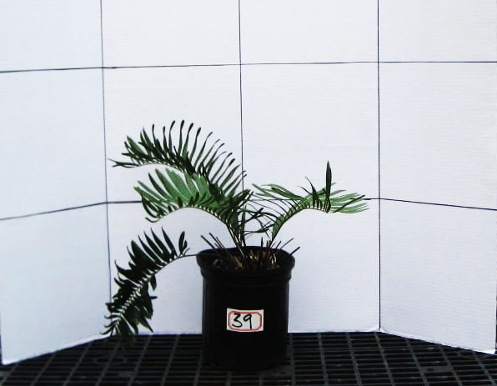

Figure 6-39. Height: ~45 cm (1.476 ft.)
Width: ~60 cm (1.969 ft.)
Fresh Wet fronds: 49.6 g. (~1.8 oz.)
Dry weight fronds: 19.1 g. (~0.7 oz.)
Number of rachides: 4
Sex: Unknown
Cones: None

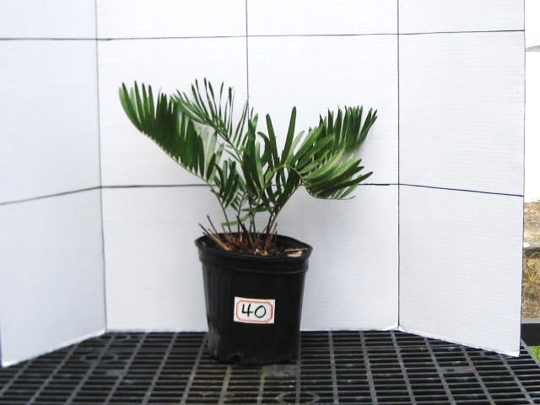

Figure 6-40. Height: ~50 cm (1.640 ft.)
Width: ~45 cm (1.476 ft.)
Fresh Wet fronds: 53.1 g. (~1.9 oz.)
Dry weight fronds: 18.4 g. (~0.6 oz.)
Number of rachides: 5
Sex: Female
Cones: One

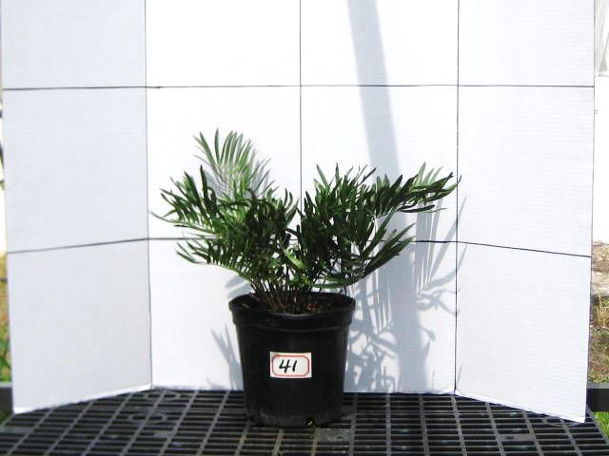

Figure 6-41. Height: ~50 cm (1.640 ft.)
Width: ~60cm (1.969 ft.)
Fresh Wet fronds: 86.1 g. (3.0 oz.)
Dry weight fronds: 27.1 g. (1.0 oz.)
Number of rachides: 17
Sex: Male
Cones: One

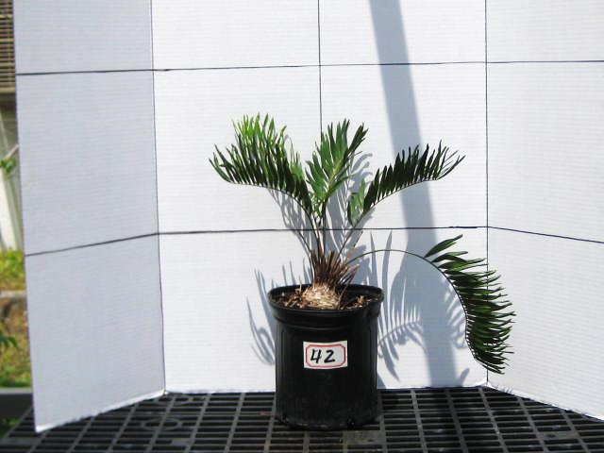

Figure 6-42. Height: ~50 cm (1.640 ft.)
Width: ~55 cm (1.804 ft.)
Fresh Wet fronds: 37.1 g. (~1.3 oz.)
Dry weight fronds: 11.9 g. (~0.4 oz.)
Number of rachides: 5
Sex: Unknown
Cones: None

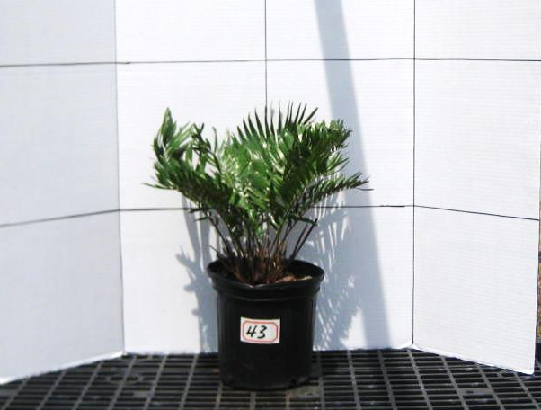

Figure 6-43. Height: ~50 cm (1.640 ft.)
Width: ~35 cm (1.148 ft.)
Fresh Wet fronds: 73.3 g. (~2.6 oz.)
Dry weight fronds: 23.0 g. (~0.8 oz.)
Number of rachides: 14
Sex: Male
Cones: One

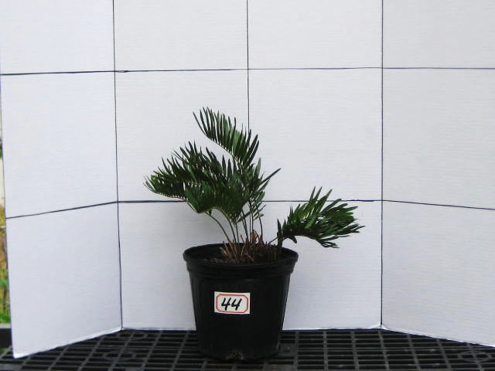

Figure 6-44. Height: ~50 cm (1.640 ft.)
Width: ~35 cm (1.148 ft.)
Fresh Wet fronds: 48.9 g. (~1.7 oz.)
Dry weight fronds: 15.3 g. (~0.5 oz.)
Number of rachides: 10
Sex: Male
Cones: One

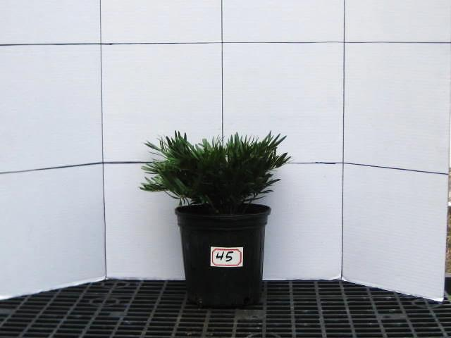

Figure 6-45. Height: ~32 cm (1.050 ft.)
Width: ~30 cm (0.984 ft.)
Fresh Wet fronds: 98.4 g. (~3.5 oz.)
Dry weight fronds: 30.0 g. (~1.1 oz.)
Number of rachides: 30
Sex: Unknown
Cones: None

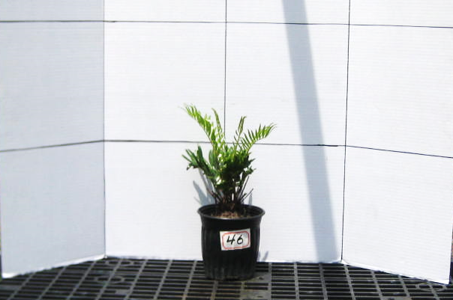

Figure 6-46. Height: ~35 cm (1.148 ft.)
Width: ~25 cm (0.820 ft.)
Fresh Wet fronds: 24.6 g. (~1.0 oz.)
Dry weight fronds: 7.0 g. (~0.2 oz.)
Number of rachides: 12
Sex: Unknown
Cones: None

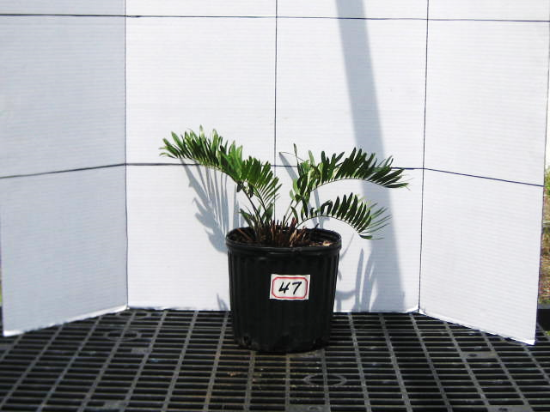

Figure 6-47. Height: ~33 cm (1.148 ft.)
Width: ~40 cm (0.820 ft.)
Fresh Wet fronds: 31.3 g. (~1.1 oz.)
Dry weight fronds: 11.9 g. (~0.4 oz.)
Number of rachides: 7
Sex: Male
Cones: One

