Margarita Vargas-Betancourt
October 14, 2013

20 FACTS ABOUT THE DAY OF THE DEAD

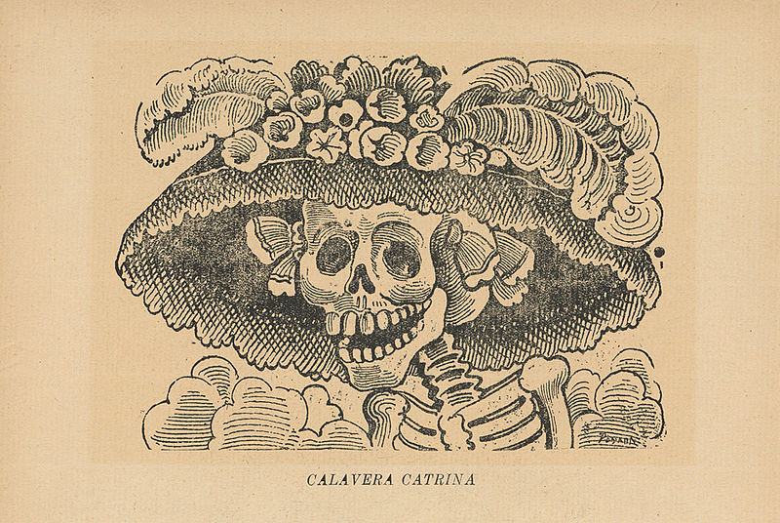

- What is the Day of the Dead?
The Day of the Dead is one of the most important holidays in Mexico. It is a celebration of the people who have died before us, in other words of our ancestors. It is also a day when we make fun of death, when we remember that we are all going to die. But it is a very cheerful event. It is a great fiesta.

To find out more visit the Latin American Collection in the 4th Floor of Library East.

- Where is the Day of the Dead celebrated?
All over Mexico, but especially in central Mexico.

To find out more, check out the book Skulls to the Living, Bread to the Dead: the Day of the Dead in Mexico and Beyond (UF SMATHERS, Latin America General Collection -- GT4995.A4B73 2006)

- How is it celebrated?
People make altars in their houses to honor their dead relatives or their muertitos. Some people also go to cemeteries to visit the tombs of their beloved. They clean and decorate the tombs, prepare offerings, eat food and drinks, bring music like mariachis, and have a fiesta.

- What are the basic elements of the offering at the altar?
Photographs of the deceased, flowers, candles, papel picado (tissue paper cut with figures of skeletons), sugar skulls, other decorations with the motif of skulls or skeletons, food, drinks, things that belonged to the muertitos, incense, and resin.

To see photographs of the altars check out the book The Day of the Dead (UF SMATHERS, Latin America General Collection -- GT4995.A4D44 2007)

- What are the typical flowers of Day of the Dead?
Marigold and purple cockscomb.

- What is the significance of flowers?
People believe that flowers’ guide the spirits of the dead to the altar. For this reason, they make paths of flowers that connect gates or doorways to the altar.

- What kind of food is included in the altar?
The food that your muertito liked the most. It usually is typical Mexican food like mole, rice, nopales. And of course, a bottle of the muertito’s favorite drink, for example tequila, mezcal, beer, or coke.

To see how my family prepared the Day of the Dead altar for my mother in 2005 go to UF’s Institutional Repository (http://ufdc.ufl.edu/IR00003507/00001)

- What is pan de muerto?
It is a round bread decorated with bone-looking pieces of bread that form a cross. These “bones” symbolize the remains of our muertitos. In the intersection of the cross, there is a small ball of bread that represents the tears we shed for them. This bread is especially made for this festivity.

- When is it celebrated?
On October 28, the people who suffered violent deaths (accident, crime, suicide) are celebrated. On November 1st, those who died as children, and on November 2nd, the adults who died of disease or old age, are celebrated.

- What are the main beliefs of this celebration?
That the spirits of the dead come back to join the world of the living for one day. It is believed that they suck the flavor of the food offered to them. When the family eats the food, it is considered to be flavorless.

- Is it also a public celebration?
Yes, this is a special festivity in the private but also in the public world. Most official and cultural institutions, like schools, prepare altars. Many are offered to Mexican historic figures. Some altars are also expression of political activism.

To see a contest of altars that took place in a Mexican University go to UF’s Institutional Repository (http://ufdc.ufl.edu/IR00003508/00001).

- What are some of the most important figures commemorated in the celebration?
Figures that are important in Mexico’s historical memory. Two of the most popular ones are of Emiliano Zapata and Frida Kahlo.

- Who was Emiliano Zapata?
Emiliano Zapata ( 1879-1919) is one of the most revered figures of the Mexican Revolution. He led the Liberation Army of the South formed by peasants from southern Mexico who fought for rights like land ownership.

To find out more on the significance of Emiliano Zapata check out the book The Posthumous Career of Emiliano Zapata: Myth, Memory, and Mexico’s Twentieth Century (UF SMATHERS, Latin America General Collection -- F1234.Z37B79 2008)

- Who was Frida Kahlo?
Frida Kahlo (1907-1954) is one of the most renowned Mexican painters. Mexican and indigenous culture in addition to her physical and psychological suffering are the main topics of her paintings. She was married to the Mexican muralist Diego Rivera.

To read more on Frida, check out the book Frida’s life check out the popular biography Frida, A Biography of Frida Kahlo (UF SMATHERS, Latin America General Collection -- ND359.K33H47x 2002)

- Who was José Guadalupe Posada?
José Guadalupe Posada (1852-1913) was an artist, illustrator and cartoonist. His most famous cartoons were political satires whose main characters were skeletons.

To see some of his illustrations check out the book José Guadalupe Posada: Illustrator of Chapbooks (UF SMATHERS, Latin America General Collection -- NE546.P6A4 2005).

- Why is he important for Day of the Dead?
His images gave way to a lot of folk art that is now used to decorate altars during the Day of the Dead.

To see some of the most beautiful calavera art check out the book En Calavera: the Papier-Maché Art of the Linares Family (UF SMATHERS, Latin America General Collection -- NK8555.5.M64L562 1994)

- Who is Catrina?
One of Posada’s most important works was La Calavera Catrina. This was the sketch of a female skeleton dressed with a European-style hat. The image criticizes the life of the upper classes prior to the Mexican Revolution. It has now become the most important symbol of the Day of the Dead.

To see photos of offerings in a little Mexican town and of offerings in Cuernavaca, the capital of the state of Morelos go to UF’s Institutional Repository (http://ufdc.ufl.edu/l/IR00003509/00001)

- What other traditions revolve around the festivity?
People write satirical poems known as Calaveras in which La Catrina or Death comes after a public figure. Calaveras are published in newspapers and journals. Sometimes, children write Calaveras at school too. It is a time when we make fun of death but also of people in power.

- What are some of the different names used for death?
La Parca (Grim Reaper), La Flaca (The Thin One), La Tilica (The Skinny One), La Tembeleque (The Shaky One), La Pelona (The Bald One), La Descarnada (The Flayed One), La Triste (The Sad One), La Huesuda (The Bony One), La Llorona (The Crying One), La Tiznada (The Smudged One), La Patona (The Big Feet One), La Huesos (The Bones), La Apestosa (The Stinky One), La Igualadora (The Equaliser One), La Dientona (The Big Teeth), La Calaca (The Skeleton).

- Where do you get the things for the altar?
You find everything you need in the market. This is one of the most colorful and busy times in Mexican markets.

