Metadata Training Assessment
True or False
- All items should include information in the title field.
- Other title types include subtitles, abbreviated titles, uniform titles, alternative titles, and series titles.
- The SobekCM system which powers the UF Digital Collections (UFDC) and the Digital Library of the Caribbean (dLOC) looks for identifiable leading articles in English, Spanish, and French and removes them for sorting purposes. Thus, the initial articles should be included when entering titles.
- For items where there is not a clear title, the most important or unique keywords (who, what, where, when) should come first.
- Languages should be entered either by the text of the language, the ISO code, or by the term from the MARC Code List of Languages.
- ISBNs, ISSNs, museum accession numbers, library call numbers, and permanent URLs are types of identifiers within their given contexts.
- All items in UFDC/dLOC have permanent URLs and these map to the 856 in MARC.
- The creator is an entity (person, group, corporation, institution) primarily responsible for making the content of the resource available or associated with the item in some way.
- Authors, illustrators, binders, publishers, and conferences can all be creators.
- The creator field is repeatable as many times as necessary to include all relevant mentions.
- When available, including the birth date for a creator is beneficial for name disambiguation.
- Bibliothèque Nationale de France’s RAMEAU is a formal classification scheme for subjects.
- Chronological and topical are two types of subject terms.
- Best practices for the specific case of oral histories: in the abstract should be included: a) interviewer’s name; b) interviewee’s name; c) address of the interview; d) date of the interview; and e) project name or reason for the interview.
- Printed sheet music should be classified as “archival” for type.
- The transcript for an oral history should be classified as “archival” for type.
- The video of an oral history should be classified as “video” for type.
- PowerPoint presentation slides should be classified as “archival” for type.
- A bound thesis or dissertation should be classified as “book” for type.
- A regularly published journal should be classified as “serial” for type.
Metadata Practice
Please complete the following chart for the items on the following pages. If there is currently insufficient information, list how and where the information could be obtained without asking someone else for the information.
 | Item One | Item Two | Item Three | Item Four | Item Five
- Title

- Other Title
- Type
- Physical Description
- Language
- Identifier
- Holding Location
- Source Institution
- Creator
- Publisher
- Place of Pub.
- Date of Pub.
- Subjects
- Spatial Subject
- Coordinates
- Abstract

- Note

Item One
Item Two
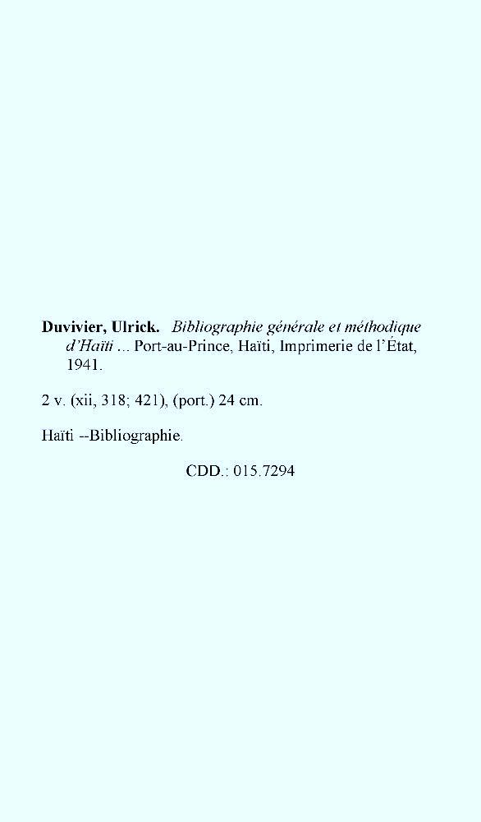
Item Three
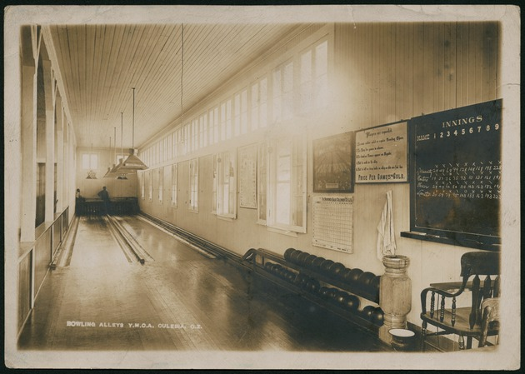

Item Four
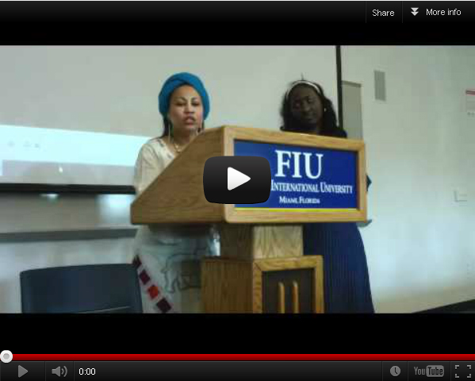
Video of Lecture from April 5, 2012
Organized by Latin American and Caribbean Center at Florida International University. Co-sponsored by Department of Religious Studies at Florida International University
Lecturer: Mambo Ingrid Lecturer's guest: Nadege Etienne First speaker: Ana Maria Bidegain, Professor, Religious Studies & Director of Research, Latin American and Caribbean Center, Florida International University Second Speaker: Albert Wuaku, Assistant Professor, Religious Studies, Florida International University

Item Five (full item on the right and close-up on the left)
