Title: Visualization, Acquisition, Modeling and Analysis of Multi-Dimensional Data (VAMA hub)
Proposer:
Library: Joe Aufmuth, MS; Michael Howell, MS; Melody Royster, MLS; Donna Wrublewski, PhD, Evan Wack, Library IT. Contact address: Government Documents Department, Marston Science Library, POB 117011, mapper@uflib.ufl.edu, 352-273-0367.
CISE (Computer and Information Sciences and Engineering): Jorg Peters, PhD, jorg@cise.ufl.edu, CSE Building Room 328, 352-392-1200 or 352-450-3443; Dan Eicher, Director CSE Computer Lab, dhe@cise.ufl.edu.
Sponsoring Organization: UF Libraries and College of Engineering
Purpose and Specific Objectives: (What is the proposal intended to improve or facilitate? Why is it important to do so? What are the expected outcomes? Clearly outline the objectives of this project in a way that it can easily be determined if they are achieved by the end of the project.)
The ability to critically analyze and visually represent increasingly large digital data sets is a crucial component of 21st century education. Increasingly, academic discipline activities generate large robust data sets requiring unique approaches to analysis and visualization. Various academic activities such as Geographic Information Systems (GIS), interactive simulation and game development in computer graphics, interactions of physical and biological forces modeled in molecular chemistry, mechanical engineering, and the earth sciences, social network analysis of interactions amongst individuals in multiple levels of society in the social sciences, as well as business and economics, all generate and require the manipulation of 2D, 3D, temporal, and multidimensional data components. Acquiring, visualizing, modeling and analyzing robust data sets requires specialized data acquisition equipment, dedicated software and computing resources, advanced display tools, and educational support not currently available through the general use campus computer labs or freely accessible in the students’ home departments. VAMA, the hub for Visualization, Acquisition, Modeling and Analysis of Multi-Dimensional Data will bring together a unique combination of data creation and analysis techniques, existing multi-dimensional data sets, and creative simulation environments at a centralized campus location to support teaching, collaborative student research projects, and individualized learning experiences about 2, 3, or multi-dimensional data. Student and class usage patterns and individual feedback during the start-up phase will validate successful deployment and responsiveness to student needs.
The VAMA hub will be housed in the centrally-located twin buildings of the Marston Science Library (MSL Room 107) and the Computer Science and Engineering building (CSE Room 313). Compliant with and improving upon existing Library and CISE ADA policies the facilities will be improved with and share specialized computers for advanced graphics, data visualization software and software development kits (SDK), Omni force feedback devices, a large format roll scanner, an 11x17 desk top scanner, a 3D handheld scanner and state-of-the-art 3D display devices. The facilities will be open to undergraduates, graduate students, and faculty during Library and CISE operating hours or adjusted for specialized requests. In addition, Provost funded video conferencing equipment in MSL107 will assist in providing distance education. No other locations on campus offer similar freely available resources to non-departmental users or users outside of registered classes.
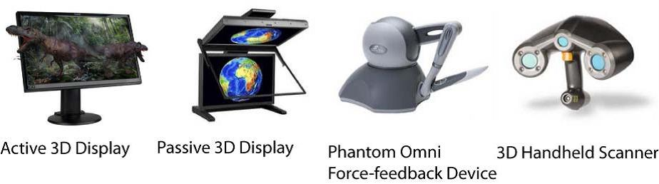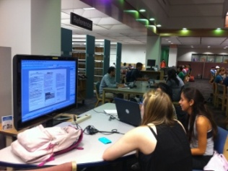
Why twin facilities? Just as the University’s technology transfer program fosters innovative technology development and transfers technology to the private sector, the relationship between the proposed VAMA facilities is similarly synergistic. The CISE portion of the VAMA hub is designed to meet the advanced innovative visualization and software development needs of students and academic programs, while the Library facility serves the purpose of supporting, transferring, and fostering newly developed data visualization knowledge amongst the general campus population. The twin facilities serve a necessary and very synergistic relationship. In order to dynamically upgrade and customize software, especially from the vibrant open source repositories, the CISE lab will be able to leverage input from a user base of students, instructors, and faculty in digital arts, graphics, and visualization programs. Visualization tools will be tested by a software development user base in the flexible environment of the CISE VAMA lab so that stable setups can be transferred to the Library VAMA lab for general use.
In-kind Contributions, MSL107 Start-Up. In order to develop MSL107 into an ADA compliant conference, instruction, and research facility the Library will commit $40,000 in funds to provide raised ADA accessible flooring. Electrical outlets and network connections in the raised flooring can be easily redesigned to adapt to changing student usage patterns. The Provost’s Office also has contributed $37,000 towards MSL107 video conferencing equipment to facilitate Library assisted distance education and meetings.
Impact/Benefit: (Benefits a large number of students, faculty and staff. Who benefits? Estimate how many students, how many faculty, how many courses will be impacted? In what ways? Does it leverage existing resources? 20 points)
Imagine a history class project centered on pottery artifacts. Using the VAMA hub facilities Geomatics students create a GIS database to track the location of known indigenous sites and their vicinity to roads for easy access. Pottery pieces found during an archaeology field trip to one of the sites are mapped and scanned in 3D. Teaming up with digital arts students, the scanned incomplete model fragment is digitally displayed and repaired by virtual clay carving using an Omni force-feedback device available in the new lab. A newly released open source 3D physics simulation package is modified in CISE and installed and customized by students to simulate how different pottery designs resist breakage and how pieces would scatter under impact. The resulting 3D model is digitally matched to an existing database of 3D artifacts to establish similarities with known archaeological finds. Through modeling and mapping activities a student’s collaborative learning experience about the history of the society that created the original pottery is enhanced. Faculty and graduate students teaching courses using new visualization technologies as in the example or incorporating them into their own research also benefit from the support VAMA will provide.
VAMA benefits a large number and range of students, faculty and staff. One way to estimate the population of potential users across campus is gate counts or number of student and faculty visits from January 2010 to December 2010 to Marston Science Library (756,882), Architecture and Fine Arts Library (40,188), and Library West (1,109,095) which total 1,906,070. If only 1 percent of library visitors each year use the VAMA hub this equates to approximately 19,000 visitors. The VAMA infrastructure will have the potential to benefit thousands of students and hundreds of faculty across multiple departments and colleges. In the 2010-11 undergraduate course catalog there are 29 courses in 13 different departments that specifically mention spatial information systems, one service emphasis of the MSL lab, however no general use spatial data lab is available to undergraduates. In CISE the undergraduate and graduate courses in computer modeling, visualization, and human-computer interaction enroll over 800 students. Besides being freely available to students and faculty outside of classes, enhancing the existing CISE313 lab will help alleviate overcrowding in existing labs, especially near project deadlines.
MSL107, despite its prime central location, is an existing underutilized class and conference room resource that will be greatly enhanced for increased student and faculty access. Historically MSL107 has been reserved for specialized meetings and Library classes. However, a highlight of last year’s MSL107 usage was 8 grant writing workshops (260 participants) conducted by the Library’s Grant Administrator that focused on NSF, Fulbright, and CoLAB seminars aimed at increasing the University’s students’ and faculties’ ability to write successful grants. MSL 107’s usefulness for instruction across disciplines and grant writing seminars in particular will be preserved and enhanced by the Library's decision to open the access. The raised floor, video conferencing equipment, and the reconfigurable collaboration tables with recessed flip top panels for computer screens will allow for multipurpose use and flexible rededication while responding to the University’s students’ needs in the area of data acquisition, analysis, and visualization.
(Proposal is a collaborative endeavor amongst several departments and/or colleges. 15 points)
VAMA is a collaborative endeavor between the Libraries and CISE. The Libraries and CISE will share hardware, basic software components, and exchange information technology assistance. As previously stated, the CISE portion of the VAMA hub is designed to meet the advanced innovative visualization and software development needs of students and academic programs, while the Library facility serves the purpose of supporting, transferring, and fostering newly developed data visualization knowledge amongst the general campus population. The twin facilities serve a necessary and very synergistic relationship.
As the University’s academic programs evolve and the interests and expectations of its faculty and students change, the Libraries strive to be a step ahead – anticipating and preparing for new needs and requests. The goals of the Library are to optimize delivery of Library resources and services, improve Library facilities to meet program need, and maintain and improve infrastructure to reflect organizational commitment. Collaboration between CISE and the Library on developing a visualization hub supports the mission of the University’s academic programs and introduces the Library to expertise in the area of 3D visualization.
(The perceived benefit to cost ratio of the project is high. 15 points)
VAMA has a high benefit to cost ratio. The key technological components - 3D scanners and cameras, high performance workstations with high-end graphics cards, high-end display devices and monitors, large format scanners, and force-feedback devices come now at consumer prices and have an unprecedented cost-benefit ratio. Existing large spatial and scientific datasets will be available for increased University wide usage. An underutilized space will be converted to an active learning environment and enhanced existing lab space will be available for increased usage.
Through collaborative review of the budget and items requested, the originally proposed cost has been reduced by ca. $150,000. The costs have been lowered through leveraging Provost’s funds for the audio-visual conferencing equipment in the MSL lab, by the Dean of Libraries funding of floor remodeling costs, and by CISE taking over some initial software cost. A budget reduction of $80,000 was achieved through eliminating the 10 gigabit network infrastructure improvement intended for fast data flow between work stations.
The twin facilities set up is more cost-efficient than packing all hardware into one room. Both locations already exist and there is no furniture or remodeling cost for the CISE location. The CISE lab space by itself is too small to house VAMA. The separation in space between the occasional user of VAMA tools and developers of VAMA tools makes appropriate types of access and software support possible. Increasing the Libraries IT support level to sustain a single highly dynamic development environment required for constantly upgrading VAMA tools would be far more costly. CISE system support on the other hand is used to this level of upgrades. Conversely Library IT is positioned to manage large numbers of public use computers and access to University wide data sets.
(Reaches students and faculty across the institution to achieve a common good. 10 points)
VAMA reaches across the institution. Students in medical, biological, and engineering departments take computer vision, visualization and graphics computer courses in CISE and spread the technology in their home departments. The Library’s mission is to support all programs throughout the institution. UF librarians will introduce the new visualization resources to their liaison departments to make high-end class projects possible. One current example of bringing campus units together is the Library’s participation in and support of the Interdisciplinary Concentration in GIS certificate program. The program’s governing board includes members from the Library, the Colleges of Liberal Arts and Sciences, Design, Construction and Planning, Engineering, Agriculture and Life Sciences, and the School of Forest resources and Conservation. The VAMA hub will achieve a common good by increasing interactions between students and faculty in similar campus wide programs.

(Improves the student’s learning experience. 10 points)
VAMA will improve the students' learning experience. As datasets become more complex in spatial and temporal scales, acquisition and visualization in multi-dimensions can give unique insights into complex time varying interactions, simulations, and physical, human-created, or natural artifacts. As implied in the previously given history class example VAMA leverages spatial reasoning, 3D interaction and visualization to enhance student learning. One specific device that will be available to students is an Omni force feedback device that for hands-on experience of geometric artifacts, modeling with virtual clay and probing of human, animal and artificial tissues.
(Improves faculty’s capacity to create quality learning environments for students. 10 points)
VAMA will improve faculty's capacity to create quality learning experiences. Projects are a crucial component of teaching research methods and are used in spatial analysis, geography, political science, urban and regional planning, graphics, modeling & art, educational game development and human computer interaction classes to name a few. The previous example stated above points out the potential to create a quality learning environment for students. The proposed labs will provide facilities for challenging class work, extended to distance learning through the MSL lab’s Provost funded videoconferencing setup. Instructors will be able to schedule the labs for class usage, and librarians and other campus groups can use the Labs to teach classes about data analysis and data visualization.
(Makes efficient use of existing resources and services (does not duplicate services or infrastructure). 10 points)
VAMA makes efficient use of existing resources and services. MSL L107, currently an under-utilized library lecture and meeting room, will be enhanced to a state-of-the-art student learning environment. Activities in MSL will be supported by existing subject specialist librarians, who will use the room for student and faculty instruction and consultations. The Library has initiated a room reservation system for student study rooms that can be utilized to manage user access to the lab or individual computers. Additionally the Library currently has a system for student check out of lap top computers and flip cameras that can be adapted to further manage the lab’s resources. MSL107 is located directly in front of the Government Documents Reference Desk which will aid in assisting students and faculty as well as providing lab safety. During normal semester hours the Government Documents Reference desk is staffed from 8:30 am to 9:00 pm during the week and various hours on the weekend allowing the lab to be utilized for longer periods during the day and week. Located in the same area as the Map and Imagery Library, students will be able to readily access library-owned spatial imagery and data sets in order to collaborate on classwork. MSL107 will also be enhanced by Library funded raised flooring and Provost supported audio-visual teleconferencing capabilities for distance education. Lastly the proposed investment will upgrade existing space in room CSE 313, which is in the immediate vicinity of MSL. Access to the CISE VAMA lab during normal 8:00 am to 5:00 pm business hours will be either through a course in CISE or students and faculty can sign up for a CISE guest account. For special cases after-hours access can be arranged.
No other campus location offers similar, free, and regularly available resources to non-departmental users or users outside of registered classes.
(Improves the student’s chances for success. 5 points)
VAMA improves the student’s chances for success. VAMA facilities will support hands-on, state-of-the-art training in computer-centered modeling, game creation and simulation/visualization as well as computer interaction. Additional experiences gained with spatial data and analysis software will improve a student's chances for success in the labor market by improving technology skills and competency. The collaborative nature of the labs fosters useful team building skills. Companies ranging from surveying and environmental consulting firms to gaming (Electronic Arts) to hardware (AMD/ATI) to publication houses (Turner) are highly interested in students with these experiences.
(Improves technology skills and competency of students. 5 points)
VAMA hub facilities improve technology skills and competency of students. As with any skill repeated interactions and hands-on experience with data, software, and equipment greatly raise an individual’s competency. Hub facilities offer students freely accessible opportunities to independently and repeatedly explore cutting edge as well as standard visualization technology outside of designated classes. The VAMA facilities will also offer opportunities to reinforce classroom experiences thereby improving skills and competency. Subject specialist librarians will be available for instruction and individualized consultations.
Sustainability: (If the project requires recurring resources, how will these be acquired? Who will be responsible and is committed to providing these resources.)
Under Purpose and Objectives, we discussed how the close interaction between the Library and CISE will keep the VAMA resources up to date and propagate innovations from a large set of computer savvy users to the broader user base at the Library. The following concerns the fiscal aspects of sustainability. A sustainability budget is provided in the budget section.
In preparing the project budget the proposal team analyzed the costs associated with staffing, equipment replacements, and software. The Library will budget sustainability funds to provide for staffing, variable electronic warranty replacement costs, annual software licensing, and equipment maintenance. Based on a 3 year computer replacement cycle, at the end of the first replacement cycle, year 6 of the VAMA hub, the labs will be evaluated for and adjusted to technological advances and student needs. The VAMA environment will continuously evolve, more dynamically in the CISE lab and more stably in the Library Lab based on tracking usage, in particular, the OPS student monitors and computer usage logs.
Staffing: Specialized subject librarians will provide instruction service and will recommend appropriate software and equipment as needs change and as new software programs become available. The UF Libraries have a dedicated IT department that will assist with computer and network maintenance as well as software installation. CISE will also dedicate 1⁄2 salary of a systems administrator to the CISE lab.
Equipment Replacements: The Library sustainability schedule is for annual student staffing, 3 years for computer replacements, 5 years for large monitors, and annual maintenance of audio visual conferencing equipment. For the CISE laboratory equipment, CISE will set aside every year over a 3-year period, 1/3 of the value of the initial purchase as replacement hardware budget.
Software: Both CISE and Library facilities will share the cost and distribution of software licenses.
Timeline: (What specific activities are to be carried out and when is each objective/benchmark achieved?)
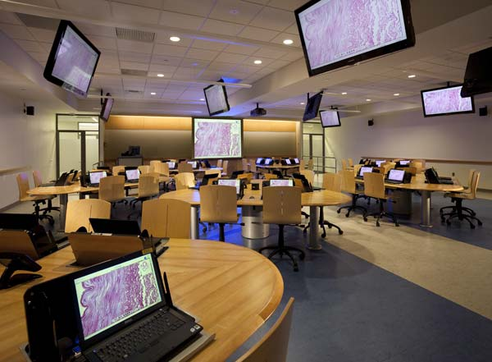
Scheduled activities such as purchases or computer software installation will occur simultaneously and take a maximum of 3 months from funding. Specific activities for MSL107 within 3 months of funding are: Purchase and install Library funded raised flooring; Purchase and install Provost funded video conferencing equipment; Purchase and install proposal funded collaboration tables and chairs; Purchase, configure, and install proposal funded computer and electronics equipment. CISE313 activity is to purchase, configure, and install proposal funded computer and electronics equipment within 1 month of funding. A combined activity for the Library and CISE is to establish VAMA hub shared network connections and devices within 3 months of funding.

