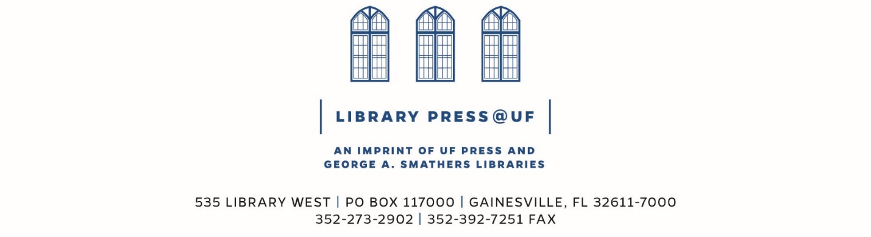

LibraryPress@UF: FAQ

What books fit for the LibraryPress@UF?
- Books that build from or add to the library collections.
- Open Access Textbooks, with Orange Grove Texts Plus.
- Books that do not need traditional peer review.
- Books that will be Open Access, for full and free access online.
- Books that benefit from online and Print On Demand (POD).

What should I do if I have a project idea?
- Please contact us! The LibraryPress@UF is a new program that is designed to meet special needs that support the Libraries. It is still growing, developing, and evolving. We welcome projects that help us define processes.
- Contact us: LibraryPress@uflib.ufl.edu

