Module Outline for Course Participants
The Social Construction of Sexual Identities

Adapted for the Anglophone Caribbean by:
John Campbell, Ph.D.
University of the West Indies, St. Augustine
Caribbean International Resource Network

Created by: Dr Paul Boyce
Thomas Coram Research Unit, Institute of Education
University of London and Dr Clare Hemmings
Director of the Gender Institute
London School of Economics and Political Science

This module was developed as part of 'Introduction to Advancing Sexuality Studies: a short
course on sexuality theory and research methodologies'. The short course was developed by the Australian Research Centre in Sex, Health and Society, La Trobe University, Melbourne,
Australia, and the International Association for the Study of Sexuality, Culture and Society.

Funded by the Ford Foundation

Licensing information

This module and the entire short course on sexuality theory and research methodologies are
available under an 'Attribution, Non-Commercial, Share Alike' licence from Creative Commons.

This licence allows for work to be used as is, amended or built upon, on provision that:
• Any use or amendments are undertaken for a non-commercial purpose
• Credit is given to:
o Module creator
o Short course developers: the Australian Research Centre in Sex, Health and
Society, La Trobe University, Melbourne, Australia, and the International
Association for the Study of Sexuality, Culture and Society (IASSCS)
o The Ford Foundation (as short course funder).
In addition, any new creations based on original modules or the original short course must be licensed under identical terms. This ensures that any derivatives of the module or the short course will also be non-commercial.

This module was created by Dr Paul Boyce and Dr Clare Hemmings and adapted by the Advancing Sexuality Studies short course team at the Australian Research Centre in Sex, Health and Society, La Trobe University, Melbourne, Australia.

Abstract

This module introduces participants to contextualize the critical perspectives on sexual identity from a social constructionist perspective. In particular, these approaches critique common assumptions about 'natural', trans-historical or universal sexuality and identify a range of factors at work in the constitution of sexual subjectivities in social and cultural context. More specifically the module encourages participants to analyse these factors particularly in relation to the development of Caribbean sexual identity as a consequence of colonialism and the current modern context. carnival and the carnivalesque will be utilized as a main example for this analysis.

Module aims:

• To introduce participants to social constructionist understandings of sexual
identity from anthropology, history and contemporary sociology
• To understand the origins/basis of Caribbean sexual identity.
• To bring together perspectives on culture and sexuality by exploring the ways in
which Caribbean sexuality is described.

Participants will:

• Develop a critical understanding of sexual identity as socially constructed in
relations of discourse and power
• Be able to assess the development of a Caribbean sexuality based on the development of the region’s sexual cultures.
• Examine connections between culture and sexuality through material culture,
especially through exploring the carnivalesque as an idea through which modern Caribbean sexual identity is represented and scripted.

Pre-reading

Chevannes, Barry. 2002. Gender and Adult Sexuality. In Gendered Realities: Essays in Caribbean Feminist Thought, edited by P. Mohammed. Kingston: University of the West Indies Press.

Kempadoo, Kamala. 2004. Sexing the Caribbean. Gender, Race and Sexual Labor. Oxon: Routledge. Chap 2:Pp15-51.

Liverpool, Hollis 2001 Rituals of Power and Rebellion: The Carnival Tradition in Trinidad and Tobago 1763-1962. Research Associates Ltd. Chicago. Pp 127- 131

Optional pre-reading (in suggested order)

Kempadoo, Kamala. 2003. Theorizing Sexual Relations in the Caribbean: Prostitution and the Problem of the "Exotic". In Confronting Power, Theorizing Gender. Interdisciplinary Perspectives in the Caribbean, edited by E. Barriteau. Kingston: University of the West Indies Press.pp 159-187

Allen, Caroline F. 1998. Caribbean Bodies: Representation and Practise. In Caribbean Portraits. Essays on Gender Ideologies and Identities, edited by C. Barrow. Kingston: Ian Randle Publishers.

Material required

In preparation for the course, participants are asked to carefully study the pictures of the carnival revelers from the Caribbean depicted below. Be prepared to discuss these pictures and their context.
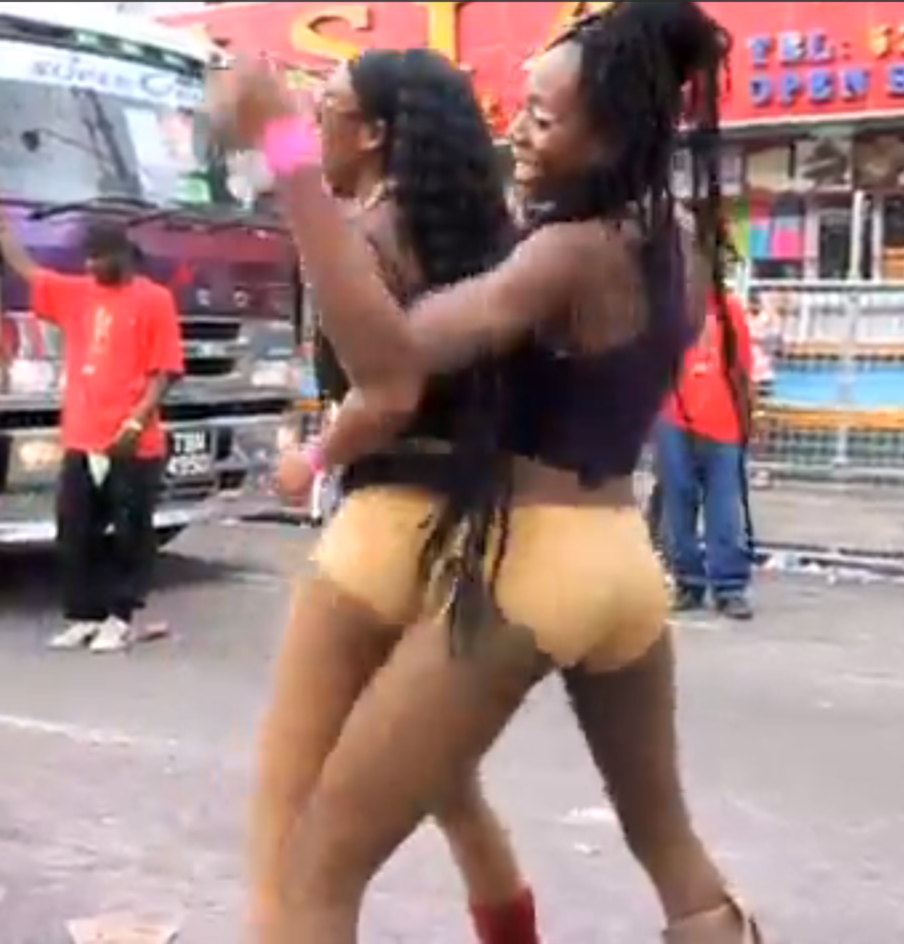

Sources: Trinidad Carnival 2011. Shutter Effex. http://www.youtube.com/watch?v=44GsNpo6h2c
& Passa Passa in Jamaica http://www.islandmix.com/backchat/f6/carnival-passa-passa-204305

Overview of module:
This module will encourage discussion on the basis of the Social Construction of Caribbean Sexual Identities. Participants will be encouraged to utilize both lecture and small group participation, utilizing reflective learning to understand the peculiar context of the Caribbean. In particular the participants will appreciate the point that the region’s colonial history influenced many aspects of its socialization including its sexual socialization. As a result of this history, indigenous forms of sexual identities emerged.

Session 1. Sexual identities and social constructionism

This session asks participants to identify the social basis to sexual identities in their own
social contexts. It includes a lecture providing an introduction to anthropological,
historical, and contemporary sociological approaches to sexual identity as a regulatory
feature of modern social life and the implications of this for sexual experience and subjectivity.

Session 2. The development of Caribbean Sexual identities

This session discusses the growth of a Caribbean sexual identity and questions the nature of the gendered dichotomy. It includes a lecture that interrogates the historical and social contexts in which a Caribbean identity(ies) developed following colonialism and to the present day. Students will be challenged to examine the extent to which the Caribbean “norm” followed on from contemporary mainstream sociological approaches.

Session 3. The Carnivalesque and the social construction of Caribbean sexualities
In groups, participants will evaluate how sexuality in the Caribbean is socially constructed. This evaluation will be done in the context of the region’s Carnival and other performative moments, which are some of the popular reference points for the expression of national or regional sexual identities.

Session 4. Caribbean Sexual Construction: “coming of age”
In this session participants will analyse the manner in which Caribbean sexualities can be understood as a social continuity of Victorian and Judeo-Christian norms and the extent to which contemporary global sexualities have impacted “Carnival culture”.

Conclusion:
At the end of this module students will realize that while the historical development of the Caribbean influenced its sexual development from the fifteenth through to the twentieth centuries, Caribbean ideas of sexuality also affected and, in many cases, dominated the imposed western Judeo Christian norms. The effects of multi ethnic societies (created as a result of the colonial legacy of 17th Century enslavement and 18th Century indentureship) not only affected accepted notions of constructionists sexual development but affected also the plural make up of the society and the divergent norms adopted. Ultimately the “Carnivalisque” will be viewed as the ultimate indigenous (sexual) creation, which ironically, in its expression challenges even the heterosexual ‘norm’.

Further reading (includes lecture bibliography)
Abelove, H., et. Al. Eds. (1993) The Lesbian and Gay Studies Reader. New York Routledge.

Abramson, P. (1990). "Sexual Science: Emerging Discipline or Oxymoron?" Journal of Sex Research 27:147-165.

Abramson, P. R. and S. D. Pinkerton, Eds. (1995). Sexual nature, sexual culture. Chicago, University of Chicago Press.

Allen, Caroline F. 1998. Caribbean Bodies: Representation and Practise. In Caribbean Portraits. Essays on Gender Ideologies and Identities, edited by C. Barrow. Kingston: Ian Randle Publishers.

Allyn, D. (2000). Make Love, not War: The Sexual Revolution, an Unfettered History. Boston, Little, Brown & Company.

Andaiye "The Angle you Look from Determines What you see: Towards a Critique of Feminist Politics in the Caribbean" Ludcille Mathurin Mair Lecture 2002, Centre for Gender and Development Studies, Mona, UWI, Jamaica.

Anthrobus, P., "The Rise and Fall of Feminist Politics in the Caribbean Women's Movement 1975-1995" Lucille Mathurin Mair 2000, Centre for Gender and Development Studies, Mona, UWI, Jamaica.

Bancroft, J., Ed. (2000). The Role of Theory in Sex Research. Bloomington, IN:Indiana University Press.

Barriteau, E., "The Construct of a Postmodernist Feminist Theory for Caribbean Social Science Research" Social and Economic Studies, Vol. 35, No. 2, pp 1-43.

Baur, K., Crooks, R., Our Sexuality. (2002) Pacific Grove CA., Wadsworth Publishers.
Bullough, V. (1994). Science in the Bedroom: A History of Sex Research. New York,
BasicBooks.

Chevannes, Barry. 2002. Gender and Adult Sexuality. In Gendered Realities: Essays in Caribbean Feminist Thought, edited by P. Mohammed. Kingston: University of the West Indies Press.
Dinshaw, C. (1999). Getting medieval: sexualities and communities, pre- and postmodern. Durham, NC, Duke University Press.
Dreger, A. (1998). Hermaphrodites and the Medical Invention of Sex. Cambridge, MA, Harvard University Press.
Fausto-Sterling, A. (1999). Sexing the Body: Gender Politics and the Construction of Sexuality. New York, Basic Books.
Fradenburg, L. and C. Freccero, Eds. (1996). Premodern sexualities. New York, Routledge.
Freud, S. (1961) Beyond the pleasure principle. London, Hogarth Press
Greene, J.E., (1993). Race, Class and Gender in the Future of the Caribean. Kingston, Institute of Social and Economic Research.
Hezekiah, J. (2001) Breaking the Glass Ceiling. The Stories of Three Caribbean Nurses.
Kingston, University of the West Indies Press.

Kempadoo, K., Ed. (1999). Sun, Sex, and Gold. Tourism and Sex Work in the Caribbean. Maryland, Rowman & Litllefield Publishers, Inc.

Kempadoo, K., Ed. (1998). Global Sex Workers. Rights, Resistance, and Redefinition. New York, Routledge.

Kempadoo, Kamala. 2004. Sexing the Caribbean. Gender, Race and Sexual Labor. Oxon: Routledge. Chap 2:Pp15-51.

Kempadoo, Kamala. 2003. Theorizing Sexual Relations in the Caribbean: Prostitution and the Problem of the "Exotic". In Confronting Power, Theorizing Gender. Interdisciplinary Perspectives in the Caribbean, edited by E. Barriteau. Kingston: University of the West Indies Press.pp 159-187

Kilbourne, J. (2000). Can't Buy My Love: How Advertising Changes the Way We Think and Feel. New York, Simon & Schuster.

Laumann, E., J. Gagnon, et al. (1994). The Social Organisation of Sexuality. Beverly Hills, CA, Sage.

Lips, H. (2001). Sex and Gender. Mountain View, CA, Mayfield.

McLaren, A. (1999). Twentieth-century sexuality: a history. Oxford, Blackwell.

Mead, M. (1963). Sex and Temperament in Three Primitive Societies. New York, Morrow.

Mohammed, P., Ed., Gendered Realities. (2002) Kingston, The University of the West Indies Press

Mohammed, P., (1998) "Towards Indigenous feminist theorizing in the Caribbean" Feminist Review: Rethinking Caribbean Difference No 59, Routledge Journals, London.

Nanda, S. (2000). Gender Diversity. Crosscultural Variations. Illinois, Waveland Press.

Nye, R. A., Ed. (1999). Sexuality. Oxford, Oxford University Press.

Pomeroy, W. (1972). Dr. Kinsey and the Institute for Sex Research. New York, Harper & Row.

Reddock, R., (2001) " Conceptualising difference in Caribbean Feminist Theory" in New Caribbean Thought: A Reader B Meeks & F Lindahl (eds) ppl 196-209.

Sanderson, Stephen K. 2003. The Sociology of Human Sexuality.A Darwinian Alternative to Social Constructionism and Postmodernism. In Annual Meeting of the American Sociological Association. Atlanta, Georgia.

Stearns, Peter N. 2000. “Results of European expansion, 1500-1900” in Gender in world history, Themes in world history. London ; New York: Routledge. Pp 57-60

Shepherd, V., Bereton, et al. (1995). Engendering History. Caribbean Women in Historical Perspective. London, James Curry Publishers.

Soodeen, R., "Issues of Difference in Contemprorary Caribbean Feminism" Feminist Review: Rethinking Caribbean Difference No 59, Routledge Journals, London 1998, pp 74-85.

Schmidt, R. A. and B. L. Voss, Eds. (2000). Archaeologies of sexuality. London, Routledge.

Threadgold, T. and A Cranny-Francis, Eds. (1990). Feminine, Masculine and Representation. Sydney, Allen & Unwin Australia Pty Ltd.

Weiderman, M. (2001). Understanding Sexuality Research.
Weeks, J. (1997). Sexuality. New York, Routledge.

