Background
The University of Florida (UF) is a major, public, comprehensive, land-grant, research university and among the nation's most academically diverse public universities. It is one of only 17 public, land-grant universities that belong to the Association of American Universities, and is one of the largest universities in the nation, with more than 50,000 students. In 2014, with the support of state lawmakers and the UF Trustees, UF launched UF Rising – a five-year initiative to elevate the University to be among the nation’s top public universities. Projected expenditures of $950 million will be aimed at hiring new midcareer and eminent professors, adding new endowed professorships, and upgrading and adding facilities.
The UF libraries form the largest information resource system in the state, consisting of seven libraries; six are in the system known as the George A. Smathers Libraries. These six libraries include the Health Science Center Libraries (HSCL). The University of Florida Legal Information Center reports through the College of Law. The Smathers Libraries are a member of the Association of Research Libraries (ARL) and other distinguished associations.
In 2011, UF adopted Responsibility Centered Management (RCM) as the campus budgeting and fiscal management model. The fundamental premise of RCM is to shift from centralized budgeting to a system with responsibility placed on the colleges for managing and expanding their revenue. Under RCM, the University’s colleges became Responsibility Centers and the Libraries became one of the numerous Support Units (non-revenue generating units primarily providing services to Responsibility Centers). Most University revenues are allocated to Responsibility Centers which must fund the direct expenses for their colleges, such as salaries for college staff, and pay taxes for the services provided to the college by campus entities like the Libraries, physical plant, academic advising, campus human resources and various other offices and officials. The colleges must balance the revenues generated (which may increase or decrease due to factors within and beyond their control) with these direct and indirect expenses and at least break even every year. Through a University RCM Budget Review Committee (largely comprised of college budget officers appointed by the respective college deans), the colleges make recommendations to the University administration about Support Center funding based on the services and resources, new or continuing, they deem worthwhile. RCM ideally permits decision-making where outcomes of strategic value to the University are given greater weight and the achievement of the University’s goals supersedes any unit’s individual self-interest; however, any funding allocated to a Support Unit, like the Libraries, results in less discretionary funding for the Responsibility Center.
RCM was implemented at UF at a time of severe budget reductions, including steep cuts in state appropriations which are a critical funding source for the colleges and the primary source of funding for the Smathers Libraries. The UF libraries entered RCM chronically under-funded and facing escalating materials costs. Since July 1, 2009, the Smathers Libraries have experienced $2.4 million in recurring funding cuts and $700,000 in one-time cuts. Materials costs have increased by an average of 5% per year and this has resulted in a purchasing capacity gap of $2.6 million from the funding level in FY 2008.
RCM, combined with decreased University appropriations and lost purchasing power for library materials has increased pressure (internally and externally) to assess library funding and expenditures. In this environment, the Libraries needed to develop effective methods for analyzing and communicating its budget circumstances and for determining what appropriate funding levels should be in order to adequately serve UF’s faculty, students and researchers.
Findings
The Smathers Libraries have engaged in repeated and varied analyses of how the resources of the Libraries and the demands of UF compare to peer institutions. Data from the National Center for Education Statistics (NCES) Integrated Postsecondary Education Data System (IPEDS) has been used as measures of university characteristics that correlate with demand for library resources and services (e.g. number of faculty) and university resources (e.g. revenue). ARL Statistics have been used for measures of library resources including funding, materials and staffing.
This analysis has consistently showed, across methodologies, that the scope of the university population and programs at UF are significantly above average for peer institutions which suggests comparably higher demand. Incongruously, the fiscal and human resources of the UF libraries are significantly below the average for library systems at peer institutions. Said differently, there is a considerable and statistically significant gap between the scale of UF demand, and the resources of the library system.
Linear Regression Analysis
Linear regression analysis is a statistical technique used to model the relationship between two variables: independent variables (e.g. university budget) and dependent or response variables (e.g. library budget). Linear regression is used to estimate the causal effect of the independent variables on the dependent variable. In instances where this effect exists the model may serve to predict one variable if the other variable is known.
The statistical significance of the relationship between the independent variable and dependent variable, that is, the degree of confidence in how the true relationship is close to the estimated statistical relationship is a key determination in interpreting regression analysis. (1) A measure of this statistical significance is r-squared or the Coefficient of Determination. The r-squared measure indicates the proportion of the change in one variable that is predictable from another. Said differently, r-squared represents the percent of variation in a variable that can be explained by the relationship between the two. R-squared ranges from zero to 1.0 and the larger the number the greater the statistical significance of the estimated relationship.
Peers
Comparisons required that the Libraries identify peer groups. Three groups of AAU public universities that comprise relevant peer groups for UF were used initially. Group A is comprised of six comparable universities from the top 11 U.S. News & World Report public universities in 2013. These represent aspirational peers as UF was ranked 15th and UF aspires to join the ranks of the top public universities. Group B represents a broader population: ten of the top 25 U.S. News & World Report public universities, all of which are comprehensive universities with law schools and two or more health colleges. Group C results from a list of peers provided by the University that had reportedly been used for previous peer comparisons. This last group of peers was comprised of distinguished public universities, but the methodology used to identify the specific schools was not available.

Relationships between Library and University Expenditures
The relationship between library expenditures and university expenditures were compared for the University of Florida and the three peer groups for UF. Linear regression analysis shows a positive and predictive relationship between university funding, as reflected in Total University Expenditures from all sources of funds, and library funding, as reflected in Total Library Expenditures at these top institutions. This is not the case at UF, where the Library Expenditures fall well below the best fit line for all peer groups and the positive relationship is muted.
Chart 1
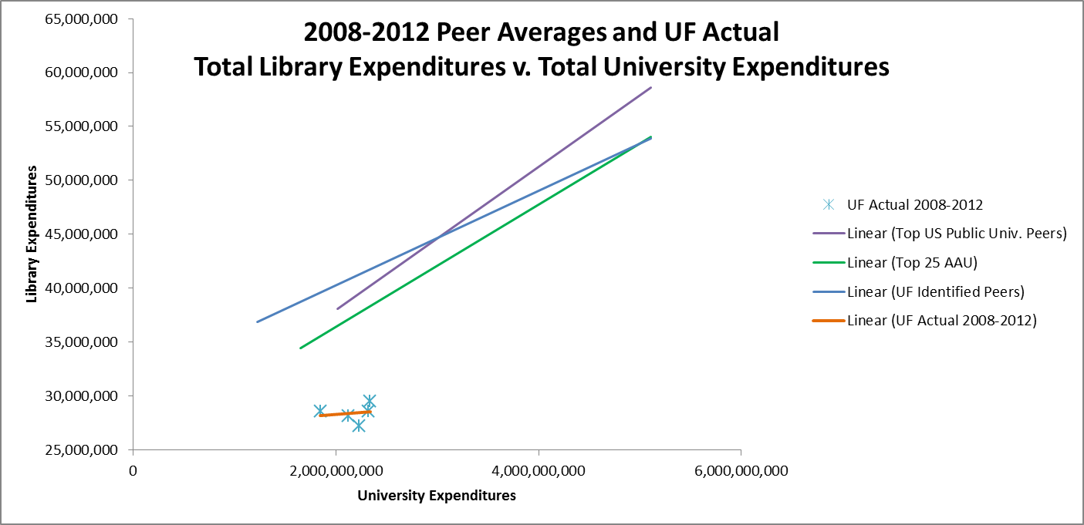
The r-squared values reported in Table 1 indicate the proportion of the change in library expenditures that is predictable by university expenditures. The statistical significance of the estimated relationship for Group A and Group B is high and reflects a significant relationship. There is no significant relationship at the University of Florida between University expenditures, which have increased over time, and library expenditures.
Table 1
Group A | Group B | Group C | UF Actual
R² = 0.8637 | R² = 0.6398 | R² = 0.445 | R² = 0.0258

Relationships between Library Expenditures and University Income
The relationship between total library expenditures and the university revenue generated from tuition and appropriations also was analyzed for the University of Florida and Group A (six comparable universities from the top 11 U.S. News & World Report public universities) using linear regression – see Chart 2. Linear regression analysis shows there exists a recurring, positive and predictive relationship between university funding, as reflected in revenue from tuition and appropriations, and library funding, as reflected in total library expenditures. This is not the case at UF, where the library expenditures fall well below the best fit line for Group A for each year analyzed.
Chart 2
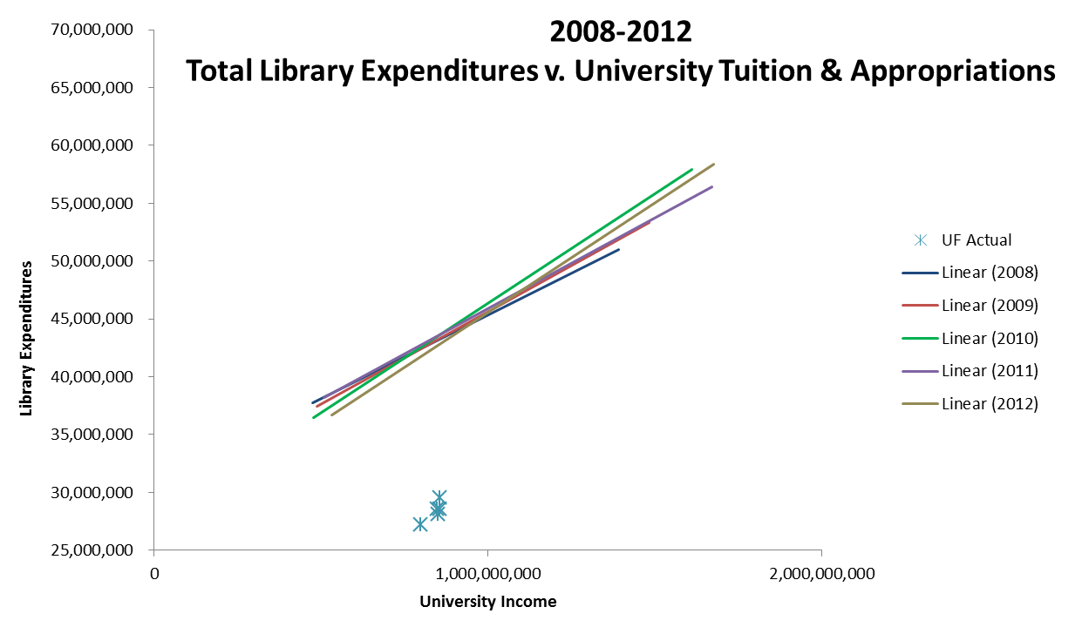
UF, and other public universities in Florida, receive relatively low state appropriations and tuition. In fact the state appropriations and tuition are nearly the lowest of any state. The relationships reflected in Chart 2 are important in that they scale the library expenditures, a reflection of library funding, to the tuition and appropriations funding actually received by the parent institutions. Accordingly, UF income from these sources may be lower than ideal, but the library funding is even lower than would be predicted by the relationship between these variables at peer institutions.

Predicting UF Library Expenditures
The model identified by the linear regression analysis of university revenue from tuition and appropriation at peer universities (independent variable) and total library expenditures at those institutions (dependent variable) for each year can be expressed in a regression line with a formula of Y = a + bX. In this formula:
Y = the dependent variable
X = the independent variable
b = the slope of the regression line
a = the intercept point of the regression line and the y axis.
The regression line formula is used in each of the best fit lines shown in Chart 1 and 2.

Importantly, the regression line formula allows for the calculation of the predicted value for Y (library expenditures) if X (university income from tuition and appropriations) is known. Table 2, reflects the result of this calculation for each year from 2008 to 2012: UF Library Predicted Expenditures based on UF Tuition and Appropriations. Also presented are the UF Actual Library Expenditures and the difference between these figures and the predicted value.
Table 2
 | UF Tuition & Appropriations | UF Library Predicted Expenditures | UF  Actual Library Expenditures | Difference
2008 | $855,300,000 | $43,231,307 | $28,573,302 | ($14,658,005)
2009 | $849,955,000 | $43,249,625 | $28,147,202 | ($15,102,423)
2010 | $797,569,000 | $42,536,788 | $27,242,279 | ($15,294,509)
2011 | $855,234,000 | $43,650,863 | $29,537,452 | ($14,113,411)
2012 | $848,376,000 | $42,701,203 | $28,581,160 | ($14,120,043)

As Chart 2 depicted, the relationship between university income from appropriations and tuition and library expenditures is strong and positive at peer institutions, but not at UF. Based on the relationship between these variables at peer institutions, the annual expenditures of the UF libraries fall between $14 and $15 million below the level that would be predicted (using the regression line formulas) given the amount of tuition and appropriation revenue generated by the University.
Summary
Linear regression analysis provides a statistically valid method for assessing the funding for individual libraries as compared to peers. In the case of UF, this analysis proves the library funding is atypical compared to relevant peer institutions. The results of the analysis are not only statistical significant, but are easily understandable which is equally important. As a result of the analyses and the communication of these findings, the financial situation of the George A. Smathers Libraries has been acknowledged by key decision makers in the RCM system at UF.

(1) Yan, Xin. Linear Regression Analysis: Theory and Computing. SGP: World Scientific, 2009.

