Pioneer Days in Florida: A Digital Archive
Diaries and Letters from Settling the Sunshine State, 1800-1900
http://ufdc.ufl.edu/pioneerdays

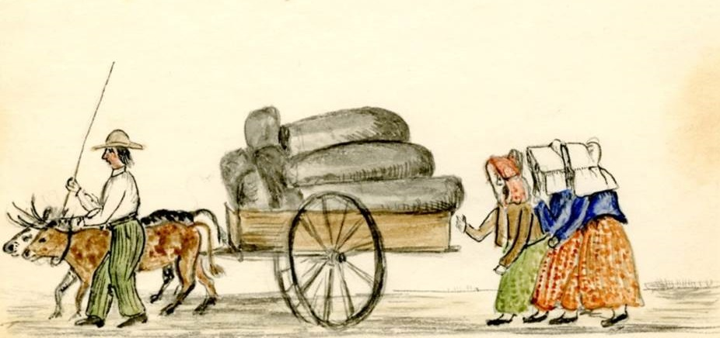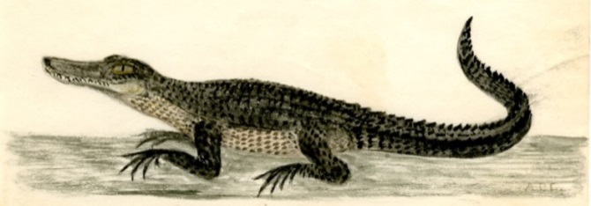

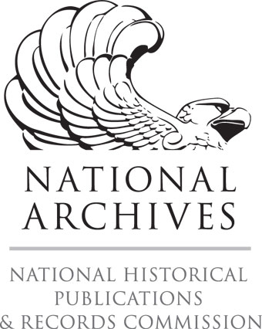
A project of the P.K. Yonge Library of Florida History
Funded by the National Historical Publications and Records Commission

