MassMine: Using MassMine on UF’s Research Computing Cloud Server

Login and Startup
Remote login to the UF cloud server setup specifically for MassMine research, through a Linux console on a computer with the Ubuntu OS installed. (UF provides training on accessing cloud resources through any operating system.)
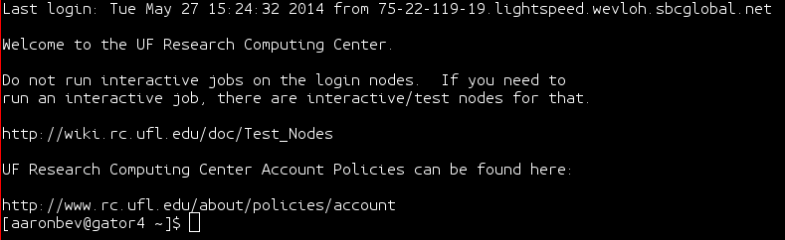

Startup Screen with basic text interface; users do not have to understand R code in order to collect data.
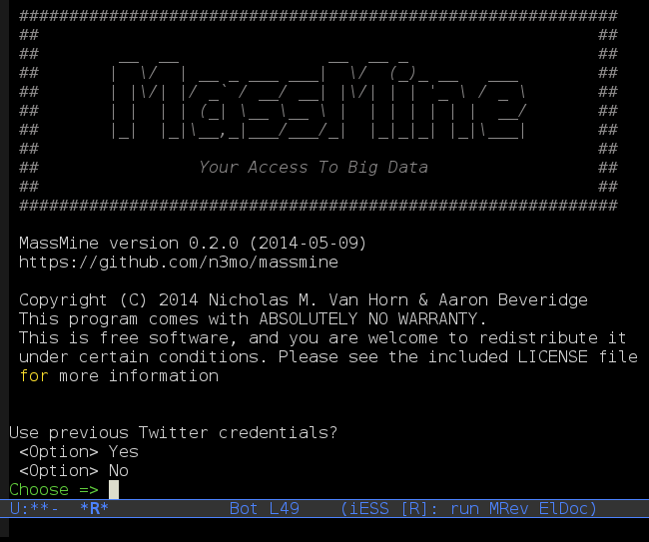

API Connection
MassMine checks the last configuration file and offers to re-authenticate API connection to restart a similar data collection.
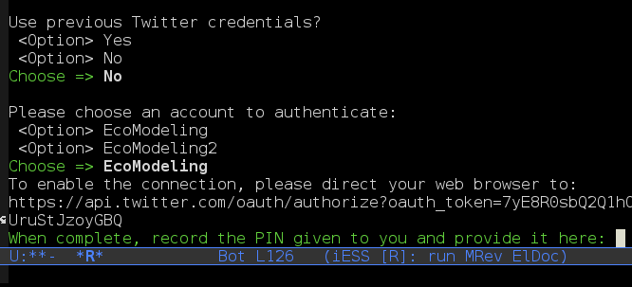

Based on the configuration file information, MassMine automatically displays the API account for authentication. Authentication only needs to happen once; after that, users can run the software each new time without re-authentication, as long as the same API credentials are used.
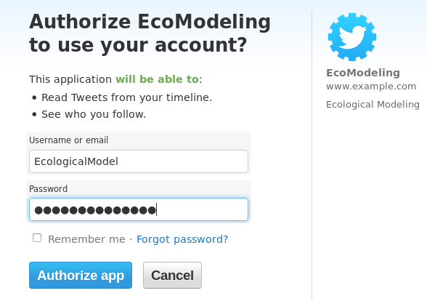

The API provides an authorization PIN, which syncs MassMine with the user’s API access once the PIN is entered.

Configuration File
MassMine collects data based on the directions provided in the configuration file. The screenshot below shows the configuration file opened in a simple text editor. The configuration file is machine readable, and editable in any basic text editor on any operating system.

Users can save and re-process multiple configuration files to run different kinds of data collection activities the console application of MassMine. Templates of various basic configuration files are in process for use in trainings and experimentation for console application users.
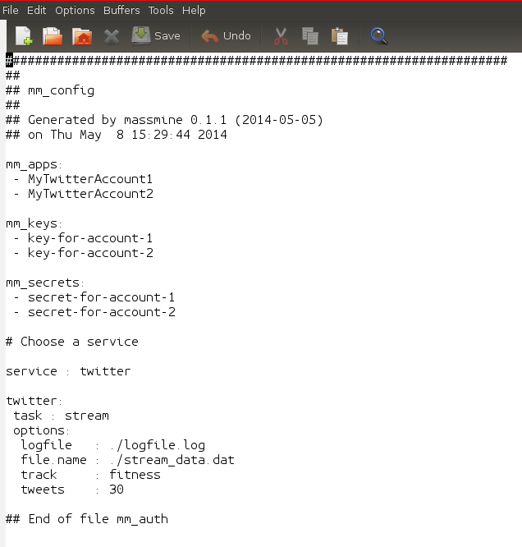

Success Screen
MassMine responds to let the user know when a collection finished successfully without error, with all data automatically saved to the cloud space provided by UF’s Research Computing.
