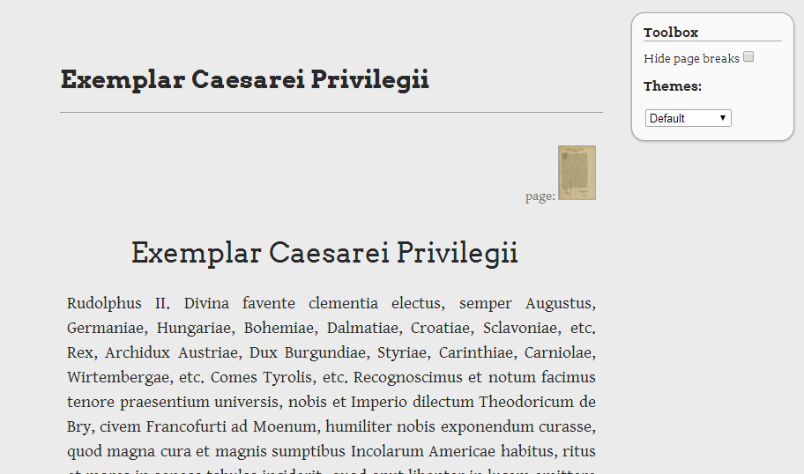
Case Study: TEI Encoding with the Latin histories of Florida

Miller Krause, Classics (June 24, 2014 in Library West 211)

For this Case Study presentation, Miller Krause (Classics) will share on the application of TEI encoding within the Latin histories of Florida.

The Case Study presentation will include:
- Reasons for selecting to use TEI (benefits of TEI over PDF and/or HTML)
- Experiences with TEI encoding
- Experiences after encoding: using TEI files with other technologies to accomplish or work towards project goals
- Overview of where TEI fits into the toolbox of technologies for bringing text to users
- Case Study specifics of the Latin histories of Florida
  - Editorial decisions on guidelines for level of detail with tagging for various needs (e.g., tagging paragraphs to facilitate aligning translations with the original text, orthographic issues, etc.)
  - Current status
  - Goals, including work and TEI decisions required for these

Examples for the Case Study presentation include different encoding level versions of the same text, using Boilerplay:
- Version with extreme level of tagging: http://www.clas.ufl.edu/users/miller.krause/teiparty/boilerplate/content/Privilegium.xml
- Version with approximately appropriate level of tagging: http://www.clas.ufl.edu/users/miller.krause/teiparty/boilerplate/content/PrivilegiumSimple.xml

In addition to the Case Study presentation, Laurie Taylor (UF Smathers Libraries) will share on the current status of TEI support in SobekCM (www.sobekrepository.org) and future considerations including the TAPAS Project (www.tapasproject.org).

The presentation will be web broadcast and recorded on Adobe Connect: http://ufsmathers.adobeconnect.com/teisobekcm/

