Baldwin Library Speaker Series 2013
Co-Sponsored by the Department of English
Featuring Dr. Lissa Paul, Brock University
Thursday, September 19, 2013: 5:30-7:30 p.m.
Smathers Library (East), Room 1A

The Game of Clue: Or Mrs. Fenwick (1766-1840), in the Library with a ...

Professor Lissa Paul will speak on the intriguing life of British author, Eliza Fenwick, whose works include Secresy; or The Ruin on the Rock as well as several children’s books and an extensive letter collection featuring Charles and Mary Lamb, William Godwin, and Mary Wollstonecraft. Paul’s talk will explore the life of Fenwick, including the chase for the plot of her story, likening it to a murder mystery and the game of Clue. Ms. Fenwick can be situated within three-degrees of Mary Shelley’s Frankenstein. The narrative arc of Eliza Fenwick’s life reads as an adventure-romance as well as a mystery story. For her talk, Dr. Paul will focus on Fenwick’s life in Barbados as an abolitionist slave-holder.

Professor Paul is an expert on the writings and life of Eliza Fenwick as well as children’s literature. Her previous published works include, Reading Otherways and The Children’s Book Business, and as co-editor of the Lion and the Unicorn. She is currently working on a biography of Fenwick tentatively entitled, “Eliza Fenwick: An Eighteenth Century Life for the Twenty-First Century.” Fenwick was part of an extraordinary group of women writing for children and adults, including Mary Wollstonecraft, in the radical London of the late Enlightenment.

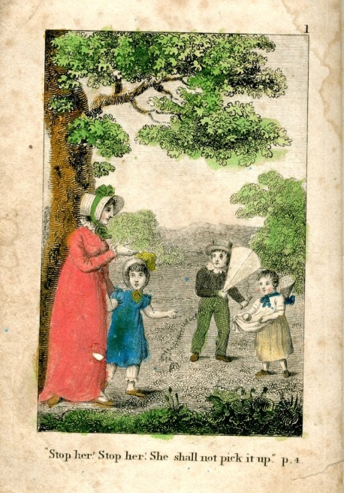
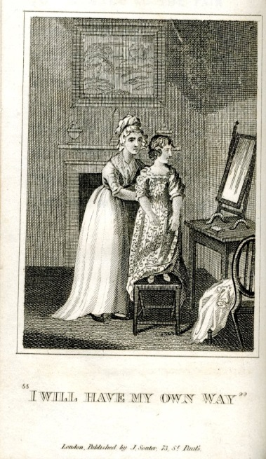
Image 1: Six Stories for the Nursery: in Words of One and Two Syllables: Intended as a sequel to ‘Baby Tales.’ By Eliza Fenwick. Printed for M. J. Godwin & Co.: London, 1819. From the Baldwin Library of Historical Children’s Literature

Image 2: Infantine Stories: in Words of One, Two, and Three Syllables. By Eliza Fenwick. J. and C. Adlard: London: 1820. From the Baldwin Library of Historical Children’s Literature

Baldwin online: http://library.ufl.edu/baldwin

Baldwin Digital Collections: http://ufdc.ufl.edu/baldwin

Document originally available as a webpage: http://www.english.ufl.edu/events/baldwinlecture/index.html

