Metadata Assignment Notes
Comment: Because many of the photographs you have chosen have not yet been fully catalogued, your work can directly contribute to their cataloguing. I will give your assignments, if you give me permission, to Rebecca Fitzsimmons, so she can include your work in making the metadata for the photographs. This is an example of the role of teaching at research universities: it involves undergraduates directly in research.

Steps
- Check to see if your photograph is in www.dloc.com by typing in the accession number and/or key words from the title.
- If you photograph is not there, it will be in the Panama Canal Museum Inventory, which houses information about archival materials from the collection that have not yet been fully catalogued. To do this, go to http://ufdc.ufl.edu/PCMI
And type in the accession number

Examples from the photographs examined in Special & Area Studies Collection in the prior class:
- http://dloc.com/AA00016121/00001/citation?search=2013.5.1
  - U.S. Dredge Sandpiper excavating in lock site at Myraflores, Panama Canal. This is an example of a photograph that has been catalogued and digitized and that has relatively extensive metadata supplied by the son of one of the engineers featured in the photograph. While it does not address the segregation and racism that most likely explains the lack of names for the black workers, the metadata does record the absence of their names and provides the basis for the researcher to examine this question. The metadata, especially in the general notes section, provides useful information about the location, the spelling, and the work done and its relevance.
Examples of photographs not yet fully catalogued that lack this detail in the metadata:
- http://ufdc.ufl.edu/PCMI003554/00001/citation?search=2000.038.003.008
  - Description of a photograph of what appears to be an Amerindian or West Indian family Panama. The title is actually a note indicating that there is the word “Native” is on the back of the image.
- http://ufdc.ufl.edu/PCMI006137/00001
  - Meal time at an ICC Kitchen – Upper Rio Grande
- http://ufdc.ufl.edu/PCMI006138/00001?search=2001.074.001.017
  - Widening of Sidewalks Panama (photograph of an apparently West Indian woman in the middle of the street and a group of men to one side)

Considerations for Adding Metadata
When making a record, the cataloguer or archivist has the option of including many possible fields (http://dloc.com/help/metadata), but usually, has limited information and includes only those fields where there is sufficient information. Considering some of the types of information (fields) that can be included may help you to identify further types of information you would like to consider in enhancing the metadata for your photograph(s).

Also, if a field is blank in the record it will not display when you view the public face of the database because not all fields are useful for every type of object and it clutters the record to see a bunch of empty fields.

Example
Item Record, Public View  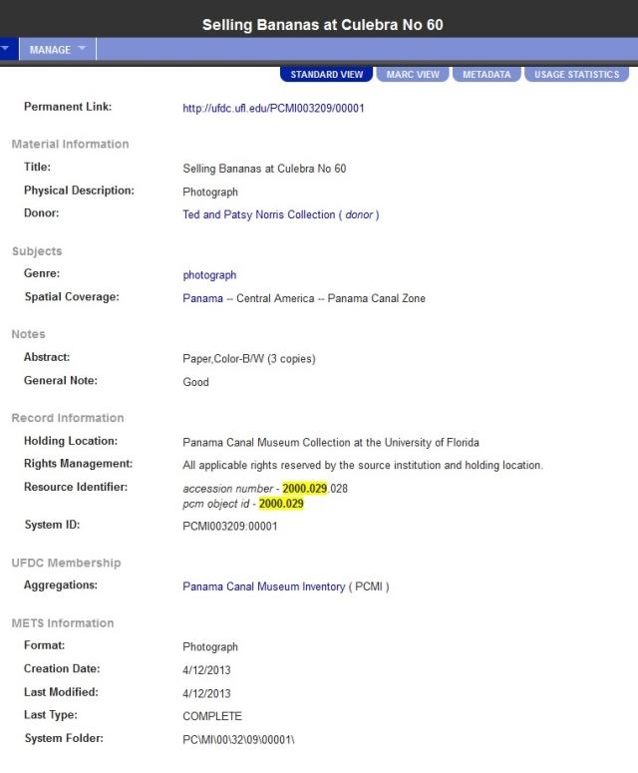 | Item Record, Internal View (many empty fields)  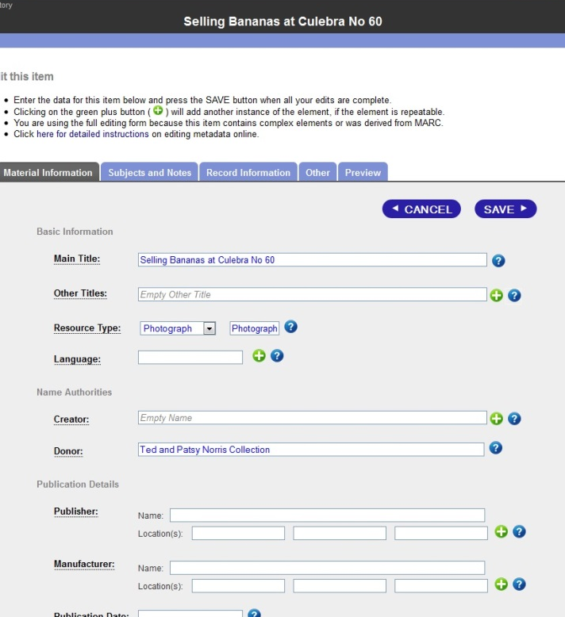
Most useful available fields for object record metadata:

Basic Information:
Main Title
Other Titles (often used for series title, alternative titles, translated titles, etc.)

Resource Type (standardized from dropdown: choice of aerial, archival, artifact, audio, book, dataset, map, newspaper, photograph, serial, video; can also add specific information—EX. photograph; gelatin silver print)

Language
Name Authorities:
Creator (can enter full name and birth/death dates, or birth date- ; and creator role ; can also be a corporate creator—EX. Smith, John 1904-1940 OR Smith, John, 1904- OR photographer OR Smith, John, photographer)
Publication Details:
Publisher (Name and, if available publication location)

Manufacturer

Publication Date (date published, if it is published material; this is often the same as the copyright date)

Copyright Year (associated with the creation of the resource, often the same as publication year)

Subject:
Subject Keywords (can use one or more that describe image; take from Library of Congress Subject Headings (LCSH), searchable here: http://authorities.loc.gov/-- EX. Dredging Spoil (lcsh) and Panama Canal Company (1879-1889)(lcsh)
Spatial Coverage (where the depicted item is, broad or specific ranging from continent down city section or area, depending on which information is most clear in identifying place—EX. Panama—Central America—Panama Canal Zone OR Panama—Colon)

Notes:
Abstract (choose heading from list, most useful choices being Abstract; Summary; Subject; and Scope and Content; describe the image and content or the subjects covered-- EX.:
Summary or abstract type note might read: Workers posing on the upper deck of the Sandpiper Dredge in Culebra Cut in December 1907.
Subject type note might describe the content in non-controlled vocabulary: dredging, Sandpiper Dredge, dredging crew

Scope and Content type note might read: Dredging crews were generally composed of both silver and gold roll employees, who lived and worked on the same dredging machinery, but maintained separate facilities such as sleeping and dining quarters.

A general note might also retype a particular caption written on the photo: Caption written on photo reads Crew of the Sandpiper: 1. Joe, Smith, 2. Jack Smith 3. Jim Brown 4. Dan Forester 5. Alan Green. Rest of crew are blacks OR Caption on back of photo reads Proprietress.

These notes can contain a lot of relevant information about the object itself, background, etc. and might even link to other related collection objects.
These are the links to the digital library and the object inventory:
http://ufdc.ufl.edu/pcm - Panama and the Canal digital library

http://ufdc.ufl.edu/l/pcmi - Panama Canal Object Inventory (just remember that some item records in this inventory are only viewable on campus because they are restricted by IP address).
ASSIGNMENT 4: VISUALIZING THE ARCHIVES & CREATING METADATA
(Due March 16 at 5:00 pm)
This assignment asks you to examine how photography historically has constructed the raced subject.

Part 1:
• Choose 1 image from photographs you examine in Special collections, from the photo gallery. or from other online sources for Caribbean photographs such as
- Duperly, Picturesque Jamaica which has images on Indo-Caribbean people on pp. 66 and 68
  - see alsoDuperly Coolies At Worship.
- http://www.caribbeanphotoarchive.com/
- National Archives UK Caribbean through a Lens Project
- National Archives UK Caribbean through a Lens on Flickr
- The National Anthropological Archives (part of the Smithsonian Museums)

• Examine the photo and consider the following:
• Note the gender of the subjects; their position vis-à-vis, machines, animals, vegetation, buildings or other racial subjects.
• What do you know about the photographer or what position or perspective do you imagine he/she had?
• What is the historical context for the photograph? If so, does the historical context (or moment in history) have particular significance? Is it possible to find sources on that context?
• Is the photograph dated?
• Is there a caption?
• What do these selections and interpretive choices tell you?

Write (500-750 words) on the provenance of the photograph and the way it constructs its subject. Paste the photo from the photo gallery into your Wiki entry.

Part 2: Meta Data
1. Consider what's included and what's missing in the citation (the citation includes the record information or metadata).

2. In the source you selected, what additional information do you think should be included to make the source more useful for scholars? Consider what information should be included on the publisher? The author? The place and date of publication for historical context? What other information should be included?

3. Complete the form (See PBworks page for this assignment) for your selected item, and post to the Wiki.

Post your assignment on your individual home page and post a link to that page below
This assignment can be done as a group project based on your group work in Special Collections on 3/11. Group assignments must include an additional section that outlines the work each person did and group assignments should have some information concerning the historical context and its significance. Each member of the group should post the assignment on his or her homepage and one version should posted below with all authors listed. Part I of a group project can also be longer than 750 words.

