Herbert Theodore Thomas

compiled by his Grandson (Gerald A. Archambeau)
Table Of Contents
Text Item for Herbert Theodore Thomas
Descendant Report for John Thomas
Family Group Sheet for Herbert Theodore Thomas and his second wife, Leonora
Herbert Theodore Thomas was born on 06 Jun 1856 in Jamaica. He lived in Pudsey, Yorkshire, England in 1871. He married Gertrude Nunes about 1882 in Montego Bay, Saint James, Jamaica. He married Leonora Chambers on 17 Jul 1924 in Kingston, Jamaica. He was baptized on 16 May 1930 in St Anne's Catholic Church. He died on 28 May 1930 in Kingston, Jamaica.
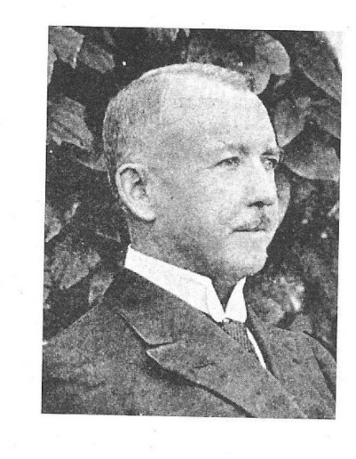
Herbert Theodore Thomas 1856 to 1930.
A Jamaican born Police Inspector; Lecturer, Naturalist, Explorer as the first man to cross the John Crow Mountains and Author of Untrodden Jamaica-1890 (http://www.dloc.com/AA00020116/) & The story of a West Indian Policeman-47 years in the Jamaica Constabulary-1927 (http://www.dloc.com/AA00010421/). He was fluent in German & French and wrote many articles on The birds of Jamaica and the Fauna & Flora Also a poem to show his love of country "A DREAM OF JAMAICA".
Name: Herbert Theodore Thomas
Born: 6th June, 1856
Place of birth: Jamaica. He was a third generation white Jamaican.
Baptized 16th May 1930, St. Anne's Roman Catholic Church in Kingston. Jamaica, because of the insistence of his 2nd wife Leonora Thomas, who was a devout Catholic.
He married his 1st wife a white Jewish Jamaican lady, Gertrude Nunes, born on Mar 21st 1862 at Montego Bay they had 8 children: 2 boys who had died in childhood by 1911, Benjamin Thomas & Harry P. Thomas. Harry Reid, Francis Hastings & a daughter Marjorie Elaine, Arthur Crichton, Herbert Prichard & Godfrey Main. In 1900 Gertrude went back to England with 3 of her children, where she died in 1921 in the UK. Four of her sons died in World War-1 as Officers in the British Army, with honours. All of her children were born in Jamaica.
Herbert fell madly in love with his 2nd wife who was a black Jamaican lady, Leonora Chambers, he lived with her for many years and had 4 daughters: Dorothy Maud, Beatrice Victoria, Phyllis Angela & Kathleen Marjorie. He eventually married Leonora Thomas (Nee) Chambers m 1924. She was a seamstress, and ran her own Bakery at the Kingston family home. Herbert was sixty eight years old, on 17th July 1924 when they married in Kingston.
Herbert's occupation was: 1st Class Police Inspector of the Jamaican Police Constabulary. He was educated in York England, and served in the police force for 47yrs, and was awarded The Kings Police Medal in 1922 for his work in the Montego Bay riots in 1902. He also wrote as a Naturalist on Jamaica's fauna, flora and on the Birds of Jamaica while exploring the John Crow mountains, as he was the first man to do so at that time. He did a lot of work in The Blue Mountains, collecting species of plant life, and wrote articles on them. His articles on botany were sent to England and were published in the British Geographic magazine. In 1901 & 2 he lectured on Jamaica twice in London at the Imperial Institute and at the Society of Arts. He wrote two books "Untrodden Jamaica"1891 and "The Story of a West Indian Policeman", 1927. His name was also listed in the 1916 Jamaican Who's Who.
His father; Rev. John Thomas of the Moravian Church. His family came to Jamaica as missionaries in 1754. His Siblings; Edmund Josiah Thomas, a Anglican Parson, with his wife Agatha Maud he had one son, Edmond Vincent Thomas, who won the Jamaican Rhodes Scholarship in 1913, he served the Royal Field Artillery at Oxford England.
Herbert Died: in 1930, three years before his grandson was born, he is buried beside his loving wife Leonora, who got him to become Catholic so they could be buried as Catholics: At the Catholic Calvary Cemetery, in Kingston, Jamaica, near Torrington Bridge. Thanks to my loving grandmother Leonora Thomas.
Grandmother Leonora.
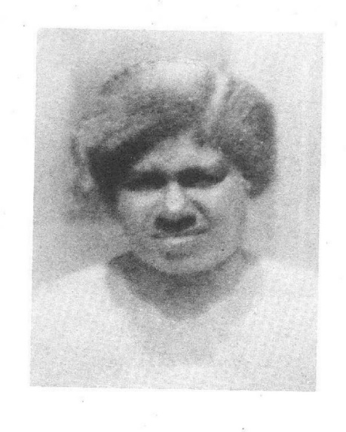
Name: Leonora Thomas (nee) Chambers.
Born in 1882: Place of birth: Savannalamar, Jamaica. She grew up, and lived with her family in Bethel Town, Westmoreland. Her proud black Jamaican parents; Mr. & Mrs. Henry Chambers, her mother was a (Montague), a respected Seamstress in Bethel Town. Leonora met my grandfather Herbert T. Thomas through her occupation as a Seamstress, taught to her by her mother. When my grandfather saw Leonora he was smitten with love for her. They lived together for many years in a number of homes around the island until they settled in Kingston at 3 Geffrard Place.
Leonora Married: Inspector, Herbert Theodore Thomas, on the 17th July, 1924. After bearing him four daughters.
The Children: Dorothy M., Beatrice V., Phyllis A., Kathleen M.
Her Occupation: Seamstress, and ran her own Bakery from her home.
Parents: Mr. & Mrs. Henry Chambers, Siblings: None.
Grandmother Leonora: Died in: 1936, as a devout Catholic, and was able to Convince my grandfather to be baptised a Catholic, so that they could be buried beside each other as Catholics. They are Buried : At the Catholic Calvary Cemetery in Kingston, Jamaica
The Children of my grandfather; Herbert Theodore Thomas, from his first marriage to Gertrude Thomas (nee) Nunes.
Gertrude; had a total of 8 children for my grandfather Herbert, all of them born in Jamaica and two boys died in childhood by 1911, Benjamin Thomas and Henry Thomas.
Son No. 1. Harry Reid Thomas, born in Jamaica B.W.I. on 15th March, 1883. He attended Jamaica College, and he volunteered to fight in the Boer War with Baden Powell's African Constabulary as a trooper. For his service he was awarded the King's Medal with 5 clasps. After the Boer War, he was shipped off to fight again in WW-1 as a Captain #8316 in France with the Royal Garrison Artillery, 34th Siege Battery where he died on 25th Dec, 1915. He is buried in France, at Vielle, Chapelle, Lacouture. Grave-1.C.9.
Son No. 2. Francis Hastings Thomas, born in Jamaica B.W. I. on 4th Dec, 1885. He went to the UK in 1900 and joined the British Army later in WW-1, and served in the Royal Marine Light Infantry on H.M.S. Talbot. He also became a Captain, and received a D.S.C. for his part in the Suvla Bay Landings at Gallipoli, Turkey. He married Frances Bell in 1912 He died in WW-1 on 15th Aug 1916, and is buried at Portsmouth England; Naval Memorial, where his name is engraved on a plaque.
Daughter: Marjorie Elaine Thomas, a born Jamaican in 1888 went on to the UK with her mother Gretrude in 1900 aboard the S.S. Lion. She married Clive Kirkpatrick Daly who was a Lieutenant Colonel in the British Indian Army in 1913 at Kew, London. He was knighted by the King and became Sir Daly & OBE, and Marjorie became Lady Daly. Her mother died in London on 30th Jan 1921 at St. Marylebone Hospital.
Son No. 3. Arthur Crichton Thomas, born in Jamaica B.W.I. on 29th Dec, 1890. He also joined the British Army of WW-1, and served in the Royal Garrison Artillery-355th Battery as a Major. He died 19th Nov, 1917 and is buried in Belgium at Talana Farm Cemetery.
Son No. 4. Herbert Prichard Thomas, born in Jamaica B.W.I. on 22nd Dec, 1892. In 1911 he went to the UK at age 18 and entered the Royal Military College Sandhurst, Surrey. He received a King's Commission Aug 24th 1912. He waited and was accepted for the Indian Army in 1914 as an Officer & a Gentleman in the 126th Baluchistan infantry. He survived WW-1 as a Captain, and was able to return from India for his mother's funeral in the UK. He was later awarded an OBE & five medals for his service. He died in Scotland in 1969.
Son No. 5. Godfrey Main Thomas, born in Jamaica B.W.I on lOth Sep, 1895. He was the youngest of the brothers to start his military service at the end of WW-las a Midshipman on the H.M.S. Colossus, in the first Battle Squadron. He was awarded the King's Medal & Dirk. His Squadron was transferred to the Royal Navy's Air Service; until the formation of the R.A.F in 1918. He went on to be a Flight Lieutenant, and died on 24th Aug, 1921 at 5pm aboard the Airship R-38 when it exploded over Hull UK and was awarded the D.F.C. along with 44 other airmen who died. He is buried at Hull Western Cemetery in Yorkshire, his name is inscribed on the British Plaque-Roll of Honour.
These five Jamaican Officers were my step-uncles, and I am very proud of them.
From Alan Greveson UK
In the 1911 England census, Gertrude Thomas stated she had had eight children of which six were still living and two had died. It is possible the Benjamin Thomas and the Henry Pritchard Thomas were the two who died in childhood.
There are eight original documents which provide primary evidence for Herbert Prichard Thomas who was born in Jamaica, not least of which is the evidence he was the executor of the wills of Godfrey Main Thomas and Gertrude Thomas. On April 1922 Fladgate and Co. Solicitors of Pall Mall, London, published a notice in the London Gazette indicating they were acting on behalf of Lillian Thomas of the Mill House, Botley, Hampshire, widow of Squadron Leader Godfrey Main Thomas. The notice explained that Lillian was acting as the "lawful attorney of Captain Herbert Prichard Thomas, now residing at 12, Native Infantry Lines, Karachi, India, the lawful executor of the will" (London Gazette, 7 April 1922 pages 2880, 2881). It would be unlikely for Godfrey to appoint an executor who was not in some way closely connected with the family and known to his wife. The England & Wales, National Probate Calendar (Index of Wills and Administrations) also recorded that administration of Godfrey's will was granted on April 1st 1922 to Lillian Thomas who was attorney of Herbert Prichard Thomas.
Two weeks before Gertrude Thomas died on January 30th 1921, a Captain H P Thomas of the Indian Army sailed from Karachi to Liverpool on board the SS "City of London" arriving at Liverpool on January 14th 1921 (Return of incoming passengers, Board of Trade: Inwards Passenger Lists. The National Archives of the UK, Series BT26 via Ancestry.com). When Gertrude's will was administered in April 1921 the executor was named as Herbert Prichard Thomas, Captain Indian 40 Army.
The Gleaner, January 11, 1921
To Inspector Thomas by People of Malvern and Santa Cruz Mountains HIGH APPRECIATION The following address signed by residents of Malvern and surrounding districts of Santa Cruz Mountains, has been presented to Inspector Herbert Thomas , accompanied by a small purse:-
Malvern P.O.
December 27th 1920
Inspector Herbert Thomas
Inspector of Police, St Elizabeth Division
Black River, Jamaica
Esteemed Sir,- We the Undersigned residents of Malvern and surrounding districts of the Santa Cruz Mountains, hereby desire at this era of your expected departure from our parish to show our appreciation of your work among us, also to express our deepest regret at having to part with you. As an official of the law, you displayed an earnest zeal in the pursuit of duty, one that defies competition whilst at the same time you proved to be a xxx friend and counselor to those in need of advice. Though to some you might seen to have been of an unapproachable nature and owing to your position xxx we know from personal contact with you that such opinions , if they do exist, are but imaginary. During the many years of your stay with us we have learned to trust and respect you, and your departure is much to be regretted We only hope that your successor in office may prove to be a man of equal caliber to yours. Criminals and law breakers lived in constant dread of you and your subordinates, and it is a pleasing fact to know that the number of crimes in the parish have greatly diminished during your term. Your presence shall long be missed by us. May yourself and family be spared to enjoy many happy and prosperous years in your new sphere and may you there gain the affection and appreciation of those you happen to meet.
As a token of good will and appreciation we are asking you to accept the small purse which accompanies this letter, the contents of which we request you to devote to the purchase of a souvenir as from us.
With sincere wishes and kindest regards
We beg to remain
Yours respectfully
(SGD) A.C. Miller, D. H. Miller, Mrs. Miller, S. G. Miller, V. S. Blair Rev. E. P. William B. Kelinton Sellars?, Charles Green.
GLEANER, THURSDAY, AUGUST 23, 1923
Sir Leslie Probyn Decorates Inspector Herbert Thomas for Excellent Services.
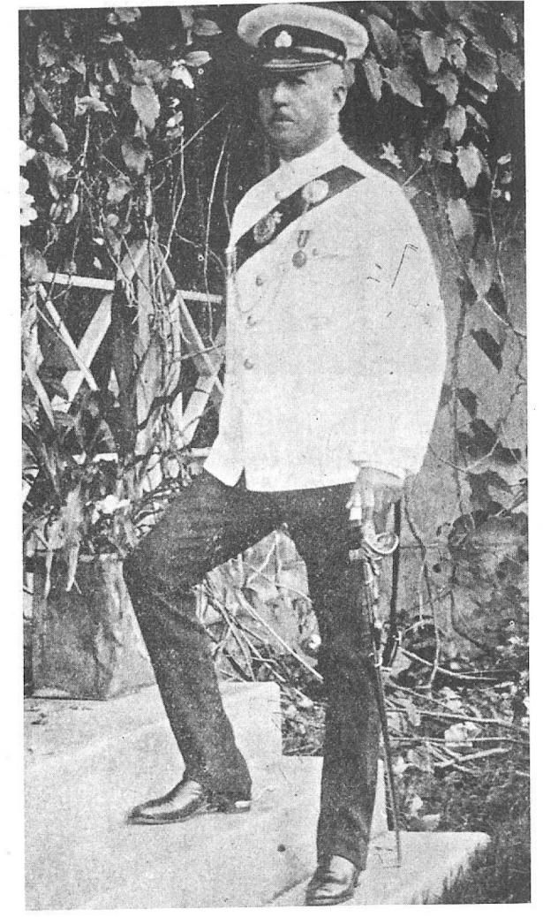
LONG SERVICE MEDAL
Urges Men To Let Past Services Influence Their Future Service In The Force.
In the presence of a large and representative gathering of citizens, His Excellency the Governor, Sir Leslie Probyn, K. C. M. G., presented the Police Medal to Inspector Herbert Thomas and the medals to ex-W. I. R.and B. W. I . R. men in the Jamaica Constabulary for services in the Great European war at the Police Depot in Elletson Road.
In addition to the Inspector General, Col. W. E. Clark, amongst those present were: Colonel Hall Grant Pringle, D.S.O., Commandant of the Forces, His Hon.Mr Justice R.T. Orpen, Col. W. Miller Officer Commanding the' West India Regiment, Hon. Claude Espeut, Hon. Robert Johnstone, I.S.O., Colonel A. H . Pinnock, Colonel H. M. Burke, Hon.St John Yates, Major T. B.Nicholson, Captain G B Groome, Major G. S. Cox, Inspector Owen Wright, Messrs B. E .W. Lucie Smith, Altamont DaCosta, M.B.E., D. C. Vaz, R. J. Macpherson, J. R. Piete, Andrews, John . Tapley, R H.Fletcher, M. M. Alexander, Beriiai.O'Toole, T. N. Aguilar, W . Baggett Gray, W. Heyliger, E . B Nethersole, S. J Streadwick, K R. Brandon, G. D. Rohertson, C. W. Dorley, Dr. Michael Grabham, Mr. T. D. Bruce, Lauriston Nunes, Dr. Lawson Gifford, Dr. C. B. Armstrong, Messrs. R. E. H. Nelson, Sergeant Major Williamson and Sergeant Major Tulloch.
The parade lined up to the South of the Depot grounds. It was under the command of Inspector Sidley, the acting Deputy Inspector General and the other officers were 'Inspector O'Hanlan, Inspector O'Connor, sub-Inspector Beaumont. In addition there were one Sergeant Major (Sergeant Major Humphre ); five sergeants; 2 corporals and 130 men. They certainly presented a very smart appearance, and the manner in which the parade acquitted itself reflected the highest credit on the Inspector-General, the officer in command and the officer who was mainly responsible for the training of the men.
His Excellency was late in arriving owing to motor car troubles, and when Sir Leslie Probyn and his A.D.C. Captain Lucie Smith approached the saluting base the parade came smartly to attention and the Royal Salute was carried out in smart precision. His Excellency accompanied by Colonel- Pringle, Col. Clark, Colonel Miller, Major Nicholson Captain Groome and Captain Lucie Smith A.D.C, inspected the parade and Sir Leslie Probyn expressed himself as being satisfied with the smart appearance of the men. The parade then marched past in columns and joined up in line and the Governor proceeded to distribute the medals to them.
Before doing so he pinned the police medal on the left breast of Inspector Thomas,shook hands with the officer and congratulated him on the distinction which he had earned. sub-Inspector Parker assisted in the distribution of the medals. He was A.D.C. to the Inspector General and was at the saluting base at the early stages of the proceedings.

Who's Who 1916
THOMAS, Herbert Theodore;
Entered the Public Service on the 17th April, 1878; appointed First Class Inspector on the lst February, 1900; at present in command of the St. Elizabeth Division ,of the Jamaica Constabulary Force. Address: Black River.
According to the World Catalog of Libraries, the following record is attributed to Herbert Thomas: Untrodden Jamaica by Herbert T Thomas, 2 editions published 1890 in English and held by 20 libraries World Wide
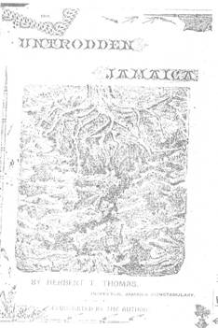
The Story of a West Indian Policeman: or Forty Seven Years in the Jamaican Constabulary by Herbert T Thomas, 3 editions published 1927 in English and held in 11 libraries World Wide
Something about Obeah by Herbert T Thomas, 1 edition published 1891 in English and held by 1 library World Wide (Columbia University in the City of New York in Microform 10 pp.)

Patricia Jackson's site
Adult Baptism
Thomas, Herbert Theodore baptised 5/16/1930 b June 6, 1856 father Rev Henry(sic) Thomas R2 (sic)at 3 Geffrard Place. Originally Moravian VII 124 # 853
also
1919 Who's Who Magistrates-Justices [of the Peace] Herbert Theodore Thomas- Black River
jamaicafamilysearch.com [Patricia Jackson's site]
Marriages Civil Registration
Thomas, Herbert Theodore, widower aged 68 years, son of John Thomas married Leonora Chambers, spinster, seamstress, aged 41 years daughter of Henry Chambers July 17, 1924 at 3 Geffrard Place, Kingston.
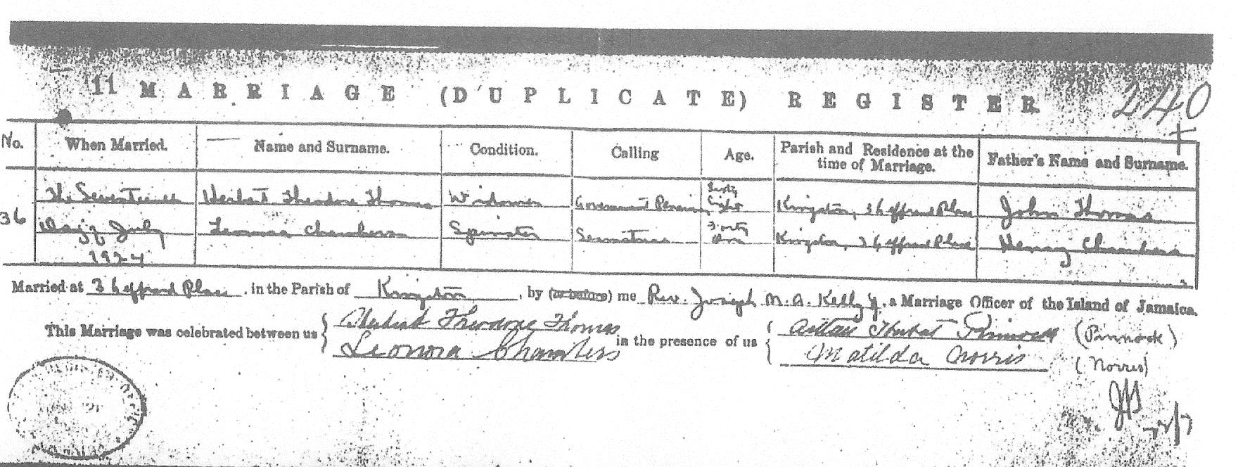

THE GLEANER, FRIDAY, MAY 30 1930.
Late Mr. H. Thomas.
Mr. Herbert Theodore Thomas whose death occurred on Wednesday last will not only be remembered as a zealous and courageous police officer but as an island explorer, a musician and a writer of distinction in the literature of the West Indies.
Mr. Herbert Thomas who was a lover of literature and an omnivorous reader throughout his life, was one of the best educated men in this island. He was born in Jamaica in 1856 and left it when a child, receiving his education in England at York and afterwards in Germany. He was appointed a sub-Inspector of the Jamaica Constabulary Force in 1876, and began his period of active service on the 8th of January 1877. He was transferred from the Depot then in Spanish Town, to Kingston in April of that year He resigned his appointment on the 28th of February 1878. He however applied and was re-appointed on the 28th of March 1878, and rejoined the Kingston division a month later. He was a police officer until 1924 when he retired from the Force.
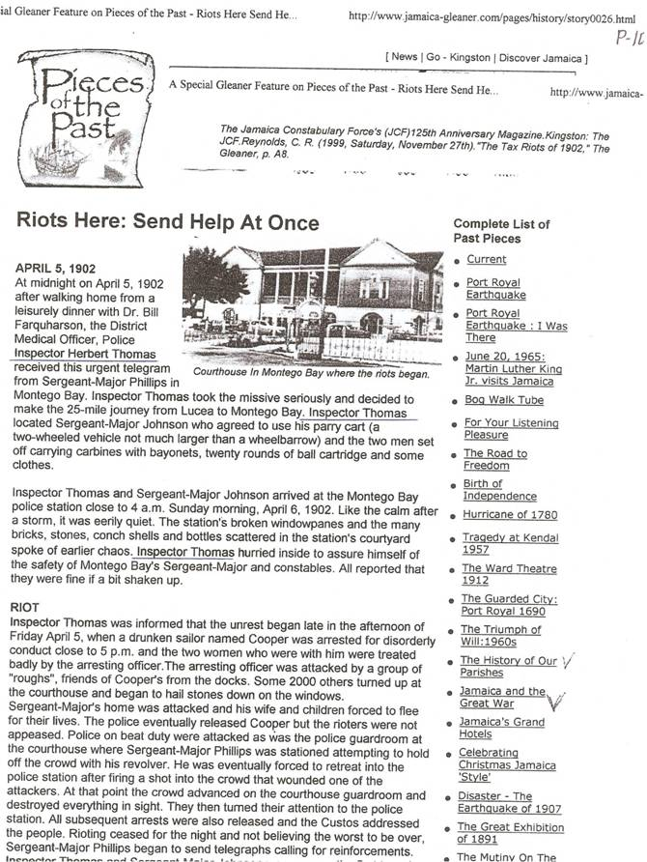
Mr. Herbert Thomas as we have already remarked, was a man of great courage. He seemed to have lived with the Spencerian line ever ringing in his ears: "Be bold, be bold, and evermore be bold' Nor did he much heed the iron door with the admonition, "Be not too bold." His courage was signally shown during the Montego Bay Rioton the night of Sunday the 6th of April 1902. Lord Olivier, who at that time was Mr. Sydney Olivier, acting Governor, in his report to the Secretary of State for the Colonies, spoke of "the courage and ability displayed by Inspector Thomas when all the other officers were disabled and much great responsibility had devolved on him and the excellent discipline and steadfastness of his men," No wonder that a man with such a fearless soul should have been the father of heroes. Like the Spartan who sent his children to the war animated by the "stern delight of battle," Mr. Herbert Thomas sacrificed his five sons in the struggle against the militarism of the Central Powers. These young men all died in the King's service on land and sea. There has been no more fervent lover of this island and the British Empire than Mr. Herbert Thomas.
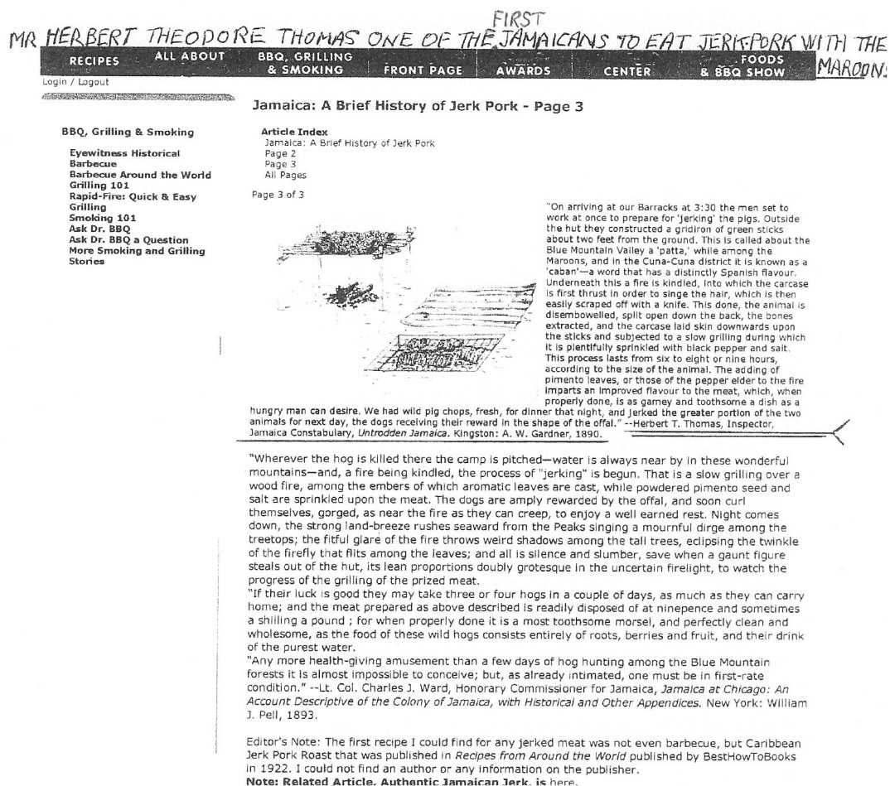
As a local explorer Mr. Herbert Thomas will be remembered for his crossing of the John Crow Mountain, and other explorations in the remote areas of the highest parts of the Blue Mountain. His book "Untrodden Jamaica" is an account of those explorations. He figured also as a lecturer. Iu 1901-02 he lectured on Jamaica twice at the Imperial Institute, the chair being occupied on the first occasion by the Earl of Standford and on the second occasion by Field Marshal Sir Henry Wylie Norman. He also lectured before the Society of Arts.
Mr. Herbert Thomas was the possessor of a clear incisive style of writing and a grim humour. His courage and fearlessness was also manifest in his writing. His best literary production in our opinion, is his book "The Story of a West Indian Policeman," which is an addition to West Indian literature. He was a devotee of music, and many musicians in Jamaica speak gratefully of their indebtedness to him. He lived bravely and was one of those who "warm both hands before the fire of life."

Descendants of John Thomas

Generation 1
1. JOHN¹ THOMAS.
John Thomas had the following children:
i. HERBERT THEODORE² THOMAS was born on 06 Jun 1856 in Jamaica. He died on 28 May 1930 in Kingston, Jamaica. He married (1) GERTRUDE NUNES about 1882 in Montego Bay, Saint James, Jamaica, daughter of Benjamin Nunes and Georgiana "Granny Ben" Hart. She was born on 21 Mar 1862 in Montego Bay, St James, Jamaica. She died on 30 Jan 1921 in St Marylebone Hospital, London England. He married (2) LEONORA CHAMBERS on 17 Jul 1924 in Kingston, Jamaica. She was born in 1882 in SavannalaMar, Westmoreland, Jamaica. She died in 1936 in Kingston, Jamaica.
ii. EDMUND JOSIAH THOMAS was born in Jamaica. He married AGATHA MAUD.

Generation 2
2. HERBERT THEODORE² THOMAS (John¹) was born on 06 Jun 1856 in Jamaica. He died on 28 May 1930 in Kingston, Jamaica. He married (1) GERTRUDE NUNES about 1882 in Montego Bay, Saint James, Jamaica, daughter of Benjamin Nunes and Georgiana "Granny Ben" Hart. She was born on 21 Mar 1862 in Montego Bay, St James, Jamaica. She died on 30 Jan 1921 in St Marylebone Hospital, London England. He married (2) LEONORA CHAMBERS on 17 Jul 1924 in Kingston, Jamaica. She was born in 1882 in SavannalaMar, Westmoreland, Jamaica. She died in 1936 in Kingston, Jamaica.
Notes for Herbert Theodore Thomas: See above in Text Item
Notes for Gertrude Nunes:
UK Census 1901
Civil parish Bedford St Peter, Town Bedford, County Bedfordshire, Reg District Bedford Sub Dist Bedford & Kempston
ED 8 Household 49
Two others, Head a married Widower was born in India and her son aged 15 years
Gertrude Thomas, wife, Married, 39, Living on own Means, b Jamaica, B.W.I
Francis H. Thomas, single,15, [b 1886 calculated], Jamaica, B.W.I
Marjorie E. Thomas, single, 12 [b 1889], Jamaica, B.W.I. Transcription in Ancestry.com has her as Martone (sic) but in the original it is clearly Marjorie.
UK 1911 Census
RG14 PN129 RG78 PN4 RD2 SD1
ED 42 SN 139
Registration District Kensington, Sub Dist Kensington South, Parish Kensington, Enum Dist 42
Address: 12a Earl's Court Square, Earl's Court SW, London
[A Boarding House]
Pawley Charles James Head M 56 [1855], Architect Surveryer, b Islington
others
Thomas, Gertrude, Boarder, married 29 years[calculated 1882], female, aged 49 [b 1862] St James, Jamaica, resident
Thomas, Marjorie Elaine, Boarder, single, female, 22 years[b 1889] St James, Jamaica, Resident
Thomas, Arthur Aighton (sic) [Crichton], Boarder, Male, 20 years [1891], office Military, St James, Jamaica, Resident
others including 3 servants of a boarding house, a cook, a chamber maid, and a waiter.
Herbert Theodore Thomas and Gertrude Nunes had the following children:
i. BENJAMIN³ THOMAS was born in Jamaica. He died before 1911.
ii. HENRY THOMAS was born in Jamaica. He died before 1911.
iii. HARRY REID THOMAS was born on 15 Mar 1883 in Jamaica. He died on 25 Dec 1915 in France.
Notes for Harry Reid Thomas:
Harry Reid Thomas, born in Jamaica B.W.I. on 15th March, 1883. He attended Jamaica College, and he volunteered to fight in the Boer War with Baden Powell's African Constabulary as a trooper. For his service he was awarded the King's Medal with 5 clasps. After the Boer War, he was shipped off to fight again in WW-1 as a Captain #8316 in France with the Royal Garrison Artillery, 34th Siege Battery where he died on 25th Dec, 1915. He is buried in France, at Vielle, Chapelle, Lacouture. Grave-1.C.9.
iv. FRANCIS HASTINGS THOMAS was born on 04 Dec 1885 in Jamaica. He married FRANCES E.J.BELL at Portsmouth in Sep Qtr 1912. He died on 15 Aug 1916 in Naval Memorial, Portsmouth, England.
Notes for Francis Hastings Thomas: Francis Hastings Thomas, born in Jamaica B.W. I. on 4th Dec, 1885. He went to the UK in 1900 and joined the British Army later in WW-1, and served in the Royal Marine Light Infantry on H.M.S. Talbot. He also became a Captain, and received a D.S.C. for his part in the Suvla Bay Landings at Gallipoli, Turkey. He died in WW-1 on 15th Aug 1916, and is buried at Portsmouth England; Naval Memorial, where his name is engraved on a plaque.
v. MARJORIE ELAINE THOMAS was born about 1888. She died in 1966 in England. She married CLIVE KIRKPATRICK DALY in 1913 in Richmond Registration District (Kew), Surrey, son of Edward Dermot Hamilton Daly and Louisa Georgina Julia Burch. He was born in 1888 in Auckland, New Zealand. He died in Sep 1966 in Winchester, Hampshire, England.
vi. ARTHUR CRICHTON THOMAS was born on 29 Dec 1890 in Jamaica. He died on 19 Nov 1917 in Belgium.
Notes for Arthur Crichton Thomas: Arthur Crichton Thomas, born in Jamaica B.W.I. on 29th Dec, 1890. He also joined the British Army of WW-1, and served in the Royal Garrison Artillery-355th Battery as a Major. He died 19th Nov, 1917 and is buried in Belgium at Talana Farm Cemetery.
vii. HERBERT PRICHARD THOMAS was born on 22 Dec 1892 in Jamaica. He married MARY RAE on 7th Oct 1925 in Aberdeen, Scotland. He died in 1969 in Scotland.
Notes for Herbert Prichard Thomas: Herbert Prichard Thomas, born in Jamaica B.W.I. on 22nd Dec, 1892. In 1911 he went to the UK at age 18 and entered the Royal Military College Sandhurst, Surrey. He received a King's Commission Aug 24th 1912. He waited and was accepted for the Indian Army in 1914 as an Officer & a Gentleman in the 126th Baluchistan infantry. He survived WW-1 as a Captain, and was able to return from India for his mother's funeral in the UK. He was a Lieutenant Colonel and he was later awarded an OBE & five medals for his service. He died in Scotland in 1969.
viii. GODFREY MAIN THOMAS was born on 10 Sep 1895 in Jamaica. He died on 24 Aug 1921 in Hull, Yorkshire, England.
Notes for Godfrey Main Thomas: Godfrey Main Thomas, born in Jamaica B.W.I on l0th Sep, 1895. He was the youngest of the brothers to start his military service at the end of WW-l as a Midshipman on the H.M.S. Colossus, in the first Battle Squadron. He was awarded the King's Medal & Dirk. His Squadron was transferred to the Royal Navy's Air Service; until the formation of the R.A.F in 1918. He went on to be a Flight Lieutenant, and died on 24th Aug, 1921 at 5pm aboard the Airship R-38 when it exploded over Hull UK and was awarded the D.F.C. along with 44 other airmen who died. He is buried at Hull Western Cemetery in Yorkshire, his name is inscribed on the British Plaque-Roll of Honour.
Leonora (2): Leonora Chambers was buried in 1936 in Calvary Catholic Cemetery, Kingston Jamaica.
Herbert Theodore Thomas and Leonora Chambers had the following children:
ix. DOROTHY MAUD THOMAS was born on 24 Nov 1903 in Jamaica. She died on 07 Nov 1989 in Brewster, New York, USA. She married JACK COOTE. He was born on 03 Aug 1899 in Jamaica. He died on 26 Mar 1984 in New York.
Notes for Dorothy Maud Thomas:
Name: Dorothy Maude Coote, nee: Thomas
Born: 24th Nov, 1903.
Place of birth: Jamaica W.I.
Married: Jack Coote, a Jamaican born 3rd Aug. 1899 & died 26" Mar. 1984, in New York State.
Children: None.
Occupation: Legal secretary & Insurance Underwriter.
Parents: Herbert T. Thomas& Leonora Chambers.
Siblings: Beatrice, Phyllis & Kathleen.
Died: Nov. 7th, 1989
Buried: in Brewster, New York State U.S.A.
x. BEATRICE VICTORIA THOMAS was born on 23 Dec 1904 in Union Street, Montego Bay, St James, Jamaica. She died on 09 Jul 1999 in Toronto, Ontario,Canada. She married ASQUITH EVELYN WHITING on 29 Apr 1944 in Falmouth, Trelawny, Jamaica. Beatrice Victoria: Beatrice Victoria Thomas was buried in 1999 in Holy Cross Cemetery, Thornhill Toronto, Ontario Grave 17a, Range 94, Section22.
Notes for Beatrice Victoria Thomas:
Name: Beatrice Victoria Whiting, nee: Thomas
Born: 23rd Dec, 1904, Certificate No.NA4333
Place of birth: Montego Bay, Union Street, Jamaica W.I.
Married: Asquith Evelyn Whiting. 29 Apr. 1944 in Falmouth, Trelawny Jamaica W.I.
Children:None
Occupation: Cost Accountant.
Parents: Herbert T. Thomas & Leonora Chambers.
Siblings: Dorothy, Phyllis & Kathleen.
Died: 9th Jul. 1999.
Buried: in Holy Cross Cemetery, Thornhill Toronto, On. Grave 17a, Range 94. Section 22.
xi. PHYLLIS ANGELA THOMAS was born on 24 Oct 1911 in SavannalaMar, Westmoreland, Jamaica. She died on 05 Feb 1990 in Toronto, Canada. She met (1) LOUIS ARCHAMBEAU. He was born on 25 Oct 1902 in Panama City, Panama. He died on 20 Jun 1983 in Kingston, Jamaica. She married (2) HERBERT JULIAN ADOLPHUS BYER on 09 Sep 1946 in Montreal, Quebec, Canada, son of Adolphus Byer and Martha Elizabeth Farnum. He was born on 25 Oct 1907 in Barbados, West Indies. He died on 11 Jan 1999 in Ontario, Canada.
xii. KATHLEEN MARJORIE THOMAS was born on 06 Aug 1913 in SavannalaMar, Westmoreland, Jamaica. She died on 13 Nov 1997 in Manchester, Lancashire, England. She married EDWIN CHARLES SLANEY in 1946 in Bury. He was born on 19 Jan 1917 in Bury, Lancashire. He died in Sep 1979 in Halifax, West Yorkshire, England.
3. EDMUND JOSIAH² THOMAS (John¹) was born in Jamaica. He married AGATHA MAUD. Edmund Josiah Thomas and Agatha Maud had the following child: i. EDMOND VINCENT³ THOMAS was born 1893 in Jamaica.
Notes for Vincent Thomas: Winner of Rhodes Scholarship

Generation 3
4. MARJORIE ELAINE³ THOMAS (Herbert Theodore², John¹) was born about 1888. She died in 1966 in England. She married CLIVE KIRKPATRICK DALY in 1913 in Richmond registration District (Kew), Surrey, son of Edward Dermot Hamilton Daly and Louisa Georgina Julia Burch. He was born in 1888 in Auckland, New Zealand. He died in Sep 1966 in Winchester, Hampshire, England.
Notes for Clive Kirkpatrick Daly: The Times of London Obits September 23, 24, 1966 Lt-col Sir Resident of Baroda and Gujerat States 1939-43. He was knighted by the King and became Sir C.K. Daly, and Marjorie became Lady Daly.
Clive Kirkpatrick Daly and Marjorie Elaine Thomas had the following children:
i. ELAINE MARION⁴ DALY was born in 1915 in England. Died 1998 in England
ii. CLIVE HENRY K. DALY was born on 21 Nov 1916.(Twin) He died Mar Qtr 1985 in Macclesfield, Cheshire, England. He married BERTHA E. P. AUSTWICK.
iii. GERARD FRANCES.K. DALY was born in 21 Nov 1916 (Twin) in Richmond S, Kent. He died 1985
iv. MARTIN ARTHUR DALY was born 6 May 1920 and died 1988.
5. HERBERT PRICHARD³(Herbert Theodore², John¹)was born 22 Dec 1892 in Jamaica. He died in 1969 in Scotland. He married MARY RAE on 7th Oct 1925 in Aberdeen, Scotland.
Herbert Prichard Thomas and Mary Rae had the following child:
i. HERBERT FRANCIS was born 1929
6. PHYLLIS ANGELA³ THOMAS (Herbert Theodore², John¹) was born on 24 Oct 1911 in SavannalaMar, Westmoreland, Jamaiica. She died on 05 Feb 1990 in Toronto, Canada. She met (1) LOUIS ARCHAMBEAU. He was born on 25 Oct 1902 in Panama City, Panama. He died on 20 Jun 1983 in Kingston, Jamaica. She married (2) HERBERT JULIAN ADOLPHUS BYER on 09 Sep 1946 in Montreal, Quebec, Canada, son of Adolphus Byer and Martha Elizabeth Farnum. He was born on 25 Oct 1907 in Barbados, West Indies. He died on 11 Jan 1999 in Ontario, Canada.
Notes for Phyllis Angela Thomas:
Name: Phyllis Angela Thomas.
Born: On 24th Oct, 1911. Birth certificate # LA-1861.
Place of birth: Savannalamar, Westmoreland, Jamaica B.W.I.
Died: On 5th Feb, 1990.
Had her first and only child by Louis Archambeau the father of her son.
She Married: Julian Herbert Byer, in Montreal, Canada, 1946.
Children: Her only child, son living Archambeau
Occupation: Night club manager in Jamaica B. W. I. Nursing Assistant in Canada.
Parents: Herbert Theodore Thomas & Leonora Thomas.
Siblings: Sisters; Dorothy, Beatrice & Kathleen.
Buried in Toronto, Ontario, Canada.
Notes for Louis Archambeau:
Name: Louis Archambeau
Born: 25th Oct.1902.
Place of birth:Panama City, Panama.
Married:Lil Archambeau in the 1950's Kingston,Jamaica.
Only Child: living Archambeau; the son of Phyllis A. Thomas daughter of Police Inspector Herbert T. Thomas.
Louis Archambeau's Interest & Occupation's: Chauffeur,Sportsman Superintendent of Myers Rum Store House Co. For 35 yrs. A Fisherman and owner of two boats. He also organised the first Soft Ball Team in Jamaica, at Issa Park in Kingston. He loved sports in general and was a good Boxer. He learned how to blend Rum's over the years, and developed his own blend called Archie's.He also owned two Clubs, with Restaurant and Cocktail Lounge's called ARCHIE'S CLUB in Kingston. He had a love for fine cars, as he was an excellent driver all his life, and a very popular man in Jamaica. His nickname was "Coolie".
Parents: Archambeau. Louis's father was born in France. He imported race horses to Panama. A businessman who lived in Panama.
His mother was from Colon, Panama's San Blas area. She was part Kuna Indian and black Jamaican.
Siblings: Two brothers and three sisters. Ted, Florence,
Died: 20th Jun. 1983.
Buried in Kingston, Jamaica.
Louis Archambeau and Phyllis Angela Thomas had the following child:
i. LIVING⁴ ARCHAMBEAU was born (Private).
Notes for Herbert Julian Adolphus Byer:
Name: Herbert Julian Adolphus Byer
Born: 25th October 1907
Place of birth: Barbados, W.I.
Died: 11th January 1999, Died in Ontario; Canada. Buried in Barbados, W.I.
Married: Phyllis Angela Thomas. 9th Sept. 1946. Certificate no. 10253
Children: None from union. Stepson: Living Archambeau
Occupation: Compositor. Worked on Canadian National Steamships as a printer and compositor. Retired at Ronald's Printing, Montreal, Quebec. Master Sergeant in Canadian Army: World War Two.
Parents: Adolphus Byer and Martha Elizabeth Farnum
Siblings: Wilhelmina Anne Harvey. Died 31St Jan, 1999 in Barbados
Living Claxton. Lives in Montreal.
Living Byer. Lives in Barbados
Living Thorne. Lives in Kitchener, Ontario.
6. KATHLEEN MARJORIE³ THOMAS (Herbert Theodore², John¹) was born on 06 Aug 1913 in SavannalaMar, Westmoreland,Jamaica. She died on 13 Nov 1997 in Manchester, Lancashire, England. She married EDWIN CHARLES SLANEY in 1946 in Bury. He was born on 19 Jan 1917 in Bury, Lancashire. He died in Sep 1979 in Halifax, West Yorkshire, England.
Notes for Kathleen Marjorie Thomas: Name: Kathleen Marjorie Slaney, nee: Thomas
Born: 6th Aug. 1913
Place of birth: Savannalamar, Westmoreland, Jamaica W.I. Married: Charles Slaney, an English man.
Children: Son, living Slaney.
Occupation: Legal secretary.
Parents: Herbert T. Thomas & Leanora Chambers.
Edwin Charles Slaney and Kathleen Marjorie Thomas had the following child:
i. LIVING⁴ SLANEY.

Family Group Sheet for Herbert Theodore Thomas

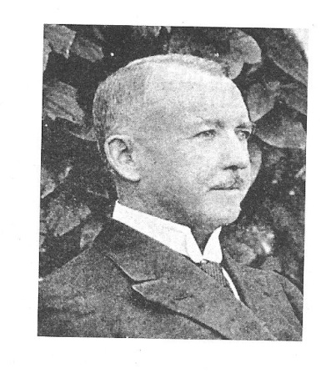
Husband: Herbert Theodore Thomas
Birth: 06 Jun 1856 in Jamaica
Baptism: 16 May 1930 in St Anne' s Catholic Church
Death: 28 May 1930 in Kingston, Jamaica
Marriage: 17 Jul 1924 in Kingston, Jamaica
Father: John Thomas
Mother:
Other Spouses:Gertrude Nunes (abt 1882 in Montego Bay Saint James, Jamaica

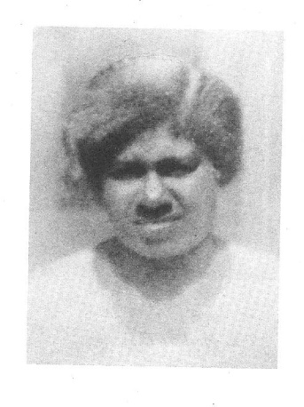
Wife: Leonora Chambers
Birth: 1882 in SavannalaMar, Westmoreland, Jamaica
Death: 1936 in Kingston, Jamaica
Burial: 1936 in Calvary Catholic Cemetery, Kingston Jamaica
Father: Henry Chambers
Mother:Miss Montague
Other Spouses:

Children:

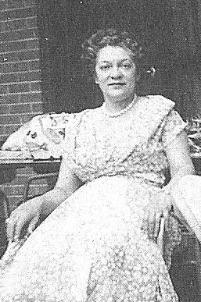
1 F Name: Dorothy Maud Thomas
Birth: 24 Nov 1903 in Jamaica
Death: 07 Nov 1989 in Brewster, New York, USA
Occupation: Legal Secretary and Insurance Underwriter
Spouse: Jack Coote
Other Spouses:

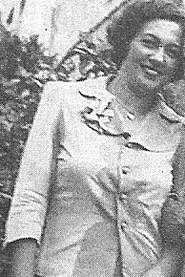
2 F Name: Beatrice Victoria Thomas
Birth: 23 Dec 1904 in Union Street , Montego Bay, St James,Jamaica
Death: 09 Jul 1999 in Toronto, Ontario,Canada
Burial: 1999 in Holy Cross Cemetery, Thornhill Toronto, Ontario Grave 17a, Range 94, Section22
Marriage: 29 Apr 1944 in Falmouth, Trelawny, Jamaica
Occupation: Cost Accountant
Spouse: Asquith Evelyn Whiting
Other Spouses:

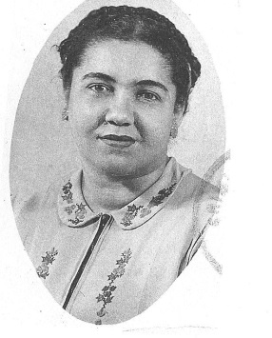
3 F Name: Phyllis Angela Thomas
Birth: 24 Oct 1911 in SavannalaMar, Westmoreland, Jamaiica
Death: 05 Feb 1990 in Toronto, Canada
Spouse: Louis Archambeau
Other Spouses: Herbert Julian Adolphus Byer (09 Sep 1946 in Montreal, Quebec, Canada)

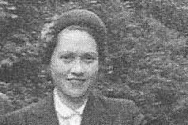
4 F Name: Kathleen Marjorie Thomas
Birth: 06 Aug 1913 in SavannalaMar, Westmoreland,Jamaica
Death: 13 Nov 1997 in Manchester, Lancashire, England
Marriage: 1946 in Bury
Occupation: Legal Secretary
Spouse: Edwin Charles Slaney
Other Spouses:

