Born Digital Curation of PDFs for High Quality Display (and Not Printing)
Many publishers, scholarly contributors, and others often contribute born-digital PDFs where they do not want the PDFs available online. In cases where contributors are granting permissions for page view image views enabled (JPG, JP2, JPGthumbnails) and not the PDF, they are granting permissions to allow the item to be easily viewed online but not easily printed in high quality.
For these, the workflow process is:
- Check to see if there is a catalog record or other record to import. If there is a record, import the record. Otherwise, create a new item record directly.
- The goal is to create high quality TIF files from the PDF.
- Open the PDF file in Acrobat Professional or other full software for PDF editing. The instructions here are for using a more recent version of Acrobat Professional.
  - Select “Save As”
  - Select to save as TIF (and change the default file name to be .tif instead of .tiff)
  - Check the settings to ensure they look have no compression or other things set, and that the save options are either RGB or Grayscale, so:
  - 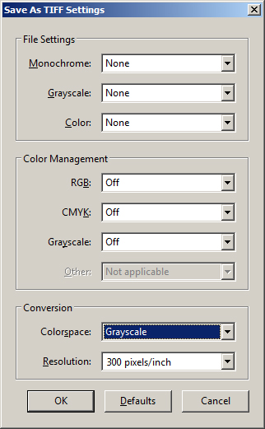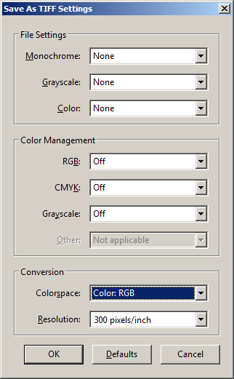
- Rename the PDF to have _archive in the filename, and process it to the DARK archive only.
- Load the TIF files to the item online to have the derivative page images created.
- Review the record for correct aggregations, rights statements, etc.; update as needed.
- Check the item to ensure all of the viewers (JPG, JP2, Related Images, and Page Turner) are all enabled for the item is done.

