Rights and Permissions Statements in SobekCM at UF

Overview
When creating a new item in the UF hosted instance of SobekCM, a standard rights statement is applied from the default metadata or default rights selected for a user’s account. Users automatically have the default metadata added, and users must choose to go into the system to change the default rights for their own accounts.
In addition to system-level settings for rights applied at the user level and with the different templates for default metadata for all items in that grouping by many users, users can also select rights at the item level which override the other settings. At the item level, users can write their own rights statements or choose from drop-downs for standard text for Creative Commons licenses or UF Rights Statements.
The variety of options for applying rights support optimal production needs at UF and for partners, alongside ease for granularly assigning rights on a per-item basis.

Drop-downs for User-Selected Rights for Items
Drop-downs are in now in place for users to select rights on an item-by-item basis. The UF Rights Statements are selectable alongside the selectable Creative Commons rights. The newly added UF Rights Statements are thus within the same, familiar interface for users.
Selecting one of the rights statements automatically places the statement into the text box for use as-is or any minor editing, if applicable. The rights statements are selected under “Edit Metadata” and then “Record Information.”
Screenshot after clicking UF Rights Statement tab, showing selectable-options in the text listing below.
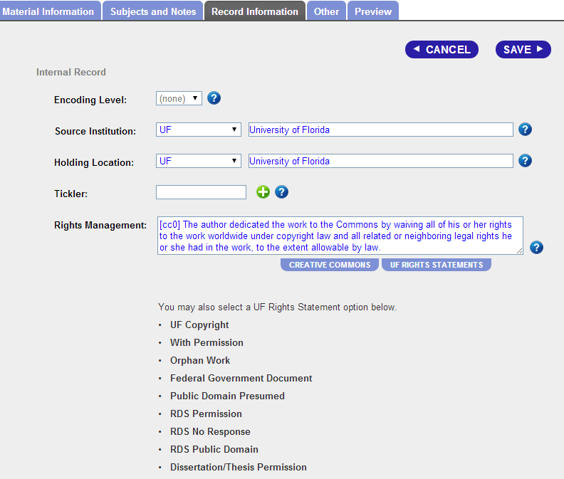
Screenshot after clicking the Creative Commons tab, showing selectable-options below.

Template and Default Metadata
Default metadata sets can be created for any project, aggregation, and other needs. Most of the UF users use the IR@UF default metadata. The IR@UF default metadata can be changed by any of the SobekCM system administrators. The current IR@UF metadata is:
Copyright Creator/Rights holder. Permission granted to University of Florida to digitize and display this item for non-profit research and educational purposes. Any reuse of this item in excess of fair use or other copyright exemptions requires permission of the copyright holder.

User-Defined Default Rights for all User Items
Individual users may select a default set of rights for all items submitted by the user. When users are logged in, they can access their own default rights as well as the default rights for projects/aggregations under “My Account”. These supply the user-defined defaults, and users can always change the rights on a particular item by editing the metadata for that item.

Updating and Enhancing Existing Rights Statements at the Collection or Aggregation Level
In addition to the default rights sets and user-defined rights for all user items or on a per-item basis, ongoing work for updating existing collections, aggregations, and sets of materials is underway. The work required for these updates includes confirmation and liaising with each of the appropriate curators to inform them on the rights statements and liaise for any bulk or group updating of rights statements for their materials that can be applied at a system-level.
The Curator of the UF Digital Collections and Digital Scholarship Librarian, as the UF Leads on the TRAC process, are collaborating with others on the process for updating and enhancing rights statements in a systematic manner. For this, they have developed a list of all 817 current aggregations and the curators for those aggregations, to confirm and liaise with curators for planning next steps on enhancing and updating rights as well as other corrections and updates needed at the system level. The Curator of the UF Digital Collections, Digital Scholarship Librarian, and Digital Development Programmer are collaborating together for full support for any updates and enhancements, including the consultancy meets with curators to define needs and steps in ways that can be programmatically addressed, track needs that require manual The first meeting has been requested with Special & Area Studies Collections with their curators for a group meeting to move the process on.
The Curator of the UF Digital Collections will be the ongoing leader for this process and will liaise with Curators on tracking where rights have been updated and areas needing attention. The Curator of the UF Digital Collections will continue to liaise and lead next-steps for the work to manually process other items in a systematic fashion for eventual correction of all rights statements.

