SobekCM Management and Reporting Tool (SMaRT)

The SobekCM Management and Reporting Tool (SMaRT) is an internal tool used at the University of Florida for activities and needs within Digital Production Services.

SMaRT Main Screen
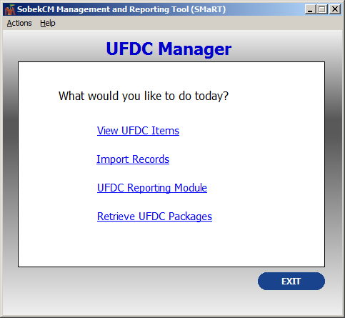
From the main screen, there are several main options:
- Actions (includes Retrieve UFDC Packages)
- Help/About
- View UFDC Items
- Import Records
- UFDC Reporting Module
- Retrieve UFDC Packages (accessible under actions from the top menu and from the core menu)

Top Menu
SMaRT Help
The help screen brings up information about SMaRT.

Actions
Actions allow users to select to Retrieve UFDC Packages.

Retrieve UFDC Packages/Items (also accessible from the top menu, under Actions)
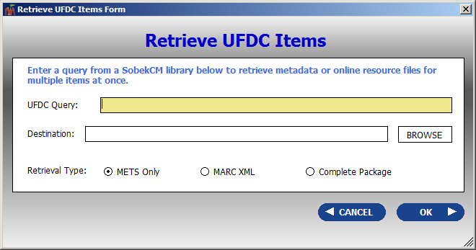
Retrieve UFDC Packages (also Retrieve UFDC Items) is an easy tool for retrieving all of the METS, MARCXML, or complete packages (METS, MARCXML, JPG, JPG2, JPG thumbnail, TXT, PRO, and any other files) for items using a standard query.
Please note that users must have read-only rights to the image server for retrieving full packages, but any user with SMaRT can retrieve the METS and MARCXML.
To retrieve the files or packages, use a standard query, including:
- Browses for all items in a collection: http://ufdc.ufl.edu/baldwin/all
- Searches for particular results: http://ufdc.ufl.edu/baldwin/results/?t=greenaway

Core Menu
From the center of main screen, the options are:
- View UFDC Items
- Import Records
- UFDC Reporting Module
- Retrieve UFDC Packages (also accessible from top menu, under Actions; and, explained above)

View UFDC Items
View UFDC Items allows for reports to be run on all items, with limiting options for restricting to collections or institutions. Reports include all DARK and in-process or private items as well as all online items.
From the file menu, users can save reports and print.
Reports can be saved as:
- Excel spreadsheet
- Tab delimited
- Comma separated
- XML

Results can be printed by:
- Print all rows
- Print selected rows

View UFDC Items: Actions
From the top menu, when items are selected, users can select a variety of actions.
The actions from the main screen are:
- Edit Serial Hierarchy
- Update Born Digital Flag
- Set Tracking Box
- Update Material Received Date
- Edit Disposition Advice
- Update Item Disposition
- Add Working History Entry
- Print Tracking Sheet(s)
- View Ad Hoc Report
Edit Serial Hierarchy
Update Born Digital Flag
Set Tracking Box | Update Material Received Date
Edit Disposition Advice | Update Item Disposition
Add Working History Entry
Print Tracking Sheet(s)
Print Tracking Sheets prints the tracking sheets to the preferred printer.

View Ad Hoc Report
View Ad Hoc Report brings up the Ad Hoc report form for running and creating reports.

View UFDC Items: Preferences
Preferences allow users to set preferences for:
- Search Precision
  - Contains exactly the search terms
  - Contains any form of the search terms
  - Contains the search term or terms of similar meaning
- Action on double-click
  - Open item group from web in browser window
  - View item group form
- Single Group Results
  - Display as grid in this form
  - Automatically open in item group form

View UFDC Items: View Item Group Details Form

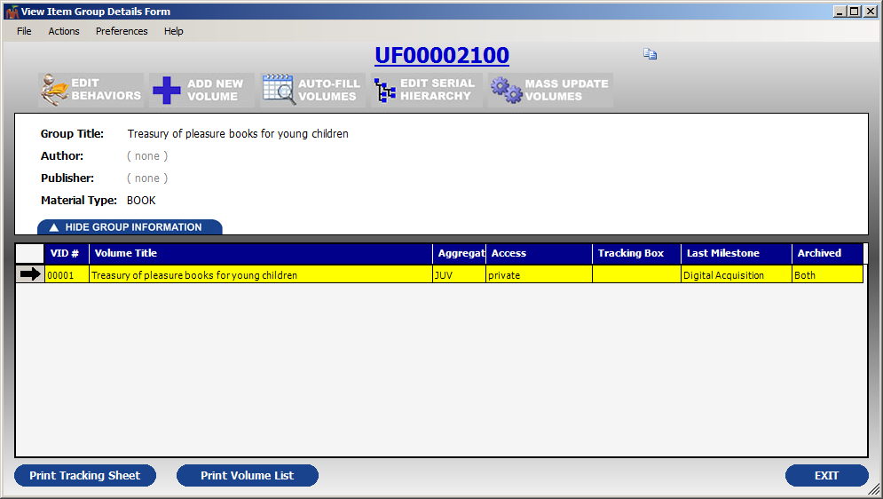
The View Item Group Details Form offers many of the same options, with a condensed form focused on a particular item group.
File, Actions, and Preferences are the same from the main View Items screen. Other details are parallel to the item group screens on SobekCM online.

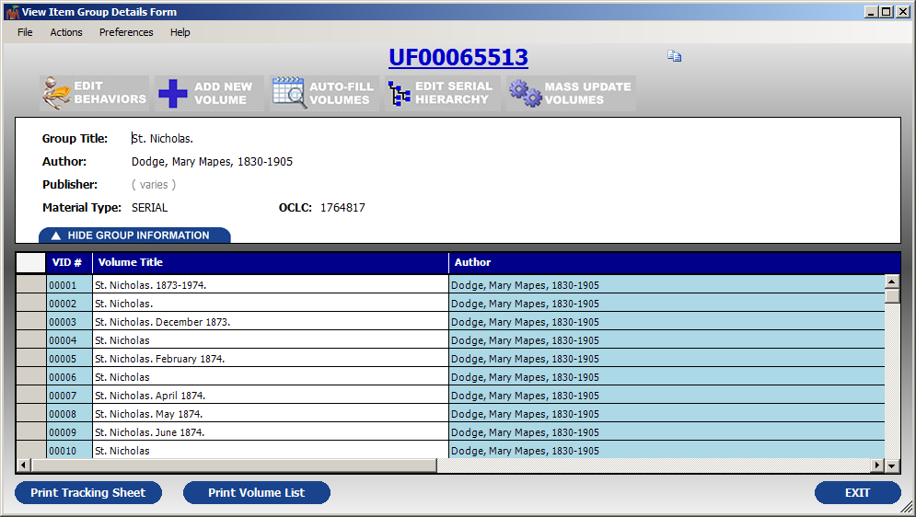
The screen appearance for the item group presents multiple volumes if they exist.

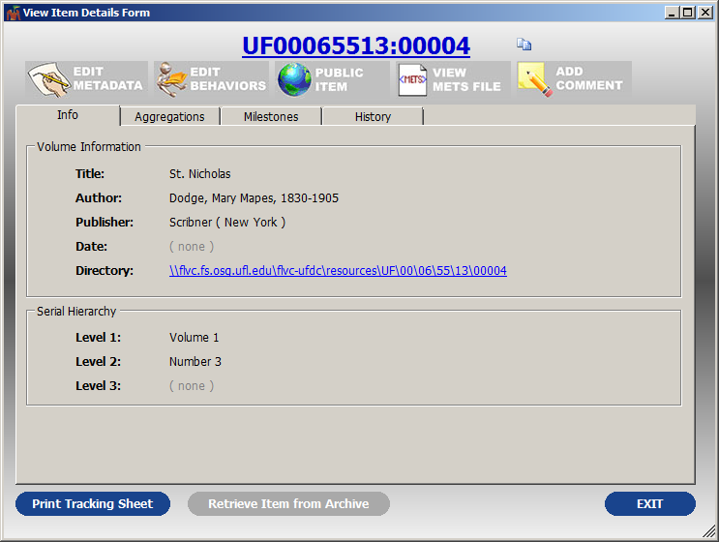
From the Item Group form, some of the selected options will go to SobekCM online.
Clicking on an individual item within the list will also bring up another form, with this information available online in SobekCM and also available in SMaRT for administrative ease until all SMaRT functions are incorporated into SobekCM.

Import Records
Import Records allows internal users with permissions to import records.

UFDC Reporting Module
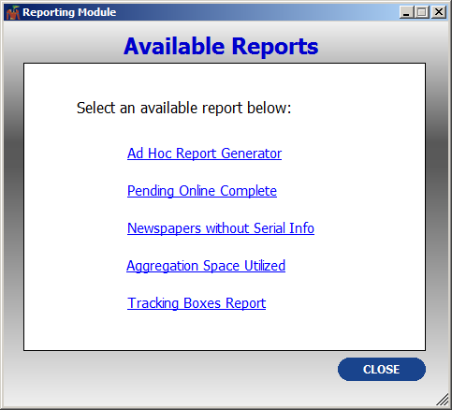
The UFDC Reporting Module supports running a variety of reports, including:
- Ad Hoc Report Generator
- Pending Online Complete
- Newspapers without Serial Info
- Aggregation Space Utilized
- Tracking Boxes Report

UFDC Reporting Module: Ad Hoc Report Generator
Covered prior in this documentation.

UFDC Reporting Module: Pending Online Complete
Pending Online Complete shows all items that have gone through the early workflow stages and are now pending online complete to be active and publicly accessible online. This is a great snapshot-view for all items in QC, as well as for many items simply needing an update to public.

UFDC Reporting Module: Newspapers without Serial Info
Prior to the official release of SobekCM, serial hierarchy handling was more difficult. The Newspapers without Serial Info report was created to assist with the clean-up work of early materials, as well as for quick corrections of any new needs.

UFDC Reporting Module: Aggregation Space Utilized
Aggregation space utilization is an older report developed for older storage estimation needs. The report was used for the sizing and cost estimates for planning for digital storage. This report was released but is no longer needed or used in its current form.

UFDC Reporting Module: Tracking Boxes Report

The Tracking Boxes report shows a list of all tracking box names in use, and users can double-click on the tracking boxes to pre-fill the box name into the Ad Hoc reporting query form for running reports.

Retrieve UFDC Packages
Retrieve UFDC Packages/Items is covered earlier in this documentation.

