Quality Control (QC) Online in SobekCM
- How to open the Quality Control tool

Once the item is opened on the webpage, click on the Quality Control icon in the grey bar which shows up. (Note that the grey bar only shows up for logged in users with appropriate rights.)

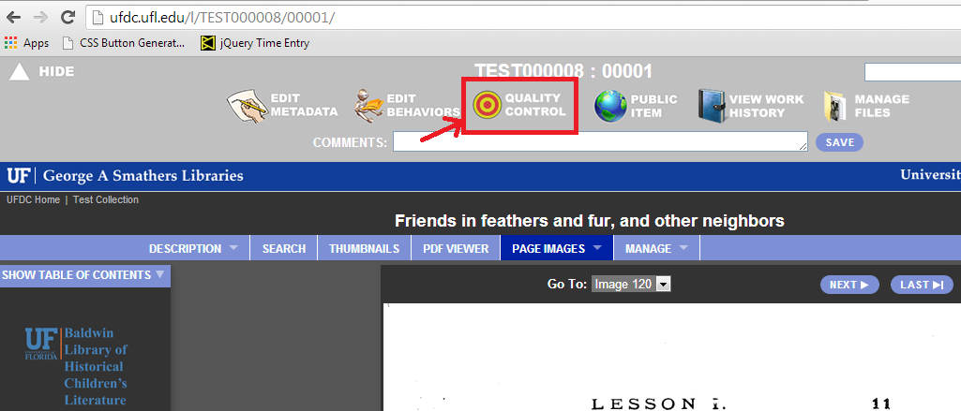
Fig. 1. Opening Quality Control

- How to edit Pagination/ Page labels
The ‘Pagination’ fields contain the page names for the thumbnails/pages of the item. The user can change this name thorough the ‘Page’ textbox below the thumbnail image. These names could also be auto-numbered. (Refer to the section on Auto-numbering below)

- Division types and names
The screenshot below shows the quality control interface. This displays thumbnail views of all the pages in the item, with Page and Division fields below each thumbnail image. Each thumbnail image corresponds to each page in the document.

The ‘Division’ checkbox, if checked, indicates that this page is the start of a new division type. The division information entered for this page is carried on for all subsequent pages belonging to this division.

The ‘Division’ dropdown indicates the type of the current division. The dropdown list is a controlled list of division types which the user can select from. If the selected division is a nameable division, an additional textbox appears below to hold the user-assigned name of this division.

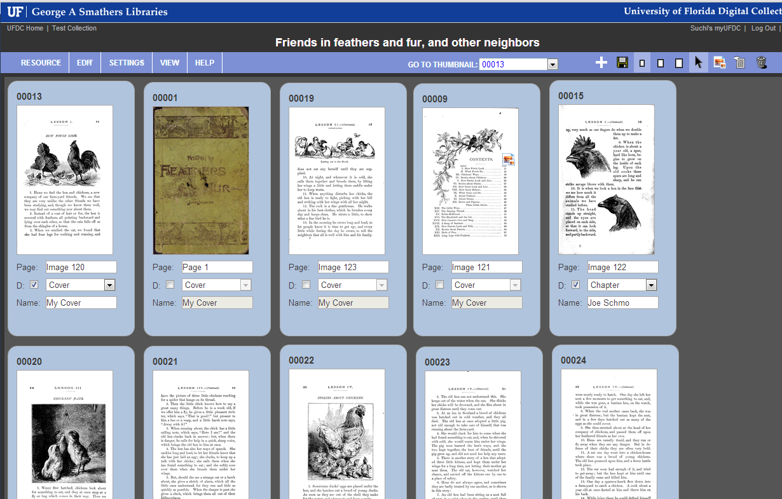
Fig. 2. Quality Control view of an item

- How to Edit Settings
- Changing the thumbnail size
By default, the pages are shown as small thumbnails. For greater clarity, these can also be viewed as medium or large thumbnails. The thumbnail size can be changed either through
- The QC menu bar. Settings -> Thumbnail Size ->Small/Medium/Large
- The Small/Medium/Large size rectangular icons on the right of the menu bar
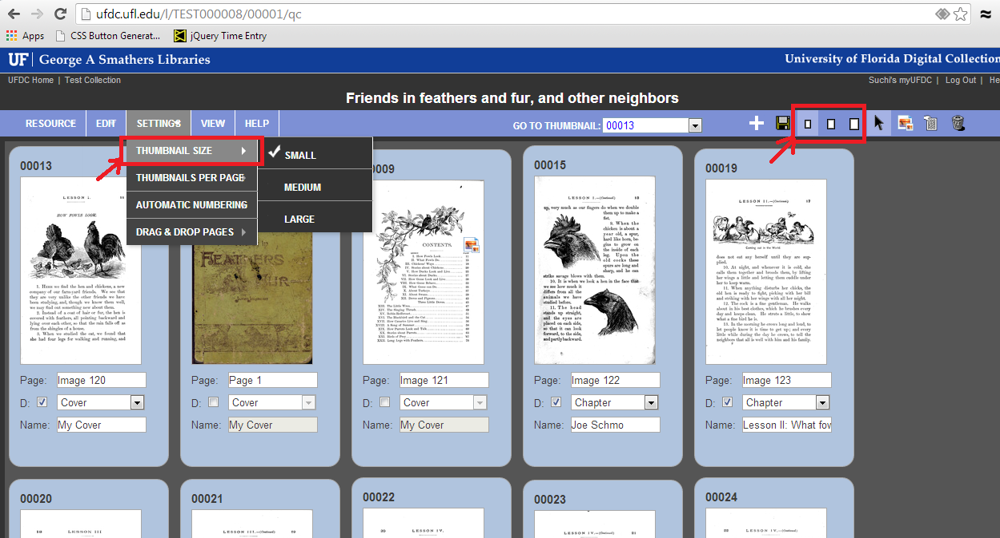
Fig. 3. Changing the thumbnail size

- Changing the number of thumbnails per page
The user also has the ability to change the number of thumbnails displayed on the screen. By default, the first 1000 pages/thumbnails of the item are displayed on the screen. This number can be changed through the Settings option on the menu bar.
Settings-> Thumbnails per page->25/50/100/500/1000

If the number of thumbnail selected is less than the total number of pages for this item, the thumbnails are displayed on multiple screen pages, with PREVIOUS and NEXT buttons to navigate between the screen pages of thumbnails.

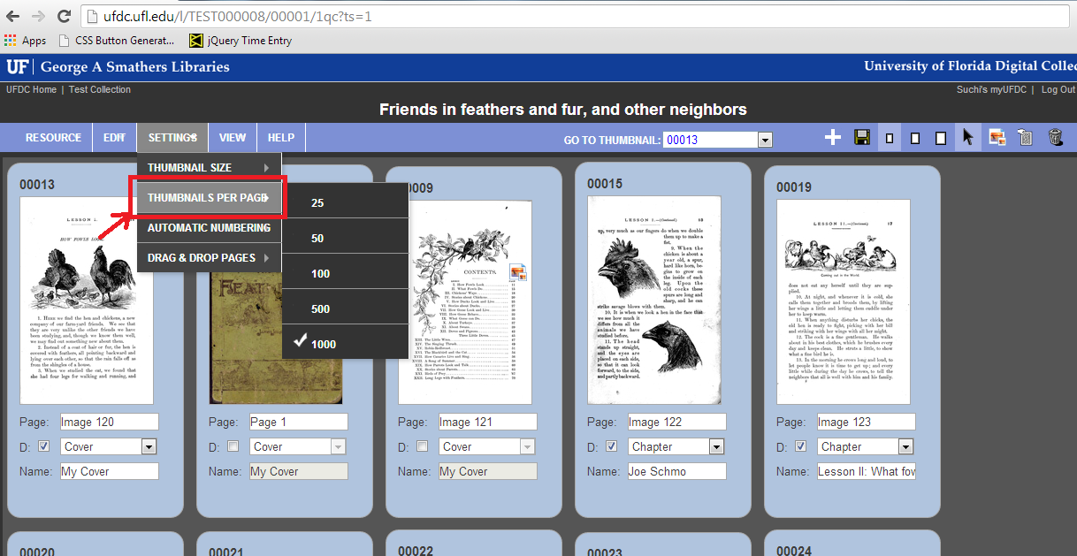
Fig. 4. Changing the number of thumbnails per page

- Automatic numbering of page labels
Page labels which are part of a sequence, like ‘Page 5’, or ‘Index ix’, can be auto-numbered using the automatic numbering feature of this tool. For the auto-numbering to take effect, make sure that the input name is of the format: Text, followed by space, and then number. The number can be either an integer or a roman numeral (upper or lower case).

Entering just a number ‘n’ (either integer or roman) in the textbox automatically replaces it with ‘Page n’.

The Automatic numbering Setting allows the user to auto-number pages throughout the item, only within a single division, or not at all.

The auto-numbering setting can be changed through the Settings option in the menu bar.
Settings -> Automatic Numbering -> No Automatic Numbering/ Within Same Division/ Entire Document

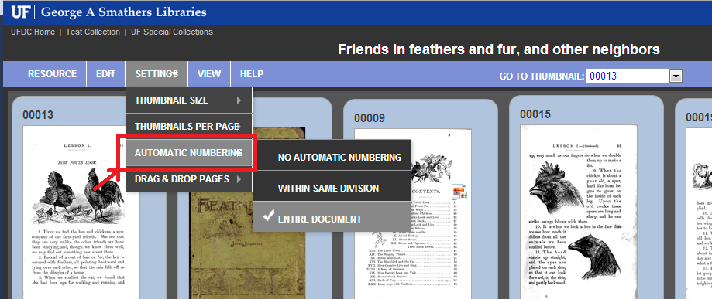
Fig. 5. Setting Automatic Numbering

- Drag & Drop Pages
Enabling this setting allows the user to grab a page, and drag and drop it to a desired location. This is particularly useful in re-ordering pages close to each other.

This setting can be enabled/disabled through the Settings option in the menu bar.
Settings -> Drag & Drop Pages -> Enabled, Enabled with Confirmation, Disabled

The ‘Enabled with Confirmation’ option additionally prompts the user for a confirmation before completing the move.

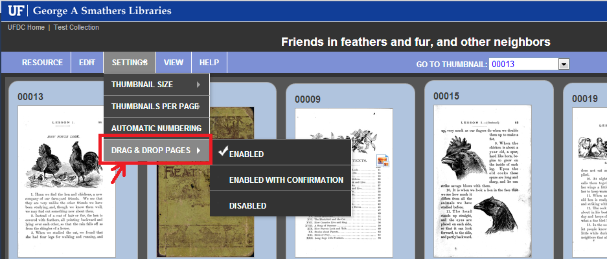
Fig. 6. Enabling / Disabling the Drag & Drop Pages feature

- Moving pages
The drag & drop feature described in the previous section allows the user to move one page. To move multiple pages, or even a single page which cannot conveniently be dragged and dropped, the ‘move’ cursor control can be used.

1] To move multiple pages, first click on the ‘hand’ icon on the far right of the QC menu bar. This changes the cursor to the hand symbol

2] This now allows the user to select the page(s) which need to be moved.
‘Ctrl + Shift + Click’ can also be used to select multiple consecutive pages with a single click.

3] Selecting the destination location can be accomplished by clicking on the small ‘left’ / ‘right’ arrows now appearing at the bottom, which indicate ‘Before’ or ‘After’ that page.
OR
The destination can also be selected by clicking on the yellow ‘MOVE’ button at the bottom right of the screen.

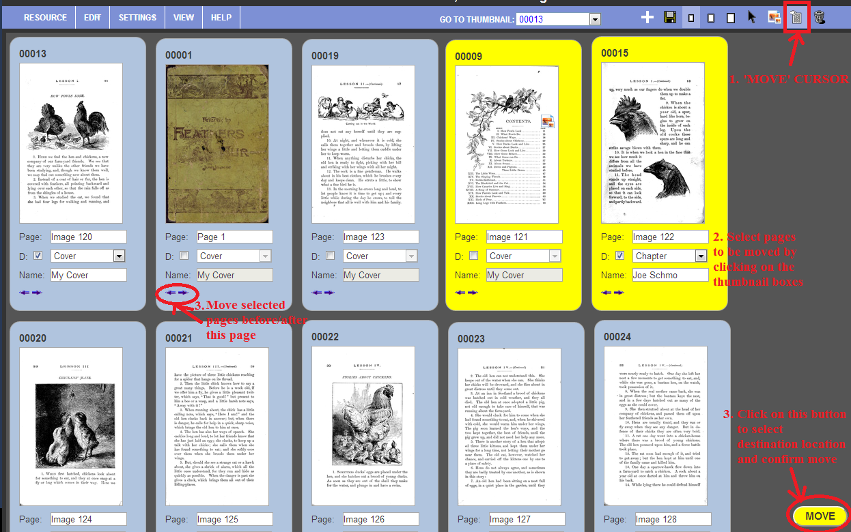Fig. 7. Moving multiple pages

This brings up the preview screen, showing a preview of the final location with dropdowns to select/change the final location, and buttons to confirm or cancel this move. (Screenshot below).
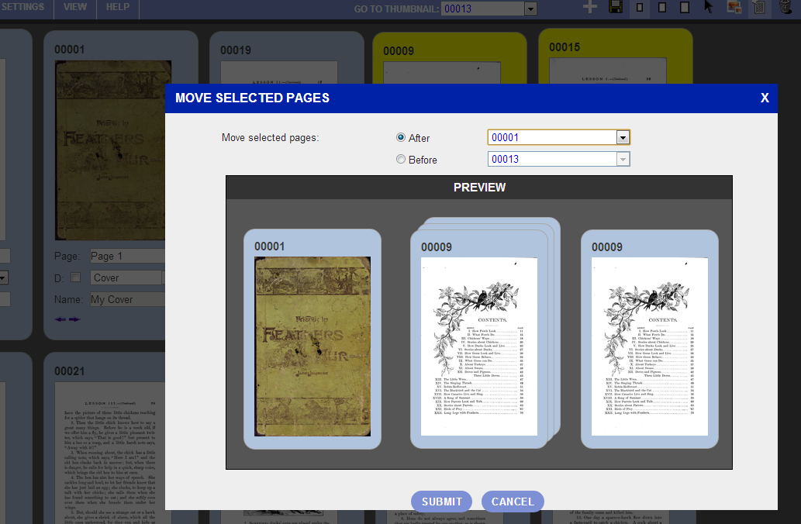
Fig. 8. PREVIEW Screen while moving pages

- Deleting pages
As in the case of moving pages, there are 2 ways of deleting a page.
- Deleting a single page
A single page can be deleted by clicking on the trashcan icon appearing at the bottom right of each thumbnail box on hovering over that box. This then prompts the user for a confirmation before deleting the page.
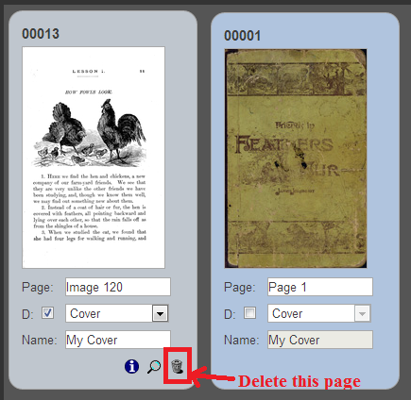
Fig. 9.a. Deleting a single page

- Deleting multiple pages
Multiple pages can be deleted by clicking on the trashcan cursor control icon at the right of the QC menu bar. The user can then select the pages to be deleted by clicking and highlighting in yellow to select the pages, and then clicking on the yellow ‘DELETE’ button at the bottom right of the screen.

‘Ctrl + Shift + Click’ can also be used to select multiple consecutive pages with a single click.

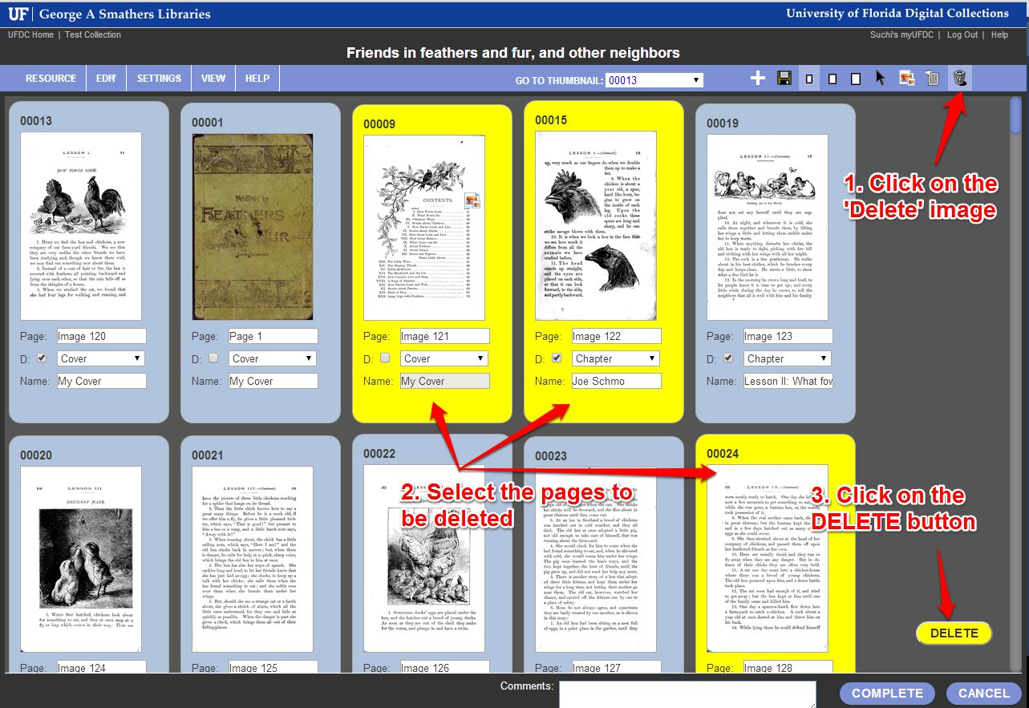
Fig. 9.b. Deleting multiple pages

7. Uploading new pages
To upload new pages within the item, click on the + (plus) icon on the right of the menu bar. This redirects to the Upload page.

On the Upload screen, the user can browse to select the image to upload. Multi-file upload is supported as well.

By default, the new pages are automatically inserted based on the filename. It is hence recommended that the files be named sequentially, typically in a numerical format like “00012”. The final page location can later be edited by the user as well.

For .TIF files, the .jpg and thm.jpg derivatives are also generated.
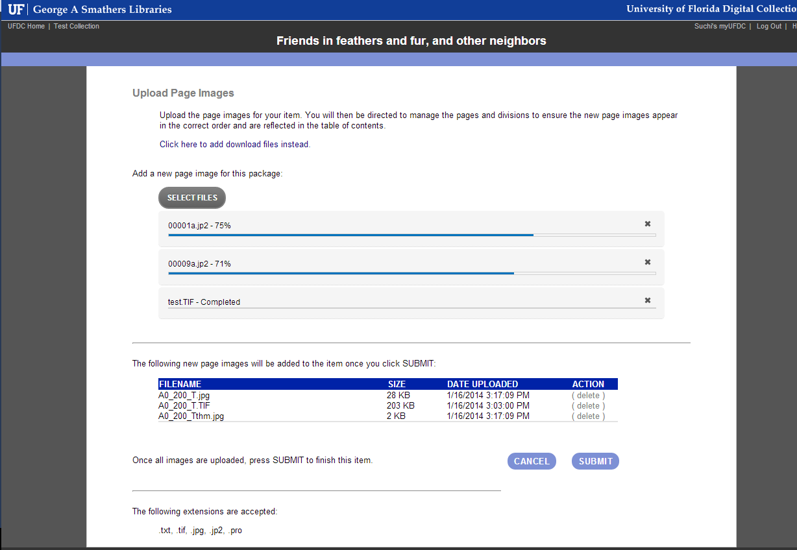
Fig. 10. Uploading new page images
8. Selecting a main thumbnail
The main thumbnail cursor-control icon at the right of the menu bar allows the user to select/ change/ remove the main thumbnail for the item. The main thumbnail is the thumbnail displayed for the item during searches and browses.
To select a thumbnail, click on the image icon on the menu bar. The cursor will change to this image. Then select the page which you want displayed as the main thumbnail. The main thumbnail icon will appear on this page and this change will be reflected on save.
To deselect, simply click on the page which was previously set as the main thumbnail.

9. Clear Pagination & Reordering Pages
This option, available in the menu bar through Edit -> Clear Pagination allows the user to clear all the pagination for the item.
The Clear Pagination & Reorder Pages allows the user to clear all pagination and reorder the pages based on the filename.

10. Adding Comments
The comments box at the bottom of the screen allows the user to add relevant comments, which are recorded in the internal tracking system with the item history.
11. Save, Complete, Cancel
The SAVE option saves all the quality control work done by the user in this session, and rolls the changes up to the main METS file for the item. Saving can be accomplished either through the save icon on the right of the menu bar, or under Resource-> Save at the left of the menu bar.
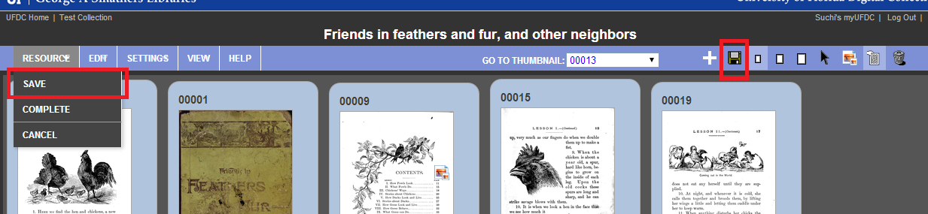
Fig. 11. Save options on the menu bar
Hitting Complete Saves the item, deletes temporary the temporary METS file once the final changes have been pushed out, and redirects the user to the main item page, where the updated Table of Contents are now visible.
The COMPLETE button is available at the bottom right of the screen, and also in the menu bar under Resource -> Complete

Related Resources
For additional information on Quality Control, see the SobekCM video on Quality Control and Serial Hierarchy: http://www.dloc.com/IR00003545/00003

