Quality Control Online in SobekCM
In SobekCM, users can load page images using “Manage Files” and selecting to load page images in a variety of formats. Users most often load TIF images, for which SobekCM automatically creates derivative files (JP2, JPG, and thumbnail JPG).
After loading the page image files, users click “submit” to be taken to the QC (Quality Control) screen for the item. QC can also be selected from the top menu when users are logged in.
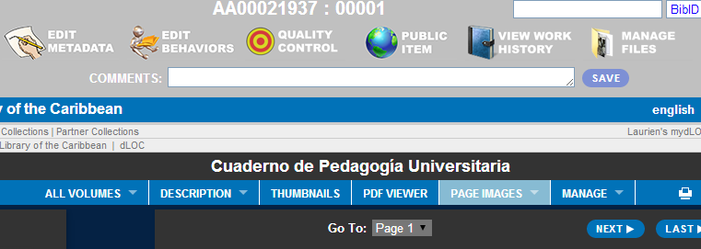

As shown in the screenshot, QC supports many different actions, including:
- Adding and pagination (which can be done by typing the pagination; for instance, “Page 1,” and clicking tab to have all subsequent pagination automatically completed)
- Assigning structural metadata to create a table of contents by selecting different item sections, using the drop-down menu beneath the page selection

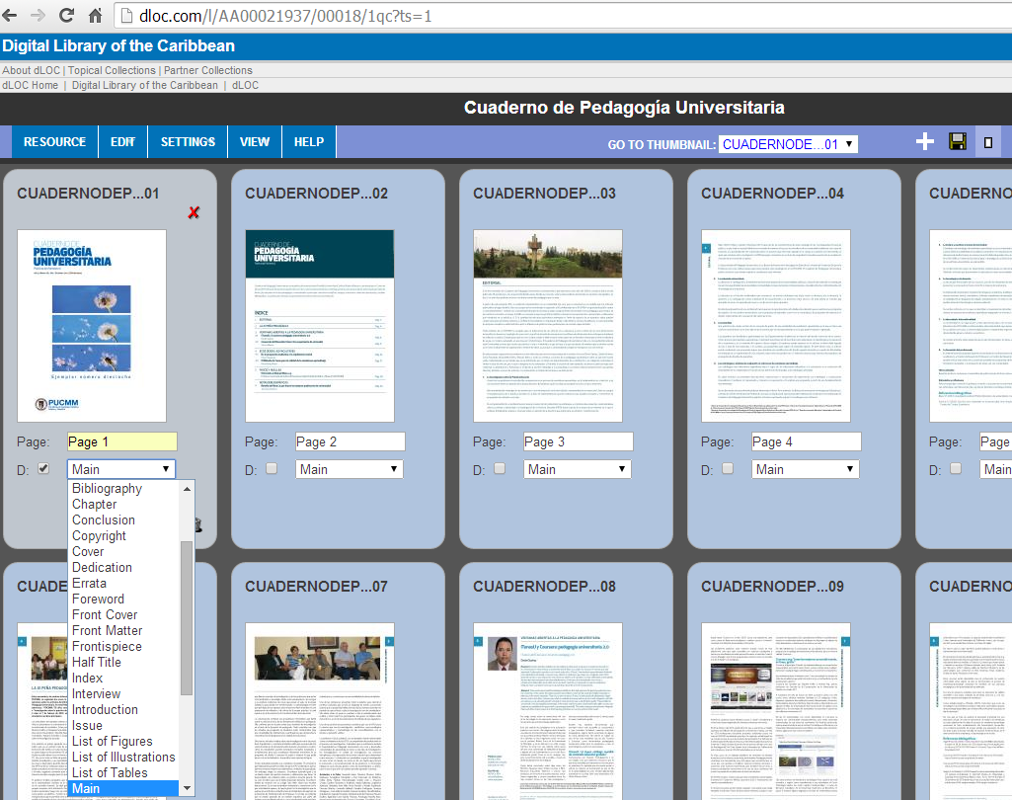
Selecting divisions:

Related Resources
For additional information on Quality Control, see the SobekCM video on Quality Control and Serial Hierarchy: http://www.dloc.com/IR00003545/00003

