Thematic Collections (Curated Digital Collections & Digital Scholarship Projects)
Supporting Collection Managers and Curators with SobekCM Projects & Templates

Sections

About Thematic Collections (Curated Digital Collections & Digital Scholarship Projects) Page 2
About the SobekCM Technology Page 2
SobekCM Projects & Templates Page 3
SobekCM Projects, Example from the University of Florida
SobekCM Templates, Example from the University of Florida
How to Use SobekCM Projects and Templates Page 7
SobekCM Projects and Templates for Administrators
SobekCM Projects and Templates for Curators and Collection Managers
Historical System Documentation for Administrators Page 8

About Thematic Collections (Curated Digital Collections & Digital Scholarship Projects)
As the technologies and needs for digital collections and digital libraries have grown, greater emphasis continues to be placed on curated digital collections as and with digital scholarship projects. Curated digital collections and digital scholarship projects are also called by many other names, including thematic research collections, explained by Carole L. Palmer:
Thematic research collections are digital resources that come closer to this ideal [of the libraries or library collection as a laboratory where “necessary materials for a research project amassed in one place, as they are in a laboratory setting”]. Where in the past scholars produced documents from source material held in the collections of libraries, archives, and museums, they are now producing specialized scholarly resources that constitute research collections. Scholars have recognized that information technologies open up new possibilities for re-creating the basic resources of research and that computing tools can advance and transform work with those resources (Unsworth 1996). Thematic research collections are evolving as a new genre of scholarly production in response to these opportunities. They are digital aggregations of primary sources and related materials that support research on a theme. […] scholars are participating in this movement, bringing their subject expertise and acumen to the collection development process. In taking a thematic approach to aggregating digital research materials, they are producing circumscribed collections, customized for intensive study and analysis in a specific research area. In many cases these digital resources serve as a place, much like a virtual laboratory, where specialized source material, tools, and expertise come together to aid in the process of scholarly work and the production of new knowledge.

About the SobekCM Technology

The SobekCM software is a full suite of applications that power digital libraries, digital content/asset management, digital preservation, discoverability, online patron user tools, and workflow tools for integration with library and other web-scale systems, digital production, and digital curation. SobekCM is the software engine which powers many digital libraries, exhibits, digital production workflows, and more at institutions around the world including the Digital Library of the Caribbean (dLOC), Florida Digital Newspaper Library, the University of Florida Digital Collections (UFDC), and many others.

SobekCM allows users to discover online resources via semantic and full-text searches, as well as a variety of different browse mechanisms. For each digital resource in the repository there are a plethora of display options, which may be selected by an appropriately authenticated use. The SobekCM software includes online metadata editing and online submissions in support of institutional repositories.

SobekCM Projects & Templates
The SobekCM software provides support specifically for scholars, libraries, curators, and others in working collaboratively together to create thematic collections, and more. For thematic collections, the SobekCM “projects” and “templates” are especially useful.
Projects are explained in the SobekCM documentation:
Projects are basically default metadata that can be selected by an authorized user for online submittal. The project-level data is stored in a project-level METS (PMETS) file that can be edited using the standard full online metadata form. When a user begins to add a new digital resource, the project-level data is loaded into the digital resource, before the user views the item in the online submittal form. The project-level data usually includes the item aggregation information linked to the project, as well as common default data.
SobekCM supports a blank “none” project that does not include any added default information, and the creation of as many new projects as are wanted for supporting ease of entry and consistency for materials.
In addition to projects which support the automatic addition of metadata when entering new items, templates support customized entry forms and entry processes. For instance, templates can specify that a grant of permissions be accepted for each new item, as is essential for institutional repositories, and templates can specify that the grant of permissions not be required, as would be wanted for many library projects where the materials are already in the public domain and free of any other rights or related concerns.

SobekCM Projects: Example from the University of Florida
At the University of Florida, SobekCM has many added projects to support all of the different collections and contributor needs. For each project, selected standard information is automatically added when new items are entered to ease the process of entering new items. The standard information can be edited during the entry process, and after the item is added using the online metadata editing.
The project for the Digital Library of the Caribbean (dLOC, www.dloc.com) includes:
- Subject keywords: Caribbean region
- Standard rights statement: Applicable rights reserved.
The project for oral histories from the Samuel Proctor Oral History Program includes:
- Default resource type set: Oral History
- Default language listed: English (can be changed, but majority are in English)
- Subject keywords: Oral history
- Source Institution: UF Samuel Proctor Oral History Program
- Holding Institution: UF Samuel Proctor Oral History Program
- Rights management: All rights reserved by the UF Samuel Proctor Oral History Program (SPOHP).

SobekCM Templates: Example from the University of Florida
Below are example item entry screens powered by different templates in use at UF with SobekCM.
Project and Template: Government Documents: requires grant of permissions, simplified entry form for metadata pull from catalog records
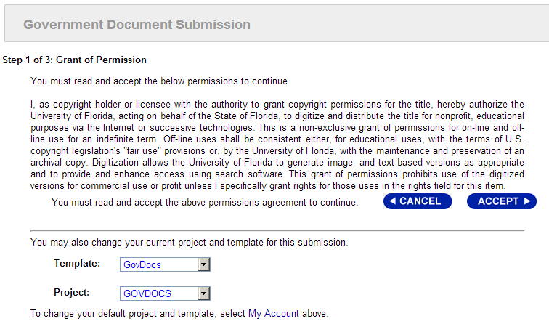
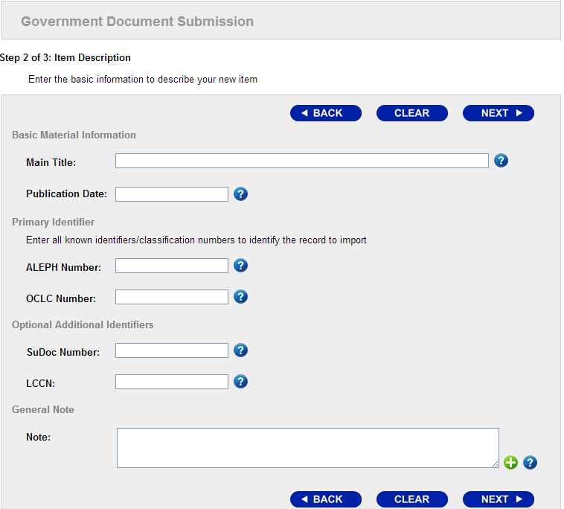

Project and Template: Internal and none: does not require grant of permissions, fuller form 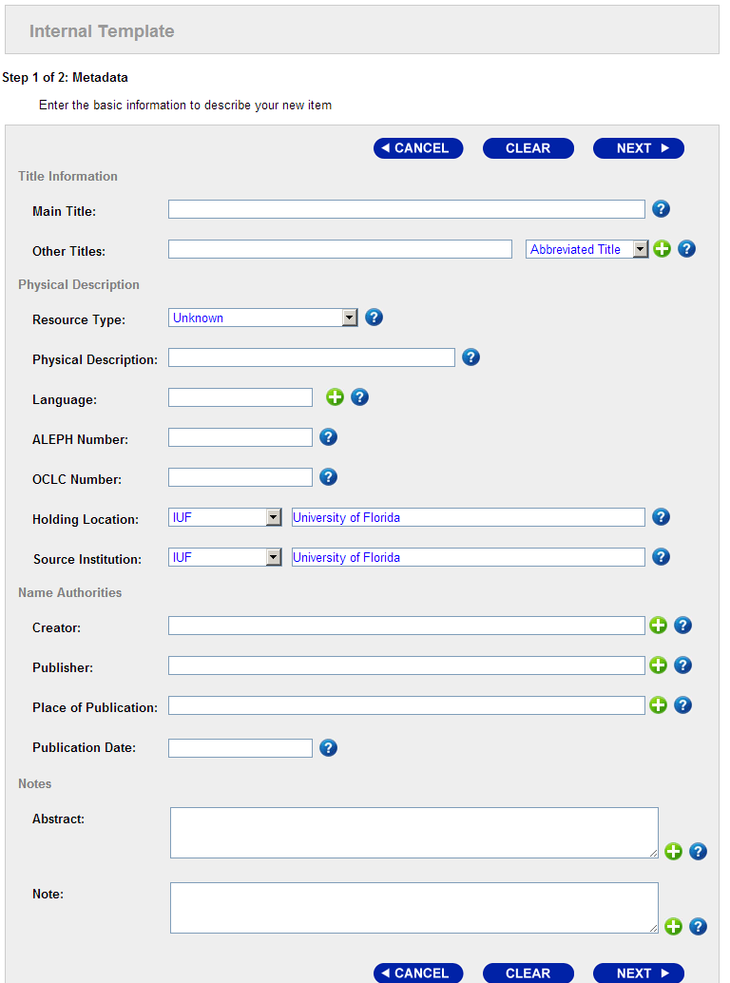

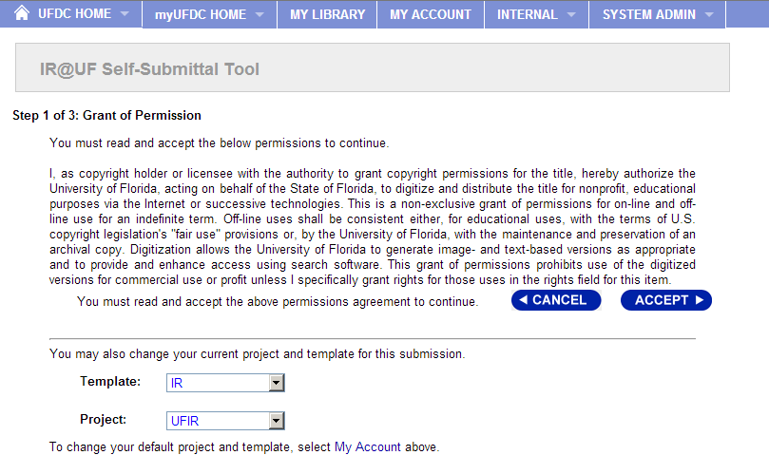
Project and Template: UF Institutional Repository: requires grant of permissions, shorter form 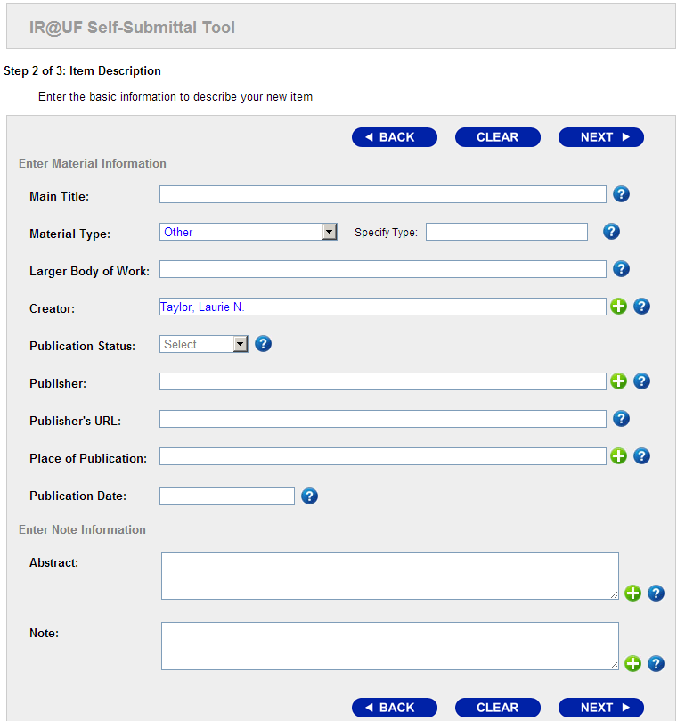

How to Use SobekCM Projects and Templates

SobekCM Projects and Templates for Administrators
SobekCM administrators create new projects using the online Administrative tools. SobekCM administrators can add and remove projects and templates for users from the user administration screens for individual users and with user groups.

SobekCM Projects and Templates for Curators & Collection Managers
When logged in, curators and collection managers can select their preferred template and project in their account preferences, under “My Account” as shown in the screenshot below.
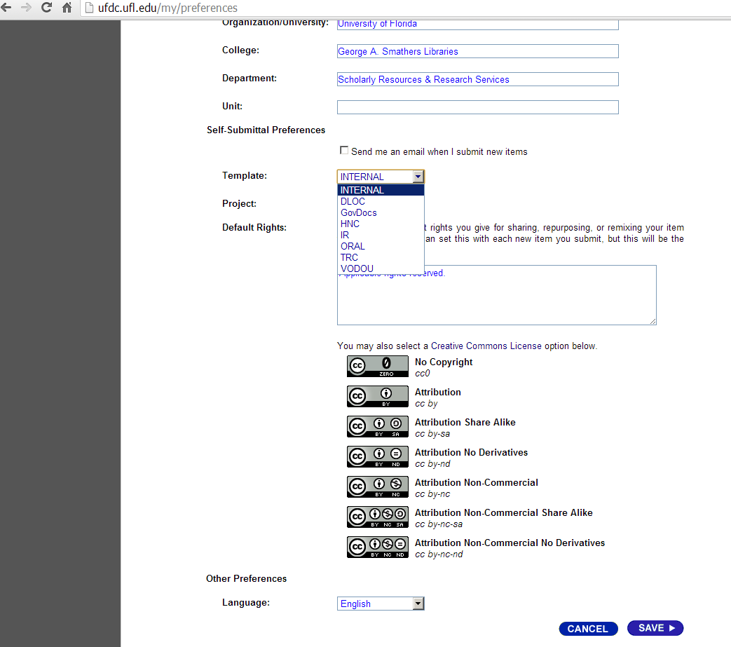

The following pages are current and historical system administration documentation for SobekCM—technical information that supports, complements, and informs the Collection Management work.

For up to date technical information, see the help resources online: http://ufdc.ufl.edu/adminhelp/projects

SobekCM Projects Administration
Text below from online help page: http://ufdc.ufl.edu/adminhelp/projects

Welcome to the help page for performing administrative updates on projects within this digital library.
This page explains the overall concept and some of the terms used.

General Concept
Projects are basically default metadata that can be selected by an authorized user for online submittal. The project-level data is stored in a project-level METS (PMETS) file that can be edited using the standard full online metadata form. When a user begins to add a new digital resource, the project-level data is loaded into the digital resource, before the user views the item in the online submittal form. The project-level data usually includes the item aggregation information linked to the project, as well as common default data.

New Project
This section allows an administrator to add a new project. Each of the elements are described below:
- Project Code
This is the code that users can select within their preferences, and is also the name of the final project METS file on the web server.
- Base Project Code
This data is used when creating a new project, but is not retained in the database. Rather than starting with a blank project METS file, the project file for the 'base' project is copied.
- Project Name
Name of this project, to help differentiate it from other projects and explain the need.

Existing Projects
This section allows the user to perform some tasks on existing projects:
- edit
The administrator can edit the metadata linked to an project. Selecting this link will open the PMETS file in the online metadata editing form.
- rename
This brings up the pop-up form to allow the user to change the name associated with the project.

Example
Below are example screenshots for adding new projects and managing existing projects:
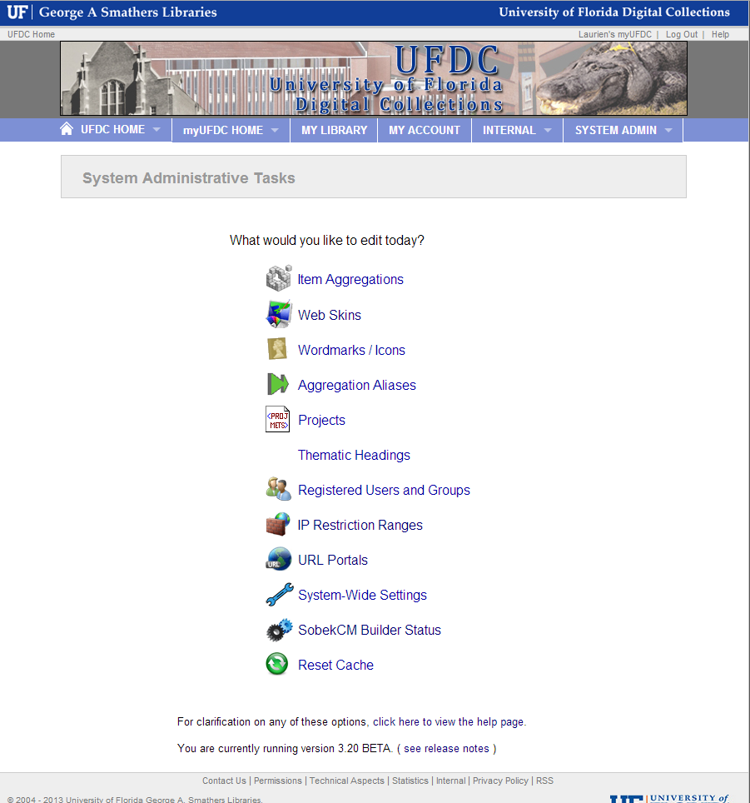
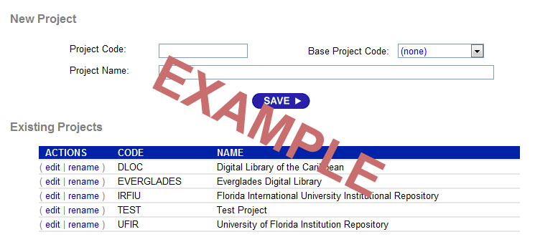
Below is the image of the pop-up form used for renaming an existing project:

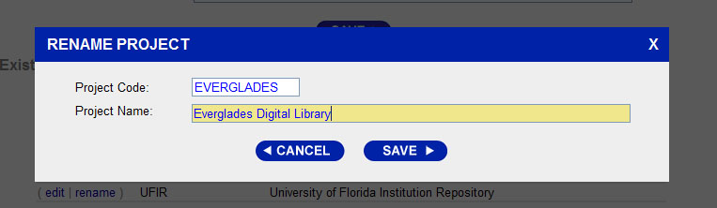

SobekCM: Project Templates (Legacy 2010 Documentation
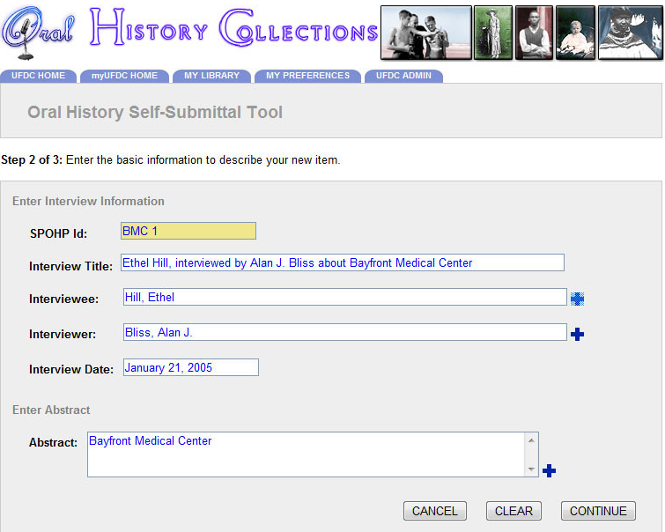

XML Template
<?xml version="1.0" encoding="utf-8" ?>
<!-- Begin the XML for this input template -->
<input_template
xmlns="http://www.uflib.ufl.edu/digital/metadata/sobekcm_template/"
xmlns:xsi="http://www.w3.org/2001/XMLSchema-instance"
xsi:schemaLocation="http://www.uflib.ufl.edu/digital/metadata/sobekcm_template/
http://www.uflib.ufl.edu/digital/metadata/sobekcm_template/sobekcm_template.xsd">
<!-- Define the information about this input template -->
<name>Oral History Self-Submittal Tool</name>
<notes>Template for the oral history program</notes>
<permissions>I, as copyright holder or licensee with the authority to grant copyright permissions for the title, hereby authorize the University of Florida, acting on behalf of the State of Florida, to digitize and distribute the title for nonprofit, educational purposes via the Internet or successive technologies. This is a non-exclusive grant of permissions for on-line and off-line use for an indefinite term. Off-line uses shall be consistent either, for educational uses, with the terms of U.S. copyright legislation's &quot;fair use&quot; provisions or, by the University of Florida, with the maintenance and preservation of an archival copy. Digitization allows the University of Florida to generate image- and text-based versions as appropriate and to provide and enhance access using search software. This grant of permissions prohibits use of the digitized versions for commercial use or profit unless I specifically grant rights for those uses in the rights field for this item.</permissions>
<dateCreated>February 18, 2010</dateCreated>
<lastModified>February 18, 2010</lastModified>
<creator>Mark V Sullivan</creator>
<banner>myUFDC/templates/images/oral.jpg</banner>
<!-- This defines the inputs which are available for the user -->
<inputs>
<page>
<name language="eng">Enter Interview Information</name>
<panel>
<element type="Identifier" subtype="fixed_type" repeatable="false" acronym="Enter the spohp identifier" >
<element_data>
<label>SPOHP Id</label>
</element_data>
</element>
<element type="Title" subtype="simple" acronym="Enter a title for this oral history interview." mandatory="true" >
<element_data>
<label>Interview Title</label>
</element_data>
</element>
<element type="Creator" subtype="fixed_role" acronym="Enter the names of the interviewee(s) (Personal names should be entered [Family Name], [Given Name].)" repeatable="true" >
<element_data>
<label>Interviewee</label>
</element_data>
</element>
<element type="Creator" subtype="fixed_role" acronym="Enter the names of the interviewer(s) (Personal names should be entered [Family Name], [Given Name].)" repeatable="true" >
<element_data>
<label>Interviewer</label>
</element_data>
</element>
<element type="Date" acronym="Enter the date for this interview" >
<element_data>
<label>Interview Date</label>
</element_data>
</element>
</panel>
</page>
<page>
<name language="eng">Enter Abstract</name>
<panel>
<element type="Abstract" repeatable="true" subtype="simple" acronym="Enter your abstract here. If your material does not have an abstract, you may include a summary of your document here." />
</panel>
</page>
</inputs>
<!-- This defines the constants which can not be edited by the user -->
<constants>
<element type="Type" subtype="simple" >
<element_data>
<value>Book</value>
</element_data>
</element>
</constants>
</input_template>
<!-- End of input template XML -->

Palmer, Carole L. “Thematic Research Collections.” A Companion to Digital Humanities, ed. Susan Schreibman, Ray Siemens, John Unsworth. Oxford: Blackwell, 2004. http://www.digitalhumanities.org/companion/
In addition to supporting thematic collections at the collection level, with these called “aggregations” which are able to exist at many levels (groups, collections, subcollections, institutions, and other types of aggregated sets of materials) where specific functionalities are supported for each collection at the full collection level, projects and templates support adding new items to the thematic collections by supporting the information entry and certain functions at the item level.
http://ufdc.ufl.edu/adminhelp/projects
http://ufdc.ufl.edu/adminhelp/users

