Collection Management with Mixed Physical & Digital Collections
Existing physical collections often include digital contents on physical media, including files on floppy disks, files on CDs, files on DVDs, and more. These materials are often at great risk because of preservation issues with the physical format, making them ideal for migration into the digital collections.
For instance, for archival collections with materials in the digital collections, the finding guides should always be updated to link to the digital collection materials. Similarly, the digital collection items should include links to the finding guides to connect to the physical materials.
In some unique cases, other options may be appropriate. For instance, if there was a large, heavily used archival collection that is entirely print, aside from a single letter on a floppy disk, the best option may blend digital and print further. For this example, it could be that the single letter would be added to the digital collections, and a printed for the print copy to be included within the physical collection for proximity and ease of access for researchers using the print collection materials.
Another blended approach includes that taken for the Panama Canal Museum collections where a separate online database section within the digital collections (in this case the Panama Canal Museum Index, powered by SobekCM) may be used for processing the physical collections in a way that simultaneously builds towards the digital collections.
Other blended approaches may be needed for handling legacy collections on CD, purchased data sets, and more. In some cases, these difficult scenarios may present opportunities for improving processes and building towards further integration with the digital collections, even when full digitization and digital curation cannot be supported because of resource limitations.
Older Documentation Notes Version
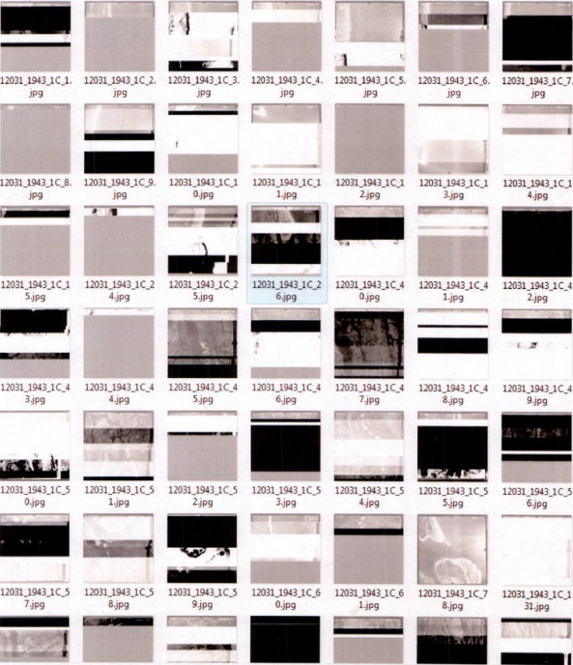
Example of Aerial Photographs Pre-Curation
“Around the world, key scientific data are at risk of being lost, either because they are held on fragile or obsolete media or because they may be destroyed by researchers who are unaware of their value. Now a team of scientists is planning to scour museums and research institutes to draw up a global inventory of threatened data.” (www.nature.com/news/2010/101102/full/468017a.html)

The digital files used in research are endangered and “at risk” data from all fields, including the humanities, arts, and social sciences. Modern research requires digital tools and the research process includes the selection, collection, organization, and analysis of digital files. Those digital files—spanning all types of content including scientific data, images of archival letters, interactive media files, and more—are all too often held in precarious ways. As such, the potential for total loss exists and this is in addition to the lost possibilities from the materials being inaccessible. The UF Digital Collections include digital objects created through the digitization of source materials as well as born digital. All materials in the UF Digital Collections are curated to support optimal access and ensure long-term preservation.

Example Digital Curation Processing Workflow

The example below is based on Special & Area Studies Collections (SASC). In the past, SASC received only small portions of collections as digital and so would preserve materials by printing files. Now, digital files should go into the appropriate digital collection and preservation archive, and copies may still be printed for user ease. This will likely be the case for any collections with only small portions that are digital, where having the material printed is needed for ease of use for the collection as a whole.

Digital Development & Web Services, Production, Curator, or Other Group
- runs virus scan
- reviews for file types; normalizing any unusable formats and/or identifying needed software
- maintains 1 complete copy until copy-in-process is complete and archived
- sends files and any processing notes/information on software needed or recommended to SASC/curatorial review

SASC/curatorial review
- reviews for organization, maintaining any existing organization (folders, if intellectually grouped and significant contents), organizing other materials as appropriate based on underlying structure, and then placing other materials into a general folder(s)
- decides whether this accession is closed/1 set or if it can be added to/expanded with future donations (processing may change based on this)
- creates a finding guide/spreadsheet for all materials at the applicable level

Digital Development & Web Services, Production, Curator, or Other Group
- imports the spreadsheet
- renames all folders into BIB_VID format
- normalizes all files and file names
- properly places all dark items for dark processing (note: multiple versions of same file are normally not kept for print collections unless literary collections because of space concerns, multiple versions will be retained for digital-only collections unless size/cost is an issue)

Prior Documentation

Prior version, last updated 24 January 2011: http://digital.uflib.ufl.edu/technologies/documentation/datacuration.htm

