UF Libraries: Creating New Digital Collections (Aggregations) in SobekCM
Contents
- Overview
- Steps for Creating New Digital Collections (Aggregations)
- Administrative Tracking of New Aggregations
- Terminology: Collections and Aggregations

Overview of Concept for Aggregations

Any collection of items into a distinct searchable or browse-able set is an item aggregation. This includes collections, subcollections, institutions, exhibits, etc. Each item aggregation has its own home page and the search types and browse types can be defined for that page.

In addition to technical functionality at the aggregation-level, research on digital libraries, digital scholarship, and digital publishing demonstrates that users prefer contextualized or thematic collections. Thematic research collections bring together digitized materials, contextual and supporting research materials, scholarly contributions, and other resources to create a research resource. Users prefer thematic collections because the collections have context and coherence, making them more sensible and usable. This leads to higher usage rates in terms of quantity of views and visits, and supports a higher quality of usage with collections that are more understandable by users and used in more complex and beneficial ways by users.

At UF, each digital collection is under the purview of one or more Curators/Liaisons, with collaborative support from Digital Support Services. For scholarly digital projects and archives, teaching faculty partner with Curators/Liaisons, with collaborative support from Digital Partnerships & Strategies

Examples from 2014:
- Florida Digital Newspaper Library:
  - Includes materials directly within the subject scope for the PK Yonge Library of Florida History and Journalism, and materials from partners
  - Curators: Jim Cusick and Patrick Reakes
  - Collaborators: Laurie Taylor
- Digital Library of the Caribbean:
  - Includes materials from the Latin American Collections, other UF collections, dLOC Partners, Scholars, and affiliates
  - Program Directors: Brooke Wooldridge (Laurie Taylor, technical)
  - Curators: Curators for all collections at all institutions

Curators often request new aggregations for new topical groupings for their materials. For example, newer aggregations include the Freedom Summer Oral Histories within the Oral History Collections and the Early American Children’s Literature Digital Collection within the Baldwin. Curators also often request new aggregations as prototypes for grant proposals, as virtual collections that bring together digital versions of materials held in different physical collections, and for many other reasons.

Steps for Creating New Digital Collections (Aggregations)

Step 1: Curator Requests

To create a new digital collection (which is really an aggregation of digital resources; see more on terminology below), a Curator contacts Digital Services with basic information on the new aggregation.

Step 2: Administrators Review the Aggregations Listing
After a new aggregation is requested, Digital Services checks the existing “Collection Hierarchy from the mySOBEK Internal Tools to see if an aggregation exists.
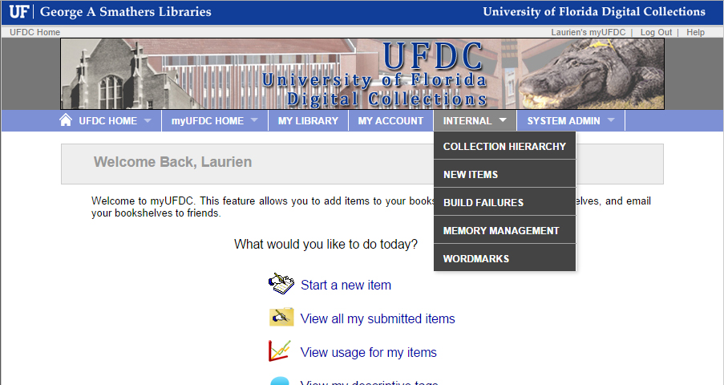

Step 3: Administrators Confirm Needed Information is Available

If there is not an existing aggregation, Digital Services confirms the information for the requested aggregation, which includes:
- Confirming that the Curator requesting the aggregation is the Curator for the new aggregation
- Confirming that all information needed for the new aggregation is available:
  - Code: human-readable name that appears in the URL
  - Type: Group, Collection, Subcollection, Institution, Institutional Division, Exhibit
  - Parent: parent aggregation, containing the new aggregation
  - Collection Name: Full and Short
  - External Link: if applicable, often not used
  - Thematic Heading: normally only used after a collection is established and populated
  - Description:
  - Whether active and whether or not to show in the parent collection homepage
  - Contact email(s)
  - Banner image, if available
- If the new aggregation is or is related to an SASC collection, confirming that the new aggregation will be made in a manner that supports SASC processing.
  - Example: Archival collections are normally begin with physical processing with a finding guide created. The finding guide is then used to create a MARC record. New aggregations that are from UF archival collections should:
    - Reference the finding guide for creating the new aggregation
    - Create the new aggregation as a collection under the MANUSCRIPTS group
    - Link to the Finding Aid on the new aggregation home page
    - After the new aggregation is created, SASC updates the finding aid to link to the new aggregation

Step 4: Administrators Create Collection in SobekCM, Liaising for Any Concerns
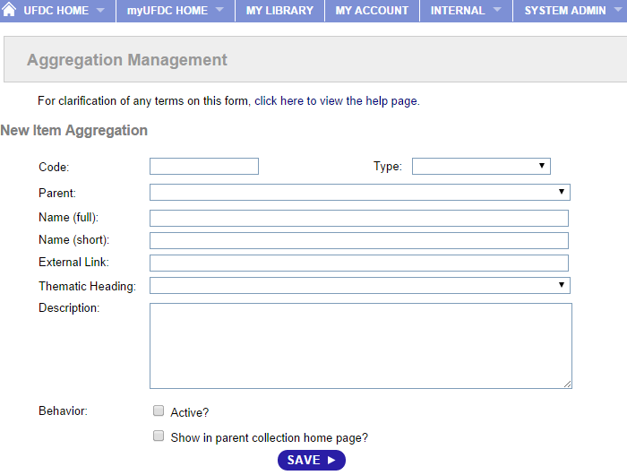
Administrators in SobekCM have the system-level permissions to create new aggregations.

To create the new aggregation, the Administrator in mySOBEK and selects “Aggregation Management.”

To create a new aggregation, an Administrator:
- Signs in to mySOBEK (myUFDC, myDLOC, etc.)
- Clicks on the “System Administration” menu (shown in the image above)
- Selects “Aggregation Management”
- Completes the Item Aggregation form with the required information: Code, Type, Parent, Full Name, Short Name
- Clicks “Save”
- After clicking “Save”, the Administrator needs to go to the new aggregation to complete the next steps

Step 5: New Aggregation Page, Administrators Update Design Files

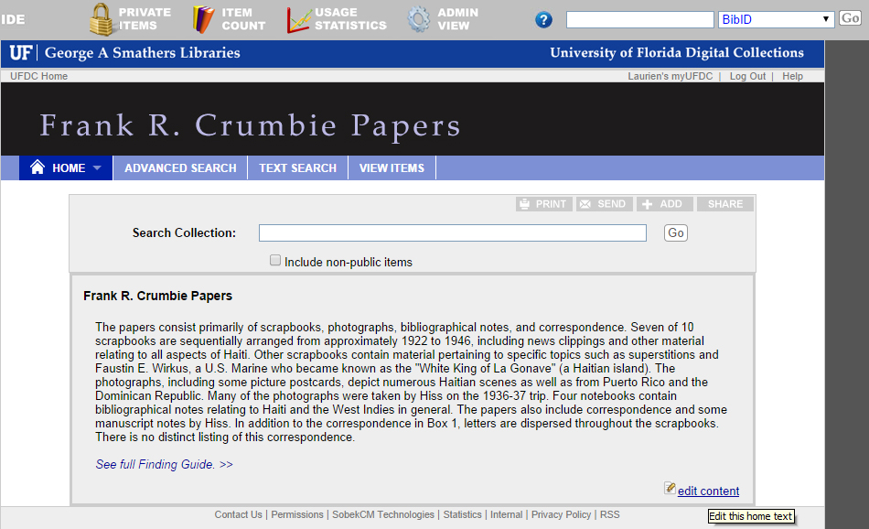
Administrators should go to the new aggregation homepage while logged in, and edit the new homepage text.

To edit the homepage text, hover over the existing homepage to see the “edit content” link, and click the link to edit the content.

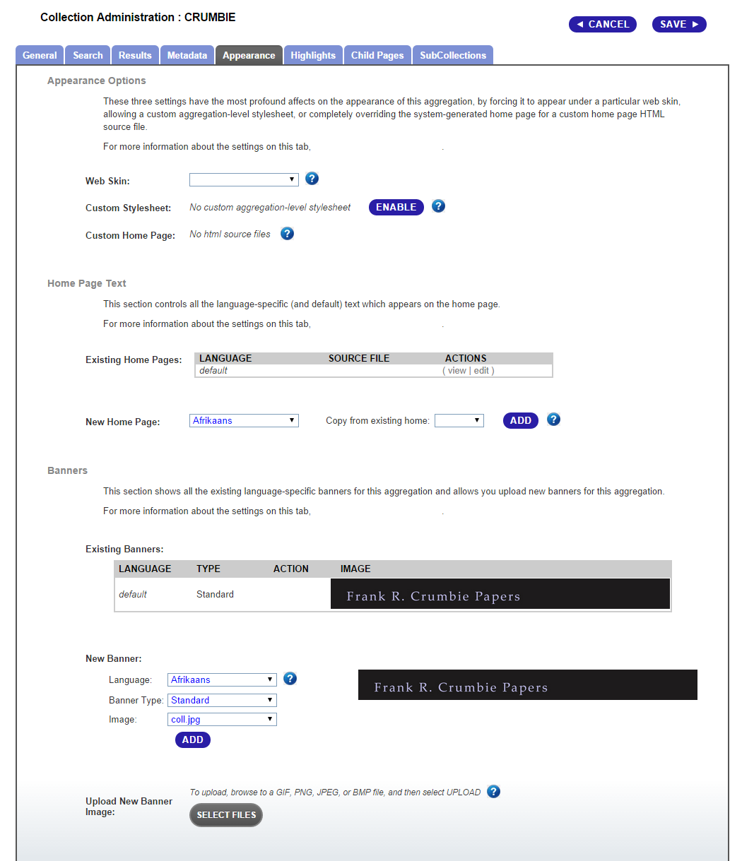
After editing the homepage text, administrators should then select the “Admin View” from the top of the new aggregation page.

This brings up the many options for editing and customizing the aggregation:
- General
- Search
- Results
- Metadata
- Appearance
- Highlights
- Child Pages
- Subcollections

Administrators should select “Appearance” and upload the new banner image for the collection, if available.

If a new banner is not available, the Curator should be asked for the banner, which is recommended to be 900 pixels wide and under 150 pixels tall.

Step 6: Administrators Update Permissions for Collection Management

After creating the aggregation code in SobekCM, updating the initial parts of the new aggregation page and design, the Administrator should update the permissions for the aggregation so that the Curator can make further changes.

For permissions and collection management, Administrators:
- Go “System Administration” and then “Users and Groups”
- Search for the name of the Curator
- Click “edit” next to the Curator’s name
- Check and select on the first “Basic Information” tab, ensure the Curator has any appropriate rights for:
  - Submitting items
  - Being listed as an internal user
  - Templates
  - Default Metadata sets
- Check and select on the “Group Membership” any memberships for the Curator
- Check and select on the “Aggregations” the appropriate rights for the Curator, which may include:
  - On Home
  - Can Select
  - Item Edit Metadata
  - Item Edit Behaviors
  - Item Perform QC
  - Item Upload Files
  - Item Change Visibility
  - Item Can Delete
  - Is Curator
  - Is Admin
- Select “save” to save the changes.

After confirming with the Curator on any others who may need rights as well, Administrators should add appropriate rights for the new aggregation for the others as designated by the Curator.

Step 4: Finalization of New Aggregation Creation

Administrators and Curators finalize the aggregation homepage, banner, and other design and functional elements, where the Curators can see the functional aggregation to easily see changes within this discussion period.

Curators and Administrators also confirm finalization of the initial stage for creating the new aggregation by confirming on updates for any existing items in other digital collections that should be and are not yet in the new aggregation. For instance, the Ethnic Newspapers from Florida Collection (http://ufdc.ufl.edu/ethnicnews) was created to bring together new and many already-digitized items in the new aggregation.

The Administrator should also:

- Contact Cataloging with the Curator copied on the message, to request that the new collection be cataloged as a digital collection
- Refers the Collection Curator to the Curator for Digital Collections to recommend promoting the collection following the standard process: http://ufdc.ufl.edu/AA00013453/00001/pdf

Next Steps and Ongoing Support

Online Presence and Materials

For aggregation design updates to the aggregation home page text and the banner and other elements, Curators contact Administrators for the updates. In the future, more of these updates may be supported with the online tools. Curators contact Administrators to grant additional rights to other users for the collection, make changes, and for any other questions or concerns.

Production

For production processes, all internal users have access to the list of aggregation codes in the system. The process of inputting items into the system and project production workflows includes adding all aggregation codes indicated by the Curator (querying the Curator for the aggregations codes, if needed).

The list of aggregation codes can be sorted by date added (link only viewable with permissions, and when logged in): http://ufdc.ufl.edu/internal/aggregations/list/date

Administrative Tracking of New Aggregations
The Curator for Digital Collections is involved in the creation of any new digital collections for the purposes of tracking the collection codes, curator(s), additional or alternate contacts for aggregations with specific needs, email addresses for reference, rights statements that should be applied at the aggregation level, and any other information at the aggregation level for ongoing needs and future anticipated plans.

The tracking of collection aggregations with basic, core information is a critical need with over 800 active aggregations at UF. All current aggregations can be seen by administrators when logged in with the internal aggregations list (http://www.dloc.com/internal/aggregations/list and http://ufdc.ufl.edu/internal/aggregations/list).

Terminology: Collections and Aggregations
The SobekCM Open Source digital repository software does not overly restrict collections. Instead of a rigid hierarchy with a limited number of levels for nesting collections and subcollections, SobekCM treats all collections as “aggregations.” Aggregations can be understood as being like the way Gmail handles email, with “labels” where items can have many labels and sub-labels. This is instead of how Outlook handles email, with fixed “folders” where items cannot be in multiple folders, unless the folders are nested.

Each aggregation represents a collection grouping at some level, like a label that collects the items together and allows for searching across the collected items. Each aggregation may be called a library, collection, subcollection, or another name as preferred. These are all aggregations and all function the same way, and function consistently in relation to each other, which allows for subcollection-style functionality.

For technological functions, each aggregation does several things:
- Groups materials together in a collection-type structure for ease of cross-searching
- Supports specific searching and advanced searching options for that specific aggregation
- Supports an aggregation home-page or landing page to orient the user, with subpages for additional information and help

There will only be one instance of the digital resource even if they item is present in many aggregations within the system.

See Palmer, “Thematic Research Collections,” http://www.digitalhumanities.org/companion/
See the template for news releases: http://ufdc.ufl.edu/AA00009727/00005/allvolumes and prior news releases: http://ufdc.ufl.edu/sobekcmhelp/results/?t=news%20release
Text adapted from this section: http://sobekrepository.org/sobekcm/concepts/aggregations

