Curatorial Review & Update Tools, within the SobekCM Curator Tools

Overview
The SobekCM Curator Tools include the Curator Dashboard and much more, including the Curatorial Review & Update Tools. The Curatorial Review & Update Tools or Curator Update Tools are specialized tools for reviewing and editing single objects already online within the curator’s digital collection.
The Curator Update Tools support enriched functionality for digital library and collection curators for curatorial control of materials.
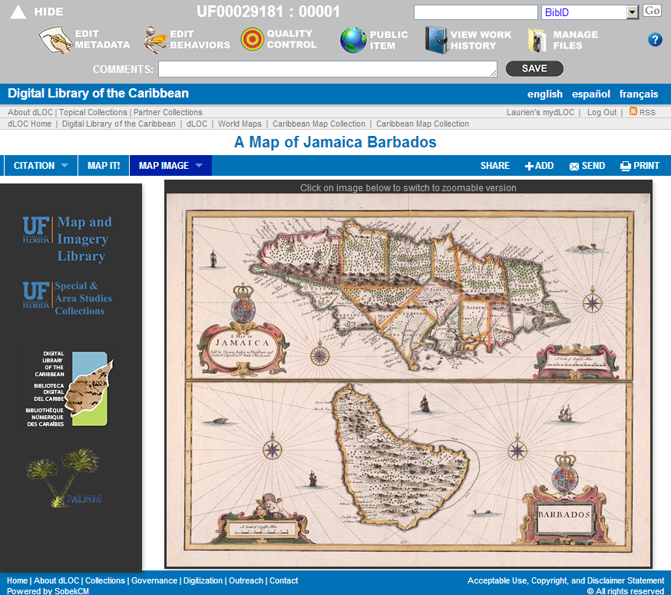
The Curator Update Tools are displayed at the top of any item pages when a curator is logged in SobekCM.
As shown in the image on this page, the Curator Update Tools includes these quick links at the top-most level:
- Hide
- Resource Object ID
- Quick Search
Also, at the next level:
- Edit Metadata
- Edit Behaviors
- Quality Control
- Public Item
- View Work History
- Manage Files
- ? (Help)
And, at the third level:
- Comments

Quick Links for the Curator Update Tools
The Curator Update Tool’s quick-links provide instant access to information frequently needed by curators. The Curator Update Tools are arranged in three levels.

Top Level Quick Links

Hide (and arrow)
The Hide and Arrow quickly hide and unhide the Curator Update Tools for curator ease when showing collections in presentations and in other situations where curators prefer not to display the Curator Update Tools.

Resource Object ID
The Resource Object ID provides the full, unique identifier for the item for ease in reviewing. The Resource Object ID is also known as the BIBID and VID. The first part of the Resource Object ID is clickable, and goes to the editable information for multi-volume items.

Quick Search
The Quick Search offers an easy advanced search with the search options tailored to curator needs.
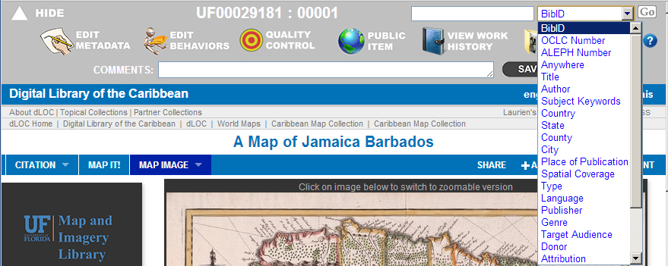

Second-Level Quick Links

Edit Metadata
The Edit Metadata link allows curators to edit metadata online, for instant updates. The standard editing form offers a plethora of supports for metadata editing with many forms and sections for ease in adding structured metadata through a simple web-form.

The standard editing form is a robust, simplified format for items without underlying MARC records. For items without MARC records, curators can click the “full form” link from the top which then transforms the metadata and allows for all granular MARC editing, again using the simplified web form.
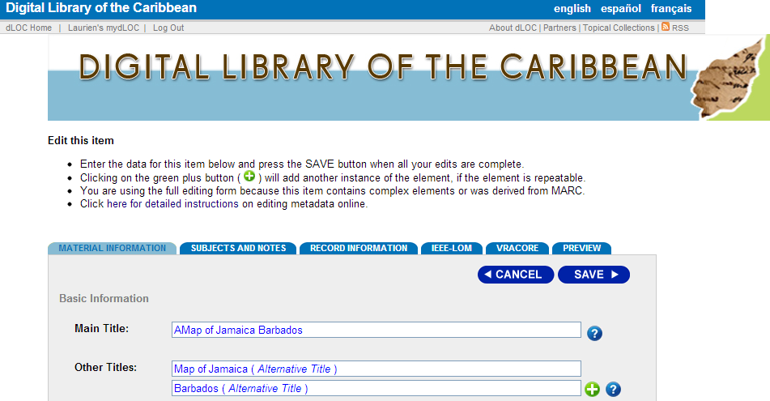

Edit Behaviors
The Edit Behaviors link allows curators to update behaviors which include assigning the preferred thumbnail, assigning and changing collection and aggregation codes, creating serial hierarchy, assigning wordmarks, assigning viewers, and more.
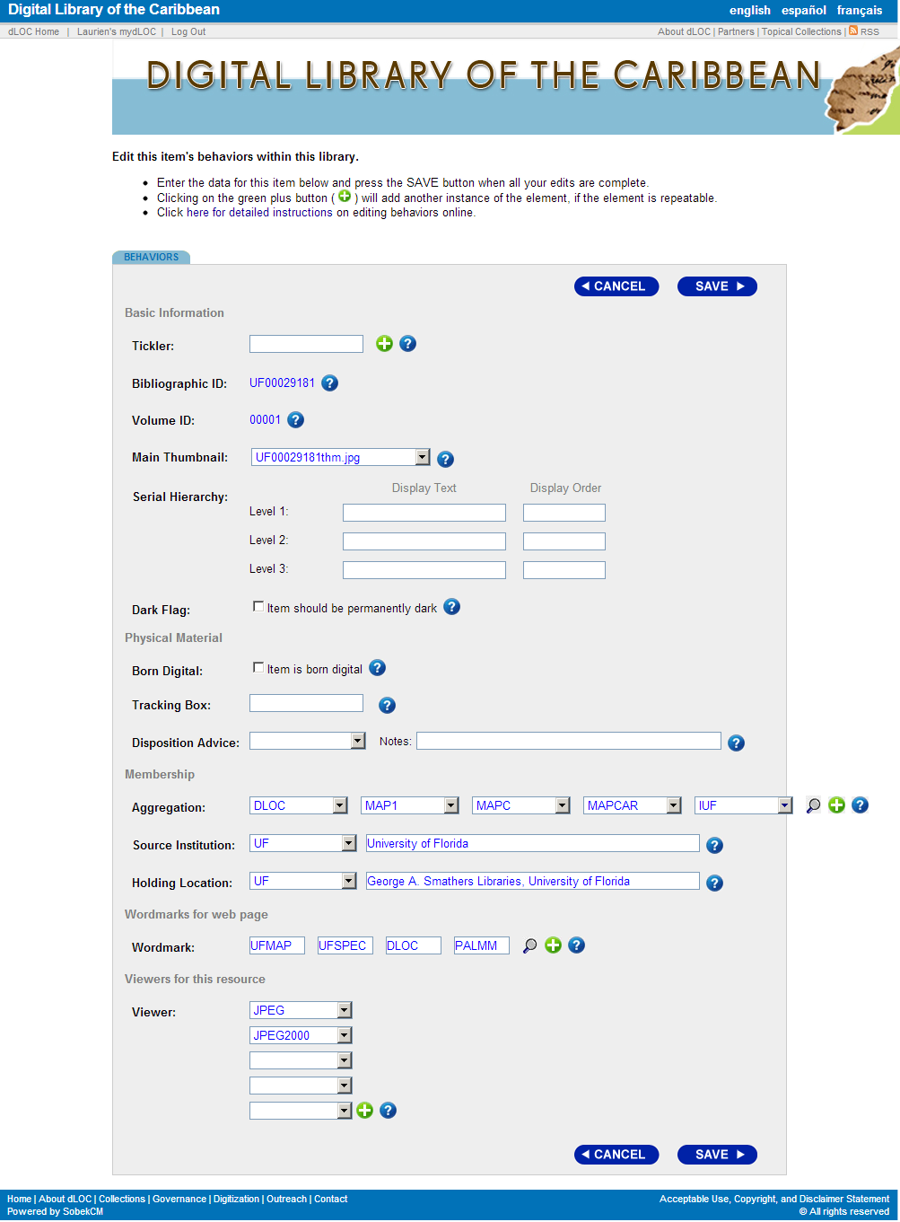

Quality Control
Quality Control allows Curators to review the item, assign pagination and structural metadata (chapter titles and other sections within items), and make various corrections to materials. Quality Control is most often used within production processes, but is also useful for various curator needs.

Public Item
Public Item is actually a range of status possibilities for an item with these options: public, restricted (by IP range), private (for in-process), and delete (for adminstrators only).

View Work History
View Work History allows curators to review the prior work history for an item.
View Work History includes several components, which are:
- Milestones
  - Production milestone information for digitization and digital curation
- History
  - Details on actions, dates, and users
- Media
  - Details on hard media, for items archived to stored media
- Archives
  - Details on digital archiving, for items in digital preservation archiving systems
- Directory
  - Listing of all files for the item with file sizes, type of files, size, and last modified date
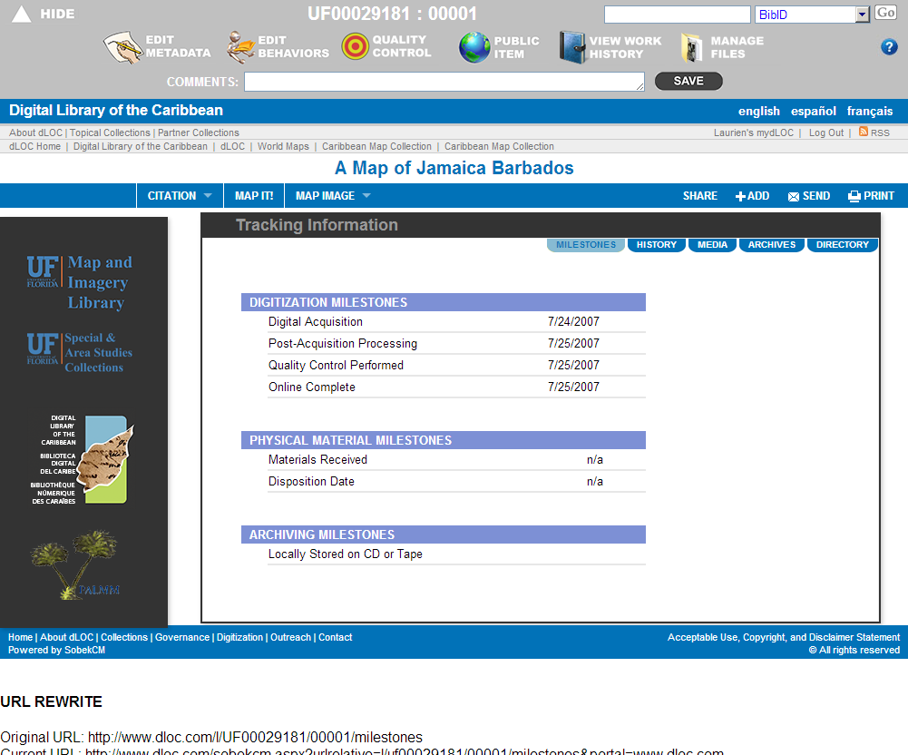

Manage Files
Manage Files allows curators to review files for an item and upload additional files.

Manage Files shows the list of files and allows for more files to be loaded by browsing, selecting, and uploading. Thus, it is as easy as attaching a file to an email:
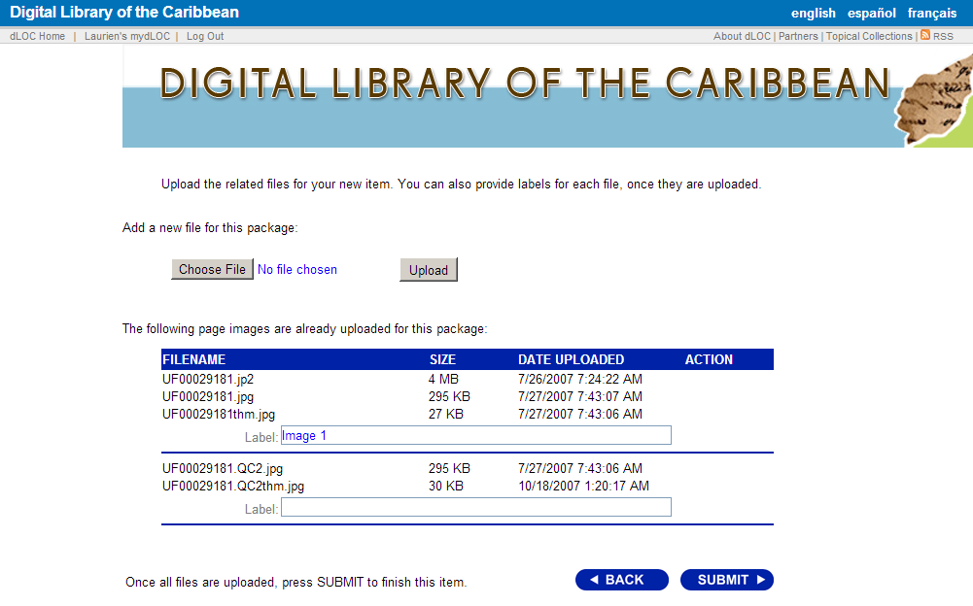

? (Help)
The ? for help links to the main SobekCM Help Pages for quick reference system help.

Third-Level Quick Links

Comments
Comments allow curators to add internal notes and comments for items with an easy form. These are the internal comments that display on the “Private Items” list, which is accessible through the Curator Dashboard.

The bottom, right corner of the text box for Comments can be dragged to increase the text box size. This ensures ease for adding longer comments as well as for shorter comments.

Guide to the SobekCM Curator Dashboard: http://dloc.com/AA00016133/00001/pdf
Administrators can enable the Curator Tools for any user using the SobekCM Administrator Tools; see the SobekCM Administrator documentation and help online: http://ufdc.ufl.edu/adminhelp/tasks
For information on adding additional volumes or items to a resource object, see: http://dloc.com/AA00011590/00001/allvolumes.
For more on metadata editing, see: http://dloc.com/sobekcm/metadata
For the Curator Dashboard and the SobekCM Curator Tools, see: http://dloc.com/AA00016133/00001/pdf.

