Curator Dashboard and the SobekCM Curator Tools

Overview
The Curator Dashboard is part of the specialized SobekCM Curator Tools, which support enriched functionality for digital library and collection curators. The Curator Tools include the Curator Dashboard which has easy access to standard collection information.
The Curator Dashboard is displayed at the top of the collection page when a curator is logged in SobekCM. Administrators can enable the Curator Tools with the Curator Dashboard for any user using the SobekCM Administrator Tools.
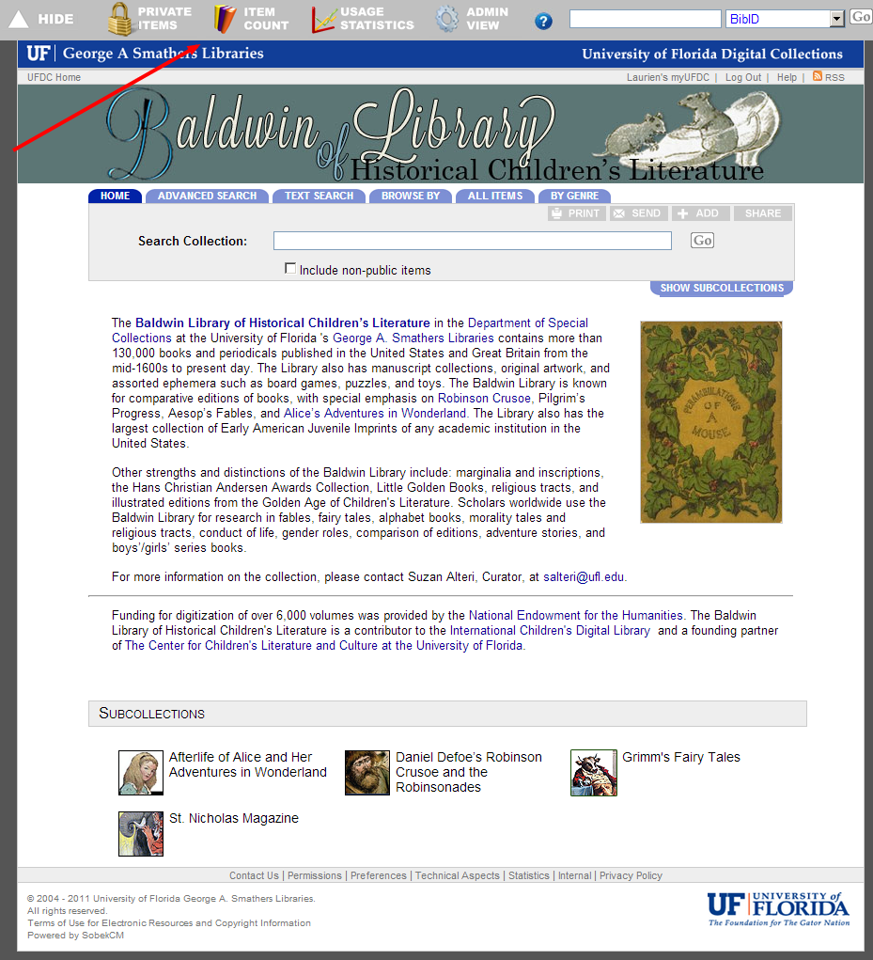
As shown in the image on this page, the Curator Dashboard includes these quick links:
- Hide
- Private Items
- Item Count
- Usage Statistics
- ? (Help)
- Quick Search

Quick Links in the Curator Dashboard
The Curator Dashboard’s quick-links provide instant access to information frequently needed by curators.

Hide (and arrow)
The Hide and Arrow quickly hide and unhide the Curator Dashboard for curator ease when showing collections in presentations and in other situations where curators prefer not to display the Curator Dashboard.

Private Items
Private Items provides the total count and a list of all in-process or “private” items and in-process items. The list is a core tool for Curator project management for production, and for status checks on items that are being digitized.

The Private Items list can be sorted in various ways, including:
- BIBID/VID
- Title/VID
- Last Activity Date (most recent and oldest)
- Last Milestone Date (most recent and oldest)

Item Count
Item Count provides immediate access to statistics (titles, items, pages, and files) for collections, and shows these for the total as well as completed/online and in-process items.
Item Count is another core tool for curators in project management for production, and status check-ins. This is also a core tool for grant and other reports.

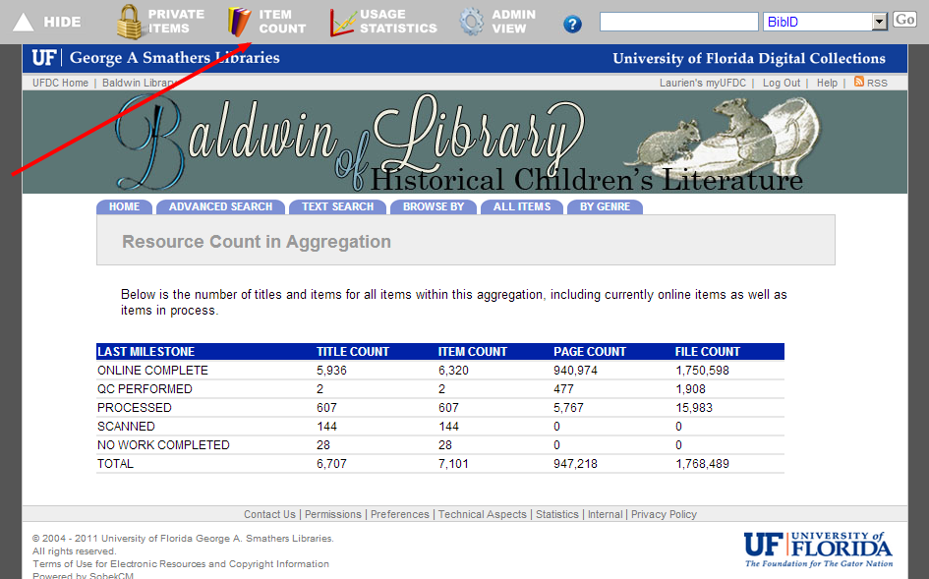

Usage Statistics
Usage Statistics provides easy access to the usage statistics for the collection, with overall usage, as well as breakdowns for different types of usage. Usage Statistics is another core resource for curators in reporting.
“Top Titles” and “Top Items” are frequently used by curators in reporting and collection planning.
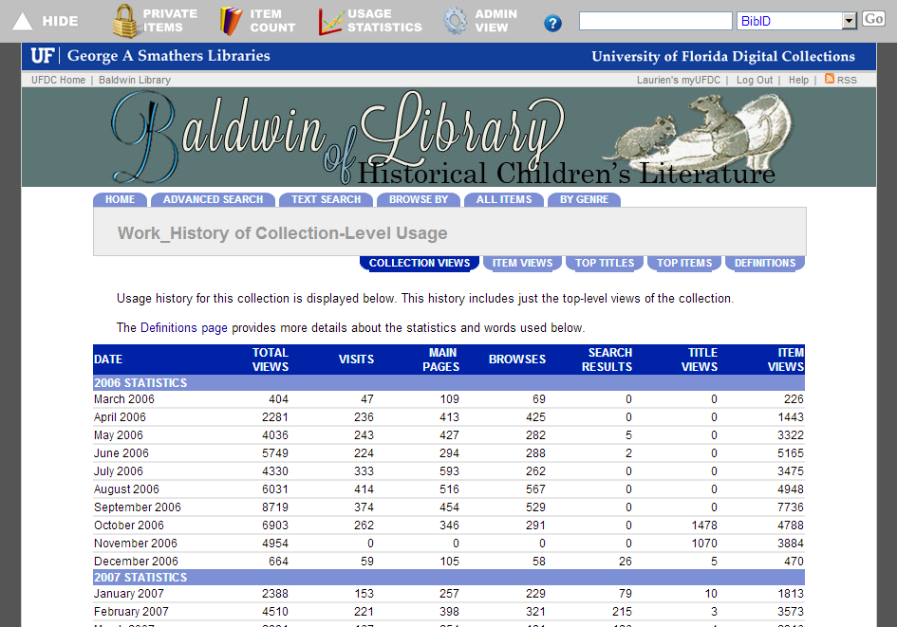
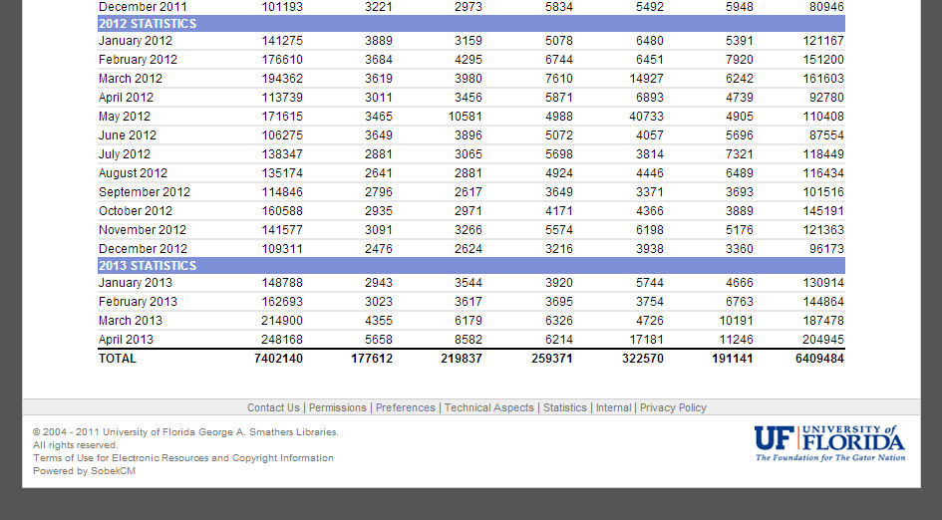

? (Help)
The ? for help links to the main SobekCM Help Pages for quick reference system help.

Quick Search
The Quick Search offers an easy advanced search with the search options tailored to curator needs.
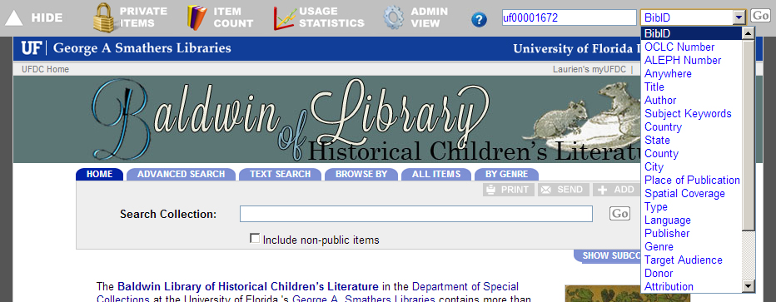

SobekCM Administrator documentation and help online: http://ufdc.ufl.edu/adminhelp/tasks

