Digital Library of the Caribbean (dLOC):
Adding a New Publication as a New Item Record + Excerpt

What is a New Item Record + Excerpt?
In order for an item in a digital library to be findable and usable, the item should be described with information about the item. For a book in a library, this is often done with a catalog record. For an item in a digital library, the item information is also known as a record or more accurately as metadata.
Metadata is data about data, or defined information about a particular thing. Library and museum metadata may look something like this:
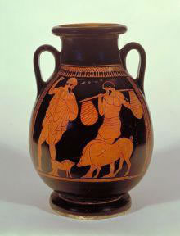 | Format: Greek Vase  Date: 470 - 460 BC  Height: 35 centimeters  Title: [Greek Vase of Odysseus and Eumaiosthe Swineherd]  Notes: from Homer’s story of the Odyssey
The record or metadata described and provides information about the item. The item itself is composed of both the metadata and the digital files. Together, these make up the Resource Object that is usable and useful within a digital library.
The Digital Library of The Caribbean (dLOC) is almost entirely composed of full Resource Objects, with all of the files housed in dLOC.
Record+Excerpt items are also appropriate in some instances. For instance, a librarian at a dLOC Partner institution learns about a new book of poetry that is published in 2013. The librarian is very interested in making sure the book of poetry is preserved and accessible in the future. At the current time in 2013, the author does not yet want the entire book to be available as Open Access, but the author does want to share a chapter or more of the book as Open Access in dLOC. For this, adding a record to dLOC with the substantive excerpt benefits dLOC users and the worldwide community by providing access to information and an excerpt for the new publication.
Records+Excerpts are also important for making information about new publications accessible. It can be difficult even for librarians to find information about books published in various places throughout the world depending on where the book was published, the publisher, whether or not the book had an ISBN, etc. The Record+Excerpt items are useful for creating access to the information about new publications alone. The excerpts provide an added benefit.

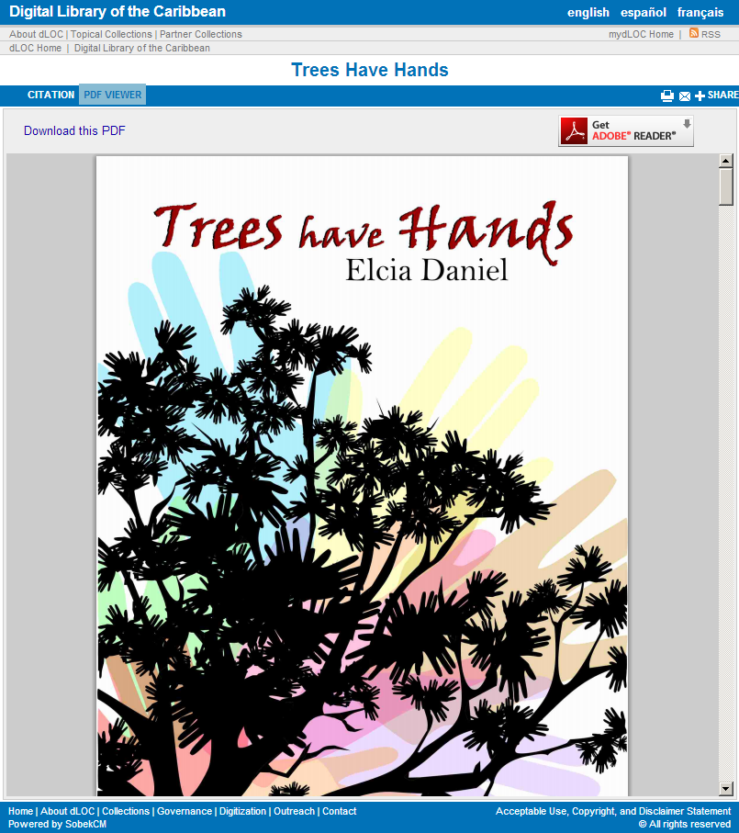
Example
In dLOC, one example of a Record+Excerpt is for a book of poetry: Trees Have Hands (http://www.dloc.com/AA00015948). Trees Have Hands includes a 13 page PDF excerpt of the book with the front and back covers, table of contents, introduction, and selected poems.
In order to best support dLOC Partners, users, and the global public, the record for Trees Have Hands includes a note that this is an excerpt and the records includes information on the full book. The record also includes information on how to acquire the full book.
The Record+Excerpt benefits dLOC users because the record metadata includes sufficient information for users to find it when searching and browsing within dLOC. Thus, the record enables this item to be usable and useful. Also, the record allows readers and book users to find information about the full book, including how to acquire a copy of the book. The record thus supports access to information now in dLOC and future access in dLOC, by supporting current publishing, distribution, and readership models.

Example of a Record+Excerpt: Trees Have Hands (http://www.dloc.com/AA00015948)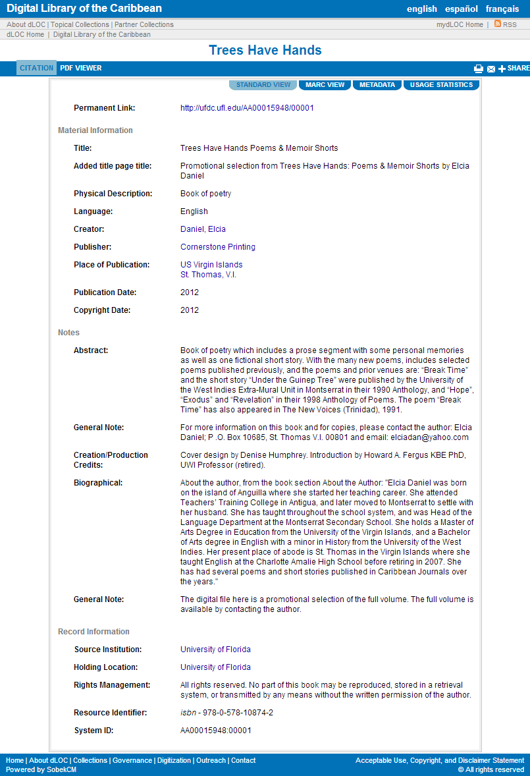
How Do I Create a Record+Excerpt Item?
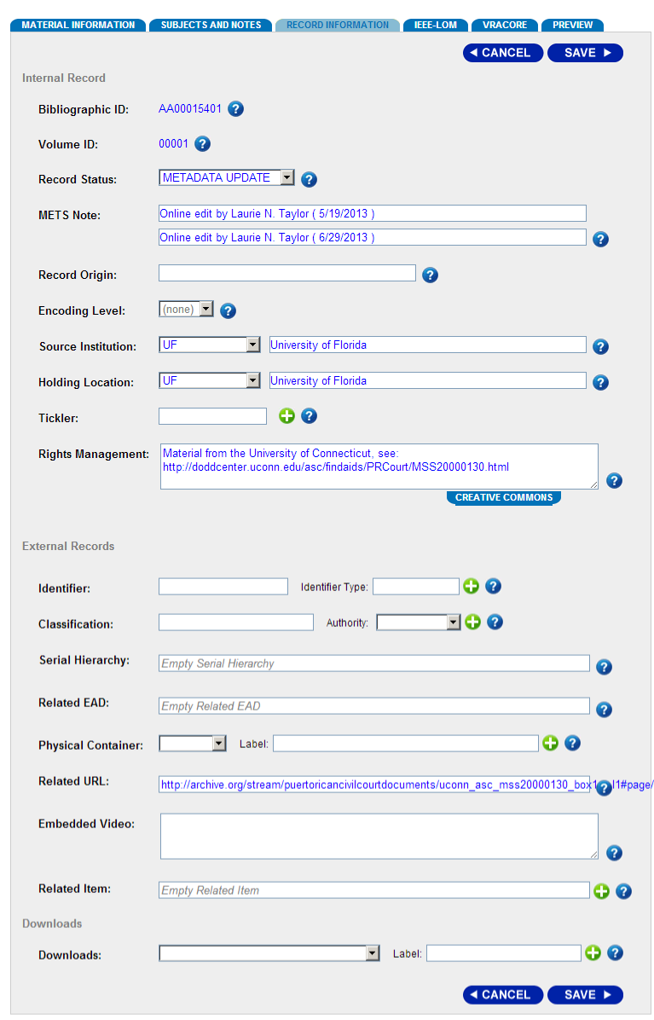
To create a Record+Excerpt, follow the same process as with submitting a new item by logging in to myDLOC, and clicking on the link to “Start New Item”.

The New Item form shows the fields for standard, simple metadata. Complete as much as possible, and click next. The next screen asks you to upload the digital files.

Because this is a record+excerpt, in most cases, you will have the excerpt file to load. Upload those files, and click “Submit”. This brings up the completed item screen.

On this screen, select “View This Item” to return to metadata editing. This is the more expanded metadata form. For Record+Excerpt items, the metadata is especially important, and additional notes to clarify that this is not the full item and notes on how to acquire the full item should be added.

Also, if there is a web address for excerpt files or for the publisher, then this should be added in the “Related URL” field, which is under the third tab, “Record Information,” when editing the metadata.

Recommended Metadata for Record+Excerpt Items
After adding the link to the resources, also make sure to review the metadata to ensure as much information as possible is included.
For all items, the recommended minimum metadata fields to be completed are:
- Title
- Other titles (as applicable)
- Type
- Physical description
- Language
- Identifier (as applicable; e.g., Library of Congress number, ISBN, etc.)
- Holding location
- Source institution
- Creator
- Publisher
- Place of publication
- Date of publication
- Subject
- Spatial subject (as applicable)
- Coordinates (as applicable)
- Abstract
- Note (as applicable)
  - Note that this is an excerpt only, or only a record with a link to the publisher for the excerpt.
  - Note on where or how to acquire a copy of the full item.

For more on these fields, see the dLOC Metadata Guide: http://www.dloc.com/AA00002864/00001/pdf

Quick Guide: http://www.dloc.com/AA00013238/00001/pdf

