User Guide Preparation

Considerations before you start:
- Don’t spend too much time preparing the design. Use a basic template to enter all the information. (see sample Publisher template)
- The trifold is primarily intended to inform readers about how to use the collections. It is not a guide to the collections content.

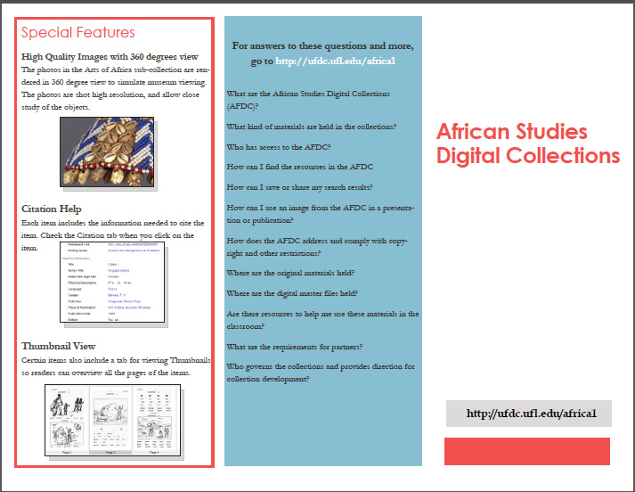
3.
1.
2.
Trifold 3
This if the cover page of the trifold.
- Enter the Title of the Collections prominently
- The link should be prominently displayed at the bottom of the page
- Visual features may include a collage of photos

Trifold 2
Word Count: 100-150 words
- This is the last page that readers will see. Include FAQ’s here. Display the link prominently again.
- The questions may be similar across Collections

Trifold 1
Word Count: Less than 100 words
- Highlight Special Features of the Collections that support users who visit the Digital Collections.
- Sample features you can discuss: Zoom, Metadata, Usage Statistics, Citation Support, Thumbnail View

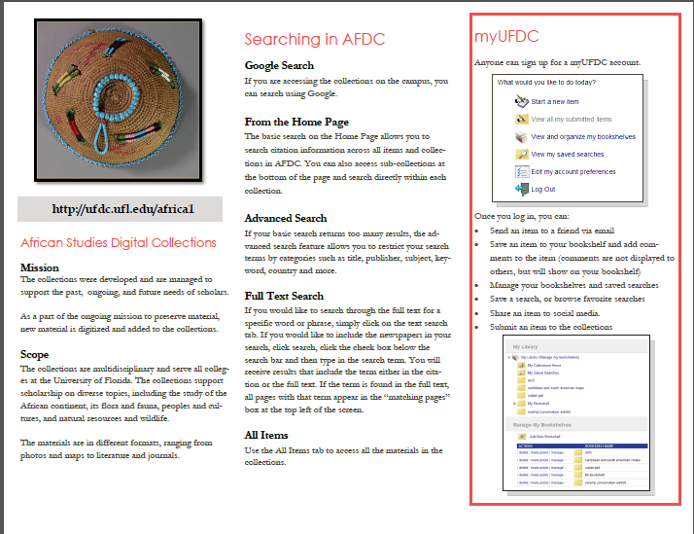
6.
5.
4.
Trifold 4
This will be first page on the inside of the trifold.
Word Count: approx. 100 words (if you include a visual)
- Describe the Mission/Goals of the Collections
- Include a brief Overview of the Collections
- You may also discuss Future Goals
- You may include an image from your collections if there is space.

Trifold 5
These search features may be common to different Collections. In that case, you may use the same content.
Word Count: approx. 200 words (without visuals)
Some suggested search features to highlight:
- Google Search
- From the Home Page
- Advanced Search
- Full Text Search
- All Items

Trifold 6
- Highlight features of the myUFDC/mySOBEK/myDLOC account, or other account used within the Collections interface by users who want to save their searchers, etc.

