**Qualtrics Survey Questions**

**Section 1: Audience**

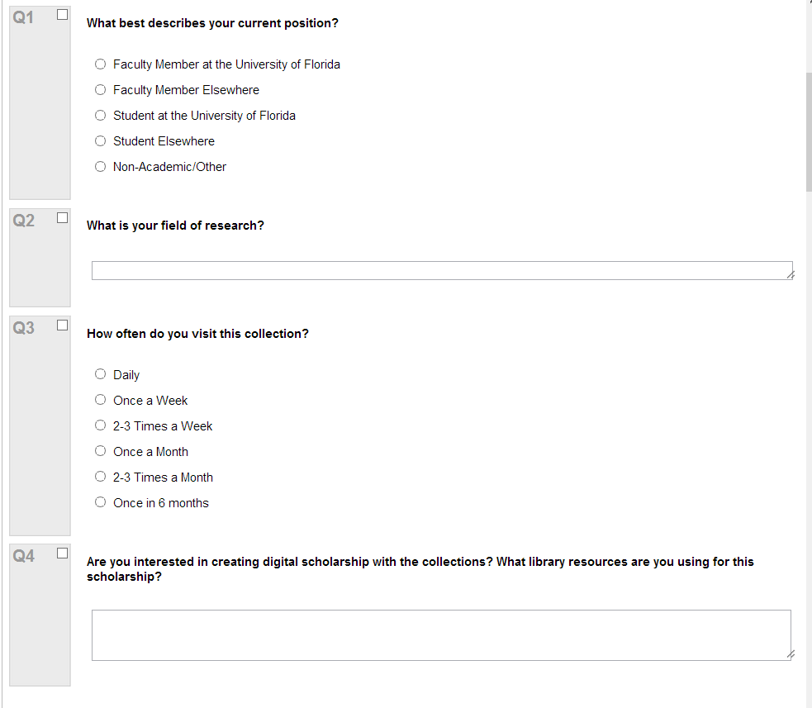

**Section 2: Purpose of Use**

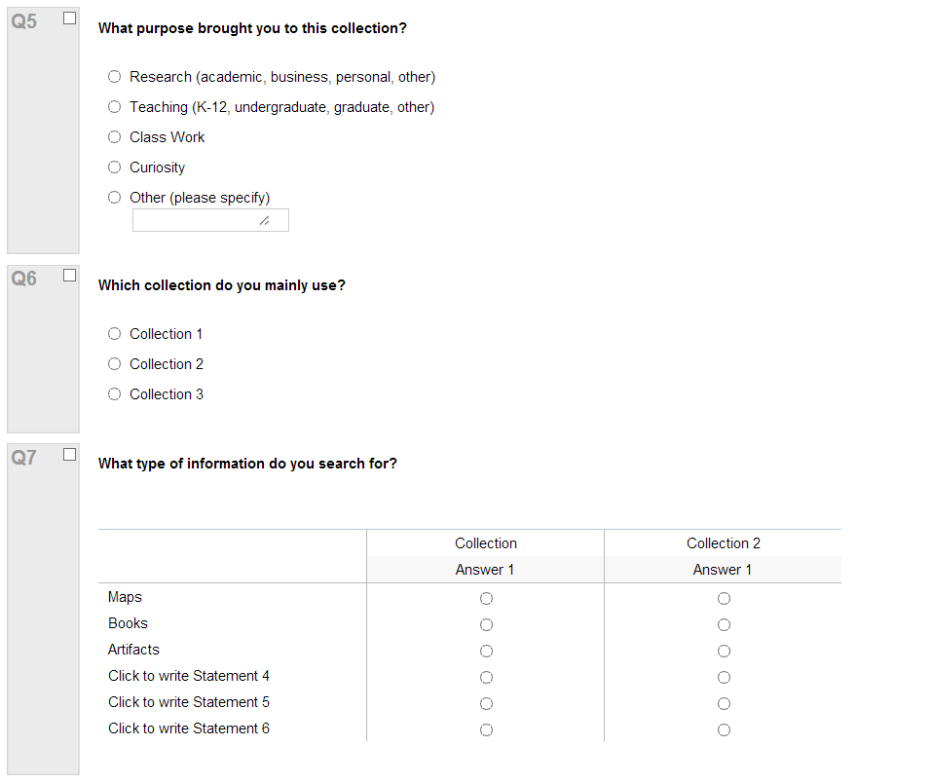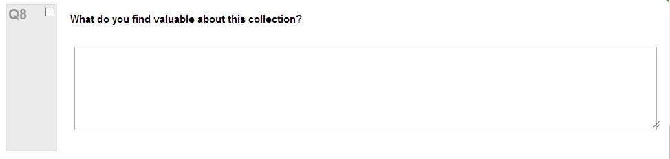

**Section 3: Quality of Service**

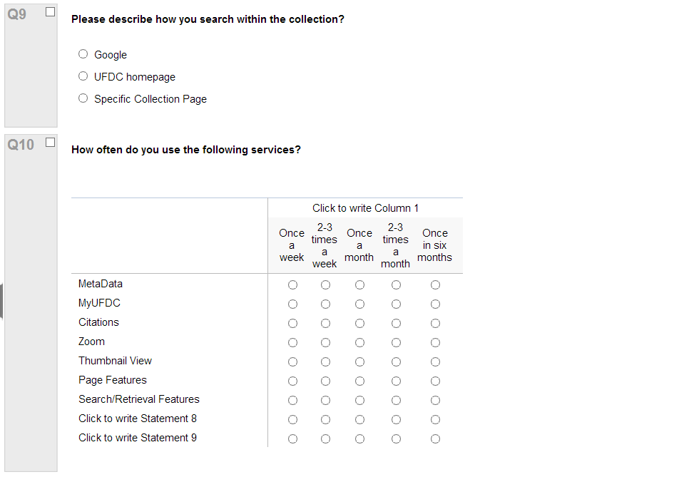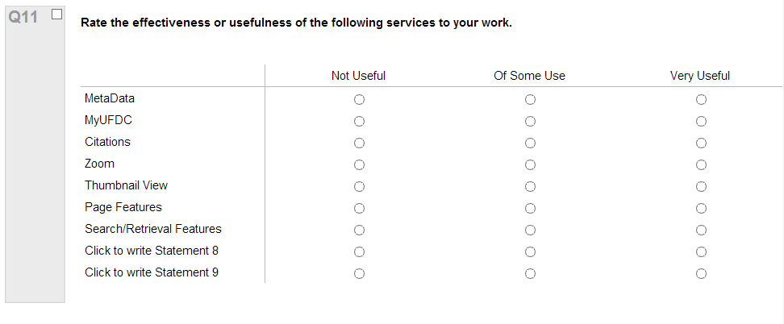

**Section 4: Future Use, Needs, Supports**

