Table of Contents

Abstract

Exhibition Proposal

Introductory Wall Panel

Object Checklist

Object Images

Object Labels

Floor Plan

Layout and Design

3-D Model

Education and Outreach

Aiming and Framing

Frame Quest

Frame the Art Museum

Educational Guide

Press Release

Sources

PowerPoint Presentation

Digital Copy

Credit

Samuel P. Harn Museum of Art
Langley Foyer Exhibition Proposal
Framing the Frame

Abstract

The task of any discussion of frames and framing in the arts is first and foremost to counter the tendency of the frame to invisibility with respect to the artwork. We see the artwork, but we do not see the frame.
-Paul Duro, The Rhetoric of the Frame

The relationship between fine art and framing devices is frequently accepted without critical examination. Picture frames have been in existence for centuries, hugging works of art as they barrier the picture plane from the wall upon which it hangs. Because the traditional frame is common, its presence is often received with little consideration if not dismissed entirely as being trivial to the viewing experience. It is when one questions the reason for frames that the persuasiveness of this device reveals itself. Framing the Frame is an exhibition that will explain how framing influences the ways people understand art.

By inviting viewers to critically engage with various framing methods applied within an art museum, Framing the Frame will draw attention to the importance presentation plays in shaping the societal appreciation for visual art. The exhibition will pose questions such as, “Why do we use frames?”, “How do frames shape the ways we see art?”, and “What are examples of non-traditional frames?” in order to evoke analytical reflection from museum visitors. Through the juxtaposition of conventional and unusual framing displays, curatorial methods will heighten contrasts between exhibits in order to visually reveal specific yet subtle framing suggestiveness. Framing the Frame will also provide visitors the educational opportunity to witness framing techniques in other galleries of the museum in an effort to further identify a wide-range of framing methods. Although Framing the Frame will focus on framing techniques in art museums, the works of art are not the subjects of the exhibition. Complimenting the educational guide that ventures into the rest of the museum, Framing the Frame will exhibit a selection of artworks from every department of the museum in order to demonstrate the various framing practices characteristic of geographic location, time period, and medium.

In the introductory quote, Paul Duro explains that when viewing art, “We see the artwork, but we do not see the frame.” This exhibition invites visitors to experience the frame.

Samuel P. Harn Museum of Art
Langley Foyer Exhibition Proposal
Framing the Frame

Introductory Wall Panel

The task of any discussion of frames and framing in the arts is first and foremost to counter the tendency of the frame to invisibility with respect to the artwork. We see the artwork, but we do not see the frame.
-Paul Duro, The Rhetoric of the Frame

Why do frames matter? The picture frame is a tool that has existed for centuries. Established as a fine art tradition, frames are commonly accepted as devices that make works of art appear more attractive. Yet, frames serve more than a decorative function.

Framing the Frame invites viewers to engage critically with various framing methods within an art museum. From different styles of picture frames to design techniques used for displays, this exhibition outlines the functions of frames as a means of influencing one’s understanding of art. Why do we use frames? How do frames shape the ways we see art? What are examples of non-traditional frames?

The frame serves an important purpose; it becomes a window, through which viewers see art. Framing the Frame will highlight the ways in which frames perform this duty, both within the exhibition and throughout other galleries in the Harn. By drawing attention to the image within, the border of the frame mediates as a boundary between the outside world and art. Museum visitors ignore frames, focusing instead on the works of art they contain. It is time to see the frame.

Samuel P. Harn Museum of Art
Langley Foyer Exhibition Proposal
Framing the Frame

Object Checklist

- Unknown
Copy after Titian’s The Penitent Magdalene
19th Century
Oil on canvas
40 x 30 in. (101.6 x 76.2 cm)
Framed: 55 1/2 x 45 1/2 in. (141 x 115.6 cm)
PA-83-4
Gift of Jeannean Green

- Eugene Atget
France, 1857 – 1927
Rue Boutebrie, Paris
c. 1900
Albumen silver print
8 1/2 x 6 7/8 in. (21.6 x 17.5 cm)
2004.40
Gift of Melvin and Lorna Rubin

- Diane Arbus
American, 1923 – 1971
Child Teasing Another
1960
Gelatin silver print by Neil Selkirk, 1990s
Mat: 20 x 16 in. (50.8 x 40.6 cm)
Image: 8 7/8 x 6 in. (22.5 x 15.2 cm)
2005.42
Museum purchase with funds provided by the Melvin and Lorna Rubin Endowment

- Andy Warhol
American, 1928 – 1987
Soup Can, Vegetarian Vegetable
1964
Silkscreen
Print mark: 32 x 18 3/4 in.
Frame: 41 5/8 x 29 1/4 in. (105.7 x 74.3 cm)
1989.12.1
Gift of Richard Anuszkiewicz

- Campbell’s Vegetable Vegetarian soup can
2011
Aluminum, paper, soup

- Mende people, Southern Sierra Leone
Hammock
c. 1950
Cotton
26 in. x 7 ft. 3 in. (66 x 221 cm)
2002.31.8
Gift of Lewis Berner and family

- Yoshiyuki
Japanese, active late 19th - early 20th century
Vase with Design of Goose by a Stream
Meiji, Meiji period, 1868-1912
Silver, gold, and copper
8 3/8 in. (21.2 cm)
2003.44.1
Museum purchase, gift of Dr. and Mrs. David A. Cofrin with additional funds provided by the David A. Cofrin Art Acquisition Endowment

- Hu Wenming
Chinese, active late 16th - early 17th century
Incense Tool Vase
Ming Dynasty (1368-1644)
7 1/4 x 2 1/2 x 1 3/4 in. (18.4 x 6.4 x 4.4 cm)
Bronze with gilding and inlaid silver wire
2005.21.1
Museum purchase, gift of private donors

- Katsushika Hokusai
Japanese, 1760 - 1849
Okitsu, from an untitled series of views of the Tôkaido Road station
c. 1800
4 7/8 x 6 1/2 in. (12.4 x 16.5 cm)
Color woodcut
PR-00-23
Gift of Rudolph Weaver

- Iatmul people, Papua New Guinea, Korogo village
Canoe Prow
20th century
Wood
39 1/2 x 15 1/4 x 8 in. (100.3 x 38.7 x 20.3 cm)
S85-SPNG-G204
Gift of Dr. Samuel Spring

Samuel P. Harn Museum of Art
Langley Foyer Exhibition Proposal
Framing the Frame

Object Images

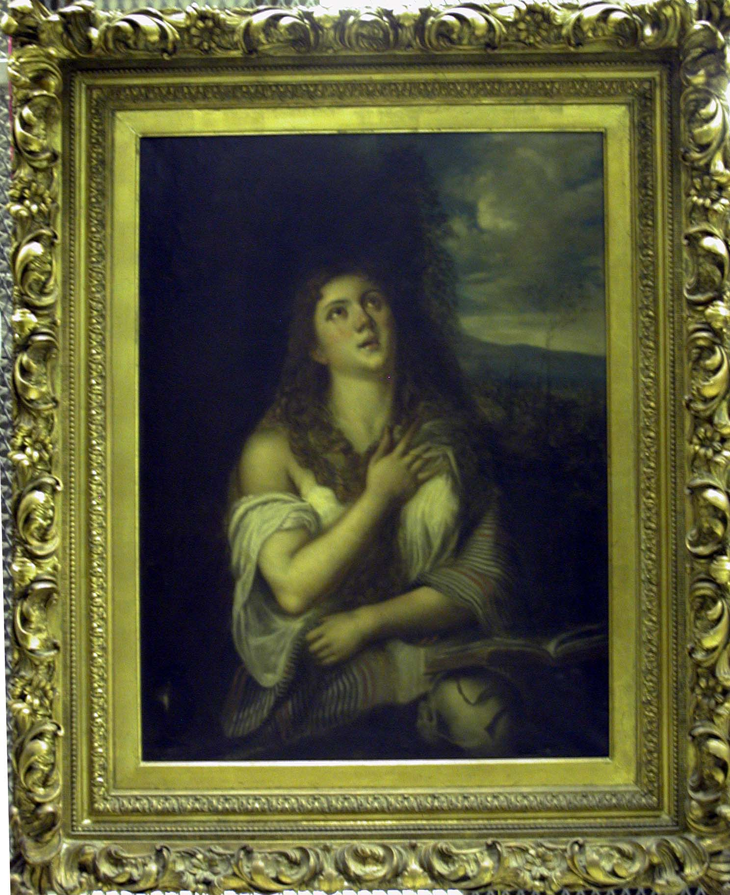

Unknown
Copy after Titian’s The Penitent Magdalene
19th Century
Oil on canvas
40 x 30 in. (framed: 55 1/2 x 45 1/2 in.)
PA-83-4

Framing Method: gilded frame, hang at eye level

Samuel P. Harn Museum of Art, University of Florida, Gainesville; Gift of Jeannean Green
Choice #2:

Charles Henry Passey
British, 1870 – 1885
Wheat Field
1878
Oil on canvas
16 x 24 in. (framed: 21 3/4 x 29 1/2 x 2 in.)
PA-70-65

Choice #3:

Emile Sabouraud
French, b. 1900
Vue sur Dieppe
Oil on canvas
n.d.
17 ½ x 25 in. (framed: 25 3/8 x 33 in.)
1995.5.13

Guidelines:

Modern collection
Oil painting
c. 1900
Gilded frame
Width- 36 in. or less

Samuel P. Harn Museum of Art
Langley Foyer Exhibition Proposal
Framing the Frame

Object Images

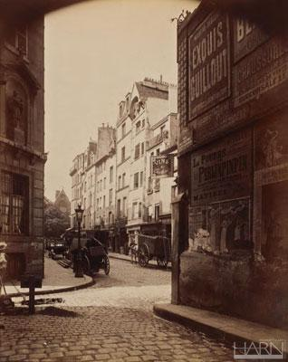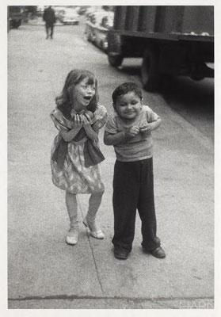

Diane Arbus
American, 1923 – 1971
Child Teasing Another
1960
Silver-gelatin print
20 x 16 in.
2005.42
Eugene Atget
France, 1857 – 1927
Rue Boutebrie, Paris
c. 1900
Albumen silver print
8 1/2 x 6 7/8 in.
2004.40

Framing Method: matted, same frame, hang vertically

Samuel P. Harn Museum of Art, University of Florida, Gainesville; Gift of Melvin and Lorna Rubin
Samuel P. Harn Museum of Art, University of Florida, Gainesville; Museum purchase with funds provided by the Melvin and Lorna Rubin Endowment
Choice #2:

Paula Chamlee
American, b. 1944
Garnet Tucson, AZ 120 #3
c. 1990
Gelatin-silver print
8 x 10 in.
2006.38.3

Choice #3:

Helmust Newton
Australian, b. Germany 1920 – 2004
A Scene from Pina Bousch Ballet
1983
Platinum print
13 x 16 in.
1994.23.8

Guidelines:
Photography collection
Black & white photograph
One early (before 1900) and one modern (after 2000)
Matted
Both in same frame

Samuel P. Harn Museum of Art
Langley Foyer Exhibition Proposal
Framing the Frame

Object Images

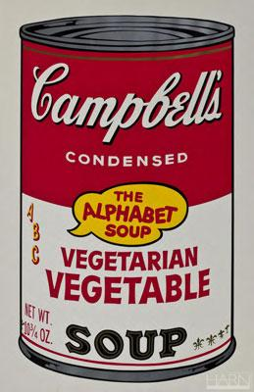

Andy Warhol
American, 1928 – 1987
Soup Can, Vegetarian Vegetable
1964
Silkscreen
32 x 18 3/4 in. (frame: 41 5/8 x 29 1/4 in.)
1989.12.1

Framing Method: matted, framed, hang elevated above eye level

Samuel P. Harn Museum of Art, University of Florida, Gainesville; Gift of Richard Anuszkiewicz
Samuel P. Harn Museum of Art
Langley Foyer Exhibition Proposal
Framing the Frame

Object Images

Campbell’s Vegetarian Vegetable soup can
2011
Aluminum, paper, soup
(Dimensions)

Framing Method: pedestal, vitrine, against wall

Samuel P. Harn Museum of Art
Langley Foyer Exhibition Proposal
Framing the Frame

Object Images

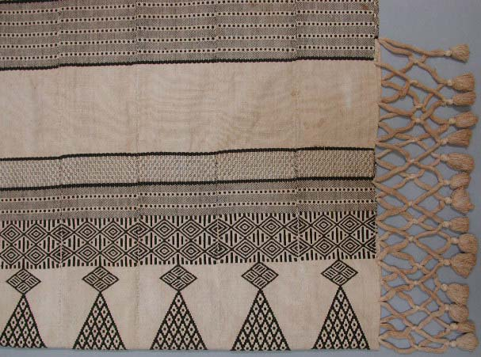

Hammock
Mende people, Southern Sierra Leone
c. 1950
Cotton
26 in. x 7 ft. 3 in.
2002.31.8

Framing Method: object mounted on wall, empty picture frames hanging from ceiling at various heights

Alternative Framing Method: object mounted on wall, Plexiglas in front of object, frame decals on Plexiglas

Samuel P. Harn Museum of Art, University of Florida, Gainesville; Gift of Lewis Berner and family
Choice #1:

Textile – blanket (mens weave)
Benadir
10 ft. 2 in. x 5 ft. 5 in.
T-82-135

Guidelines:

Non-Western mural/narrative/textile
At least 6 feet wide
Unframed

Samuel P. Harn Museum of Art
Langley Foyer Exhibition Proposal
Framing the Frame

Object Images

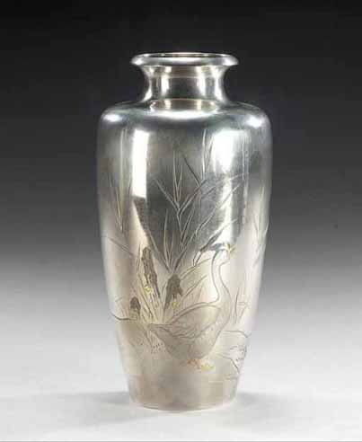

Yoshiyuki
Japanese, active late 19th – early 20th century
Vase with Design of Goose by a Stream
Meiji, Meiji period, 1868 – 1912
Silver, gold, and copper
8 3/8 in.
2003.44.1

Framing Method: low pedestal, tall vitrine

Samuel P. Harn Museum of Art, University of Florida, Gainesville; Museum purchase, gift of Dr. and Mrs. David A. Cofrin with additional funds provided by the the David A. Cofrin Art Acquisition Endowment
Choice #2:

Covered Vase
China
Imperial Qianlong Reign (1736 – 1795),
Attributed to the Qing Dynasty (1644 – 1911)
Nephrite, jade
12 x 7 7/8 x 1 1/2 in.
1987.3.26

Choice #3:

Kozan
Japanese, active late 19th – early 20th century
Vase with Buddhist Symbols
Meiji, Meiji period (1898 – 1912)
Bronze with gilt stand
11 13/16 in.
2003.44.2

Guidelines:

Asian collection
Short height
Visually appealing from top

Samuel P. Harn Museum of Art
Langley Foyer Exhibition Proposal
Framing the Frame

Object Images

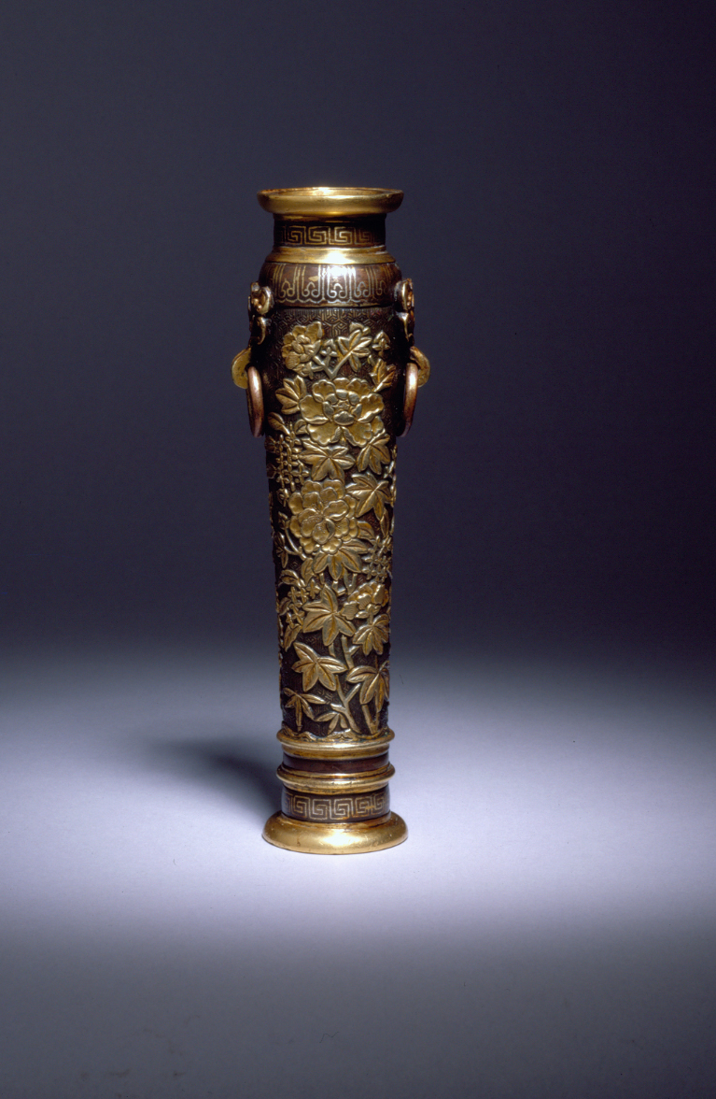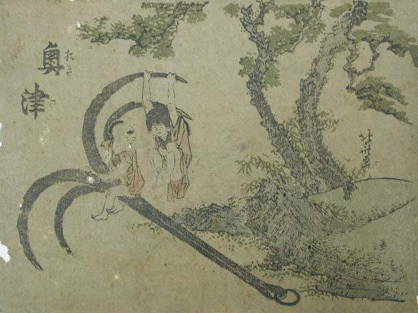
Katsushika Hokusai
Japanese, 1760 – 1849
Okitsu, from an untitled series of views of the Tôkaido Road station
c. 1800
4 7/8 x 6 1/2 in.
Color woodcut
PR-00-23
Hu Wenming
Chinese, active late 16th – early 17th century
Incense Tool Vase
Ming Dynasty (1368-1644)
7 1/4 x 2 1/2 x 1 3/4 in.
Bronze with gilding and inlaid silver wire
2005.21.1

Framing Method: pedestal, vitrine

Samuel P. Harn Museum of Art, University of Florida, Gainesville; Museum purchase, gift of private donors
Samuel P. Harn Museum of Art, University of Florida, Gainesville; Gift of Rudolph Weaver
Samuel P. Harn Museum of Art
Langley Foyer Exhibition Proposal
Framing the Frame

Object Images

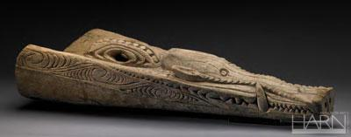

Canoe Prow
Iatmul people, Papua New Guinea, Korogo Village
20th century
Wood
39 1/2 x 15 1/4 x 8 in.
S85-SPNG-G204

Framing Method: pedestal, against wall, object slightly suspended above pedestal

Samuel P. Harn Museum of Art, University of Florida, Gainesville; Gift of Dr. Samuel Spring
Choice #2:

Spear
African, Libera
Wood, metal, cowrie shells, fabric, leather
38 1/4 x 2 3/4 x 2 ¾ in.
1995.28.66

Choice #3:

Bowl
New Guinean, Siassi
c. 1915
Wood
24 1/4 x 8 1/2 x 3 1/2 in.
S85-SPNG-G120

Guidelines:

Oceanic or Pre-Columbian collection
Wide object

Samuel P. Harn Museum of Art
Langley Foyer Exhibition Proposal
Framing the Frame

Object Label Text

- Unknown
Copy after Titian’s The Penitent Magdalene
19th Century
Oil on canvas
40 x 30 in. (101.6 x 76.2 cm)
Framed: 55 1/2 x 45 1/2 in. (141 x 115.6 cm)
PA-83-4
Gift of Jeannean Green

The use of frames in Europe began with small panel paintings in the 12th and 13th century. Initially, the frames and the paintings were made from the same piece of wood. Over time, the more efficient method of the engaged frame emerged. This process attaches wooden custom fit molding to flat wooden panels for the artwork.

Prior to the Renaissance, many frames in Europe were customized architectural elements. During the 14th century, a rise in arts patronage necessitated frames with more portability. The portable, removable frame became an essential component in the display of painting on canvas. Most present-day frames are still based upon this model—a three-dimensional border that accents the artwork it borders.

- Eugene Atget
France, 1857 – 1927
Rue Boutebrie, Paris
c. 1900
Albumen silver print
8 1/2 x 6 7/8 in. (21.6 x 17.5 cm)
2004.40
Gift of Melvin and Lorna Rubin

Diane Arbus
American, 1923 – 1971
Child Teasing Another
1960
Gelatin silver print by Neil Selkirk, 1990s
Mat: 20 x 16 in. (50.8 x 40.6 cm)
Image: 8 7/8 x 6 in. (22.5 x 15.2 cm)
2005.42
Museum purchase with funds provided by the Melvin and Lorna Rubin Endowment
The advent of photography in the late 19th century introduced a new medium for fine art. Museums frame photographs in simple frames regardless of the time period in which the photograph was taken. This presents a contrast to the various frames used for paintings of similar date. How does the style of frame influence the way you see the photograph? If the photographs were placed in carved, gilded frames would it change the way you think about the image?

- Andy Warhol
American, 1928 – 1987
Soup Can, Vegetarian Vegetable
1964
Silkscreen
Print mark: 32 x 18 3/4 in.
Frame: 41 5/8 x 29 1/4 in. (105.7 x 74.3 cm)
1989.12.1
Gift of Richard Anuszkiewicz

Contemporary art challenges the need for frames. Some works benefit from a frame’s appearance while others bypass the use of frames entirely. Pop art collapses the space between everyday life and art. It often uses commercial imagery as social commentary. Andy Warhol is known for his “factory” that produced hundreds of controversial silkscreened works. Warhol’s Soup Can, Vegetarian Vegetable is both matted and framed. Does the frame intensify or weaken the commercialism of the image? Does it make the image a work of art? Notice how this painting has been hung high in the “skyed” position. By elevating Soup Can, Vegetarian Vegetable in contrast to the surrounding artwork, it disrupts the harmony of the wall.

- Campbell’s Vegetable Vegetarian soup can
2011
Aluminum, paper, soup

Does displaying an object in an art museum automatically make it a work of art? Warhol changed the relationship between popular culture and art. Here the exhibition questions the connections between an infamous painting and the original object it depicts. By framing this common object behind glass in a museum, how are your perceptions of the can confronted? Does this juxtaposition influence you to think differently about the Warhol painting?

- Mende people, Southern Sierra Leone
Hammock
c. 1950
Cotton
26 in. x 7 ft. 3 in. (66 x 221 cm)
2002.31.8
Gift of Lewis Berner and family

What happens when decorated materials like canvas, wood, or paper are unframed? It simply becomes an object with a decorated surface. A picture frame hides the edges of such materials and disguises the fact that the image is applied to an object. Why then are the edges of this textile exposed? What kinds of objects are unframed?

These frames draw attention to specific parts of the textile. Frames create visual borders. The borders cut off the lines, colors, patterns, and textures of the painting, as well as help focus attention on the enclosed spaces.

- Yoshiyuki
Japanese, active late 19th - early 20th century
Vase with Design of Goose by a Stream
Meiji, Meiji period, 1868-1912
Silver, gold, and copper
8 3/8 in. (21.2 cm)
2003.44.1
Museum purchase, gift of Dr. and Mrs. David A. Cofrin with additional funds provided by the David A. Cofrin Art Acquisition Endowment

Museums generally show objects at eye level. This case’s altered proportions subvert viewer expectations by creating a new visual experience. Is it worse? Is it better?

- Hu Wenming
Chinese, active late 16th - early 17th century
Incense Tool Vase
Ming Dynasty (1368-1644)
7 1/4 x 2 1/2 x 1 3/4 in. (18.4 x 6.4 x 4.4 cm)
Bronze with gilding and inlaid silver wire
2005.21.1
Museum purchase, gift of private donors

Katsushika Hokusai
Japanese, 1760 - 1849
Okitsu, from an untitled series of views of the Tôkaido Road station
c. 1800
4 7/8 x 6 1/2 in. (12.4 x 16.5 cm)
Color woodcut
PR-00-23
Gift of Rudolph Weaver

Display cases work the same way as picture frames by creating a discrete space for images. Placing these two objects together creates a single image that imposes a relationship on them. Would such a relationship exist if they were in separate display cases?

- Iatmul people, Papua New Guinea, Korogo village
Canoe Prow
20th century
Wood
39 1/2 x 15 1/4 x 8 in. (100.3 x 38.7 x 20.3 cm)
S85-SPNG-G204
Gift of Dr. Samuel Spring

The edges of a pedestal restrict the area surrounding an object and create a frame for it. This display creates a visual tension by allowing the object to leave its designated space and intrude upon the viewers’ space. How does this display violate the idea that frames form boundaries?

Samuel P. Harn Museum of Art
Langley Foyer Exhibition Proposal
Framing the Frame

Langley Foyer Floor Plan

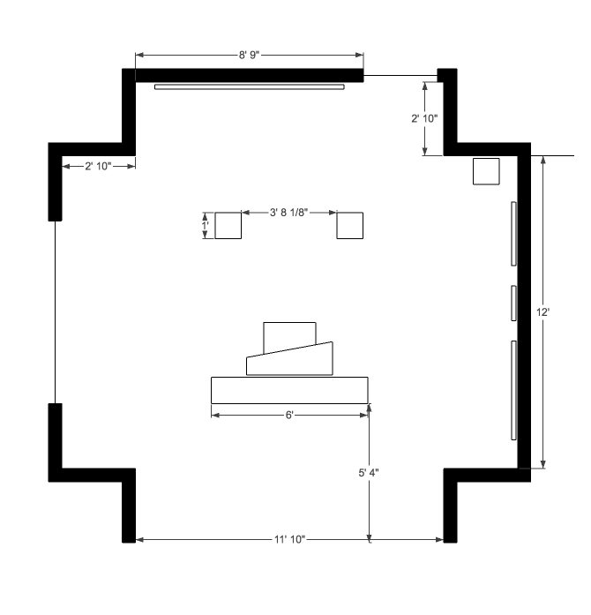

Samuel P. Harn Museum of Art
Langley Foyer Exhibition Proposal
Framing the Frame

Langley Foyer Layout and Design

- Unknown
Copy after Titian’s The Penitent Magdalene
PA-83-4

- Eugene Atget
Rue Boutebrie, Paris
2004.40

Diane Arbus
Child Teasing Another
2005.42

- Andy Warhol
Soup Can, Vegetarian Vegetable
1989.12.1

- Campbell’s Vegetarian Vegetable soup can
Aluminum, paper, soup

- Mende people, Souther Sierra Leone
Hammock
2002.31.8

- Yoshiyuki
Vase with Design of Goose by a Stream
2003.44.1

- Hu Wenming
Incense Tool Vase
2005.21.1

Katsushika Hokusai
Okitsu, from an untitled series of views of the Tôkaido Road station
PR-00-23

- Iatmul people, Papua New Guinea, Korogo Village
Canoe Prow
S85-SPNG-G204

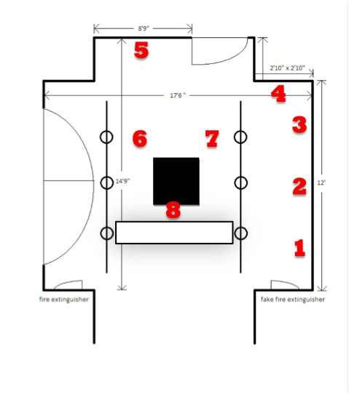

Samuel P. Harn Museum of Art
Langley Foyer Exhibition Proposal
Framing the Frame

3-D Model of Layout

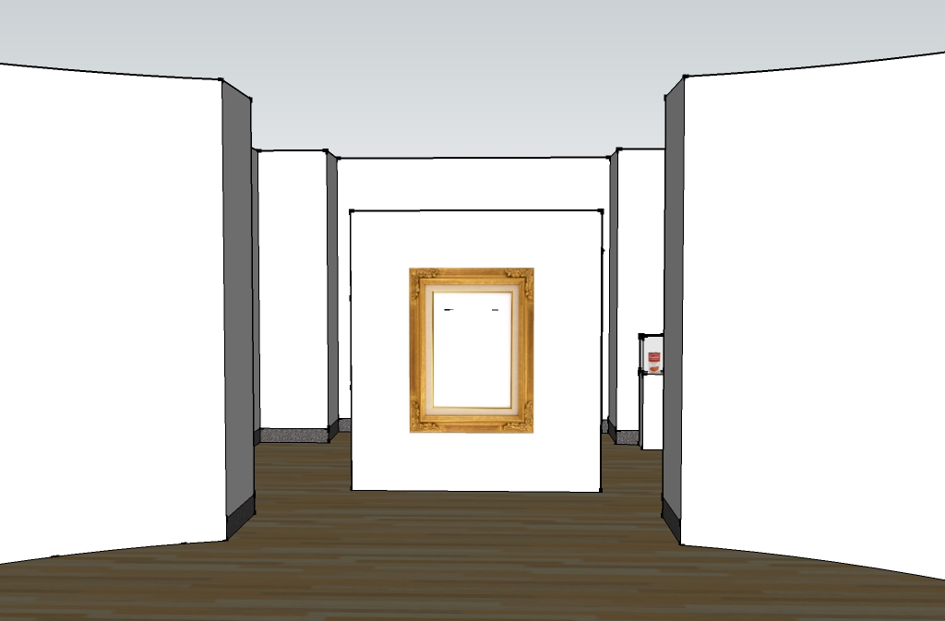

Samuel P. Harn Museum of Art
Langley Foyer Exhibition Proposal
Framing the Frame

3-D Model of Layout

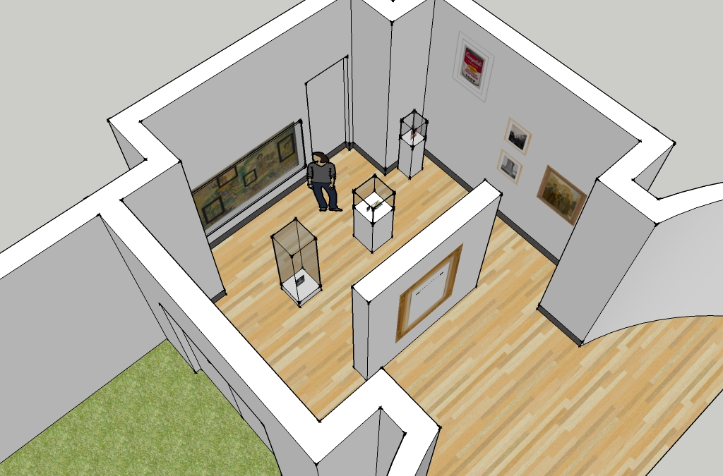

Samuel P. Harn Museum of Art
Langley Foyer Exhibition Proposal
Framing the Frame

3-D Model of Layout

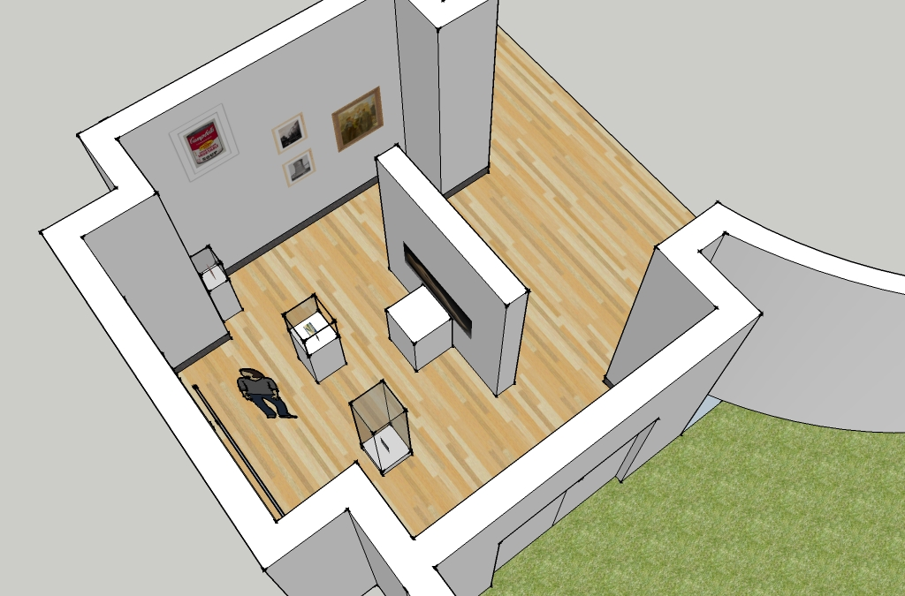

Samuel P. Harn Museum of Art
Langley Foyer Exhibition Proposal
Framing the Frame

3-D Model of Layout

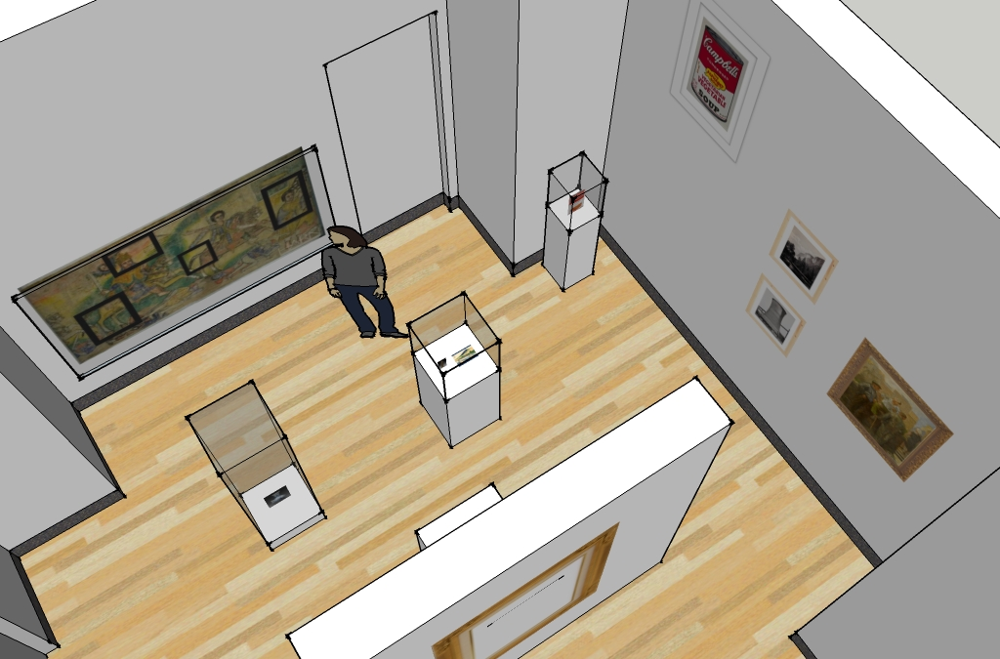

FOR IMMEDIATE RELEASE

April 20, 2011

Framing the Frame Exhibition to Open at the
Samuel P. Harn Museum of Art

Graduate students in the University of Florida’s Museum Studies program created and designed a new exhibition for the Langley Foyer at the Harn Museum of Art.

GAINESVILLE, Fla.-- The relationship between fine art and framing devices is frequently accepted without serious examination. In an exhibition created and designed by University of Florida Museum Studies graduate students, Framing the Frame will invite visitors of the Samuel P. Harn Museum of Art to engage critically with the use of frames in art museums.

Picture frames have been in existence for centuries, hugging works of art as they barrier the picture plane from the wall upon which it hangs. Because the traditional frame is common, its presence is often received with little consideration if not dismissed entirely as being trivial to the viewing experience. It is when one questions the reason for frames that the persuasiveness of frames reveal themselves.

Framing the Frame will draw attention to the importance presentation plays in shaping the societal appreciation for visual art. The exhibition will pose questions such as, “Why do we use frames?”, “How do frames shape the ways we see art?”, and “What are examples of non-traditional frames?” in order to evoke analytical reflection from museum visitors. Through the juxtaposition of conventional and unusual framing displays, curatorial methods will heighten contrasts between exhibits in order to visually reveal specific yet subtle framing suggestiveness.

Located in the Langley Foyer, a small gallery space attached to the Harn’s rotunda, Framing the Frame will also provide visitors the opportunity to witness framing techniques in other galleries of the museum. Interactive educational activities such “Aiming and Framing” and “Frame Quest” suggest visitors discover framing devices that could not be shown in the petite Foyer. Unlike most art exhibitions, the specific works of art are not the main subjects of the Framing the Frame. Rather, the exhibition highlights historical and curatorial art presentation decisions that influence public understanding of art. Framing the Frame will exhibit a selection of artworks from every department of the Harn museum in order to demonstrate the various framing practices characteristic of geographic location, time period, and medium.

The mission of the Harn Museum is to “promote the power of the arts to inspire and educate people and enrich their lives.” The museum is located on the west side of the University of Florida’s main campus at SW 34th Street and Hull Road. The museum offers free admission, and is open Tuesday - Friday 11 a.m. - 5 p.m., Saturday 10 a.m. - 5 p.m., and Sunday 1 - 5 p.m. For more visitor information, please visit the Harm Museum of Art’s website at www.harn.ufl.edu, or call the visitor services information line at (352) 392-9826.
Sources

Bailey, W. H. Defining Edges: A New Look at Picture Frames. New York: Harry N. Abrams, Inc., 2002.

Derrida, Jacques. The Truth in Painting. Trans. Geoff Bennington and Ian Macleod. Chicago: University of Chicago Press, 1987.

Duro, Paul, ed. The Rhetoric of the Frame: Essays on the Boundaries of the Artwork. New York, Cambridge University Press, 1996.

Greenberg, Reesa, Bruce W. Ferguson, and Sandy Nairne, eds. Thinking about Exhibitions. New York: Routledge, 1996.

Oberhardt, Suzanne. Frames within Frames: The Art Museum as Cultural Artifact. Washington, D.C.: Peter Lang Publishing, Inc., 2001.

Putnam, James. Art and Artifact: The Museum as Medium. New York: Thames & Hudson, 2009.

Savedoff, Barbara E. “Frames.” The Journal of Aesthetics and Art Criticism 57.3 (Summer 1999): 345-356.

Tate Britain. “Frame Conservation.” Tate Online. 19 April 2011. http://www.tate.org.uk/conservation/frames.

Wilner, Eli, ed. The Gilded Edge: The Art of the Frame. San Francisco: Chronicle Books, 2000.

