OVERVIEW OF CARIFESTAS THEMES & LOGOS 1972 – 2013

FESTIVAL | YEAR | HOST COUNTRY | THEME | LOGO
CARIFESTA I | 1972 | GUYANA | The Artist in Society with Special Reference to the Third World | 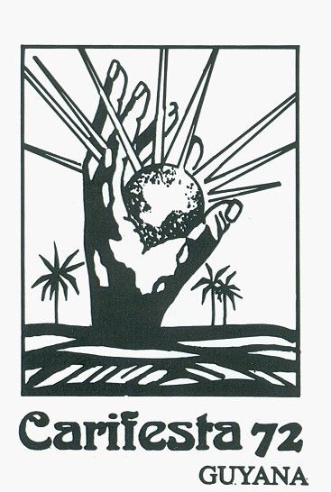
CARIFESTA II | 1976 | JAMAICA | A Hallmark of Cultural Extravaganza | 
CARIFESTA III | 1979 | CUBA | A Rainbow of Peoples Under One Caribbean Sun | 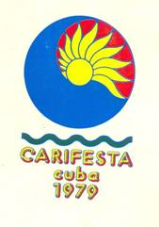
CARIFESTA IV | 1981 | BARBADOS | Living Images of the Sun | 

FESTIVAL | YEAR | HOST COUNTRY | THEME | LOGO
CARIFESTA V | 1992 | TRINIDAD AND TOBAGO | Together is Strength | 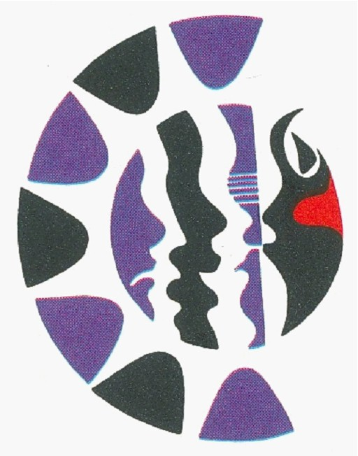
CARIFESTA VI | 1995 | TRINIDAD AND TOBAGO | The World’s Best Cultural Mix
CARIFESTA VII | 2000 | ST.KITTS AND NEVIS | Caribbean Arts and Culture…Reflecting, Consolidating,  Moving On | 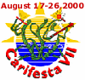
CARIFESTA VIII | 2003 | SURINAME | Many Cultures: The Essence of Togetherness of  Togetherness - The Spirit of the Caribbean | 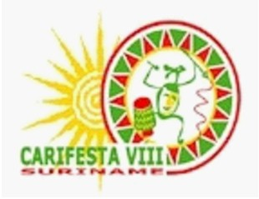

FESTIVAL | YEAR | HOST COUNTRY | THEME | LOGO
CARIFESTA IX | 2006 | TRINIDAD AND TOBAGO | Celebrating our People, Contesting the World Stage | 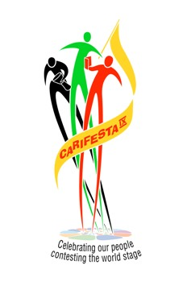
CARIFESTA X | 2008 | GUYANA | One Caribbean, One Purpose -  Our Culture Our Life | 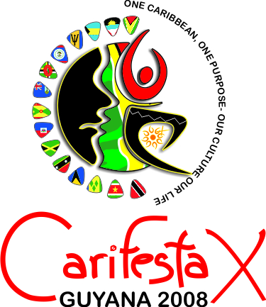
CARIFESTA XI | 2013 | SURINAME | Culture for Development: Celebrating our Diversity and Promoting the Central Role of Culture in Economic, Social and Human Development | 

