Additional File 6:
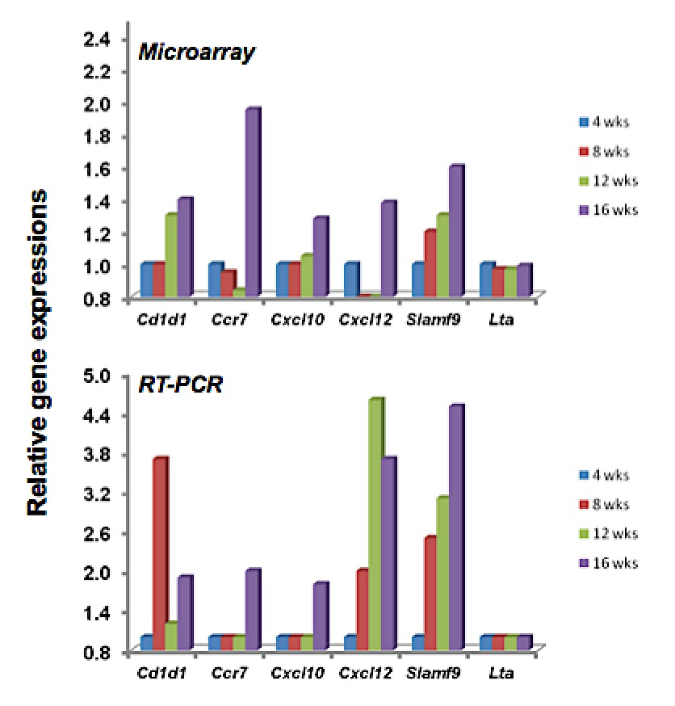

Verification of selected gene expression
Previous verifications of microarray gene expression data using randomly selected genes have been carried out using semi-quantitative polymerase chain reaction (RT-PCR) analysis [34, 35], quantitative real-time PCR (rt-PCR) analysis [35, 36], and comparative microarray analyses using SABioscience arrays [37]. These analyses have provided excellent correlations. To verify a set a selected gene expressions (n=7), aliquots of salivary gland RNA originally used for the microarray data were pooled, then prepared as described elsewhere [36]. Each cDNA preparation was quantified by spectrophotometry and PCR performed. Quantifications were determined by ImageJ. Relative gene expression values yielded by the PCR arrays are compared directly with data yielded by the Affymetrix 3’ Expression Array GeneChip Mouse Genome 430 2.0 arrays. Pooling RNA from each time point prior to cDNA preparation is thought to be the underlying reason for higher transcript detection in a couple of RT-PCR reactions, e.g., in Cxcl12 samples.

