ARL Position Description Bank (ARL PD Bank): User Guide
Table of Contents
Introduction 3
Permissible Use and Appropriate Data 3
Contact Information 4
User Accounts 5
Log On 5
Lost Password 6
Searching 9
Basic Search 9
Advanced Search 9
Search Results 11
Customizing the View 13
Sorting Results 14
Exporting Data 15
Adding a New Position 16
Standard Data 16
Institution-Only Data 17
Attach Documents 18
Submit a Position 20
Viewing and Maintaining a Position 20
Actions Sidebar 22
View Position 22
View Position History 23
Edit Position 24
Delete Position 25
Add New Position 26
Duplicate Position 26
Forwarding Documents 26
Send an Email to the Institution 28
My Positions 31
My Employees 32
Customizing the View 34
Sorting Results 34
Exporting Data 34
Adding a New Employee 35
Submit a New Employee 35
Assign Employee to a Position 36
Viewing and Maintaining an Employee 36
Institutional Administration 39
Institutional Administration 39
Review Pending User Registrations 40
View Institutional Users 43
Institutional Options / Questions 45
Adding New Questions and Editing Questions 48
Institution-Only File Types 52
My Employees Module 54

Introduction
The Association of Research Libraries Position Description Bank (ARL PD Bank) is a collection of position descriptions (PDs) from major academic and research libraries. The ARL PD Bank fosters the sharing of information through a browseable and searchable database that provides access to a collection (or bank) of PDs throughout Canada and the United States. The ARL PD Bank supports the management of PDs for individual institutions, providing an effective organizational method and system that supports findability as well as archiving for long-term digital preservation.
The ARL PD Bank is accessible online: http://www.uflib.ufl.edu/arlpdbank
Background:
The ARL PD Bank was developed based on specifications determined by Library Personnel Officers through focus groups and other feedback channels. The ARL PD Bank provides a more useful source for current PDs and will depict the evolution of positions, and library functions and services as reflected over time in the PDs.
The opportunity:
Perhaps the most common collaboration between personnel officers from different academic libraries is the sharing of position descriptions. This is usually initiated by a request for samples over an electronic mailing list. The responses are 'hit or miss' and not often distributed to the whole list, and neither the responses nor the requests are archived. Additionally, library human resources management staff spends a considerable amount of effort managing (archiving, locating, and retrieving) and distributing position descriptions. These documents serve as important elements of effective human resources management and are only useful if maintained, organized and accessible. Techniques for and effectiveness in managing these documents vary from institution to institution.

Permissible Use and Appropriate Data
We value individuals’ privacy and actively seek to preserve privacy.
Though the ARL PD Bank is secure, access is restricted, data and documents are encrypted and only very limited data is available to those outside of the individual institutions, submitted data and documents must not include:
- Social Security Number or the comparable
- Driver's license number, alien registration number, passport number, etc.
- Bank account, credit or debit card information
Further, institutions should review position descriptions and any other documents that will be accessible by other ARL PD Bank institutions to ensure they do not include other personal identifiers, such as employee names, home contact information, and complete birth dates.

The ARL PD Bank is hosted by the George A. Smathers Libraries at the University of Florida, with all data and system security complying to the UF IT Data Security Standard. Please contact us should you have any questions or concerns regarding this.

Contact Information
For assistance or any questions, please contact:
ARL PD Bank Team: arlpdbankhelp@uflib.ufl.edu or 352-273-2595.
Brian W. Keith (brikeit@uflib.ufl.edu; 352.273.2595), Associate Dean for Administrative Services and Faculty Affairs, University of Florida George A. Smathers Libraries. Responsible for overall project direction, implementation, and high-level coordination of the UF Leadership Team, ARL Project Liaison, and Contributors.
Bonnie J. Smith (bonniesmith@ufl.edu; 352.273.2595), Assistant Program Director, Human Resources, University of Florida George A. Smathers Libraries. Responsible for engagement with ARL Personnel Officers. Primary coordinator and director for all communication with ARL Personnel Officers for focus groups, surveys, communications, and evaluations.
Dr. Laurie N. Taylor (laurien@ufl.edu; 352.273.2902), Digital Humanities Librarian, University of Florida George A. Smathers Libraries. Responsible for analysis, synthesis, and translation of user needs into technical specifications and requirements. Supports system usability, creation and refinement of documentation for technical and user needs, gathering user feedback, user testing, and user training.
Mark V. Sullivan (marsull@uflib.ufl.edu; 352.273.2907), Head, Digital Development and Web Services, University of Florida George A. Smathers Libraries. Responsible for all technical aspects of the system development. Assists in user training to ensure the technical strength and ease of use for all tools and technologies.

User Accounts

Log On
After registering (contact arlpdbankhelp@uflib.ufl.edu ) and once your user account is activated, log on by entering your account Username or associated Email address, and your ARL PD Bank Password.
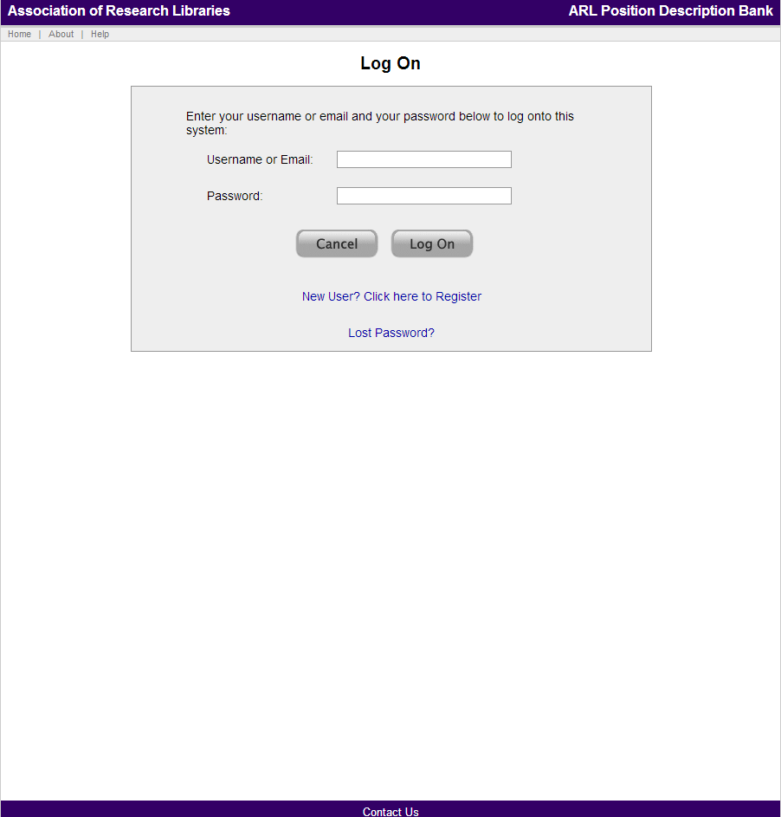
After successfully logging on, the screen colors will update to colors for your institution and the name of your institution will appear in the top left corner of the screen.
The Welcome or Home page for the ARL PD Bank includes the following tabs:
- Basic Search
- Advanced Search
- Add New Position
- My Positions
- My Employees (for institutions that have elected to use the My Employees module)
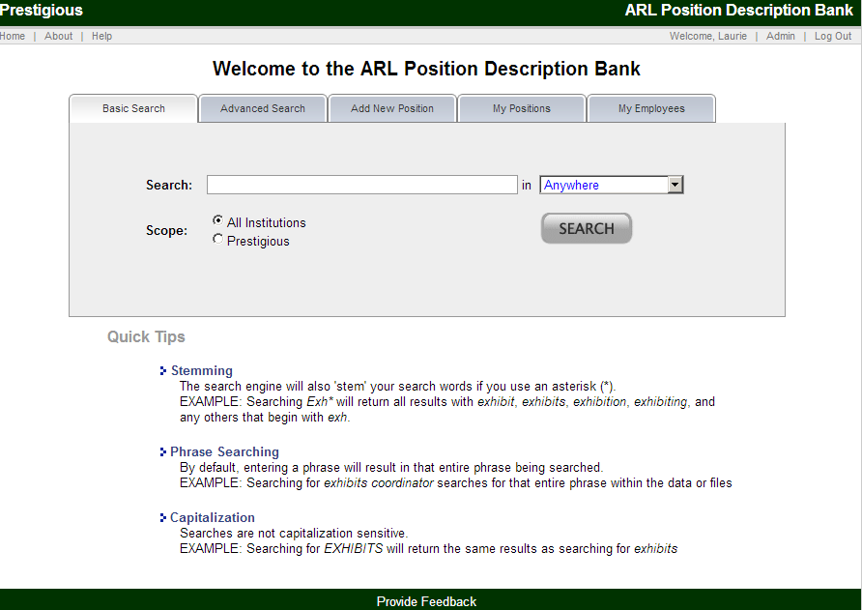

Lost Password
After you have created an account, if you lose your password, go to the ARL PD Bank and select the “Lost Password?” link which is below the login portion of the main screen.

Clicking on the lost password link takes you to the lost password screen which is shown below.
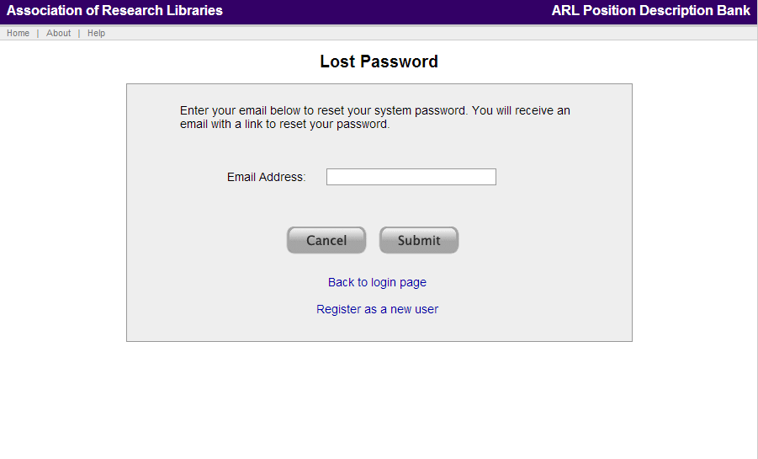
Once you enter your email address, you will receive an email message from ARLPDBankHelp@uflib.ufl.edu stating:
We received a request to reset your password for the Association of Research Libraries [ARL] Position Description Bank. This request was submitted via our online system.
This password reset request will be valid for the next 24 hours.
To reset your password, please select the link below:
CUSTOM LINK FOR EACH PASSWORD REST
You will be taken to a page which will allow you to enter a new password for your account.
Feel free to respond directly to this email if you have any questions about this request or the process
- ARL PD Bank Team
After clicking on the link in the email message, you will see the Reset Password screen, which is shown below.
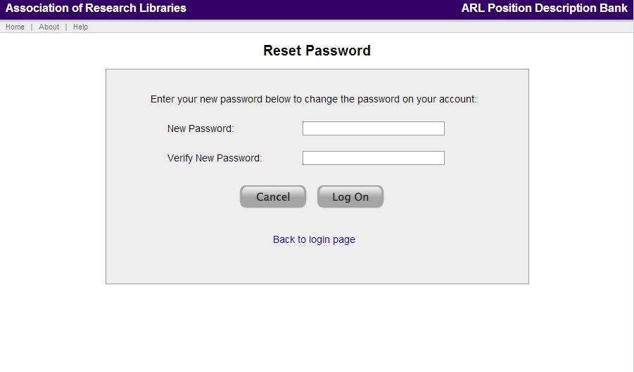
After entering your new password, and entering again to verify, you will be logged in and redirected to the ARL PD Bank system main page.

Searching
The ARL PD Bank allows you to search the records and/or submitted documents (e.g., position descriptions, vacancy announcements, etc.).

Basic Search
The Home page for the ARL Position Description Bank (shown below) is the Basic Search tab.
The default Basic Search is for all records and all institutions. This Scope can be narrowed to your institution in the search Scope field.
The Basic Search is driven by keyword(s) entered into the text box. This search by default will look for instances of the word(s) Anywhere in Record – all submitted data and all documents. By clicking on the drop-down to the right of the text box, you can change this selection to one of the standard data fields or your optional Institution-Level data fields, if applicable.

Advanced Search
By clicking on the Advanced Search tab, the full advanced search screen is displayed:
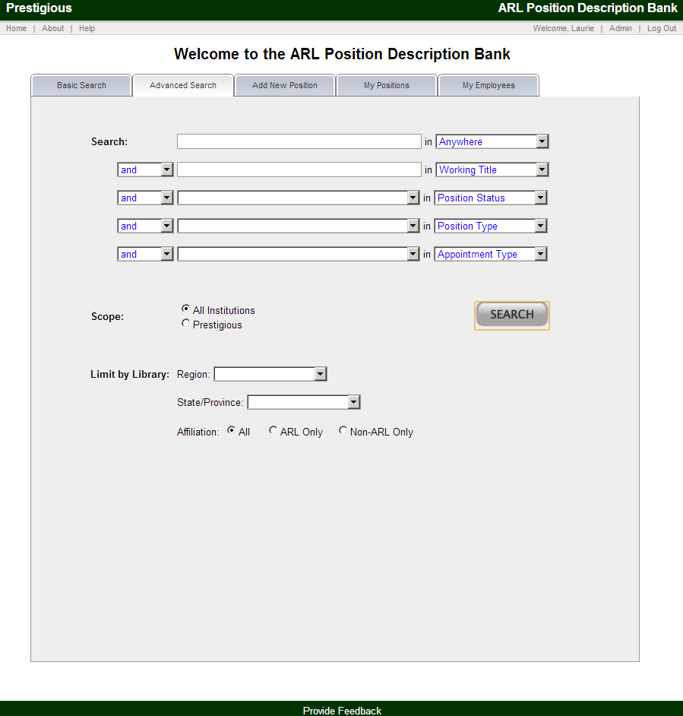
The Advanced Search extends the functionality found in the Basic Search by allowing you to add multiple search criteria. Additionally, you may filter search results by institutional characteristics such as Region, State/Province, and/or ARL membership.
Example Advanced Search
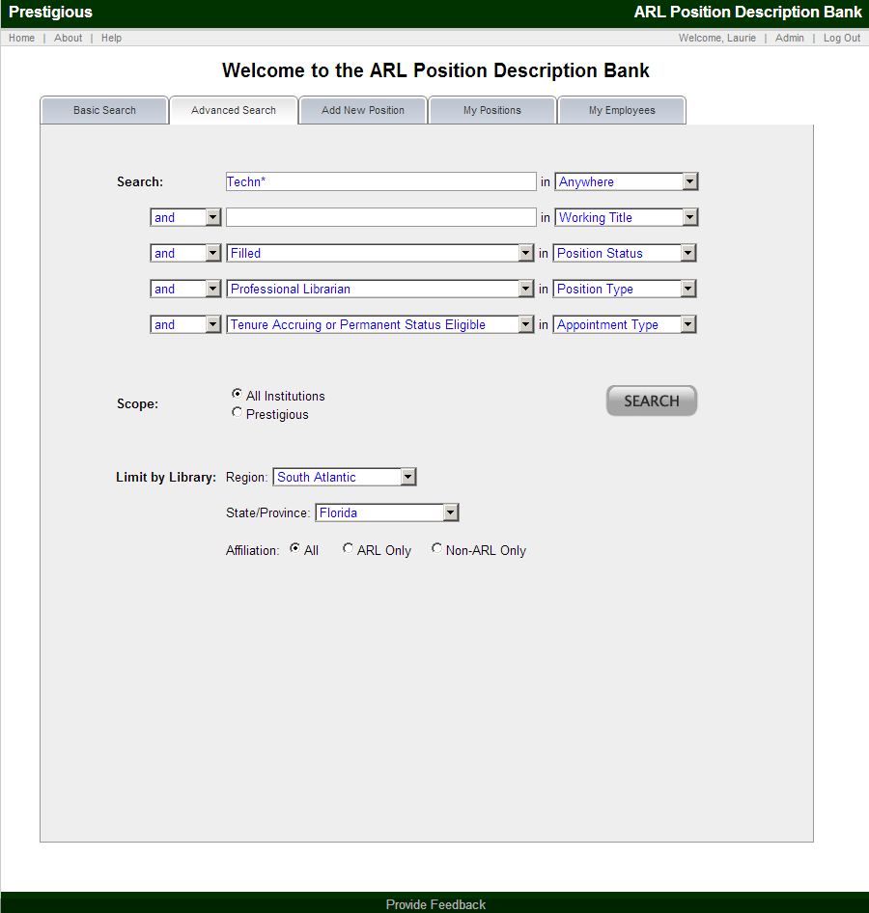

Search Results
Regardless of the search type (Basic or Advanced), the search results are depicted in a standardized screen. An example of search results is shown below:
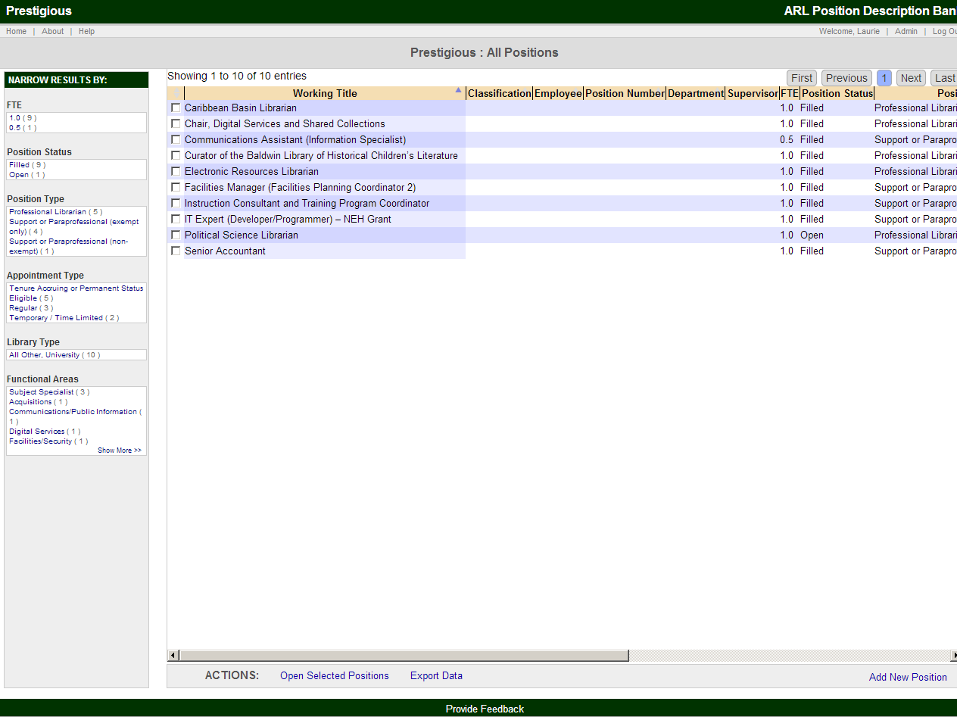
The search results screen is comprised of a number of elements. Each is described in turn in the following section.
- Search Terms:
  - Top of page
  - Shows current search terms and allows you to remove any of your current search terms
- Narrow Results By (search facets):
  - Left panel
  - The facets allow you to narrow your search while you are in the search results screen
- Search results:
  - Middle of screen
  - Displays list of all the matches to your search criteria in the form of a sortable table with customizable columns (see Customizing the View below)
  - Clicking on a single position will open the position, where you can view all the data and documents. Checkboxes next to each of the results allow you to select a number of positions and perform the actions listed at the bottom of the page (see next section)
- Actions:
  - Bottom of page
  - The Actions bar allows you to perform actions against any selected positions in the results pane which have been selected
  - Actions include: Open Selected Positions and Export Data
    - Open Selected Positions opens the selected positions in separate windows. (Please note that your browser’s pop-up blocker may prevent these windows from opening. You can change in your browser preferences to accept pop-ups from the ARL PD Bank.)
    - Export Data opens the full search result in an XLS Excel file.

Customizing the View
The table headers can be adjusted to increase or decrease the column width. The order of the columns can also be changed by clicking and dragging column headers.
Default and Reordered Columns
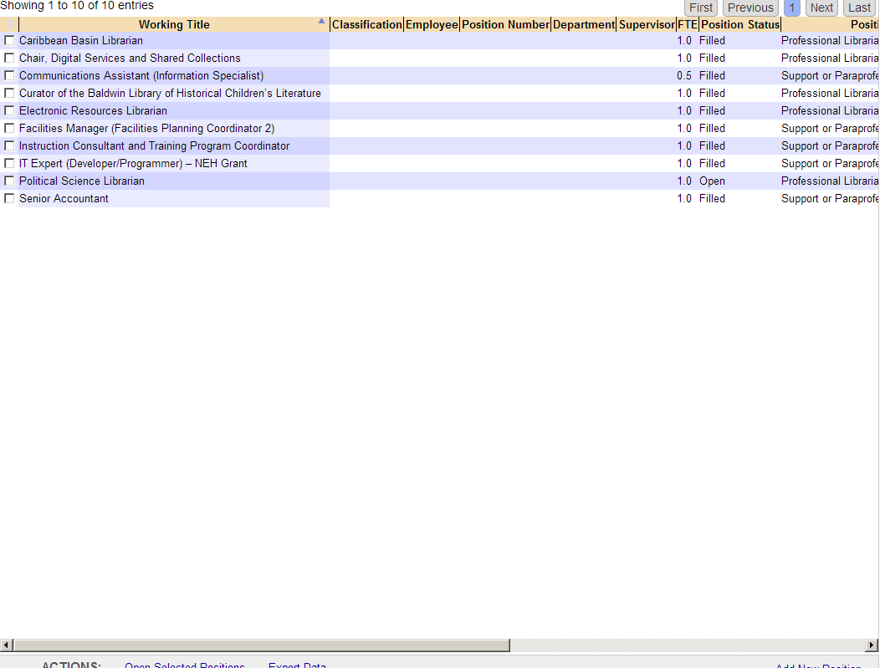
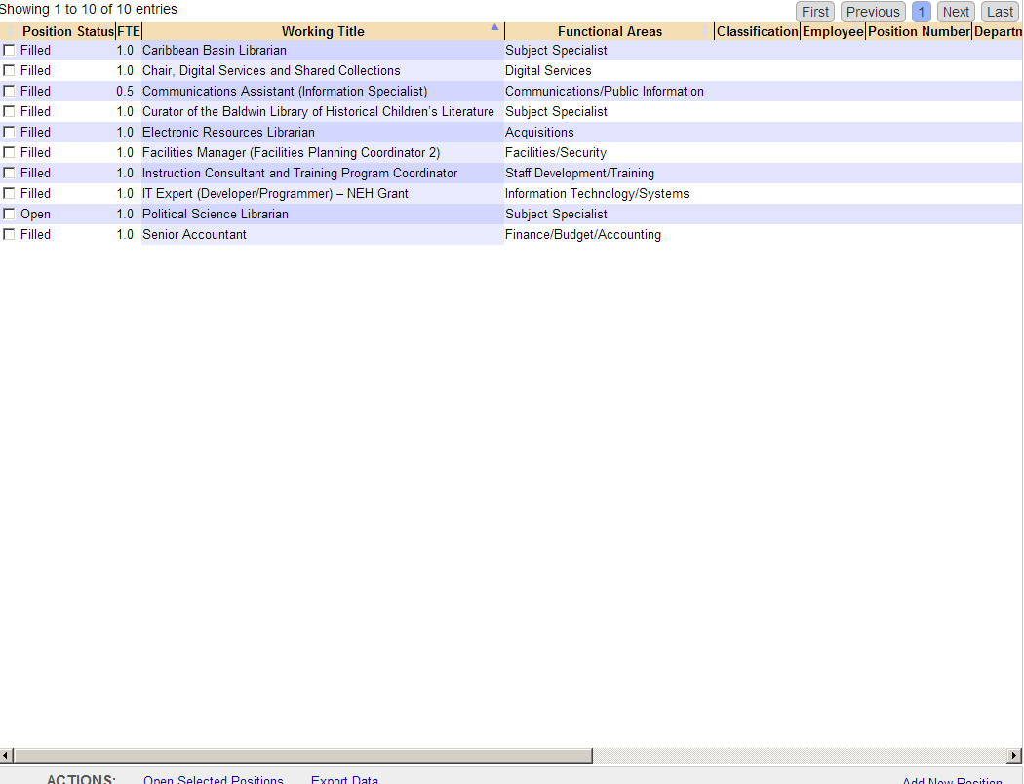

Sorting Results
The results can be sorted from least to greatest or alphabetical to reverse alphabetical by clicking on any one of the column headers. Cells with no data are sorted as the lowest number/alphabetical character.
Additionally, the search facets on the left can be used to further narrow the search results. Clicking on one of the facets will narrow to only the search results that include the selected information. The facet information is then added to the top search terms, and can be removed to expand the results.
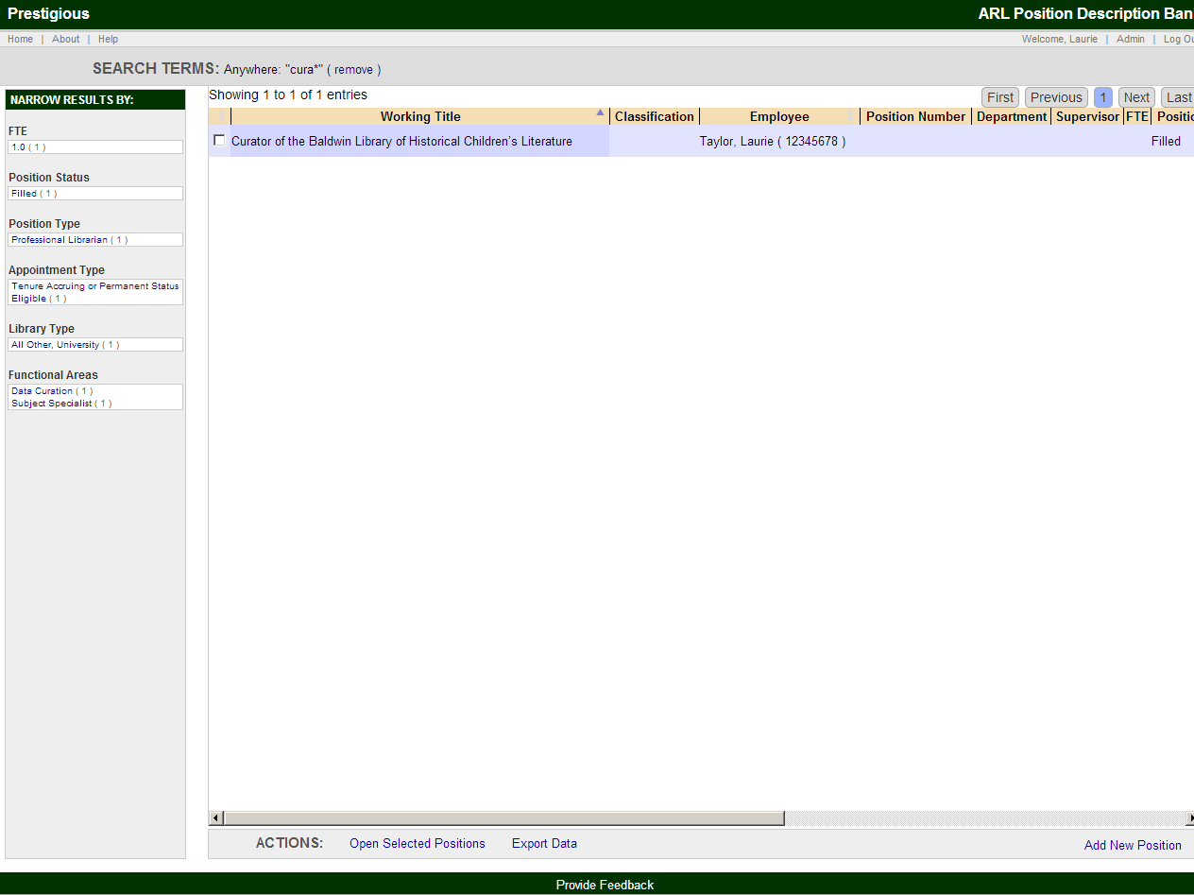

Exporting Data
Export Data, located in the Actions bar at the bottom of the page exports the current search result to an XLS Excel file named arlpdbank.xls. The file can then be opened or saved:

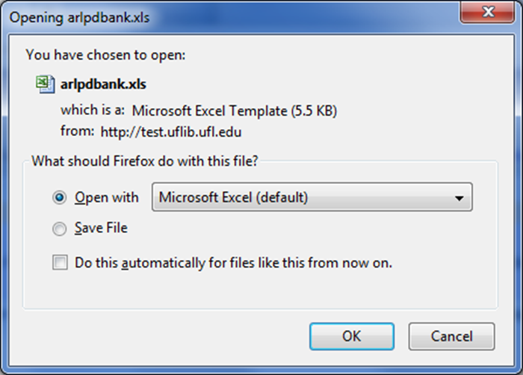

Adding a New Position
Click on the Add New Position tab to add a new position. This process is divided into three tabs:
- Standard Data
- Institution-Only Data (if the institution opts to use)
- Attach Documents

Standard Data
Below is a screenshot of the top portion of the Standard Data tab.
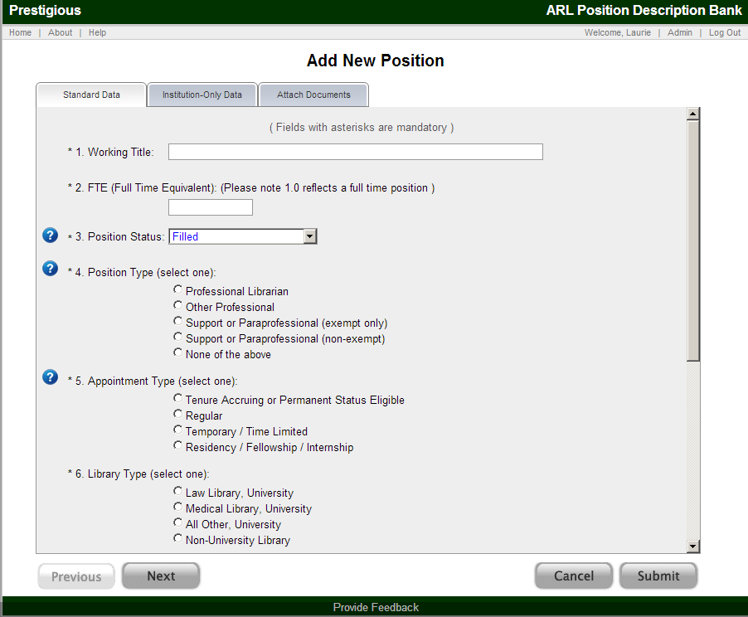
From this tab, you can enter the required Standard Data. This data is viewable to other ARL PD Bank users for use in searching the ARL PD Bank. The required data is:
- Working title
- FTE (Full Time Equivalent) – the acceptable range is any number above 0 up to 1.0
- Position status (select one)
  - Active (Filled position)
  - Open (Position in recruitment process)
  - Discontinued (Vacant position not slated to be filled in the foreseeable future)
- Position type (select one)
  - Professional librarian (Positions requiring an MLS, MLIS, or other directly relevant advanced degree or equivalent years of experience)
  - Other professional (Professional positions which may or may not require an advanced degree and might serve in field such as human resources, grants, fiscal, information technology, etc.)
  - Support or paraprofessional (exempt only – salaried position)
  - Support or paraprofessional (non-exempt – hourly or overtime eligible position)
  - None of the above
- Appointment type (select one)
  - Tenured, Tenure Accruing, Permanent or Permanent Status Eligible
  - Regular (No pre-determined time limit) [An employee (regardless of title) who has been hired for a position without a pre-determined time limit. Includes recurring, ongoing appointments including non-tenure accruing, non-permanent status eligible faculty or administrative personnel appointments. This type differs from Term, Temporary or Time Limited employment, which have a pre-determined period of employment.]
  - Term / Temporary / Time Limited (Appointments with specific durations including project-based or seasonal employment. May be benefitted or non-benefitted, and regardless of title.)
  - Residency / Fellowship / Internship
- Library type (select one)
  - Law Library, University
  - Medical Library, University
  - All Other, University
  - Non-University Library
- Functional areas (check all that apply)
There are over 25 functional areas. By clicking on the to the left of question 7 you will be taken to a document with a definition of each functional area. A description of each functional area is also provided by hovering over the functional area with your mouse.

Institution-Only Data
Once all of the required Standard Data has been submitted, click Next to proceed to the next tab.
Institution-Only Data is only collected if the institution opts to use this system feature. If your institution elects to use the Institution-Only Data fields, the submitted data will not be viewable to other ARL PD Bank users or usable by users outside of your institution in searching the ARL PD Bank.
The Institution-Only Data is customizable by each institution based on their needs. Some common data fields will be pre-programmed, but institutions may create or modify fields as they deem useful.
- Pre-programmed fields
  - Job classification
  - Employee ID
  - Employee name
  - Position number
  - Department
  - Supervisor name
  - Effective date of edit/change
  - Notes

Below is a screenshot of the Institution-Only Data for a sample institution.
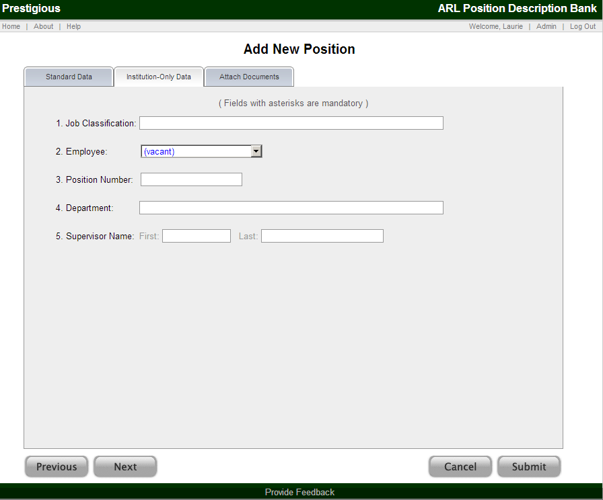
In this tab you can enter Institution-Only Data.
The institution may opt to make some of the Institution-Only Data fields mandatory. If so, those fields will be noted on the page with asterisks.

Attach Documents
After entering the Institution-Only Data (if applicable), click Next to Attach Documents.
The ARL PD Bank will accept documents falling into two broad categories:
- Public
- Private (Institution-Only)
Public documents are searchable and accessible by ARL PD Bank users. Private (institution only) documents will only display for and may only be keyword searched by those users from within the submitting institution.
Below is a screenshot of the Attach Documents tab for a sample institution that has opted to use Private documents in addition to the standard Public Documents.
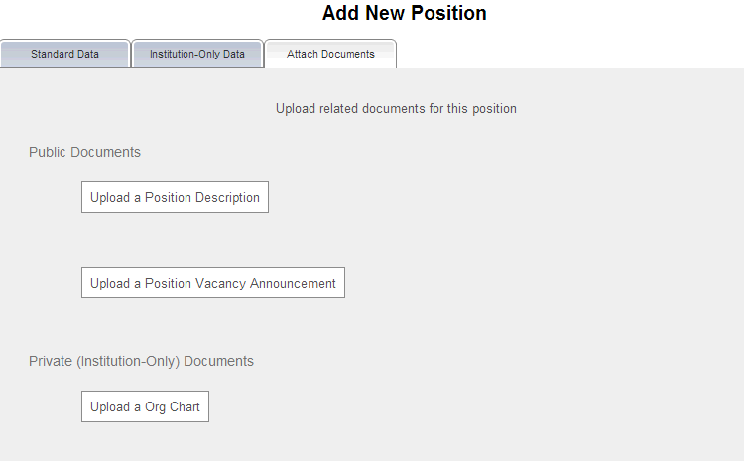
At the Attach Documents screen, you can upload two types of Public Documents:
- Position Description
- Position Vacancy Announcement
Please note: Position Description might include a variety of documents describing a position. For example, some institutions might use annual assignments to describe the work of their staff. In lieu of a traditional position description, those documents may be submitted if they are the institutional documents which best reflect the duties, qualifications, etc. for the position.
The Private (Institution-Only) documents are optional and can only be submitted if the institution opts to use this system feature. If your institution elects to permit the submission of Institution-Only documents, the submitted documents will not be viewable to other ARL PD Bank users or usable by users outside of your institution in searching the ARL PD Bank. Documents of this type might include Org Charts (as in the example above) or Annual Goals. The types of Private (Institution-Only) documents can be customized by the institution.
Regardless of the category of document (Public or Private), documents are submitted in the same manner as adding an attachment to an email message.
The attachments can be PDF, Word (DOC and DOCX), and TEXT (TXT) documents.

Submit a Position
When you have finished entering the Standard Data and Institution-Only Data (if applicable), and attached the documents, click Submit to complete the process, thereby creating a new position record. You will then automatically proceed to the Single Record view for the position record. Here, you can review and edit the single record.

Viewing and Maintaining a Position
After submitting a position, you can view the Single Record. The Single Record screen includes:
- Standard Data
- Institution-Only Data (if applicable)
- Public Documents
- Private (Institution-Only) Documents (if applicable)
- Actions Sidebar:
  - View Position
  - View Position History
  - Edit Position
  - Delete Position
  - Add New Position
  - Duplicate Position
  - Email Position (from the documents at the bottom, using the forward link)
- Bottom links
  - Email Position (from the documents at the bottom, using the forward link)
  - Send an email to the institution about this position (bottom of the page)
The screenshots below are of a single record with Public Documents and Private Documents, and with multiple versions of the record which can be accessed using the arrow buttons.

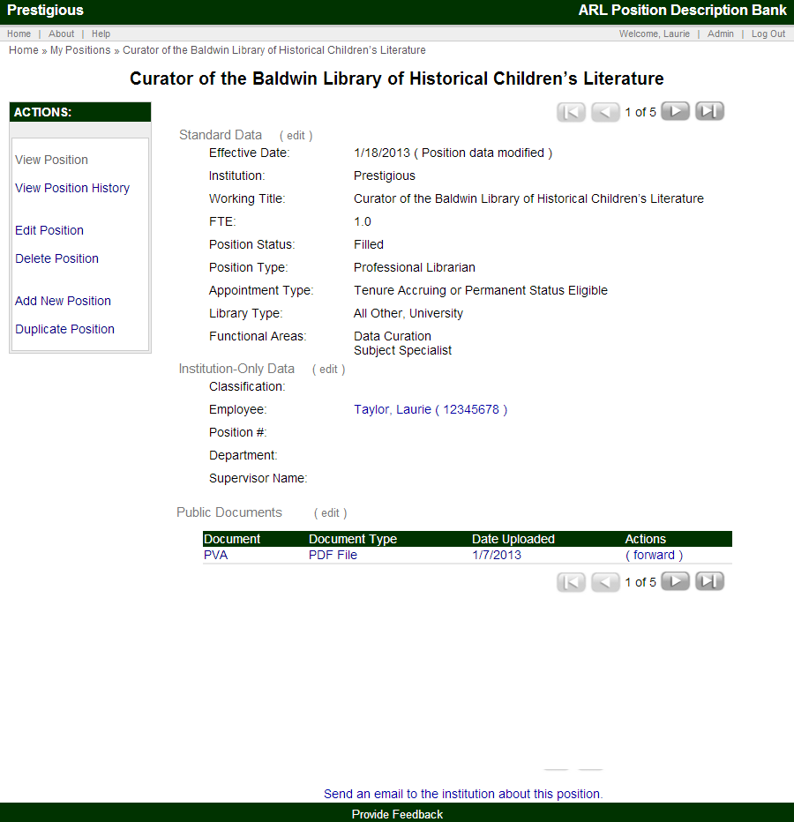
Please note: The system automatically tracks the date and username when documents and data are added and/or modified. This logged information can be accessed in View Position History, explained in the Actions sidebar section below. Changes are reflected immediately in the single record screen.

Actions Sidebar
Clicking on one of the options in the Actions sidebar will bring up a new screen. You can always return to the Single Record screen by clicking View Position.

View Position
From this screen you can view a single position record and access any associated documents. In the upper right hand corner (see screen shot below) you can access historical records of this same position by selecting the directional arrows.
Each change to the position data or submission of a new document creates a historical record of the position.

View Position History
The View Position History screen shows all versions of the position, the date, and username for the edits. By clicking on one of the versions, you will see the record as it existed at the time of that change, including the then current documents.
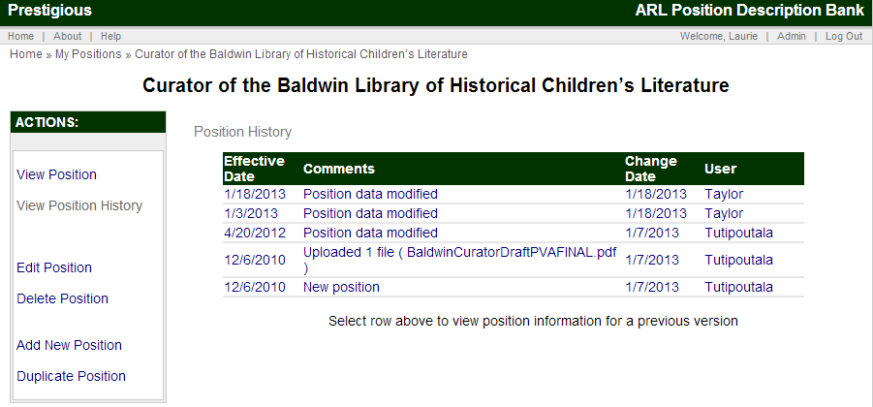

Edit Position
The Edit Position Data screens are very similar to the initial Add New Position screens introduced above in that they include:
- Standard Data
- Institution-Only Data
- Attach Documents
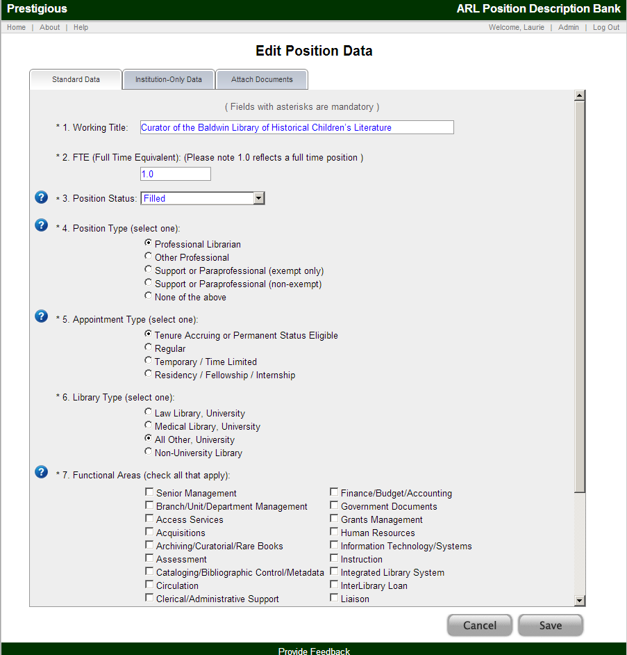

Delete Position
The Delete Position link from the Actions sidebar allows you to delete the position and all files for the position. Delete Position actions are not reversible and, therefore require a confirmation:
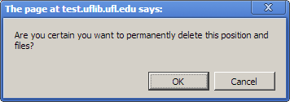
Clicking OK permanently deletes the position and all associated documents. If an employee is associated with a deleted position, the employee will not be deleted.

Add New Position
The Add New Position link from the Actions sidebar opens the standard process for adding a new position covered earlier in this guide. The process is identical, and the Add New Position link is included in the Actions sidebar for ease of use.

Duplicate Position
Duplicate Position allows you to create a duplicate of the existing position record. This makes it easier to create multiple similar positions.
Clicking on the Duplicate Position action prompts a confirmation:
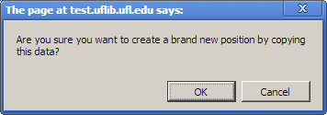
Clicking OK then brings up the Add New Position screens with all of the information from the duplicated position already filled in. You can then edit the new position data, attach documents, and submit to save the duplicated position.

Forwarding Documents
From the Single Record screen, there is a Forward link next to the documents, as shown in the screenshot below.
Clicking the Forward link brings up the Forward a Document screen:
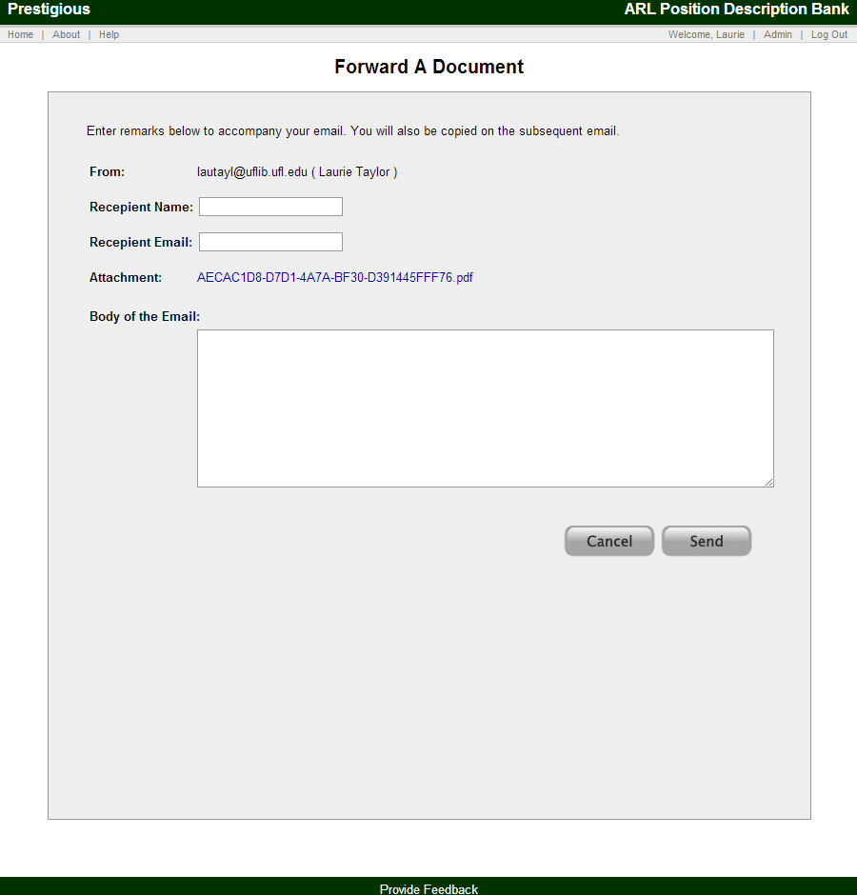
Complete the form and click Submit to send an email with the selected document attached. You will then automatically be returned to the Single Record screen where you will receive a confirmation message: Email Sent Successfully.

Send an Email to the Institution
From the Single Record screen, there is a "Send an email to the institution about this position" link at the bottom of the page, as shown in the screenshot below.
Clicking the Send link brings up the Email screen:
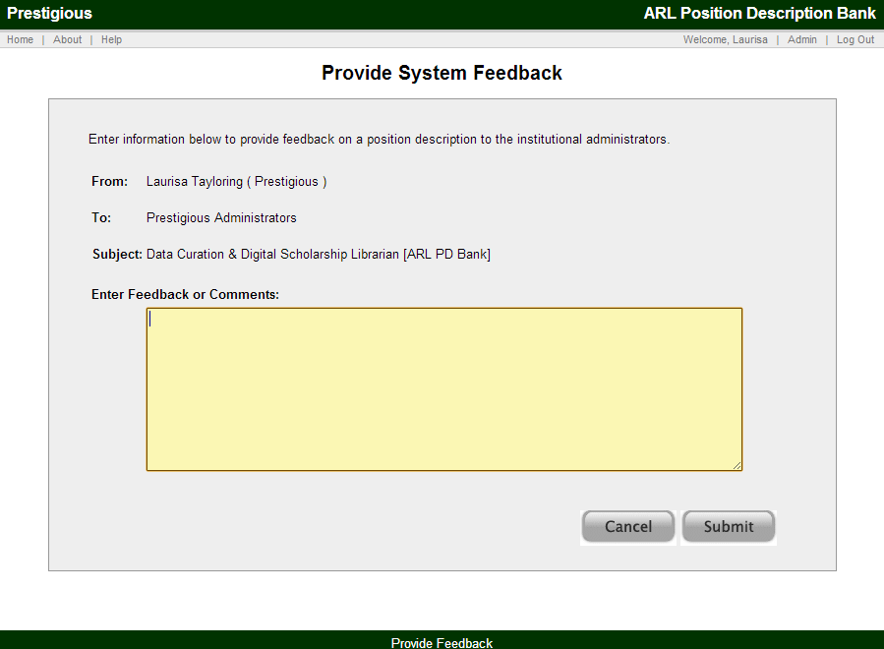
Complete the form and click Submit to send an email to the institution regarding the position. You will then see a Thank You message screen with a link to return to the ARL PD Bank.

My Positions
The My Positions tab opens a screen showing all of the positions for your institution (see example below). The positions can then be filtered and organized using the facets and column headers, and the other functions described in the Search Results section above.
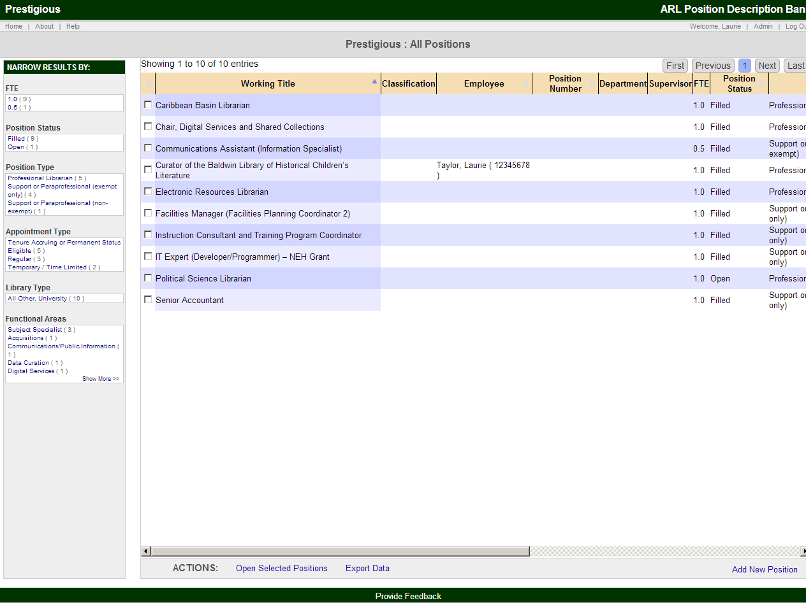

My Employees
Institutions may elect to use the My Employees module. This module expands the system’s ability to support data management functions for Institution-Only Data. Please recall, Institution-Only Data is only collected if the institution opts to use this system feature. If your institution elects to use the Institution-Only Data fields, the submitted data will not be viewable to other ARL PD Bank users or usable by users outside of your institution in searching the ARL PD Bank. The functionality described below is only available for institutions opting to use the My Employees module.
Please note: the My Employees module requires the institution to use an Employee ID number for each employee record.
The My Employees tab launches a screen which allows you to search for your institution’s employees by Employee Name or Employee ID number. A blank search will return all employees for your institution.
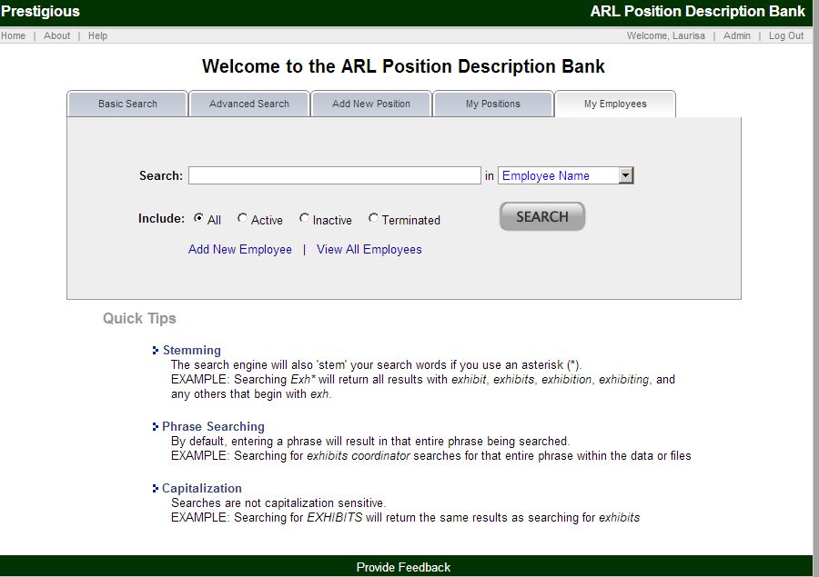
The search results for My Employees are depicted in a standardized screen. An example of search results is shown below:
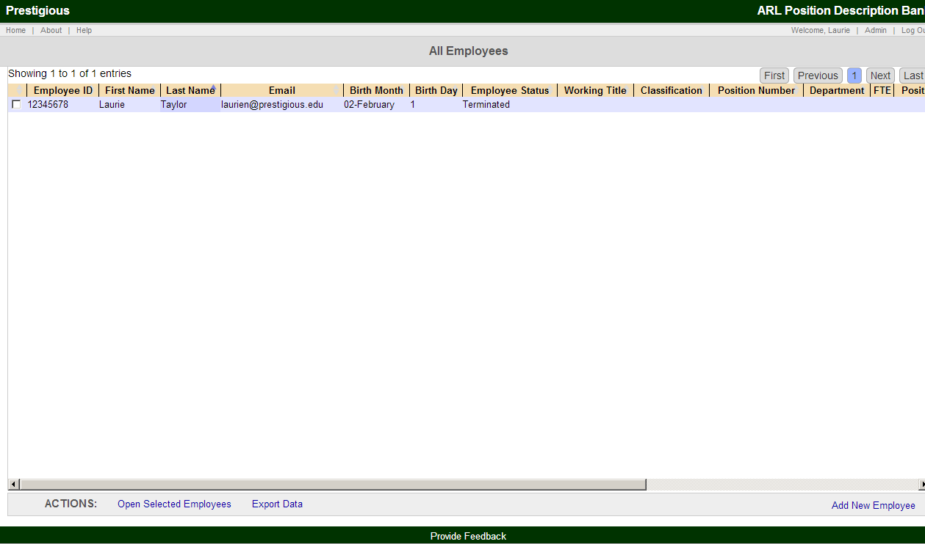
The search results screen is comprised of a number of elements. Each is described in turn in the following section.
- Search Terms:
  - Top of page
  - Shows current search terms and allows you to remove any of your current search terms
- Search results:
  - Middle of screen
  - Displays all the matches to your search criteria in the form of a sortable table with customizable columns (described below in Customizing the View and Sorting Results)
  - Clicking on a single employee will open the employee record, where you can view all the data. Checkboxes next to each of the results allow you to select a number of employees and perform the actions listed at the bottom of the page (see next section)
- Actions:
  - Bottom of page
  - The Actions bar allows you to perform actions against any selected employees in the results pane
  - Actions include: Open Selected Employees; Export Data; and Add New Employee
    - Open Selected Employees opens the selected employee(s) in separate window(s). (Please note that your browser’s pop-up blocker may prevent these windows from opening. You can change your browser preferences to accept pop-ups from the ARL PD Bank.)
    - Export Data opens the full search result in an XLS Excel file.
    - Add New Employee takes you to the screen to enter the information for a new employee.

Customizing the View
The table headers for My Employees can be adjusted to increase or decrease the column width. The order of the columns can also be changed by clicking and dragging column headers.

Sorting Results
The results can be sorted from least to greatest or alphabetical to reverse alphabetical by clicking on any one of the column headers. Cells with no data are sorted as the lowest number/alphabetical character.
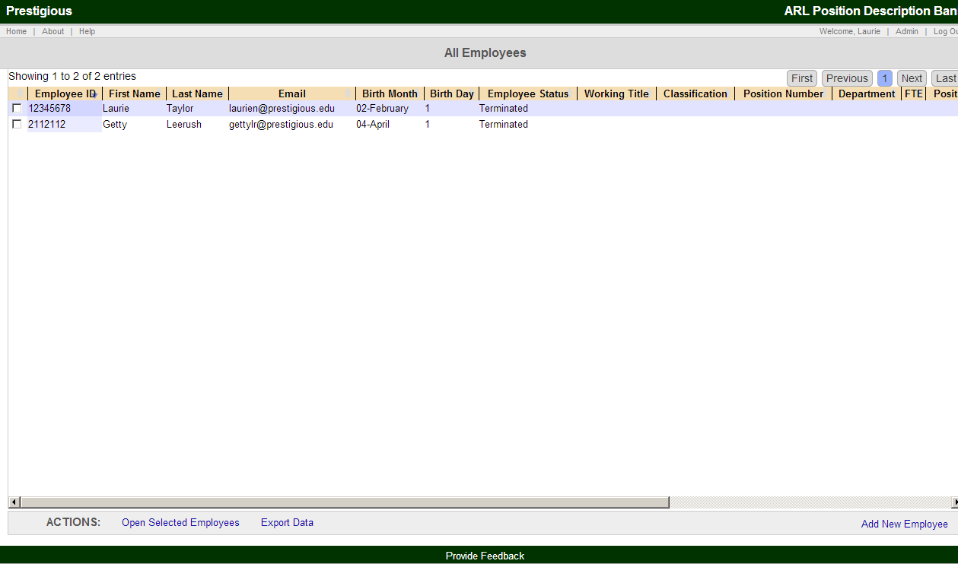

Exporting Data
Export Data, located in the Actions bar at the bottom of the page, exports the current set of results into an XLS Excel file named arlpdbank.xls. The file can be opened or saved:

Adding a New Employee
From the bottom of the My Employees search results screen or from the Actions sidebar when viewing a Single Employee Record, click on the Add New Employee link to add a new employee. An example of the Employee Data is provided below. Institutions may select from a variety of preprogrammed employee data fields.
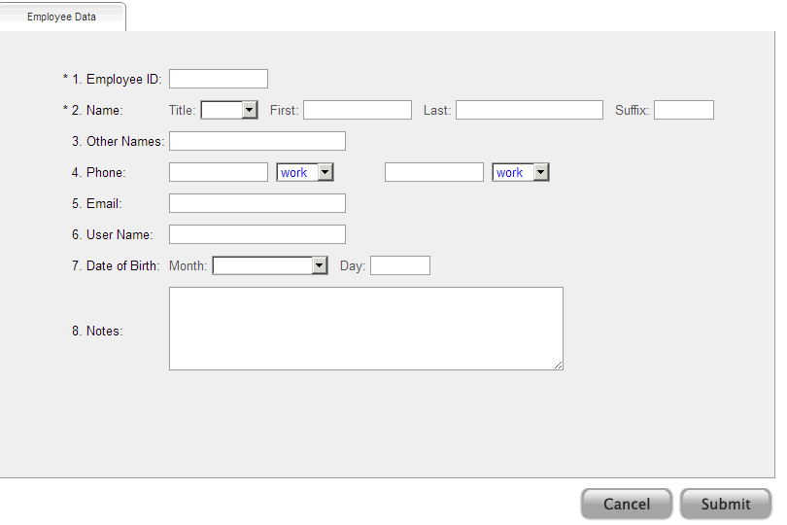

Submit a New Employee
When you have finished entering the employee data, click Submit to complete the process, thereby creating a new employee record. You will then automatically proceed to the Single Record view for the employee record. Here, you can review and edit the single record.

Assign Employee to a Position
The screen below shows the standard message when an employee is not currently assigned to a position. This screen includes a link to assign the employee to a position by editing an existing position or adding a new position.
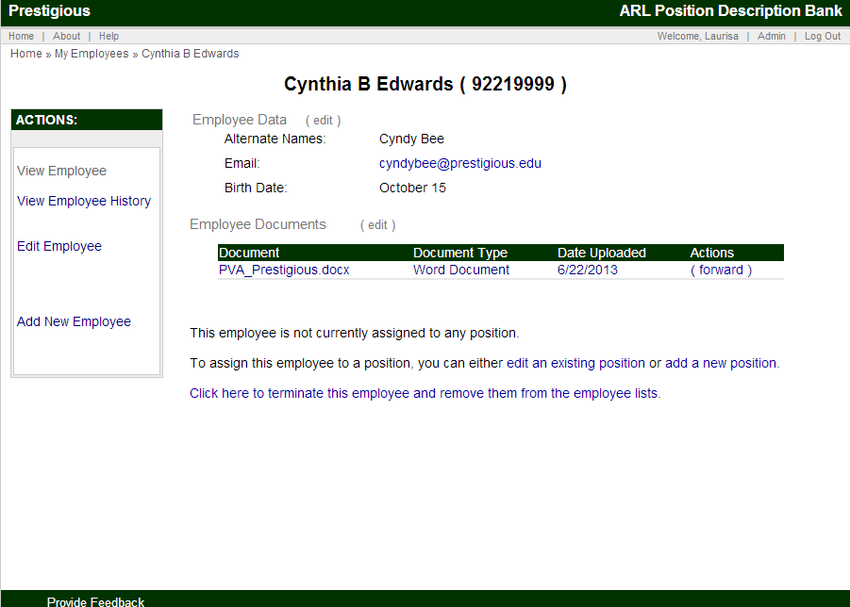

Viewing and Maintaining an Employee
After creating a new employee record, you will see the Single Employee Record screen. This screen can also be accessed by selecting employee(s) from the Employee Search results.

An example of the Single Employee Record screen is shown below.
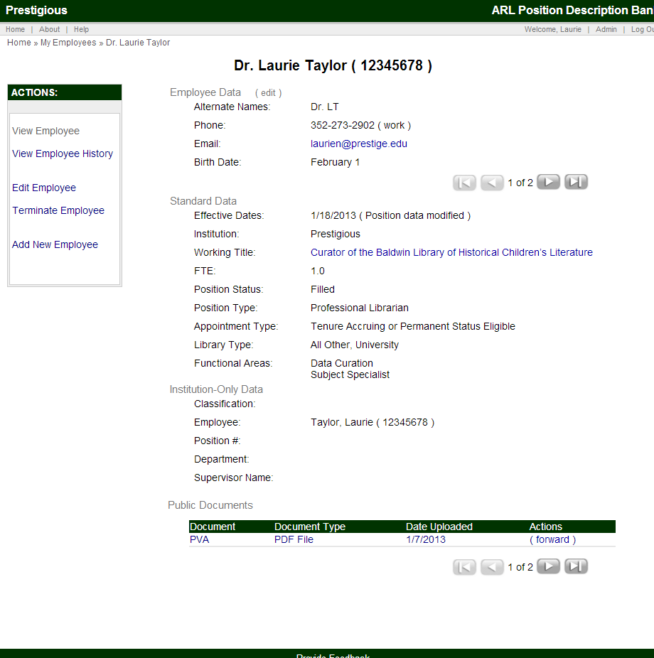

This record includes the Employee Data, Standard Data, and the Institution Only Data.

The Employee screen is comprised of a number of elements. Each is described in turn in the following section.
- Breadcrumbs to return to the Employee Search
  - Top left of page
- Actions Sidebar
  - Left panel
  - View Employee (standard Employee Record view)
  - View Employee History
  - Edit Employee
  - Disassociate from Position
  - Add New Employee
- View Employee Main Section
  - Middle of page
  - Employee Name and ID
  - Employee Data
    - Edit link, to edit this data directly
    - Data fields with data are shown; data fields are not displayed if no information is available
  - Arrows and Numbers, for different versions of the data for this employee
  - Standard Data
    - The Working Title links to the Position Description. Clicking on the Working Title takes you to the Position Description where you can update the Position Description to remove or link an Employee record to that Position.
  - Institution-Only Data
  - Public Documents (includes link to forward the documents)
  - Private Documents (Institution only)

Institutional Administration
The Institutional Administration features can be accessed by users with administrative privileges. Institutional Administrators can review and approve other users for their institution as well as create and edit institution-only data fields (or questions) and document settings.
Please note, the ARL PD Bank already includes the relevant factual data on all ARL institutions (e.g., in terms of location with Region, State/Province; private or public; etc.) so these do not need to be set by the Institutional Administrator.

Institutional Administration
The Institutional Administration features can be accessed by users with administrative privileges from the "Admin" link in the top, right-hand corner.
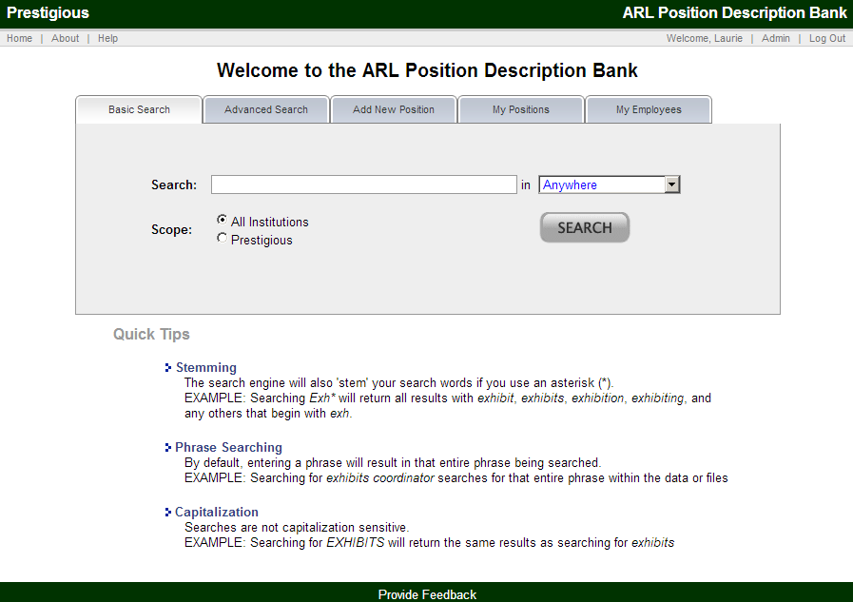
The Administrative Menu screen is shown below and includes:
- Review Pending User Registrations
- View Institutional Users
- Institutional Options/Questions
- My Employees Questions (if My Employees module activated)

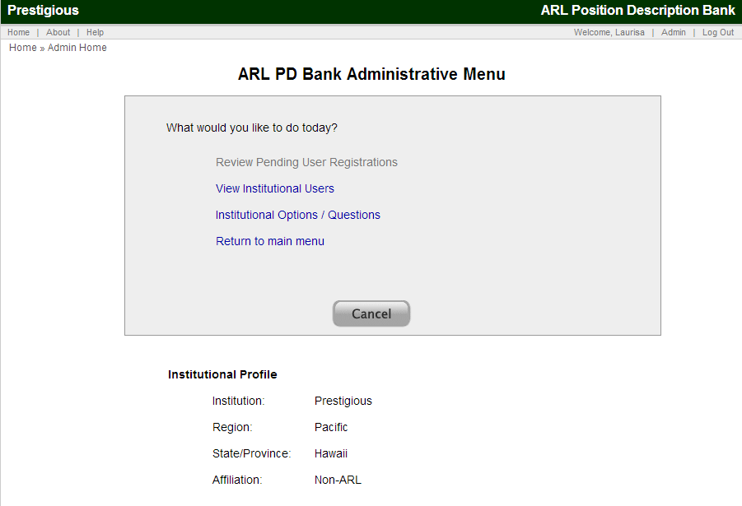
Please note, the ARL PD Bank already includes the relevant factual data on all ARL institutions (e.g., in terms of location with Region, State/Province; private or public; etc.) so these do not need to be set by the Institutional Administrator.

Review Pending User Registrations
Institutional users seeking access to the ARL PD Bank register through the system and provide identification and contact information, and identify the member institution to which they are affiliated.
Upon the submission of the user’s registration, the Institutional Administrator(s) for the identified institution will receive an email notice like the following:
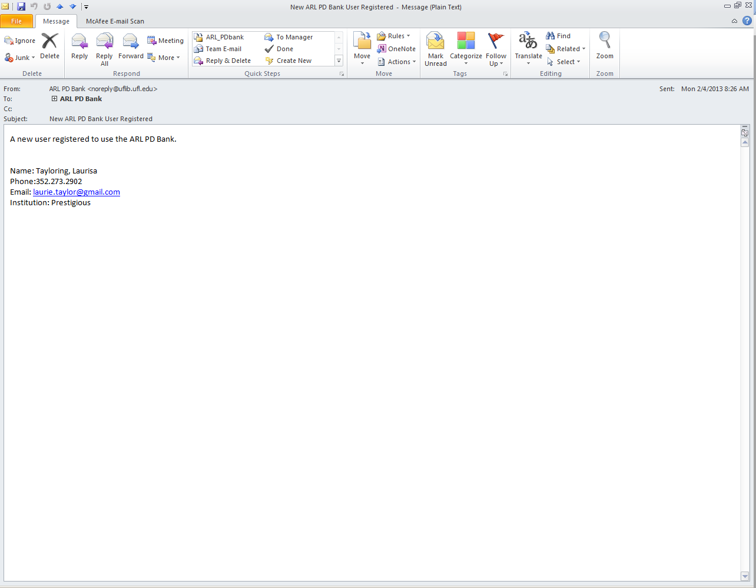
The Review Pending User Registrations screen allows the Institutional Administrator to review and approve newly registered users for their institution. The screen provides a list of newly registered users as shown in the screen below.
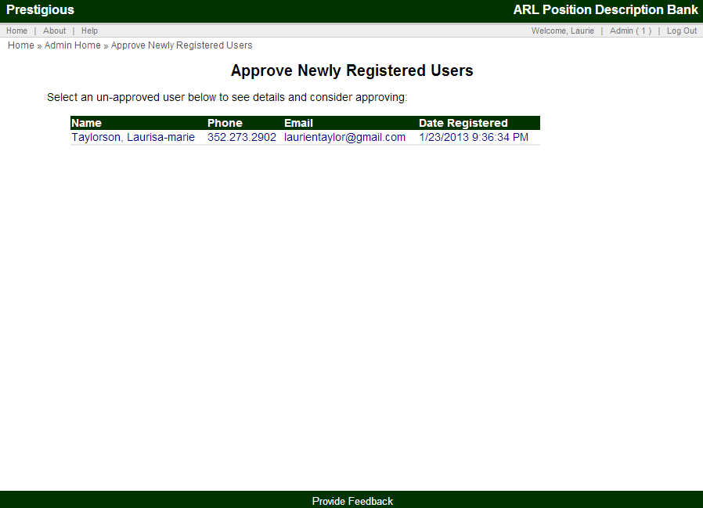
Clicking on one of the registered users opens the Edit User screen which provides information on the user as well as options to approve the registered user or reject the newly registered user.
The Edit User screen also allows the Institutional Administrator to assign roles and permission levels for the newly registered user. The progressive permission levels are:
- Can View Data
- Can Add/Edit Data
- Can Delete Positions
- Is Institutional Administrator
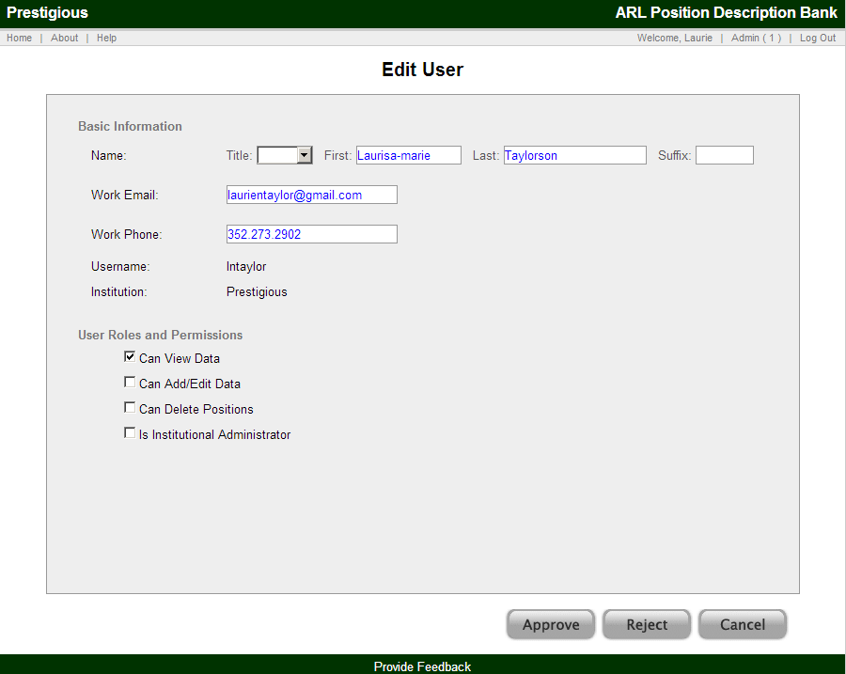

View Institutional Users
The "View Institutional Users" option displays a list of all of the already registered and approved users, with basic information and roles and permissions.
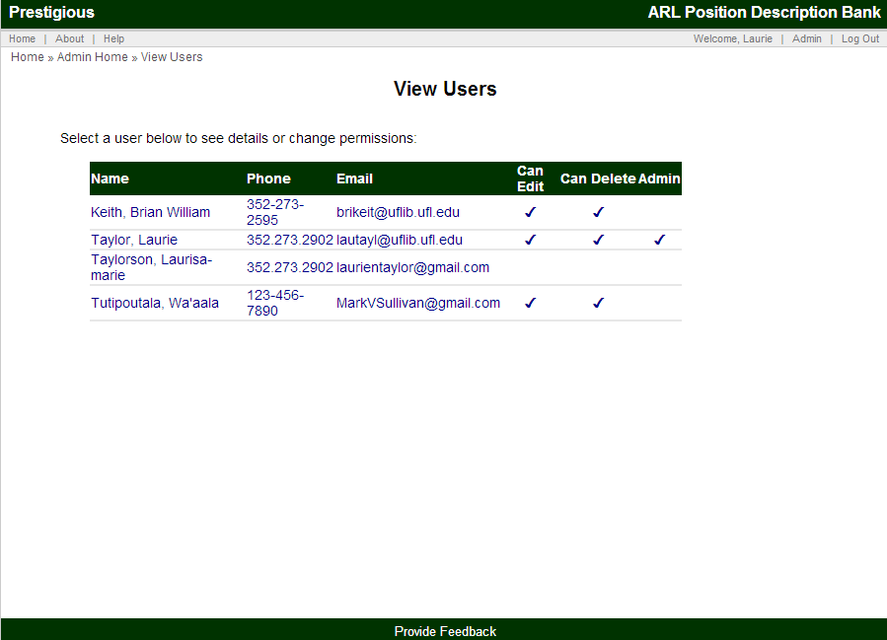
Clicking on one of the individual users then opens the Edit User screen (described above) and permits the Institutional Administrator to update user information and change the institutional user’s roles and permissions.
The following screenshot represents a user that will be authorized for all 4 user role levels:
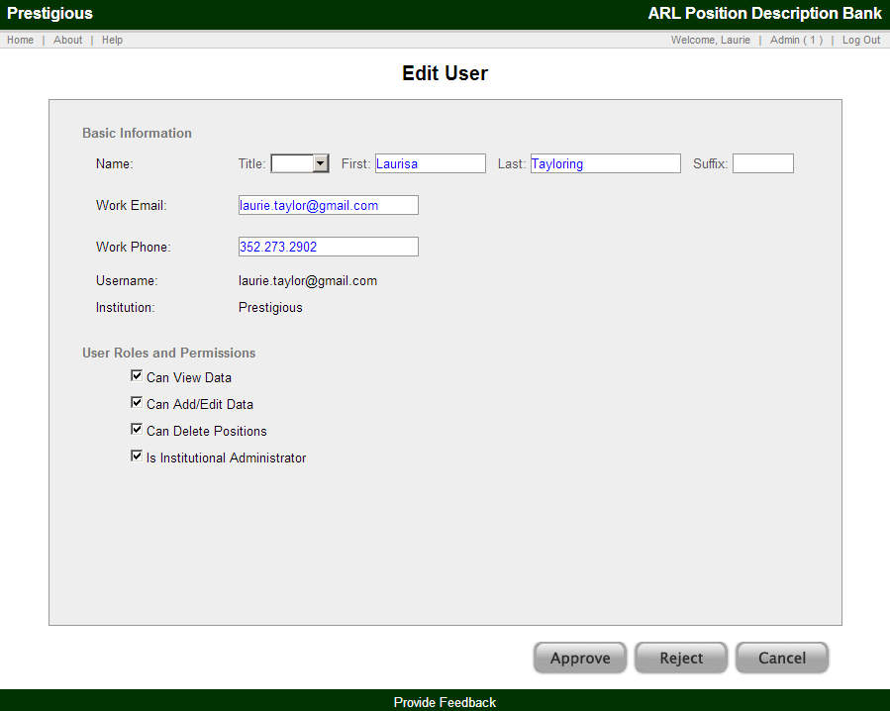
Once the user’s role(s) are determined, the Institutional Administrator must Submit the change to the system. The approved roles will be effective immediately, and the user will receive a system generated email alerting them to the change and specifying their approved user role(s).
The following is an example of the notice a user would receive, if as in the above example, they were to be authorized for all 4 user role levels:
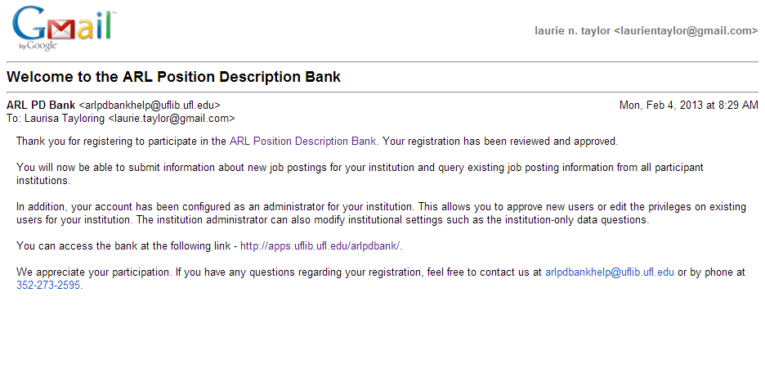

Institutional Options / Questions
The "Institutional Options / Questions" link shows the institutional questions in use for the institution-only data as well as the options for setting Institution-Only File Types. Each of the questions is listed along with type, whether or not the question is active, and other options cover in the following sections of this User Guide.
Before there are institution-only questions, this screen includes a link to add new questions ("Click here to add a new institution-only question") and the fields to complete the information for institution-only file types.
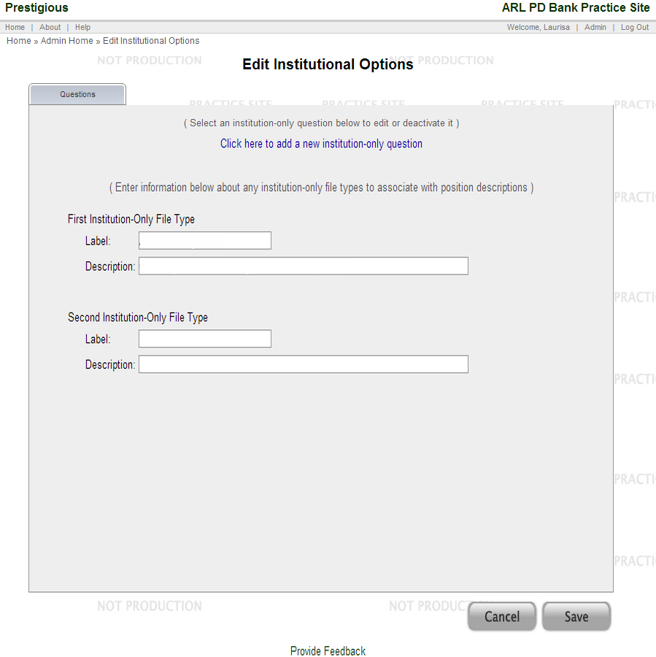
Once questions have been added, clicking on any of the existing questions opens a new screen where the question can be edited.

Also, at the bottom of the list of questions is the option to add new questions. This is further described in a subsequent section.
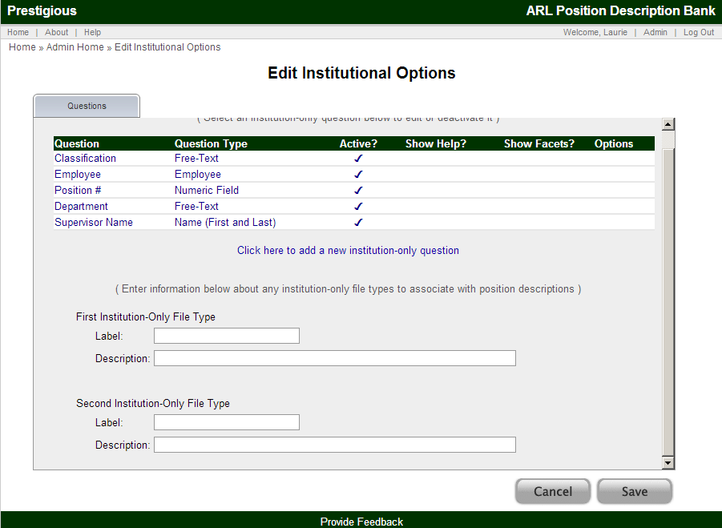
Below is one example for editing an institutional question. In the example below, the question being edited is for a Position Number, to add this as a standard question for the institution-only data.
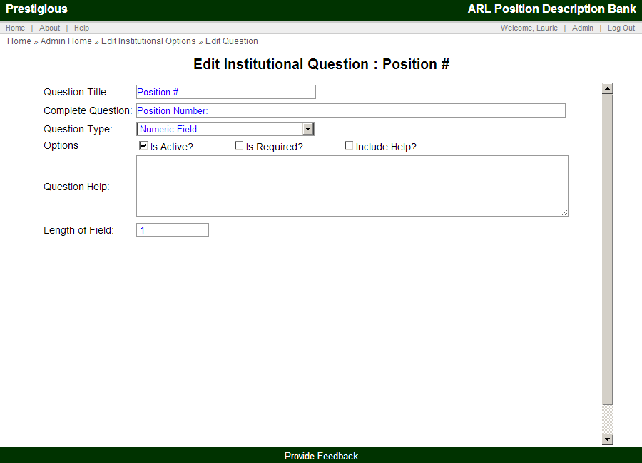

Adding New Questions and Editing Questions
For adding new questions and editing questions, there are many options which are explained below.
Please note: Not all of the elements below are available for each type of question.
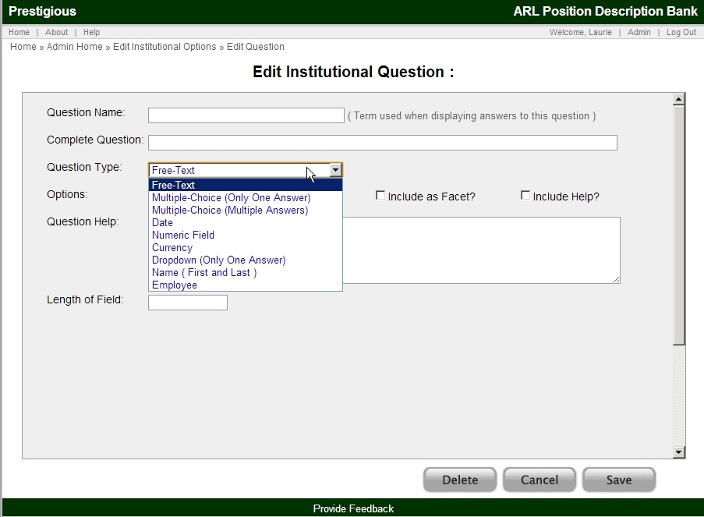
Question Name
This is a short term (or terms) which best describe the data you wish to collect.
These words will appear before the specific entries when looking at results or single positions. In addition, this will appear in the drop-down for advanced searching if you choose to make this field searchable.
Possible Examples:
Classification
Department
Supervisor
Complete Question
The Complete Question appears when users from your institution are prompted to enter answers when entering a new position, or editing an existing PD. The Complete Question is longer than the brief Question Name terminology and can provide more information for your users. This can also be left blank to default to the question name, followed by a colon.
Possible Examples:
Job Classification or Rank:
Department Name:
Supervisor’s Name:
Question Type
The Question Type sets the type of question and thus the type of answers to be collected. The following types are available for institutional questions:
- Free-Text:
  - The user will enter information, without having any pre-set options to select from, as opposed to a drop-down menu.
- Multiple-Choice (One Selection):
  - The user will select one and only one of the possible pre-set answers from a radio-button list. The user can only select ONE of the answers (or, none if the question is not required).
- Multiple-Choice (Multiple Answers):
  - The user will select one or more of the answers from the pre-sets using a checklist. The user can select as many as they wish (or, none if the question is not required).
- Date:
  - The user will enter a date, and will have a calendar box pop-up to assist them with selecting a date.
- Numeric Field:
  - The user will enter a value, which must be numeric.
- Dropdown (Only One Answer):
  - The user will select from your controlled values by selecting one answer from a drop-down list. The user can only select ONE of your answers.
- Name ( First and Last ):
  - The user will enter a name, first name, followed by a separate last name field.
- Employee
  - This option will enable the employee module. (See help section on the Employee Module).
Options
Is Active? This checkbox determines if the question is currently active and soliciting input when users edit or add a new position.
Is Required? This checkbox determines if the user is required to enter data or select a value for this question.
Include As Facet? This option adds this question and answers to the facet bar on the left of the results/browse screen when viewing your institution’s positions. (See the earlier Search Results section for more on facets.)
Include Help? Enabling this will result in an automatically-created help page being available to your users when entering data into this question. To enable help, you must include text in the ‘Question Help’ box below.
Question Help
This field can be used to enter any additional help, explanation or clarification you wish to provide to your institutional users when they are entering the data for this question.
Length of Field
This field can be left blank. When left blank, input boxes will default to a system-determined length. However, if you wish to dictate the length of a field used to collect data from your users, you can enter values here. Values greater than 500 will result in a multi-line input box.
Controlled Values
Certain fields provide controlled values for your user to select. Those values should be entered into this box with each selection on a different line.
If this is for a Dropdown question, leaving the first line blank will result in not having a default value. Otherwise, the first answer will be the default answer when entering new positions.
For instance, if adding a question on department status, you could choose to enter these for possible answers, with each answer on a separate line:
Department
Cataloging
Digital Curation
IT
Special Collections
This is shown in the image below.
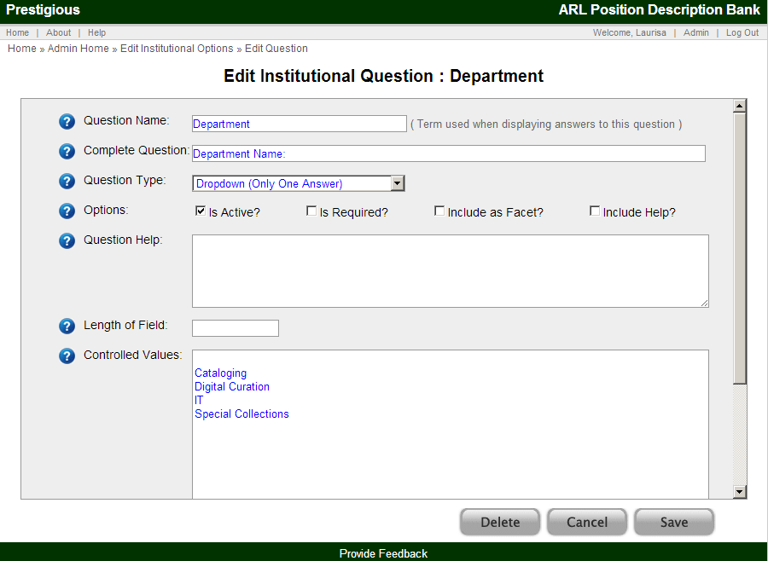
Below is a depiction of how the above example would result in a field for institutional users when in Add New Position.
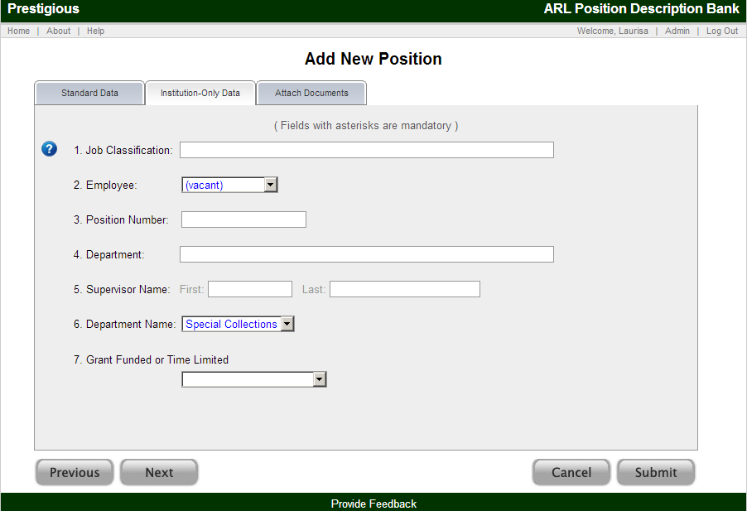

Institution-Only File Types
In addition to setting institution-only questions, institution-only file types can be established from the main screen for "Institutional Options / Questions" as shown below.
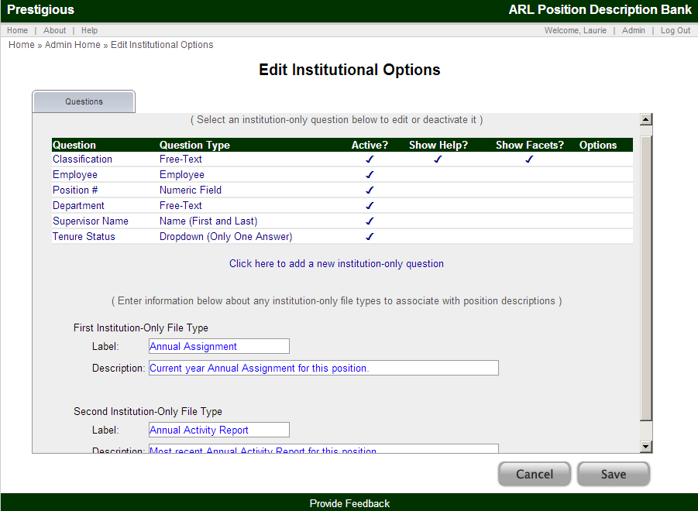
The Label is a brief descriptive term (or terms) that will help your institutional users identify the File Type.
The Description is a longer explanation of the File Type that will help institutional users understand the appropriate kind of documents to submit for the specific File Type.

My Employees Module
The My Employees module can be activated in the Institution Options / Questions by selecting "Employee Module" as the question type.
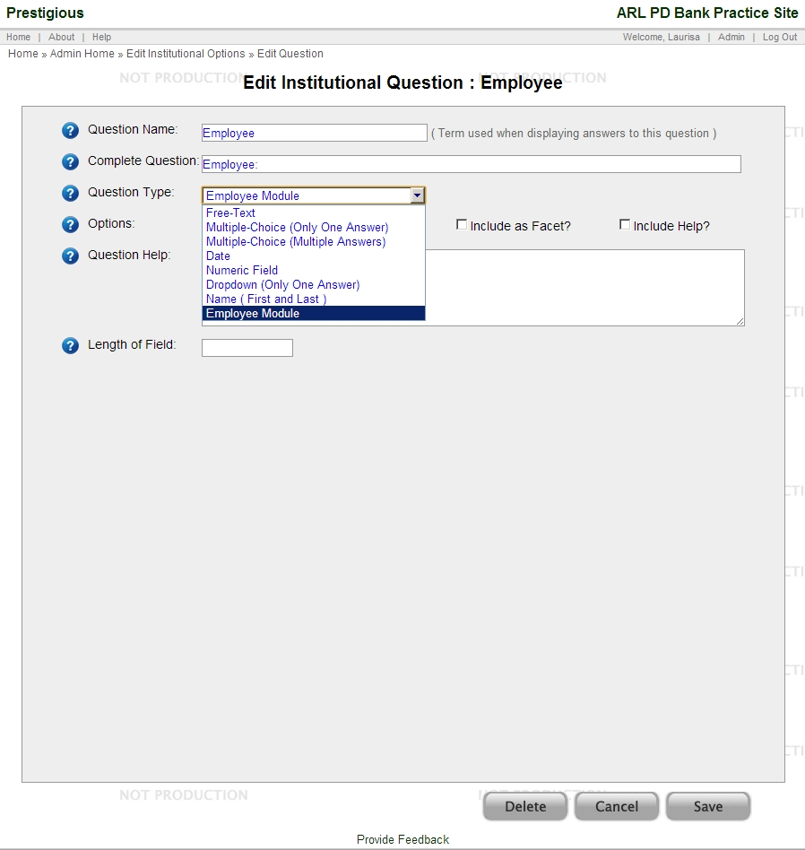

When the Employee Module question type is selected, the following screen will appear:
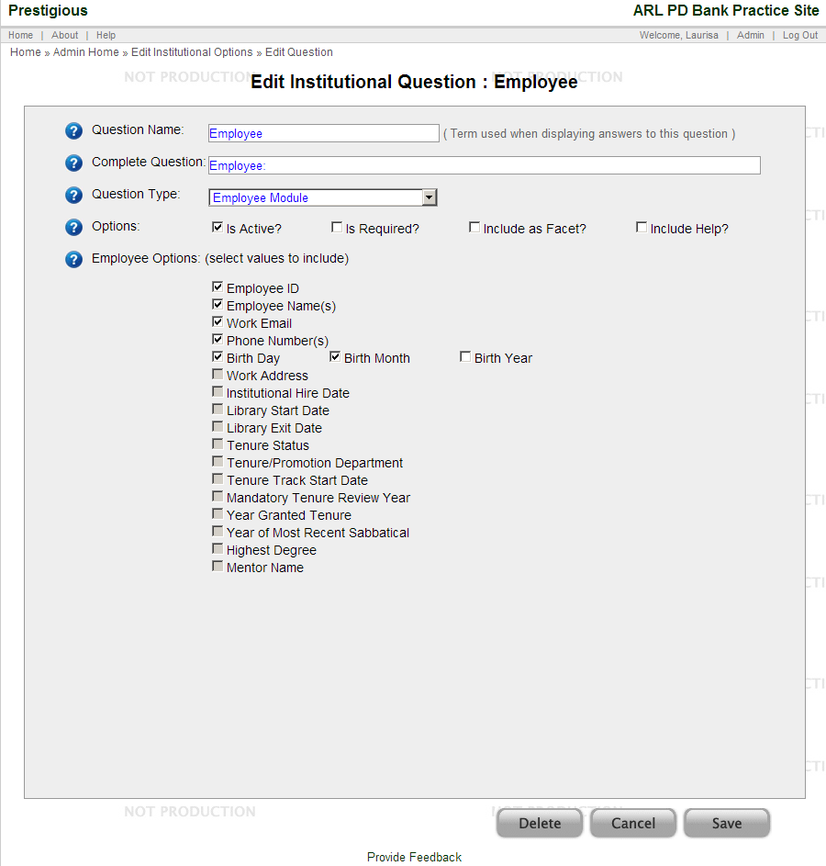
By enabling the Employee Module, the questions for Employee ID and Employee Name(s) are automatically selected and are required.
The available data fields or questions for the My Employees module are:
- Employee ID:
- Name:
  - Title
  - First Name
  - Middle Initial
  - Last Name
  - Suffix
- Other Names
- Email
- Phone
  - Phone1 (Home/Cell/Work)
  - Phone 2 ( Home/Cell/Work)
- Office Address
- Date of Birth
  - Month
  - Day
  - Year
- Institution Hire Date
- Library Start Date
- Library Exit Date
- Tenure Status
- Tenure/Promotion Department
- Tenure Track Start Date
- Mandatory Tenure Review Year
- Year Granted Tenure
- Year of most recent sabbatical
- Highest Degree
- Mentor Name
- Notes
Other than the required Employee ID and Employee Name(s), any of these fields may be used or may remain inactive depending on the institutions preference. Fields are checked to be included, or can be left unchecked to leave them inactive. Adding or changing field selections will be implemented when the users clicks the Save button at the bottom of the screen.
Please note not all of the subfields for topics must be active. For instance, an institution may elect to use Date of Birth to track the birth Month and Day, but elect to not activate the Year.
Please also note that many of these fields may not be applicable to all institutions and that each institution using the fields may define and use these fields in different manners based on the local institution.
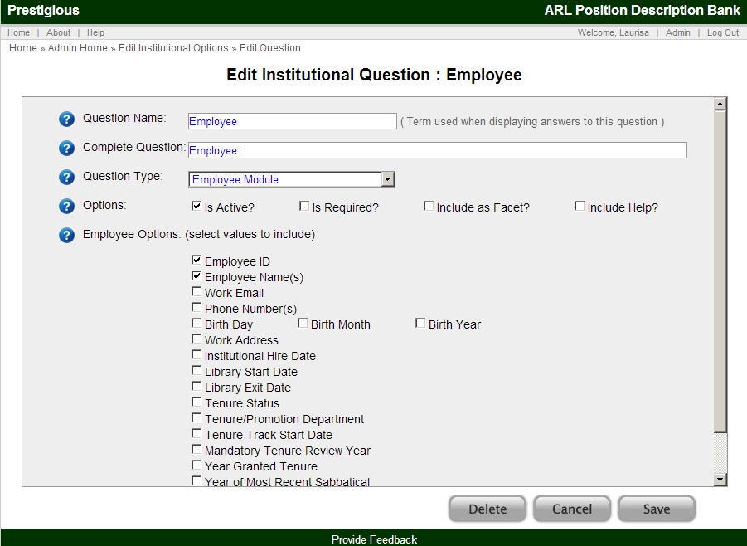
The "Employee Options" can be checked to be included as part of the employee data for each employee.

