A Teaching and Research Guide to Stephen N. Cobham’s Rupert Gray
Prepared and written by Thomas G. Cole, II
December 2011; Revised August 2012

Keywords: Stephen Cobham; Rupert Gray; Trinidad; teaching guide; research guide; resource guide; botany; tourism; postcards; racism; colonialism; Empire; imperialism

Scope

This guide is meant to underscore and illuminate the historical and cross-cultural merit of Stephen N. Cobham’s Rupert Gray: A Tale in Black and White for an undergraduate readership by examining two specific chapters in relation to race, science, and colonialism. These two chapters depict acts of tourism and discussions of botany that relate directly to late nineteenth- and early-twentieth-century conceptions of race, science, and colonialism.

Cobham’s text illustrates the engagement of early national and Pan-African writers with tourism and horticulture. The two chapters that comprise the focus of this guide demonstrate Cobham’s understanding of colonial discourse and orientalism, which is a false understanding of non-European cultures that is based on European prejudices of or against the other non-European culture, because readers see how clearly Rupert Gray engages issues in science (botany) and commerce (tourism), which are both inextricable from colonialism and imperialism.

Finally, Rupert Gray also demonstrates a contrast between the two scenes that highlights how Rupert moves up from being classified as a “typical negro” of tourist photographs to being the type of elite citizen of the world who goes on a grand tour and eventually becomes a Senator in the government of Trinidad.

How this Guide Works

Each of the following sections will provide information on Stephen N. Cobham’s Rupert Gray and how the novel relates to historically important aspects of Botany, Racism, Tourism, and Colonialism. (These sections are underlined so as to indicate the titles of subsequent sections.) In turn, each of these terms will be explained in brief, and any other unfamiliar terms will be explained in footnotes for readers. There are also hyperlinks to vintage postcards that will supplement and clarify the significance of the literary descriptions of the scenes of the novel and also scenes of Trinidad. This guide will also provide some study questions throughout the sections. These questions are intended to facilitate in-depth analysis of the material presented here and in the scenes from Rupert Gray. Finally, quotations from Rupert Gray as well as from secondary sources appear throughout the guide. These quotations will be cited according to MLA guidelines regarding parenthetical citations, with a Works Cited page at the end of the guide.

Introduction and Description of the Novel

According to Leah Reade Rosenberg, a scholar on Caribbean literature:

The literary history of Trinidad traditionally began in the 1920s with C.L.R. James’s yard fiction (“Triumph” and Minty Alley). James was a member of a literary group called the Beacon Group, after the literary and political journal The Beacon (1931-33 and 1939), which is credited by scholars such as Reinhard Sander and Kenneth Ramchand with introducing working class culture (calypso in particular) and emergent nationalism into literature. This tradition is beginning to be challenged as a growing number of nineteenth-century and early twentieth-century novels are reprinted or made available digitally, such as Michel Maxwell Philip’s 1854 Emmanuel Appadocca; or, Blighted Life. A Tale of the Boucaneers, Frieda Cassin’s With Silent Tread published in the 1890s, and Cobham’s Rupert Gray. This small and fascinating collection of fiction demonstrates that Trinidadians produced politically engaged literature nearly a century earlier than the Beacon Group. Their works confound the prevailing assumption that the region’s literature focused primarily on the peasant and working classes and that it was grounded in an opposition to British colonialism. It contradicts as well the earlier assumption on the part of scholars that West Indian literature developed in a linear fashion toward anti-colonial politics and aesthetic of the mid-twentieth-century writers such as George Lamming and Sam Selvon. Rupert Gray plays a particularly important role because it imagines a future in which the West Indies appears to be a federated country or dominion led by our hero Rupert Gray, a leading senator in the democratic government.

Rupert Gray, written by Stephen N. Cobham, appeared in print in 1907 (Dalleo 78). Produced by the Trinidadian publishing house Mirror Printing, the story itself is about Rupert Gray, a black, Afro-Caribbean accountant, who falls in love with Gwendoline Serle, the daughter of Rupert’s employer, a white, Creole named Primrose Serle. While this Trinidadian novel does, to some extent, participate in the earlier ‘novel of manners’ tradition, Rupert Gray also breaks with conventional attitudes of its time, for Rupert and Gwendoline marry and live happily ever after. However, before such a peaceful life can ensue, Rupert and Gwendoline suffer through great hardship—an attempted murder, a faked death, and even a theatrical court case.

When Primrose discovers his daughter’s affair with a black man, he attempts to murder Rupert, which naturally causes turmoil in the once happy relationship between father and daughter. Gwendoline becomes despondent because Primrose has also fired and shunned Rupert, whose recent membership into a scientific society, the Linnaean Society, is quickly revoked owing to the affair and scandal with the Serles. Without Rupert and her father’s support, Gwendoline begins to sicken and beg for her father’s forgiveness. Defiant, Primrose banishes her from his life, only to discover a few weeks later that she has died. He, too, shortly after, dies from overconsumption of alcohol. Meanwhile, Rupert travels to England and earns law credentials, and when he returns to Trinidad, he embarks on a court case of inheritance—to whom will the Serle fortune go? Miraculously, we learn that Gwendoline is, in fact, alive, and she inherits all of her father’s estate. The novel closes with the marriage of Gwendoline and Rupert and also their successes: a happy life with young children’s footfalls through their residence as well as Rupert’s hopeful rise to the Senate of Trinidad.

On the whole, the novel is not simply about melodrama. Rather, it portrays an interracial marriage between a native and a Creole, with the concluding chapter proclaiming a different Trinidad from the rest of the novel. Trinidad, at the end of Rupert Gray, is a country on the brink of change with regard to race in the government and society at large.

While the novel Rupert Gray deserves attention as a literary text, this guide focuses primarily on its historical and cross-cultural merit by highlighting two scenes that illustrate the novel’s engagement with colonialism, race, tourism, botany, colonialism and imperialism. Indeed, these two chapters demonstrate Cobham’s own vision of Empire, race, and the Caribbean in his depictions of tourism and botany.

The plot of the two chapters, while fictional, take place in real-life locations, some of which still exist today. The first scene, which is in chapter 9, titled “My Name Is Gray – Rupert McKinley Gray,” shows the initial interaction between Rupert and another character named Lady Rothberry, a member of the British peerage. Here, they meet in the Trinidad Botanical Gardens, which were first established in 1818 (Pemberton 19) and are one of the oldest and most successful colonial botanical gardens (McCracken 17). Thus, there will be sections of this guide that will deal directly with the Botanical Gardens and the related issues of Botany, Tourism, and Colonialism, as well as racism, which will be dealt with in the other sections, as it is an issue that features in all of the sections.

The second scene comes from chapter 16, titled “Fiat Justitia, Ruat Coelum,” which—from the Latin—means, “Let justice be done though the heavens may fall.” In this chapter, Rupert again meets a royal noble, but this time, instead of Lady Rothberry, who has passed away, Rupert meets her nephew, the new Earl of Rothberry. Furthermore, instead of staying in a garden in Trinidad, Rupert travels to England and undertakes a grand tour, an educational journey and rite of passage that wealthy young Englishmen often took to learn about the history of Europe among other things. Thus, there will also be a short section of this guide that explains the importance of the Grand Tour in relation to the Tourism and Colonialism of the Botanical Gardens.

In these two scenes, readers see two cultures, two classes of people, and two races coming into contact, what the scholar Mary Louise Pratt famously calls “contact zones” (33). Thus, for all its aspects of melodrama, cloak-and-dagger, and romantic love, Rupert Gray incorporates contemporary, white (namely, British) attitudes toward Afro-Caribbeans, tourism, botany, cultural capital, and colonialism and imperialism.

Botanical Gardens

Chapter 9, set in the botanical gardens, is interesting for numerous reasons but principally because of its construction. In it, there are a white noblewoman and an Afro-Caribbean man who discuss the names and taxonomies of various plants in the gardens, that is, the subject of Botany, in order to demonstrate their intellect. Furthermore, Lady Rothberry’s initial observation of Rupert and the scene of the garden mimics that of a picture, for she even holds a “kodak,” one of the first portable cameras manufactured for mass Tourism. Finally, the scene is set not simply in any garden but in the Trinidad Botanical Gardens, where Government House was (and still is) located—the seat of power for the crown colony (Colonialism). The following sections on Botany, Tourism, and Colonialism will demonstrate how Rupert Gray was influenced by its historical context at the beginning of the twentieth century. But first, a little textual analysis, or close reading, is needed.

Textual Analysis

Set in a botanical garden, “a typical negro” meets “a lady, evidently English, of the tourist type” (Cobham 52; 51). These are the first two ways the two characters are described: one by race, and the other by class (“lady” denotes upper class) and nationality, which implies race. Moreover, the English lady, who is also a representative of colonial or imperial power, is the foreigner who comes to visit the picturesque colony of Trinidad. The “typical negro” is characterized as a native who, before she speaks to him, might not be all that smart, which is why she tests him on his knowledge of botany.

They appear in an almost idyllic setting, characterized by a vibrant tone. The author writes, “The band discoursed sweet music at the Botanic Gardens. Beauty and fashion filled Trinidad’s Eden. Little children with chubby limbs and faces gamboled round the fountain” (51). The music is described as sweet; the Botanical Gardens become the biblical Eden, from which beauty, fashion, and even life—the little, playful children—spring. This overly idealized setting seems to underscore how a tourist might see some foreign place as a paradise rather than the Governor’s residence, the government that instills a legal system that keeps non-white people disadvantaged. According to Donal P. McCracken, a historian of colonial botanical gardens, botanical gardens were the favored spot “for parents to leave their children to play” (170). Thus, this scene appears historically accurate.

When Lady Rothberry first sees Rupert, her movement and subsequent observation of him is described as such: “The stranger [Lady Rothberry] entered the gardens by the westernmost gate, a little above the car terminus. Away in, behind the nutmeg grove, south of the burial place, there towers a gigantic specimen of the ‘Hog Plum’ tree. Against its grand old trunk there leaned with upturned face, crossed leg, and folded arms, a typical negro” (52). The sentence construction and its flow mimic the process of looking or gazing at the scene in the botanical garden: as readers, our gaze is situated in the garden where we look at a large Hog Plum tree and then look down the tree to notice a man leaning against the base of the tree. Moreover, in this initial movement, Lady Rothberry is described as a stranger who is encroaching upon a native of the island, one who seems a “typical negro.” What exactly is typical about him is not explained. Thus, readers have to intuit what is typical about Rupert, and from the limited information readers have from this chapter, his type must be the type that Lady Rothberry believes she would find in Trinidad: a black man in a garden. The connection between black men and working the land is not much clearer in the novel than at this point.

In fact, the use of the word typical, thereby invoking the word type, is indicative of a few things. First, typical has the connotation of regular or simple—not at all intricate, complex, or unique. Thus, typical signifies the way in which Europeans viewed the Caribbean as an antithesis to the more complex, modern continent of Europe. Second, the word type also has a denotation of classification in relation to science, and therefore the notion of a certain type of flower or plant gets extended here to include a certain type of racial classification. Typical, then, implies both European exceptionalism and racist and racialized science.

Lady Rothberry’s method of asking Rupert questions is akin to a quiz, a grilling of Rupert’s knowlege, for she wants to see if he is able to rival her in botanical familiarity and information. For example, at one point she asks Rupert a question regarding the health of coffee trees, and even the narrator’s words demonstrate that Lady Rothberry is meticulously examining her companion:

“Pray, excuse me, but which in your opinion is the deadliest enemy to coffee-trees?” she asked, glancing at him with increased confidence. “The pest,” he answered, “known as coffee leaf fungus, the Hemeliae vastatrix, I should say.” “The very same – just the same – that’s exactly what Miss Forestier contented in her paper!” she exclaimed, with genuine approval, as she walked right up to him.” (53)

First, Lady Rothberry acts as if she is asking an intrusive question by saying, “excuse me,” but then the narrator describes her confidence in Rupert and his ability to display his knowledge as increasing. Of course, Rupert, too, catches onto the fact that Lady Rothberry is testing his knowledge, for he provides the answer to the question, not only its common name in English but its Latin name as well, thereby demonstrating his knowledge of Linnaean taxonomies. Rupert even adds, “I should say,” as to prove he knows what he is talking about. Lady Rothberry, then, makes it clear that she already knew the answer to the question by confirming Rupert’s answer as the same answer in an academic paper. Finally, the narrator describes the Lady Rothberry’s approval of Rupert as genuine, at which point she approaches Rupert, closing the distance between the two. Rupert has past her test and gained her respect.

The reason behind Lady Rothberry’s quizzing of Rupert is most likely due to the fact that she wants to see if he is as typical as she thinks he is. Once he has proven his knowledge, she finally introduces herself as not simply a tourist but as an English noblewoman. Thus, there is a class distinction between the two: royalty and commoner; upper class and lower class. Readers are also even given Lady Rothberry’s pedigree (who her ancestors were). Lady Rothberry’s ancestral line, which includes the Teutonic race (Aryans) and an ancestor who fought at Agincourt, lends her respectability and import. Lady Rothberry’s ancestor who fought at Agincourt is meant to demonstrate how her family helped to create the magnificent power of England and Great Britain.

Finally, the botanical garden, while being a space of nature, is also a space of colonialism and imperialism, to which the “natural” spoils—that is, the rare flowers, plants, and crops, such as orchids, jangli almond trees, and coffee—of the colonies are brought. The very placement of Rupert in the garden suggests, implicitly, that this “typical negro” is closer to nature, especially when he is juxtaposed to the English tourist who is of a much higher class, for she, the foreigner, is described not simply in appearance but in ancestry, pedigree, and social standing. Moreover, the interplay between Rupert, the “West Indian native” (another descriptor used for Rupert) and the groomed space (for a botanical garden is meticulously designed and well-kept) implies that proximity of nature to Rupert (54).

And yet it is in the botanical garden where two members of different races, classes, and nationalities are able to meet on equal ground through their shared knowledge of botany. The narrator’s description of the scene compares it, again, to an Edenic or promised land of Zion and the setting as harmonious and jubilant, even glorious. “[A]t the foot of Charles Warner’s grave,” who was an Attorney General of Trinidad in the mid 1800s that anglicized Trinidad (Cobham 140, note on Charles Warner’s grave), the narrator writes,

Here…was made this self-introduction – here, betwixt nature’s concert and man’s – ’twixt sylvan music an artificial harmony – the dulcet carolling of piccolo, the euphony of flute and clarion, the triumphant drawl of cornet, the tiny tinkling of steel, the weird clashing of cymbals – Zion’s own instruments, and the martial base and drum. Betwixt these, and the honey-throated chirping and whistling from vale and hillside, stood Europe and Africa upon the ashes of the dead. West Indian native and English noblewoman, face to face, on the common ground of science. (54)

Botany, the “common ground of science,” equalizes the playing field between two very different individuals.

Study Questions

- Why is Lady Rothberry visiting Trinidad?
- What do you think the narrator or Lady Rothberry thinks of the “typical negro”? Moreover, what does “typical negro” mean?
- Why do you think the narrator sets the scene in such an idyllic manner?
- Do you think the narrator is more favorable to Lady Rothberry or Rupert? Does the narrator’s attitude towards or portrayal of the characters change during the chapter?
- How does Lady Rothberry’s view of Rupert change? What specific phrases show a change, and what do those phrases show about Lady Rothberry’s change of opinion?

Botany

The study of botany—the biology of plants—like many of the natural sciences became formalized in the nineteenth and early twentieth centuries, and, as Londa Schiebinger notes, scientists, who were almost always men, would often look to nature, which they saw as a monolithic, universal force that had all the rules, as the “guiding light” for creating the science of biology, botany, and even medicine (Nature’s 4). Andrew Goss, writing about the Buitenzorg Botanical Gardens in Dutch East Indies (modern-day Indonesia) of the early 1910s, argues that the director of the Buitenzorg Botanical Gardens saw “pure scientists” as “elite conduits between man and nature” (187). (The Buitenzorg Botanical Gardens, according to McCracken, were the most successful at scientific cultivation and scientifically oriented of the botanical gardens of colonialism, too [147].) This gendering of science as a masculine endeavor kept women and men of color outside the realm of science and simultaneously suggested that white, imperialist men were the best to study nature. For example, since it seemed that women were better caretakers of children, then, in the minds of many of these scientific thinkers, there had to be a scientific reason for it, which justified keeping women at home, barred from jobs, education, and totally dependent on men. Schiebinger writes, “In many cases, ancient prejudices were merely translated into the language of modern science” (Nature’s 38). And botany was not too dissimilar, for it had powerful men who influenced its formalized study.

A distinguishing characteristic of botany, however, was that it was popular (Schiebinger, Nature’s 3). Botany was one of the least funded sciences in formal educational institutions. Thus, botany, one of the earliest popular sciences, was influenced by amateurs—very learned amateurs. Beth Fowkes Tobin, a historian of botany, argues, “Amateur botanists saw their hobby as much more than a form of recreation as they were convinced of the educational, emotional, and even spiritual benefits of botanizing” (175). And when readers come across Lady Rothberry’s interrogation of Rupert on his botanical knowledge, they come to understand that this white woman and black man are, in fact, interested in one of the few sciences that was easily accessible to them.

Moreover, botany utilized Linnaean taxonomies, a system of cataloguing plants—what plant was related to what other plants—and the way in which Lady Rothberry and Rupert study botany is through the Linnaean taxonomic method, which “opened up botany to the amateur, to both the committed botanist and the occasional botanist who loved to ramble in the fields looking at flowers” (Tobin 179). While Lady Rothberry and Rupert’s battle of wits in the botanical garden seems somewhat far-fetched or even farcical, their verbal sparring is not unlike how botanical knowledge got transmitted, as Tobin suggests of botanical discourse (172).

Finally, the various species of plants that Lady Rothberry and Rupert discuss also signify more than just plants. Of the species they mention, the most important, in some respects, seem to be the following: Wellingtonia gigantea, Coffea arabica, and Coffea liberica (Cobham 53). The Wellingtonia gigantea is more commonly known as the Giant Redwood, like the Sequoia in California. Wellingtonia, however, clearly delineates a designation in honor of the Duke of Wellington, the British general who was victorious at the Battle of Waterloo, which was almost exactly four hundred years after the Battle of Agincourt. Lady Rothberry is the one who brings up the Wellingtonia gigantea, which fits with her reverence of England’s glorious imperial past. According to literary critic Simon Gikandi, “imperial history must always be conceived as romantic as a compensation for its tragic acts and consequences,” like battles or invasions of other countries, for example (103). Lady Rothberry also points out Coffea arabica, which is Arabian coffee, but, quick on his feet, Rupert Gray corrects her and tells her it is Coffea liberica, which is Liberian coffee. Rita Pemberton, a historian of the Trinidad Botanical Gardens, records the existence of both coffees in the Trinidad Botanical Gardens (6; 16), so Rupert’s correction of Lady Rothberry’s mistake, which may seem contrived to readers, could also have been quite possible. Thus, while Lady Rothberry brings up a species of plant named after the notable and glorified English Duke of Wellington and the Battle of Waterloo, Rupert corrects her coffee misidentification with an invocation of the country of Liberia, a country founded and governed by freed American slaves, quite unlike the crown colony of Trinidad.

Study Questions

- Why do you think this scene occurs in a botanical garden?
- What other instances of botany could be at play in the scene, other than the Wellingtonia gigantea and the types of coffee?
- What other reasons could there be that the narrator and Lady Rothberry bring up England’s glorious past?
- How could you better see the connection between Liberia and Trinidad? Why are these two countries being compared? What is important about this comparison?
Tourism

In the nineteenth century, the first real tourist boom occurred in Britain and Europe. For hundreds of years before, many Europeans, who could afford it, would make pilgrimages to religious sites, whether the sites be in Europe or in the holy land. However, eventually travel became a means, not simply to show religious devotion, but to gain experience in the world, to gain education (see definition of ‘cultural capital’ above in footnote 6). Thus, the early beginnings of the mass tourist industry started to flourish in the nineteenth century.

In order to prove some person had gone on a trip, evidence—artifacts or photographs—was important to bring back from these trips. Writing about tourism and the Grand Tour (which will comprise the final section of this guide), literary critic James Buzard declares, “Touring might … prepare the young Englishman for his future rôle by offering him the opportunity not only to cultivate his historical consciousness and artistic states but actually to acquire the works of art and antiquities that, displayed at home, would testify to the quality of his taste and surround him with objective confirmations of his self-worth” (40). These photographs and artifacts became the symbols not only of someone’s personal travels and “self-worth” but also representations of the cultures, countries, and people of the tourist’s destination. However, a question arises: do the pictures and artifacts accurately represent the other country’s culture or people? According to Simon Gikandi, if a description in a travel journal or a travel book, much like the way a souvenir is supposed to stand for another country’s character, “appeals to travel writers because it functions simultaneously as a form of interpretation and as a rhetorical construct, it is inherently a camouflaged form of ideological projection and imperial mythmaking” (94). Thus, pictures of foreign lands were projections of the tourist-photographers: they saw what they wanted to see. Indeed, the tourists’ own prejudices or admirations were woven into the descriptions of the land. These prejudices, whether positive or negative, created myths about the foreign land that did not always take into account the reality of the country.

This same notion of projection occurs in the collection of artifacts, which could include souvenirs, like modern-day snow globes, or the plants in the botanical gardens. Regarding the plants in the botanical gardens, Beth Fowkes Tobin writes, “Radically severed from their places of origin, exotic plants circulated in British society, divorced from their stories, recipes, and local knowledge that had used and produced these plants” (171). Thus, these plants, like artifacts and photographs, often seemed only like what tourists wanted to see; they cohered to the myth that travelers had already made up in their minds.

In the last decade of the nineteenth century and the first two decades of the twentieth century, postcards were at the height of their popularity; this time period has been called the Golden Age of the Postcard. Postcards, like the pictures and souvenirs tourists brought back from their trips, were little representations for tourists’ friends and family who were not traveling. Thus, the person who stayed at home and could not travel also got to experience tourism, though in a disconnected sort of way. The postcard, like the pictures and artifacts, were essentially projections of tourists’ prejudices or myths about the foreign land: the producers of the postcards saw what they wanted to see. Postcards, like pictures, were made by photographers, and those photographers chose what places, people, or scenes would be on the photographs. Therefore, representations of a country’s culture were heavily influenced by the person making the photograph or postcard. And the botanical gardens scene in chapter 9 of Rupert Gray mirrors much of the postcard industry’s choices of what was on a postcard in Trinidad in the early twentieth century.

Chapter 9, “My Name Is Gray – Rupert McKinley Gray,” like most of the book, begins by setting the scene so that the reader can visualize the surroundings, as if the chapter were a set of pictures. There is a band playing in the bandstand; there are carriages “drawn up before the Governor’s palace”; there are little children playing around a fountain; there is also “a parade of the Local Forces” (emphasis added, Cobham 51). The narrator continues, “The savannah was all animation. A lady, evidently English, of the tourist type [Lady Rothberry] … walked across from the Queen’s Park Hotel. To her this was no novel spectacle,” though it is still a spectacle, something to be watched and looked at, like postcards and photographs (emphasis added, 51). And finally, Lady Rothberry sees Rupert: “The stranger [Lady Rothberry] entered the gardens…. Away in, behind the nutmeg grove, south of the burial place, there towers a gigantic specimen of the ‘Hog Plum’ tree. Against its grand old trunk there leaned with upturned face, crossed leg, and folded arms, a typical negro” (emphasis added, 52). In this scene, the narrator calls readers attention to a number of things: a bandstand, the Governor’s palace, a fountain, the Queen’s Park Hotel, the botanical gardens, and finally an Afro-Caribbean leaning against a tree. All of these places, items, or people could be found on postcards from Trinidad in the early to mid twentieth century.

In these first postcards, viewers can get a sense of the botanical gardens and their large trees.

(All of the postcards contained in this guide are from the Eric Scott Henderson Collection.)

Trinidad Botanical Gardens –

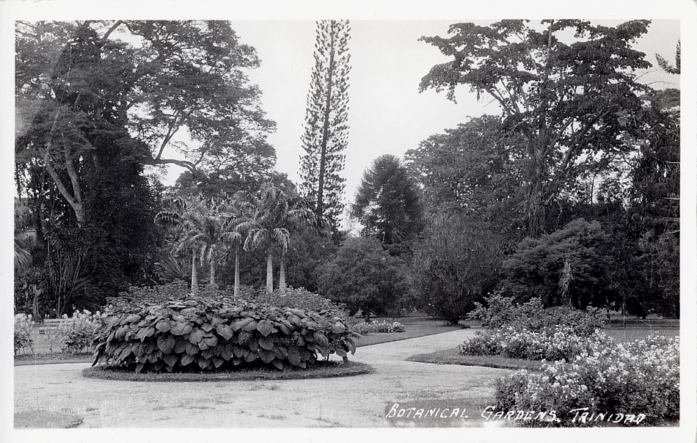

The image above may be accessible via the following web address: http://www.flickr.com/photos/striderv/2546526590/in/set-72157601052586092

These two post cards (above and below) display how well kept the botanical gardens were. Moreover, viewers can see the accommodations of clean walkways and nicely manicured shrubberies. Viewers can also see the tall trees that visitors could find in the botanical gardens. Finally, these postcards also appear to be actual photographs; some could have been high quality postcards, known as RPPCs (“real photo postcard”).

Trinidad Botanical Gardens –

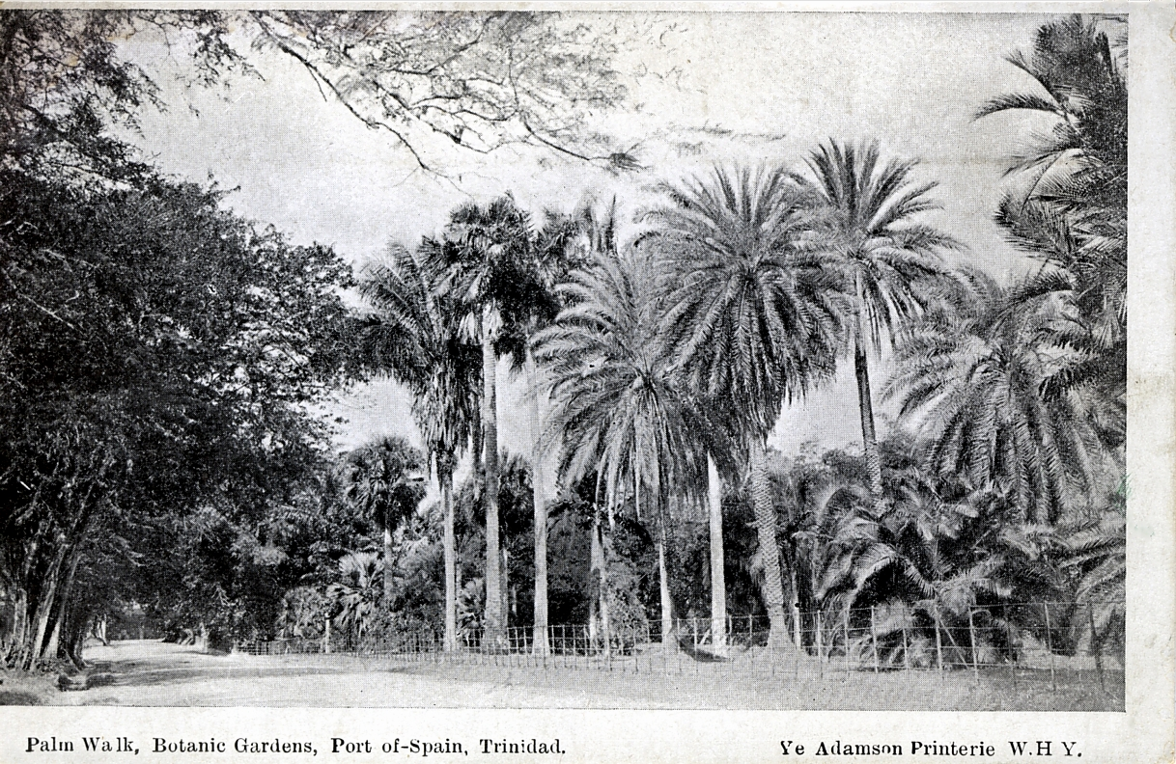

The image above may be accessible via the following web address:
http://www.flickr.com/photos/striderv/2750694465/in/set-72157601052586092

Other postcards were often artistic renderings, like small paintings, drawings, or watercolors. For example, the next image is a non-photographic postcard of the botanical gardens, and on the far left, a viewer can see the bandstand that might have been the one mentioned in Rupert Gray.

Botanical Gardens with Bandstand –

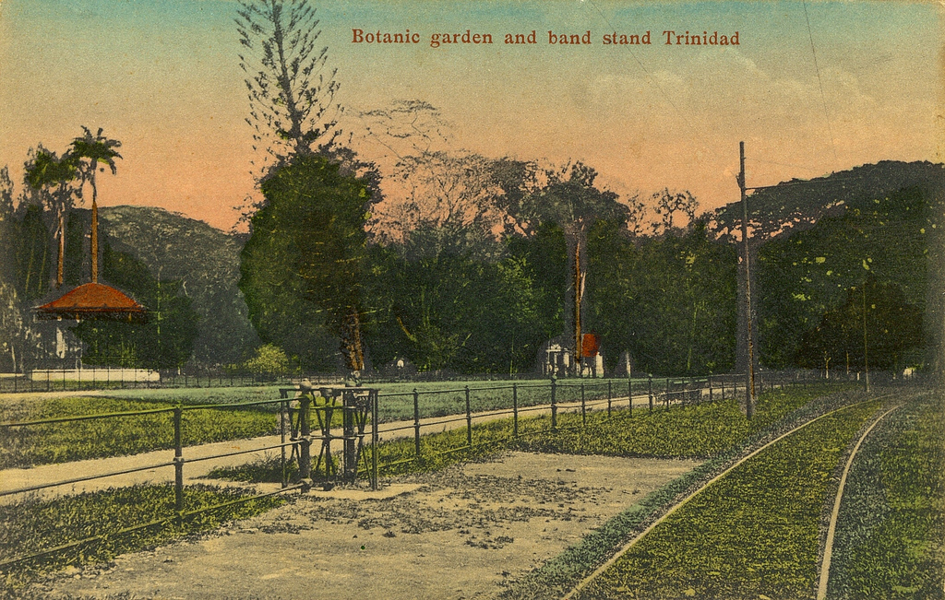

The image above may be accessible via the following web address:
www.flickr.com/photos/striderv/3825819989/in/set-72157601052586092/

Viewers ought to notice in the first two postcards of the botanical gardens and then also the one of the bandstand that there are no people around. Does these seem like a “savannah [that] was all animation,” as the narrator says of the scene in chapter 9 (Cobham 51)? These postcards already demonstrate how representations of foreign lands in postcards were posed and created by the photographers. That no one is walking around in these postcards has the effect of focusing the viewer’s gaze on the features of the botanical gardens—the nicely kept lawns and enormous trees. But, it also prohibits the viewer from seeing locals or natives who may visit the gardens. With the erasure of the gardens’ visitors, then, the postcard attempts to create an authentic image of the garden, an image that is actually contradictory: the gardens are a picture of undisturbed yet ordered beauty.

In the next two postcards below, there are two different fountains in each, and one postcard has an image of Government House, which was located in the botanical gardens. Again, viewers should notice how no individual is walking around.

Botanical Gardens and Fountain –

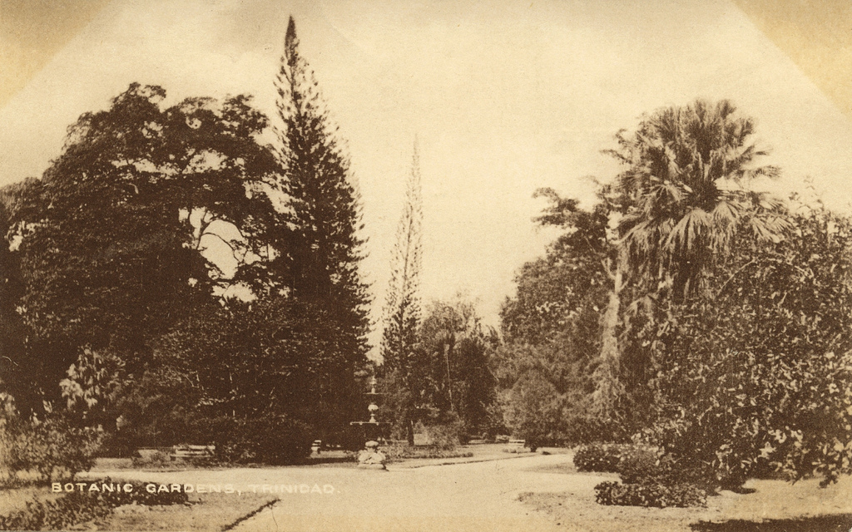

The image above may be accessible via the following web address:
http://www.flickr.com/photos/striderv/3837091148/in/set-72157601052586092/

This first fountain could likely be the fountain around which the “chubby” limbed children were dancing and playing (Cobham 51). But, here, there are no little children, let alone people of any kind, around. The effect of the people-less postcard is one that accentuates the features of the gardens: a nice walkway, a pristine fountain, and a verdant bunch of trees.

Botanical Gardens and Government House –

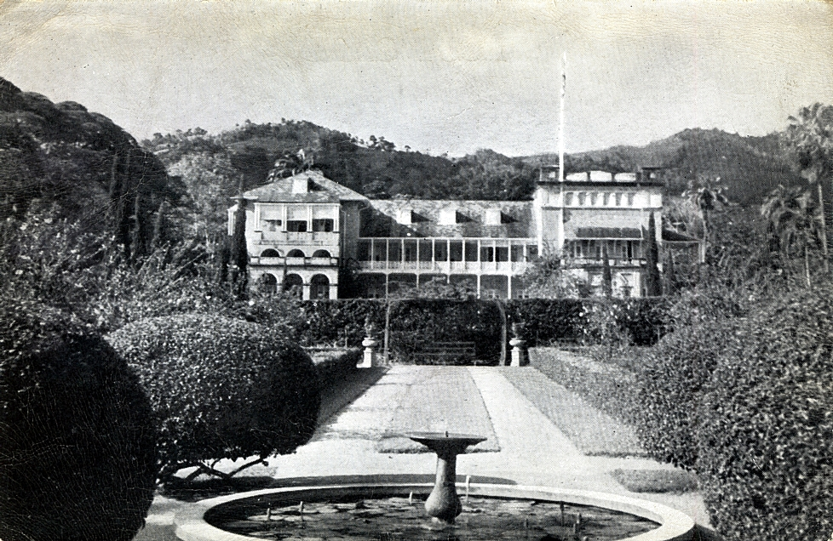

The image above may be accessible via the following web address:
http://www.flickr.com/photos/striderv/2929719452/in/set-72157601052586092

Another place mentioned in chapter 9 of Rupert Gray is the Queen’s Park Hotel. This was one of the most prestigious hotels to stay in during the late nineteenth and early twentieth centuries, and it was often busy with dozens of visitors. The first of the following three postcards of the Queen’s Park Hotel is postmarked “1906,” only a year before Rupert Gray was published. Again, viewers should note that no one is entering, exiting, or even strolling by the hotel—and it is clearly sunny out!

Queen’s Park Hotel –

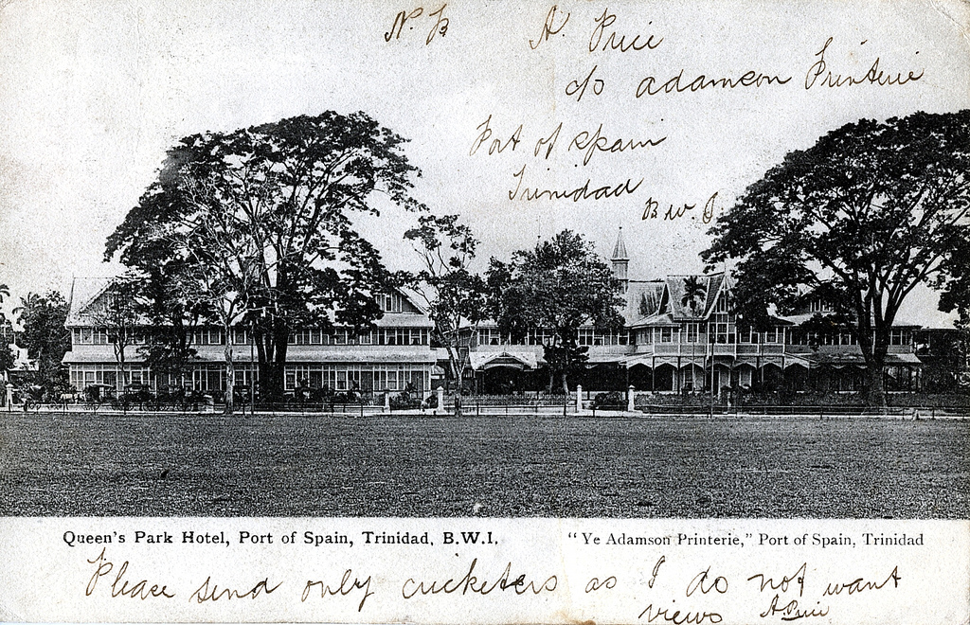

The image above may be accessible via the following web address: http://www.flickr.com/photos/striderv/2928841351/in/set-72157601052586092/

Queen’s Park Hotel –

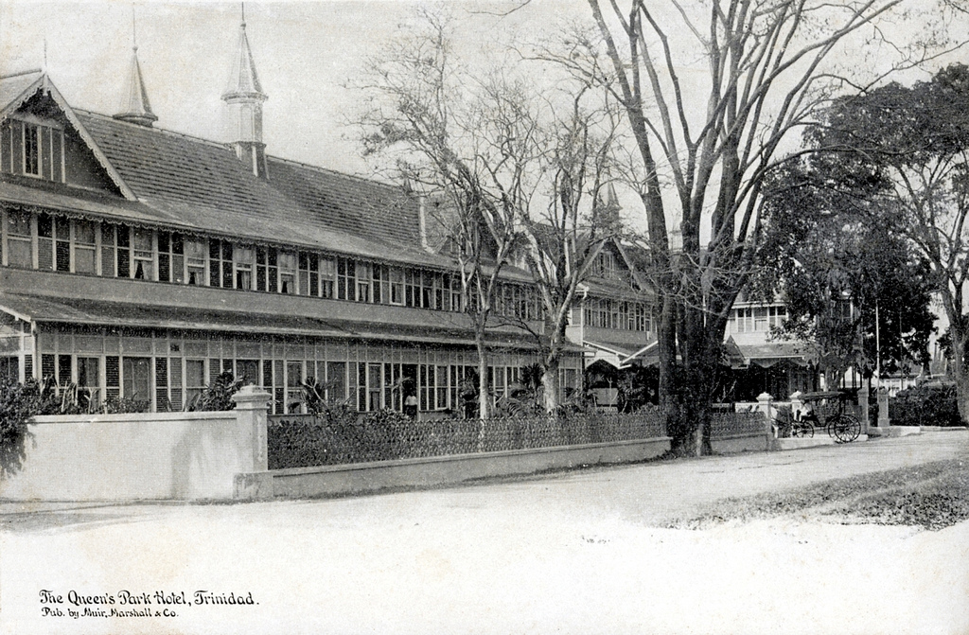

The image above may be accessible via the following web address:
http://www.flickr.com/photos/striderv/3401519745/in/set-72157601052586092

Queen’s Park Hotel –

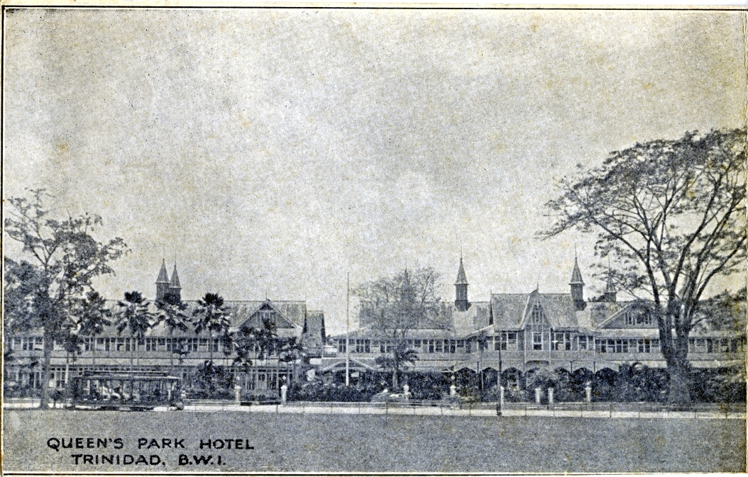

The image above may be accessible via the following web address:
http://www.flickr.com/photos/striderv/3079470256/in/set-72157601052586092/

Sadly, this beautiful hotel was demolished in 1930s (or thereabouts—there is conflicting information), and a new hotel was built in the art deco style. The art deco hotel is now the headquarters of BPTT, British Petroleum of Trinidad and Tobago, a subsidiary of the oil company BP. (That the former Queen’s Park Hotel became an internationally owned subsidiary of an oil conglomerate demonstrates a new form of neocolonialism.)

While the postcards provided so far in this guide have had no people in them, there are, however, postcards with people. Yet, even the postcards with people are staged and created, just like those first few postcards.

Here is a photograph of Trinidad’s Marine Park. Though it was not mentioned in Rupert Gray, this postcard of Marine Park is a good example of what a group of “typical” local people might look like in a postcard from the early twentieth century.

Marine Park with “Typical Negros” (to use the parlance of Cobham’s narrator from the scene in the botanical garden) –

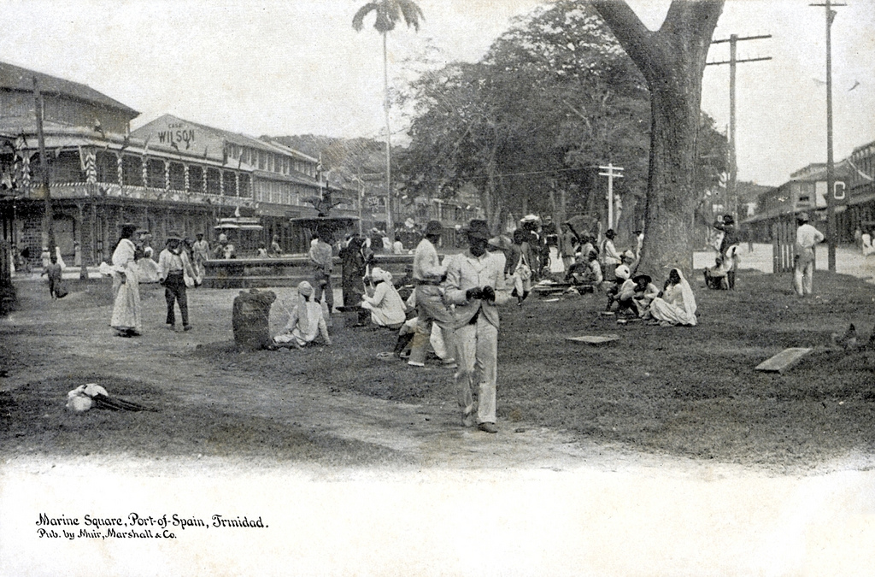

The image above may be accessible via the following web address:
http://www.flickr.com/photos/striderv/3401523045/in/set-72157601052586092/

This postcard may be one of the few postcards that were staged the least, for it appears as if the photographer merely chanced upon the scene and took a picture. However, viewers can see that, perhaps, a few of the photographs’ subjects (the women at the base of the tree on the right; the man in the hat directly beneath the “Wilson” signage) are looking at the photographer. They have noticed the photographer is there. A question for readers of this guide: how might this postcard feel differently than the postcards without people? Whereas the postcards without people merely look like a nice scene, this postcard allows the photographed subject to “look back” at the viewer. This itself—the viewer looking at the postcard’s subjects—is what Mary Louise Pratt calls a contact zone (see definition of ‘contact zone’ above in footnote 4).

If the postcards without people create an authentic scene of ordered and undisturbed beauty in the botanical gardens—which highlights the features of the gardens—then, the inclusion of people in a postcard like the one above seems to highlight other features—what Afro-Caribbeans look like, how they dress, or what they do. The people in Marine Park from the postcard above become something to look at, like the trees or walkways of the botanical gardens.

In the next four postcards, viewers see the “typical negro” again, but this time, the “typical negro” is under a tree, in the exact same manner that Lady Rothberry observes Rupert Gray. Moreover, the first three (of the next four postcards) show Afro-Caribbeans under trees in the botanical gardens, though none of them is under a Hog Plum tree.

“Typical Negro” under a Tree (again, to use the parlance of Cobham’s narrator from the scene in the botanical garden) –

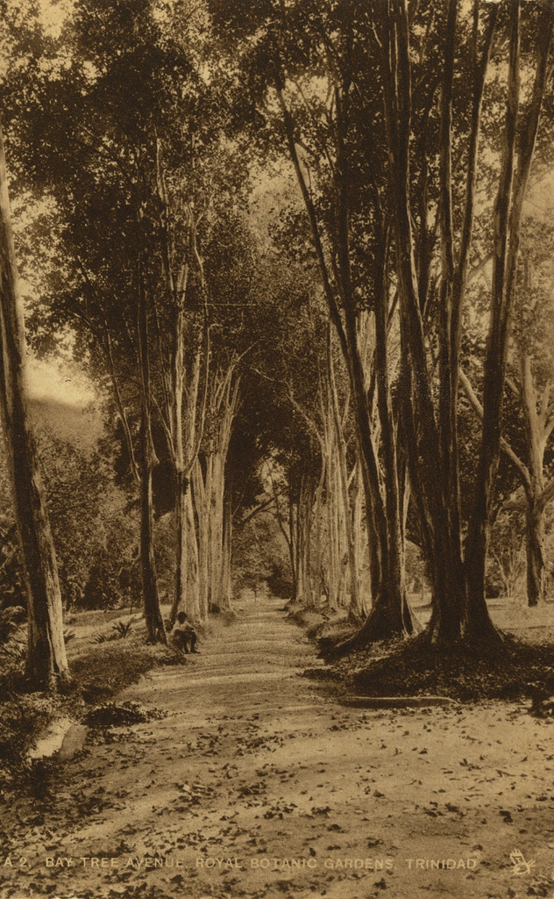

The image above may be accessible via the following web address:
http://www.flickr.com/photos/striderv/3836309577/in/set-72157601052586092/
“Typical Negro” under a Tree –

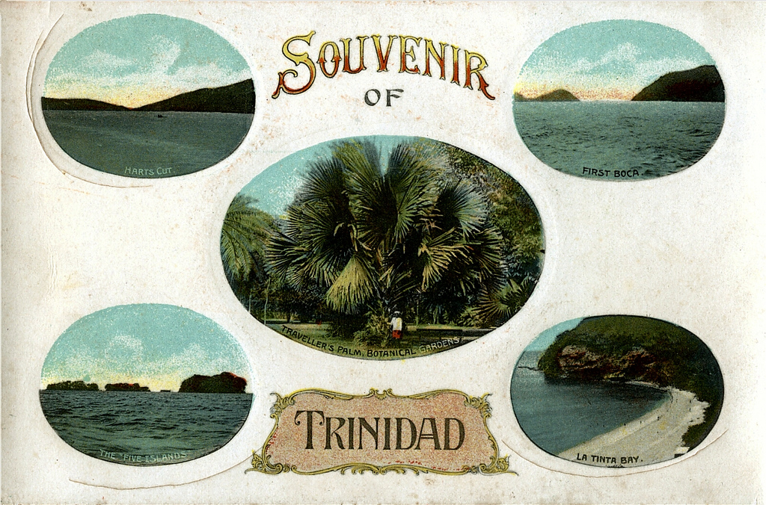

The image above may be accessible via the following web address:
http://www.flickr.com/photos/striderv/925192497/in/set-72157601052586092/

The first three postcards (the two above and the next one below) have the Afro-Caribbean persons looking at the camera, or at the artist in the case of the second one. The subjects look back at the viewers. Again, how do the first three postcards seem different from the fourth below, in which the Afro-Caribbean person is looking away from the camera?

“Typical Negro” under a Tree –

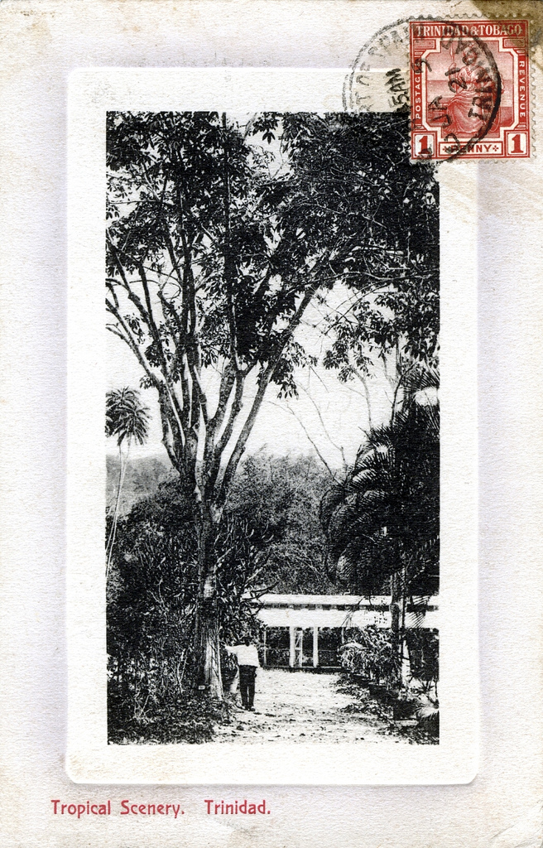

The image above may be accessible via the following web address: http://www.flickr.com/photos/striderv/3511002408/in/set-72157601052586092/
“Typical Negro” under a Tree –

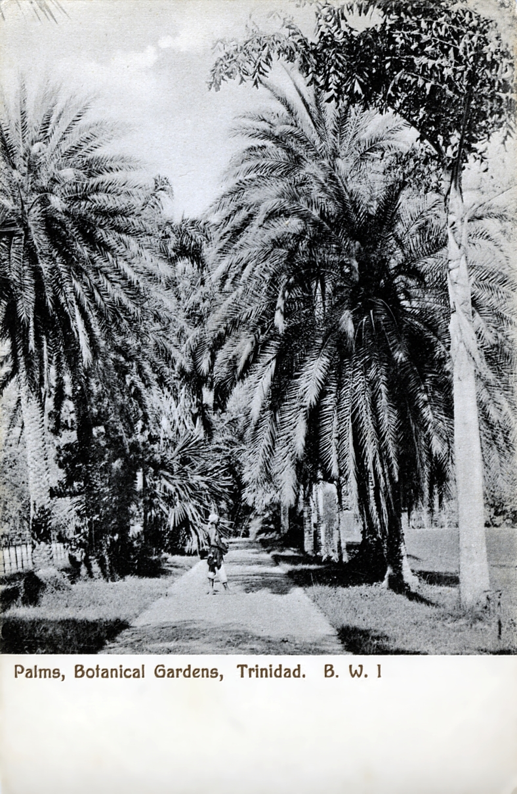

The image above may be accessible via the following web address: http://www.flickr.com/photos/striderv/2652042669/in/set-72157601052586092/

As this guide has tried to show, the descriptions of the scene in chapter 9 of Rupert Gray closely resemble the postcard industry’s choice of representation of Trinidad in the early twentieth century.

Study Questions

- Why are some postcards devoid of people and others not? What is the effect of having people in or nowhere in postcards?
- How do you feel when you see the postcards without people versus with people? How do you feel when the subject “looks back” at you?
- Which postcards do you like the most? Why?
- What are other aspects of chapter 9 that seem like a postcard?
- Why do you think the scene in chapter 9 mimics contemporary postcards?

Colonialism

Note: Much of the discussion that will occur in this section on colonialism builds upon the previous two sections on Botany and Tourism.

A brief definition of ‘colonialism’ is simply the expansion of an empire (usually one country, such as Great Britain or France) by acquiring or creating new territories, and, in turn, these new territories are under governmental, political, social, and economic control of the mother country, which is also known as the metropole. Furthermore, the relationship between the metropole and its colony or colonies is often characterized by an unequal distribution of economic, political, social, or self-governmental autonomy, customarily in the mother country’s favor. For example, Trinidad, for much of its existence, was a colonial possession of Spain and then Great Britain, though during Spanish rule many of Trinidad’s foreign settlers were French or descendants of the French. Thus, in understanding Trinidad’s status as a crown colony (see definition of ‘crown colony’ above in footnote 7), the people who lived in Trinidad and who were neither white nor descendants of white Europeans had little control over their economic, social, or political livelihood. A power imbalance existed between England and Trinidad, and the authority rested primarily in England.

Colonies, like Trinidad, were often the places where much of the empire’s economic capital came from, either from farming cash crops or from export tariffs. In Rupert Gray for example, Rupert works as an accountant for Primrose Serle, a proprietor of cocoa and sugar, which were major cash crops for export, making Primrose and others of his class great amounts of money. The uneven distribution of the profits and income from Primrose’s crops between himself and his workers mirrors the relationship of colonialism between the metropole and the colony. Indeed, even saying that the crops were Primrose’s crops erases the labor of or connection to the actual Afro- or Indo-Trinidadian laborers that worked the land. For example, Tobin, writing about James Grainger, an English poet that visited the West Indies in the late 1700s, captures this same sentiment of attributing the work of laborers, slaves in the case of James Grainger’s poetry, to the landowners, like Primrose. Tobin writes, “In keeping with his tendency to credit the plantation owner or nature with the creation of agricultural bounty and to deny enslaved Africans agronomic knowledge and skill as producers, Grainger reduces their stature as agriculturalists to the purely physical form of labor” (Tobin 46). That the people of color receive little credit also appears in other travel texts from the nineteenth century.

Charles Kingsley, an English novelist, professor of history, and priest of the Church of England, visited the West Indies, specifically Trinidad, and like Grainger, Kingsley recorded his travels in his book At Last: A Christmas in the West Indies. One of the places Kingsley visits while in the West Indies is no other than the Trinidad Botanical Gardens. He writes,

[T]he Botanic Gardens … are a credit, in more senses than one, to the Governors of the island. For in them, amid trees from every quarter of the globe, and gardens kept up in the English fashion, with fountains, too, so necessary in this tropical clime, stood a large ‘Government House.’ This house was some years ago destroyed; and the then Governor took refuge in a cottage just outside the garden. A sum of money was voted to rebuild the big house: but the Governors, to their honour, have preferred living in the cottage, adding to it from time to time what was necessary for mere comfort; and have given the old gardens to the city, as a public pleasure-ground, kept up at Government expense.

Readers should note how the gardens are credited to the “Governors of the island.” Also of note is Kingsley’s tone toward the governor: the poor governor has to take “refuge in a cottage.” It is hard to imagine a colonial governor out tending to the garden! Kingsley also indicates how all the trees come “from every quarter of the globe,” a direct reference to colonialism and the exportation and importation of crops or natural plants. Kingsley even describes the botanical gardens in much the same way the narrator of Rupert Gray describes them:

This Paradise—for such it is—is somewhat too far from the city; and one passes in it few people, save an occasional brown nurse. But when Port of Spain becomes, as it surely will, a great commercial city, and the slopes of Laventille, Belmont, and St. Ann’s, just above the gardens, are studded, as they surely will be, with the villas of rich merchants, then will the generous gift of English Governors be appreciated and used; and the Botanic Gardens will become a Tropic Garden of the Tuileries, alive, at five o’clock every evening, with human flowers of every hue with human.

The botanical gardens are a paradise, like the biblical Eden or Zion that the narrator of Rupert Gray calls them. Also in this section, readers ought to heed whom Kingsley mentions: “an occasional brown nurse” and “rich merchants.” He also equates wildly colored plants to the different colored peoples. Again, a disparity exists between the laborer (the nurse, in this case) and the owners (the merchants). The merchants are for whom the great work of the gardens exist—work that apparently the governors made possible.

The work of the botanical gardens that Kingsley attributes to the governors fits within two larger themes relating to colonialism: Georgic poetry and exploitation, both of which have been hinted at thus far. Created by the poet Virgil, Georgic poetry is, simply, poetry that focuses on aspects relating to agricultural or farming life. However, it frequently demonstrates an “erasure of labor” (Tobin 35). Thus, Kingsley’s ignorance of the actual people work in the botanical gardens lays bare the problem of Georgic poetry in relation to colonialism. For example, he disregards the fact that the land on which Trinidad’s Botanical Gardens exist had to be cleared by someone, and it certainly was no governor. (McCracken notes that the original land on which Trinidad’s Botanical Gardens sits were actually quite swampy [111]). Kingsley also omits the fact that there has to be workers that keep the garden well manicured. Finally, this false attribution suggests significance given to not simply the governors but to the empire itself. Like Tobin argues, “As markers of elite status, cultural capital, and scientific expertise, tropical plants within these various botanic and horticultural discourses were also suggestive of British mastery over the globe’s natural resources” (171).

The “mastery” of “natural resources” points to an issue of exploitation in the system of colonialism. Plants were not only shipped across the world to botanical gardens for their beauty and for the pleasure of wealthy English merchants or governors, but they were also transported between differing “agricultural research stations” within the various botanical gardens located all over the empire (McCracken 135). And the main overseer of all these importation and exportation of plants across the British Empire was located in London. According to Rita Pemberton “the imperial government was interested in the establishment of a complete catalogue of the islands [sic] flora and kept close watch an [sic] developments through its agency, the Royal Botanic Gardens, Kew” (20). The belief that “pure science would extend the entitlement of colonial power” was one of the principles that governed the reason for having botanical gardens (Goss 188).

Thus, botanical gardens became agri-centers of the system of colonialism and the empire. Indeed, as Nina Antonetti writes, “The rapacious exploitation of the New World colonies for plantation development and exportation of cash crops in the eighteenth century led scientists to recognise nature as both bountiful and fragile. British colonial botanical gardens played an important role in achieving this understanding” (138). These discoveries also reciprocated the colonizing of conquered or acquired territories, for, as Roy Bridges claims, “With technological superiority came presumed intellectual superiority: Europeans could claim to be able to understand and interpret not only the terrain they entered but the inhabitants as well” (53). This relationship of colonizer to the colonized peoples went hand-in-hand with the agricultural practices of the botanical gardens, for the goals and practices of the metropole “streamlined…the needs of the imperial government and its perception of what was best of the colony’s agriculture” (Pemberton 20).

Study Questions

- How does Cobham’s description of the botanical gardens scene relate to Kingsley’s view of the botanical gardens? Does Cobham mirror Kingsley or offer a revision of Kingsley’s depiction? For example, Rupert is standing in the botanical gardens, demonstrating his labor of botany. What other ways is Rupert signifying labor that either is similar to or different from Kingsley’s representation of labor?
- How does the relationship between metropole and colony play out in the scene with Rupert and Lady Rothberry?
- Note who does the moving in the scene in Rupert Gray. Who sees whom? Who moves towards whom? Is this important? Why or why not?

Grand Tour

As a conclusion to this guide, we should look to the scene in which Rupert travels to England. In this scene, which comes from chapter 16, entitled “Fiat Justitia, Ruat Coelum,” the “West Indian native” travels to England, and thus the novel moves from the colonial space of Trinidad and the botanical garden to the center of the empire (Cobham 54). Here, too, is another interaction between Gray, now the foreigner, and a Rothberry, though this time it is Lady Rothberry’s nephew, who is now the native. As in the Botanical Gardens, there is an obvious focus on objects that symbolize power of some sort: in the botanical garden, the plants signify knowledge of their types and invoke the issue of “race”; in Gray’s European travel, there are ruins, statues, and memorials that comprise the “grand tour,” on which the Earl of Rothberry takes Rupert—a way the Rothberrys impart knowledge and, consequently, power to the colonial subject Rupert (102). In each instance, different artifacts—plants or places (the “sights” of Europe)—symbolize knowledge or power in some way and demonstrate different types of relationships between the characters.

A grand tour was an educational journey that wealthy young Englishmen often took to learn about the history of Europe. These tours became very commonplace throughout the nineteenth century, according to Roy Bridges and James Buzard, critics on travel literature. Moreover, as Buzard points out, the practice of grand tours led directly to the advent of mass tourism (38), the same type of tourism the postcards will become a major part of. The connection between the grand tour and tourism links this second scene to the chapter where Lady Rothberry visits Trinidad and consequently Rupert. So when Rupert travels to England, the Rothberrys want to provide Rupert with his own form of educational travel. Thus, the young Earl of Rothberry takes him around Europe.

The route that the Earl of Rothberry and Rupert Gray take is similar to the second of the two primary routes established for grand tours (see Cobham 102-3). According to Buzard, the first set path was to travel across the channel to France and then south through southern France to Italy, with lots of stops along the way, and then the return journey back to England took a northerly route through Austria and Germany. The second established path was simply reversed (Buzard 39), which is the itinerary Rupert follows. Rupert however begins his grand tour by first traveling around England and Scotland, a necessary lesson if the tourist were not familiar with the home country (Buzard 37). Moreover, once Rupert ends the usual circuit (England, Scotland, France, Germany, Austria, and Italy), his journey does not stop there, for he then travels to Greece, Egypt, the Holy Land, India, the Bearing Strait, Canada, and finally New York (Cobham 103). This is, indeed, the grandest of tours because Rupert gets an almost total expedition around the world.

The purpose of the grand tour was “an ideological exercise,” relating to the issue of cultural capital (see definition of ‘cultural capital’ above in footnote 5; Buzard 38). The ideology that Buzard cites is the notion that an education can relate to mastery of knowledge, hopefully leading to benefits of power—high social standing and great riches. The purpose of the travel is also to define the limits or boundaries of the world, as Gikandi has suggested of travel by British men in his book Maps of Englishness (87). When Rupert, a black accountant from Trinidad, embarks upon his grand tour, he experiences something that normally would be reserved for rich white men. Thus, he is able to cross the boundaries of race and class almost as simply as he is able to cross the borders of countries. The reasoning for his ease of crossing such boundaries is rooted in his earlier abilities to appear as a gentlemen not only to Lady Rothberry but also to many other characters in the novel. As literary theorist Belinda Edmondson argues, “Rupert Gray is a peculiarly Caribbean version of the African American uplift novel, a story founded on the concept of black self-determination and respectability that reconciles black nationalism with a desire for brown status and English approval” (73). Because he is conversant in the rhetoric of science and because he is gentlemanly, Rupert is able to contrast older, stereotypical images of Afro-Caribbean men. As literary critic Raphael Dalleo writes,

Rupert Gray tells a story that makes a modern, professional black man its hero and poses his position as a contrast to both the black working class and the literary intellectual. Rupert is an intellectual in his own right, and his story has anticolonial implications: as Rosenberg notes, the novel makes the case for self-government ‘by envisioning an Afro-Trinidadian as the most prominent politician in a Trinidad with representative government’.” (Dalleo 80; Rosenberg qtd. in Dalleo 80).

Study Questions

- Where can you see instances of colonialism in the grand tour Rupert Gray takes?
- What do you think Rupert Gray actually learns from his grand tour?
- Why is Rupert Gray’s grand tour larger than the grand tour that Buzard provides?
- Is Rupert Gray a problematic figure or is he a revolutionary figure? Why or why not?
Conclusion

The purpose of this guide was to utilize these two smaller chapters and illuminate the various influences of the early twentieth century that were real political, social, and economic issues relating to Botany (and science), Tourism, and Colonialism. Finally, this guide employed chapters 9 and 16 as sections for close reading analyses that opened up these larger issues throughout the text.

Cobham’s text illustrates the engagement of early national and Pan-African writers with tourism and horticulture. The two chapters that comprise the focus of this guide demonstrate Cobham’s understanding of colonial discourse and orientalism, which is a false understanding of non-European cultures that is based on European prejudices of or against the other non-European culture, because readers see how clearly Rupert Gray engages issues in science (botany) and commerce (tourism), which are both inextricable from colonialism and imperialism.

Rupert Gray also demonstrates a contrast between the two scenes that highlights how Rupert moves up from being classified as a “typical negro” of tourist photographs to being the type of elite citizen of the world who goes on a grand tour and eventually becomes a Senator in the government of Trinidad.

As should be clear, Rupert is a unique figure working for more than just his romance with Gwendoline. He is very much a man who is, as Edmondson suggests, moving up in society and, as Rosenberg argues, making the case against Trinidad’s crown colony status and for Trinidad’s self autonomy. Rupert’s actions in both the Botanical Gardens scene as well as the Grand Tour should indicate the literary value but also the cross-cultural and historical merit of further study into Stephen N. Cobham’s Rupert Gray.

Acknowledgments
This guide would not have been possible without the helpful guidance of Leah Reade Rosenberg (Associate Professor in the Department of English at the University of Florida); nor would it have been as successful as a digital production without Laurie Taylor, Ph.D. (Digital Humanities Librarian in the George A. Smathers Library at the University of Florida). Finally, but nowhere in the least, I give special thanks to Eric Scott Henderson with whose permission I was able to include the postcards that readers have seen in this guide. His collection of postcards of Trinidad made much of this guide a visual success. Readers of this guide may access the Eric Scott Henderson Collection of postcards at the following web address:

http://www.flickr.com/photos/striderv/

Henderson’s collection is not limited solely to Trinidad and Tobago but includes thousands of images of postcards from other countries.

Works Cited
Antonetti, Nina. “British Colonial Botanical Gardens in the West Indies.” Botanic Gardens: A
Living History. Eds. Nadine K. Monem and Blanche Craig. London, UK: Black Dog, 2007. Print.
Bridges, Roy. “Exploration and Travel Outside Europe (1720-1914).” The Cambridge
Companion to Travel Writing. Eds. Peter Hulme and Tim Youngs. Cambridge, UK: Cambridge University Press, 2002. 53-69.
Buzard, James. “The Grand Tour and After (1660-1840).” The Cambridge Companion to
Travel Writing. Eds. Peter Hulme and Tim Youngs. Cambridge, UK: Cambridge University Press, 2002. 37-52.
Cobham, Stephen N. Rupert Gray: A Tale in Black and White. Kingston, Jamaica: UWI Press,
2006. Print.
Dalleo, Raphael. Caribbean Literature and the Public Sphere. Charlottesville, VA: University of
Virginia Press. Print.
Edmondson, Belinda. Caribbean Middlebrow: Leisure Culture and the Middle Class. Ithaca,
NY: Cornell University Press, 2009. Print.
Gikandi, Simon. Maps of Englishness: Writing Identity in the Culture of Colonialism. New York:
Columbia University Press, 1996. Print.
Goss, Andrew. “Decent Colonialism? Pure Science And Colonial Ideology In The Netherlands
East Indies, 1910-1929.” Journal Of Southeast Asian Studies 40.1 (2009): 187-214.
McCracken, Donal P. Gardens of Empire: Botanical Institutions of the Victorian British Empire.
London: Leicester University Press, 1997. Print.
Pemberton, Rita A. The Trinidad Botanic Gardens and Colonial Resource Development, 1818-
1899. 1997. Print.
Pratt, Mary Louise. “Arts of the Contact Zone.” Profession 91 (1991): 33–40.
Schiebinger, Londa. Nature’s Body. Boston: Beacon Press, 1993. Print.
Tobin, Beth F. Colonizing Nature: The Tropics in British Arts and Letters, 1760-1820.
Philadelphia, PA: University of Pennsylvania Press, 2005. Print.

For further reading on Rupert Gray, botanical gardens, and other miscellany:
Danforth, Susan. “Cultivating Empire: Sir Joseph Banks And The (Failed) Botanical Garden At
Nassau.” Terrae Incognitae 33 (2001): 48-58.
Rosenberg, Leah Reade. Nationalism and the Formation of Caribbean Literature. New York:
Palgrave Macmillan, 2007. Print.
Schiebinger, Londa L. and Claudia Swan. Colonial Botany: Science, Commerce, and Politics in
the Early Modern World. Philadelphia, PA: University of Pennsylvania Press, 2005.
Print.
Thompson, Krista. “The Evidence of Things Not Photographed: Slavery and Historical Memory
in the British West Indies.” Representations 113.1 (Winter 2011): 39-71.

A ‘secondary source’ is a text that interprets or analyzes a ‘primary source,’ and the ‘primary source’ for this teaching guide is mainly Rupert Gray but also the pictures and vintage postcards as well as any other descriptions of Trinidad or tourism from authors other than Cobham.
The ‘novel of manners’ tradition started in the 18th century but continued through the 19th and well into the 20th centuries, with notable authors such as Jane Austen, the Brontës, and Edith Wharton, all who are considered canonical authors. The novel of manners primarily dealt with a specific class of people and their behavior, especially romantic love, amongst themselves. The ‘manners’ of the novels come through in the social codes, broken or unbroken, that frame the characters’ interactions.
‘Peerage’ refers to a legal system of hereditary nobility, such as dukes, earls, or barons, for example.
A ‘contact zone’ refers to “social spaces where cultures meet, clash, and grapple with each other, often in contexts of highly asymmetrical relations of power, such as colonialism, slavery, or their aftermaths as they are lived out in many parts of the world today” (Pratt 33).
First formally theorized by Pierre Bourdieu, a French sociologist and philosopher, ‘cultural capital’ refers to the non-monetary value of intelligence or education that allows individuals to maneuver in society, especially when they can advance. For example, as will be seen in later sections of this reading guide, Rupert is able to demonstrate he is as smart as Lady Rothberry, and, in turn, she gives him financial and moral assistance for his education; had he not been able to demonstrate his intelligence through his knowledge of botany in the botanical gardens, Lady Rothberry would probably not have offered her assistance to him. He also gains cultural capital from the grand tour he takes.
When an author creates a scene, they have a choice of ‘construction’: for example, which characters are there, how are they portrayed, how are they communicating, and where is the scene taking place?
‘Government House’ was the common name for any official residence in a colony of the British Empire, especially colonies in the West Indies. After such colonies gained independence from Britain, the various Government Houses often became the residences of the new countries’ presidents or prime ministers. A ‘crown colony’ was administered by a governor whom the ruling Monarch of the United Kingdom of Great Britain appointed. Until 1925, Trinidad was run solely by the colonial governor, which often meant that those who were not white, not British-born, or descendants of the white, British families (i.e., Creoles) had little influence on the politics governing their country.
An ‘idyll’ is usually a poem written like a pastoral, which is an idealized version of rustic or country life on the land. In such a way, nature is always beautiful and sweet—not a scary wilderness.
A ‘terminus’ is a destination point for carriages or cars, much like the word ‘terminal.’
‘Exceptionalism’ is the belief or set of beliefs that a society or country is ‘exceptional’ and above all others. Here, it would be that Europe is better than any other place in the world.
Often a ‘pedigree,’ which is a person’s ancestral line, is provided for important people or more commonly nowadays for animals. Since people do not depend as much on being born rich or poor for social advancement or social privileges, we tend to think of pedigrees for purebred animals.
The Aryan race becomes more important in the 1930s when Adolph Hitler takes power in Germany. Hitler’s holocaust was intended to eradicate those individuals who did not have the attributes of the Aryan race. The Battle of Agincourt in 1415 is notable for being one of most historic victories for King Henry V of England in the Hundred Years War against France, a battle also made famous by the St. Crispin’s Day speech in William Shakespeare’s play Henry V.
The orchids, Jangli Almond trees, and coffee are examples of plants not native to Trinidad that were imported during the 19th-century boom of botanical gardens in Europe and its colonies.
Like the Battle of Agincourt, the Battle of Waterloo in 1815 is remembered as a glorious victory for England against France.
‘Holy land’ refers to the current region of Israel and Palestine, where much of the religious texts of the great religions (Christianity, Judaism, and Islam) come from.
‘Art deco’ is a style of architecture that flourished in the early- to mid-twentieth century. It was a style that was distinctly modern and industrial. Art deco buildings look elegant but definitely modern, such as the Empire State Building.
After the heyday of colonialism, all imperial countries lost control over the former colonial colonies—Trinidad gained independence in the 1960s. These imperial countries do not have governors overseeing the colony, nor do they have militaries controlling them. Former imperial powers, like Great Britain or the United States, can influence the former colony’s politics and commerce by instituting practices of ‘neocolonialism,’ which is “the economic and political policies by which a great power indirectly maintains or extends its influence over other areas or people” (Merriam-Webster.com).
This teaching guide excerpts from an electronic version of At Last, which can be found through the following web address: http://www.readbookonline.net/read/19430/55453/
See previous note 18.
See previous note 18. Also Laventille, Belmont, and St. Ann’s are smaller sections of the country of Trinidad, now parts of the capital, Port-of-Spain. Tuileries is a large and very grand public park in Paris.

