French Pamphlet Planning Project: An International Collaboration for Improvement of Collection Access (NEH Planning Grant) - SobekCM Technical Information
(Updated: 15 June 2013)

Overview
The NEH-funded planning grant for the French Pamphlet Planning Project: An International Collaboration for Improvement of Collection Access is ongoing from 2013-2014 with the SobekCM Digital Content Management System and related technologies supported by the University of Florida Libraries. This document provides additional information on SobekCM and the technologies for the French Planning Project. The developing FPP digital portal supported by SobekCM is here: http://ufdc.ufl.edu/fpp

SobekCM Digital Content Management System
The French Pamphlet Project (FPP; http://ufdc.ufl.edu/fpp) database utilizes the SobekCM Digital Content Management System (http://ufdc.ufl.edu/sobekcm).
SobekCM allows users to discover online resources via semantic and full‐text searches, as well as a variety of different browse mechanisms. For each digital resource in the repository there are a plethora of display options, which may be selected by an appropriately authenticated use. This repository includes online metadata editing and online submissions in support of institutional repositories. The SobekCM repository supports online metadata editing and online submissions.
The SobekCM software engine powers both the UF Digital Collections (UFDC; www.ufdc.ufl.edu) and the Digital Library of the Caribbean (dLOC; www.dloc.com) digital repositories. The SobekCM software was developed at the George A. Smathers Library at the University of Florida by Mark Sullivan, with ongoing effort spanning several departments. Additional user testing, input, and resources have been contributed from other libraries, universities, and archives around Florida, the Caribbean, and beyond. See the credits (http://ufdc.ufl.edu/sobekcm/credits) for more information.
SobekCM is released as open source software under the GNU GPL license and can be downloaded from the SobekCM Software Download Site (http://ufdc.ufl.edu/software). To learn more about the technologies, please visit the SobekCM page (http://ufdc.ufl.edu/sobekcm).
Some of the outstanding features of the SobekCM digital library include:
- Fully searchable and browseable ‐ with browse options for all and new items, and customizable browses for all metadata fields(e.g., subject, author, publisher)
- Powered by rich metadata support, with automatic transformations for maximum interoperability
- Google‐map based searching or map browsing, when geographic metadata is available
- Broad, internationally applied description methods using METS/MODS Metadata with all records automatically transformed and available as MARCXML and qualified Dublin Core metadata
- Integrated support for OAI‐PMH (Open Archives Initiative) and optimized for search engine access ‐ via Google, and other search engines
- Ability to serve various organizational options including: hierarchical groupings allowing collocation by Area, topic, and geographical hierarchies for College, Department; monographic, page‐turning functionality; multiple files connected to one descriptive record; one item, one record; mapping between various versions of a single work; and journal volume, issue, title organization.
- Internationalized/localized interfaces in English, Spanish, and French

Building the Database
The proposed FPP digital portal will build on existing metadata by directly exporting current records from institutional and federated catalogs in order to populate a resulting database. The records will be augmented to include links to existing digital facsimiles when available.
SobekCM and its associated tools (http://ufdc.ufl.edu/software) provide robust metadata support for ingesting MARC records into METS/MODS and MARCXML. SobekCM allows records to be directly imported with all information retained and usable, individually and in batches. After records are imported, SobekCM provides an easy to use graphical interface for authenticated users to add hyperlinks to records to link to available digital facsimiles.
One of the existing current workflows for creating portal collections using SobekCM is:
- Select/identify materials for inclusion
- Acquire and import records (importing from CSV, EAD, MARC, and OAI‐PMH feed using the SobekCM METS Editor; for more information: http://ufdc.ufl.edu/metseditor/batch and http://ufdc.ufl.edu/UF00103089/00003
- Add a link to the record in FPP for the online resource location
- Add/enhance the existing metadata (e.g., adding geographic coordinates to the record to power map‐based searching and browsing)
UF’s open access servers have the necessary memory and storage capacity to support, organize and deliver the above described digital metadata and content involved in the project planning process. As the project expands beyond planning stages, UF has the technology infrastructure and programming expertise to ensure long‐term sustainability of interactive digital collections. UF can easily scale to match collaborative project needs, including CRL’s possible future hosting role, due to its commodity storage, supported through UF’s central IT.

Sustainability of project outcomes and digital content
In practice consistent with all other UF digital projects, the FPP database will be maintained in perpetuity as a redundant digital archive (for details, see: http://ufdc.ufl.edu/sobekcm/preservation). Moreover, the resulting French pamphlet database resource and portal will be integrated with other existing CIFNAL association projects (Bibliothèque Bleue, Digital Library of the Caribbean, Microfilm Project) insuring future development and perpetual association oversight and management. The resulting project plan will serve to inform the NEH Humanities Collections and Reference Resources Program implementation application (Jul 19 2014) for funding of the project from 2015 to 2018. From 2014 to 2015 the CIFNAL FPP working group will continue to identify and position relevant materials and corresponding data sets in preparation and support of developed project goals. SobekCM functionalities allow working group members to contribute both in‐person and remotely to continued development of Project structure and organization, including support of possible project migration to CRL in 2014.

Dissemination
The planning and project work completed under this proposal will be promoted broadly to local, national and international scholars and students through publication, presentations and, as part of CIFNAL’s contributions to shared research, missions, and goals. The project portal itself will provide immediate information on partners’ collections, project standards, and working plans. The pamphlet database, in the context of CRL/CIFNAL will be easily accessible by bibliographers and subject specialists who will insure its dissemination through the channels of scholarly communication and support structures as well as contribute to the further development of resources and research direction.
Additionally, UF provides search engine optimization (SEO) for all hosted collections to ensure materials are listed and findable through simple commercial web searches using Google and other search engines (for details see: http://ufdc.ufl.edu/sobekcm/robots). Deliverables produced during the project will be uploaded to CRL’s French Pamphlets Forum page, and linked to partner collection sites. Promotion of project and deliverables will occur through UF official press releases, libraries’ newsletters, email lists, conference presentations, and social media including Facebook, Twitter, blogs, and Wikipedia, among other vehicles used by partners.

Additional Resources
- SobekCM: http://ufdc.ufl.edu/sobekcm/
- SobekCM Resource Object Metadata & Class Structure: http://ufdc.ufl.edu/AA00014734/
- SobekCM Help Documents & Guides: http://ufdc.ufl.edu/sobekcmhelp
- Full grant proposal and other documents: http://ufdc.ufl.edu/AA00012378
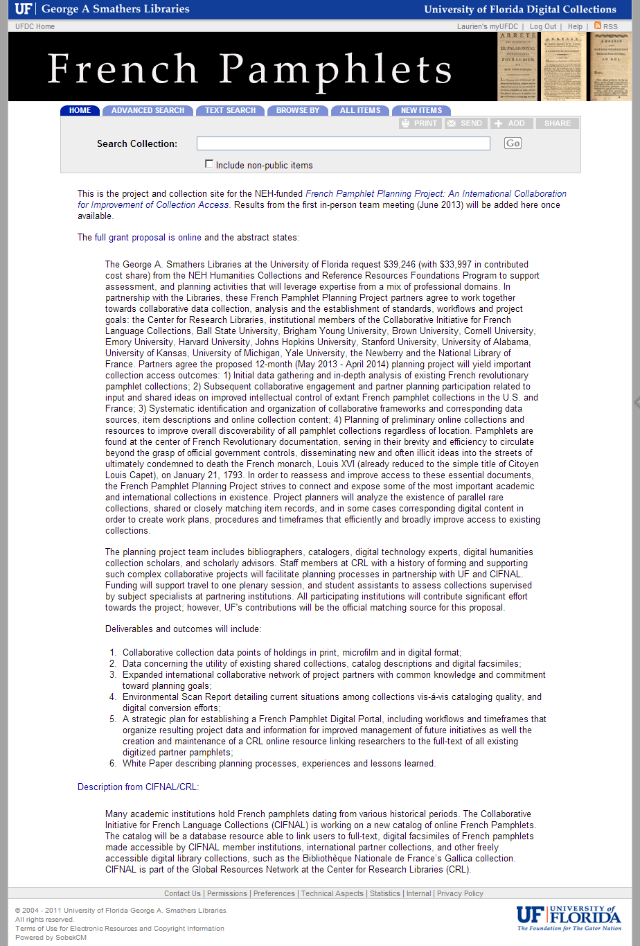
FPP site: http://ufdc.ufl.edu/fpp

