Saving St. Augustine’s Architectural Treasures:
Project Blog

This is the archived content from the project blog for Saving St. Augustine’s Architectural Treasures. The blog is an example of a collaborative documentary project with students and faculty contributors.

The results of the project can be seen in the Carrère & Hastings Digital Collection:
http://ufdc.ufl.edu/caha

The original blog URL is: http://flaglerdrawings.wordpress.com/

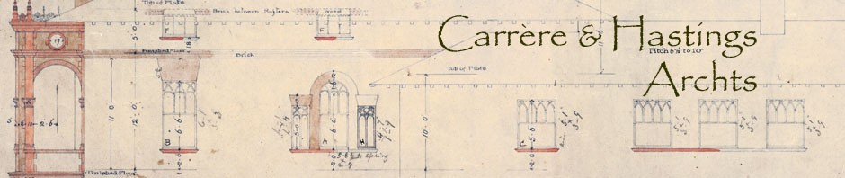

Pages from the Blog
- About the Project
- NEH Support
- Project Partners
- Project Personnel
- Home (blog posts)

Authors (Usernames)
- ufarchivist
- ocrivera
- kimtinnell
- jrb74
- ufdigitizer
- joeka1

About the Project
The Saving St. Augustine’s Architectural Treasures project will conserve and digitize an irreplaceable collection of the earliest architectural drawings of John Carrère (1858-1911) and Thomas Hastings (1860-1929). In 2010 Flagler College received a prestigious Save America’s Treasures grant (administered by the National Park Serviceand the National Endowment for the Humanities) to help preserve architectural drawings for the National Historic Landmark Hotel Ponce de Leon and the Flagler Memorial Presbyterian Church in St. Augustine, Florida. During this two-year project, over 260 drawings will be conserved and reproduced digitally by the University of Florida Smathers Libraries.

Created for Henry Flagler in St. Augustine, many of these drawings had been “lost” for decades. The few people who knew of their existence were unaware of their historical significance. Stored in a boiler room under high Florida temperatures and humidity, and exposed to insects and rodents, this treasure trove remained unknown and endangered until its rediscovery in 2004.

Carrère and Hastings were two of the most significant American architects of the late-19th and early-20th centuries. Their firm designed more than 600 buildings, including the New York Public Library (1902-11) and the House and Senate Office Buildings in D.C. (1908-09). According to Charles D. Warren, co-author of Carrère & Hastings Architects, they were “innovators in both technology and aesthetics.”

Regrettably, as Janet Parks, Curator of Drawings & Archives, Columbia University, states: “Most of the archive of [their] office was destroyed in the 1920s.” Comprised of 267 original, fragile drawings on cloth, silk and paper, as well as blueprints and copies, the collection is the largest known archives documenting the firm’s earliest work.

In 1885 multi-millionaire industrialist Henry Flagler initiated a grand scheme to turn the Florida wilderness into the “American Riviera” and St. Augustine into the “Winter Newport.” The Hotel Ponce de Leon (1885-1887), now Ponce de Leon Hall at Flagler College, was the first and the flagship of Flagler’s resort empire. This palatial Spanish Renaissance Revival hotel, with Italian, French and Moorish influences, was the first major commission for Carrère and Hastings. Nationally significant for both its architecture and engineering, the building is America’s first large cast-in-place concrete building. Following construction of the Hotel, Flagler also commissioned Carrère and Hastings to design the Memorial Presbyterian Church (1889-1890).

In 2005 the drawings for the Hotel and Church were deposited at the University of Florida Architecture Archives to ensure that they were protected and available for research. Many of the drawings cannot be handled because they are literally crumbling on the shelf, and even items in stable condition are in jeopardy due to increasing demand by researchers. These drawings have been inaccessible to scholars for years, but use of the drawings can only occur once the drawings are properly conserved by the UF Libraries Conservation Unit and digitized by the Digital Library Center.

NEH Support

The Saving St. Augustine’s Architectural Treasures project is supported by a Save America’s Treasures grant, administered by the National Park Service and the National Endowment for the Humanities (NEH).

Project Partners
Flagler College
Flagler Memorial Presbyterian Church
University of Florida George A. Smathers Libraries
- Architecture Archives
- Conservation Unit
- Digital Library Center
Supported by: U.S. National Park Service in partnership with the National Endowment for the Humanities

Project Personnel
- Flagler College
  - Leslee F. Keys (Principal Investigator), Director of Corporate, Foundation, and Government Relations Office of Institutional Advancement & Adjunct Faculty in History, Department of Liberal Studies
- University of Florida
  - John Freund, Head, Conservation Unit, Preservation Department, University of Florida Smathers Libraries
  - Matthew Mariner, Digital Validation, Archive, and Preservation Coordinator, Digital Library Center, University of Florida Smathers Libraries
  - John Nemmers (UF Project Director), Descriptive and Technical Services Archivist, Department of Special and Area Studies Collections, University of Florida Smathers Libraries
  - Randall Renner, Operations and Digital Projects Manager, Digital Library Center, University of Florida Smathers Libraries
  - Odette Rivera, Conservation Technician, Conservation Unit, Preservation Department, University of Florida Smathers Libraries
  - Kim Tinnell, Conservation Technician, Conservation Unit, Preservation Department, University of Florida Smathers Libraries

Home (blog posts)
Saving St. Augustine's Architectural Treasures

Collection Guides are now Online
Posted on May 22, 2012 by ufarchivist
The last activity for the project has been completed: full descriptions for the drawings are available online. The Guide to Flagler College’s Hotel Ponce de Leon Architecture Collection is available at http://web.uflib.ufl.edu/spec/manuscript/guides/hotelponce.htm. The Guide to the Memorial Presbyterian Church Architecture Collection is available athttp://web.uflib.ufl.edu/spec/manuscript/guides/memorial.htm. These archival finding aids provide both collection- and item-level links to the digital images available in theCarrère & Hastings Digital Collection (http://ufdc.ufl.edu/caha).
Posted in arrangement & description, digitization | Leave a comment

Nearing the End
Posted on April 26, 2012 by ufarchivist
We’re excited to be nearing the end of this wonderful project. I’m happy to report that all of the drawings have been conserved and digitized. The digital images are available online at http://ufdc.ufl.edu/caha, and the original drawings are now protected from further deterioration. The guides to the collections will be published on the UF Special Collections website any day now.
A few of the original drawings, now flattened and encapsulated, are going to be on display in the Flagler College Proctor Library for the next few weeks. Lourdes Santamaría-Wheeler, exhibits coordinator for the UF Smathers Libraries, has created posters and labels to promote the project.
Posted in Uncategorized | Leave a comment

Society of Florida Archivists Annual Meeting 2011
Posted on June 15, 2011 by kimtinnell
At the beginning of May 2011, Leslee Keys, John Nemmers, Laurie Taylor, and myself presented on various aspects of this project at the Society of Florida Archivists Annual Meeting which, fittingly, was held at Flagler College. The response to the project was very positive and I think many others who are embarking on similar projects or have architectural drawings/blueprints in their collections were able to get ideas on how to move forward on preserving those objects.
The presentations are available to view through the University of Florida’s Digital Library and are linked below.
Saving St. Augustine’s Architectural Treasures: About the Project
John Nemmers, UF Descriptive Archivist
Saving St. Augustine’s Architectural Treasures: Conservation of Architectural Drawings
Kim Tinnell, Conservation Technician/Student Assistant
Saving St. Augustine’s Architectural Treasures: Digitization of Architectural Drawings
Laure Taylor, UF Digital Library Center
Posted in Uncategorized | Leave a comment

Conservation Treatment-Hotel Ponce de Leon Large Drawing Continued
Posted on January 24, 2011 by kimtinnell
We are continuing work on the very fragile, large drawings of the Hotel Ponce de Leon. As noted in the previous post on these drawings, we have already separated them into three separate sections (as they originally had been), removed the dirty cloth backing, cleaned the surface of the paper, reattached loose pieces, and backed them with a heat set tissue to keep the loose pieces intact and provide the paper with some support while they were being digitized. We have decided to remove the heat set tissue backing and back these drawings with Japanese paper.
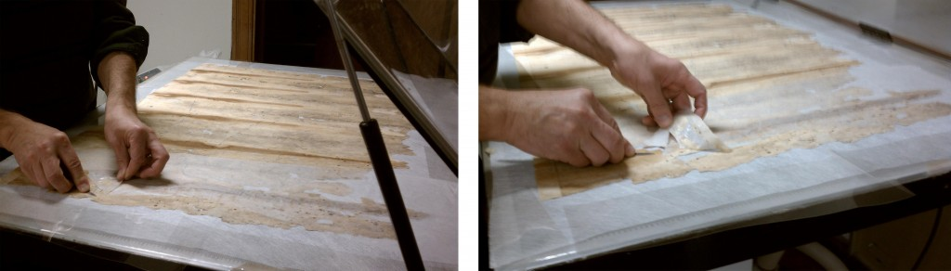
To remove the backing, we place the drawing on a suction table. The suction holds the drawing down as we gently remove the heat set tissue backing by separating it from the drawing with a spatula and pulling it off in small sections. Since conservation materials are designed to be reversible, it comes off relatively easily.
Next, we make starch paste using wheat starch and distilled water, which will be used as the adhesive for attaching the Japanese paper to the drawing. The wheat starch and water are combined over heat until they form a thickened paste. (The Northeast Document Conservation Center has a very informative leaflet on their website on using adhesives to repair paper artifacts. It can be found here.)
After this cools, we apply a thin layer to the Japanese paper making sure we apply the paste in different directions. Japanese paper is prone to stretching and shrinking so applying the paste in different directions helps ensure that it will not stretch or shrink all in one direction once adhered to the drawing.
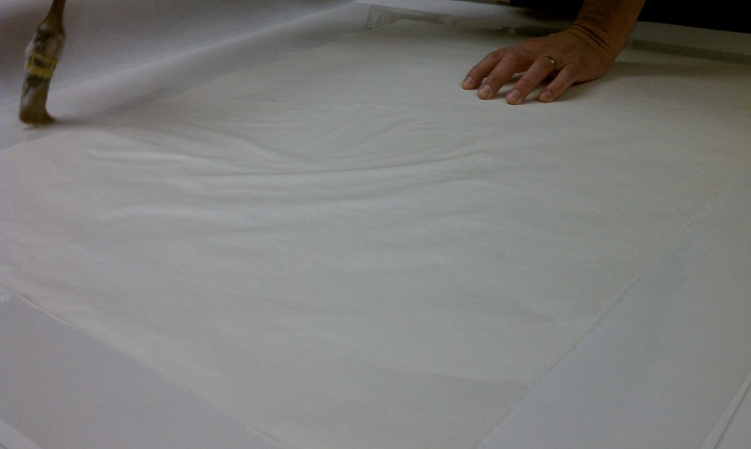
The Japanese paper is then laid on the back of the drawing while it is still on the suction table and is kept there until it dries.
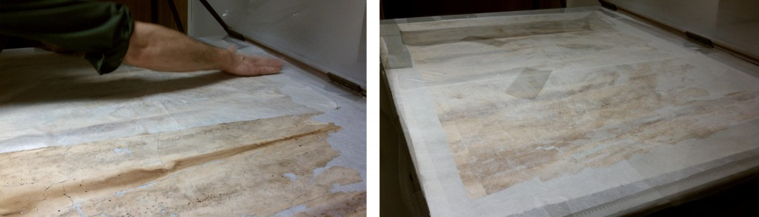
So far we have completed this work on two thirds of one of the drawings. In these images, John Freund, the head of the conservation department, demonstrated this process which I was later able to perform under his supervision. I hope we will finish treatment on the last third of the drawing this week.
Posted in conservation, Flagler College, UF Libraries Conservation Unit | 1 Comment

Flagler Memorial Presbyterian Church
Posted on December 28, 2010 by kimtinnell
We have completed all the conservation work, description, and digitization of the drawings and blueprints of the Flagler Memorial Presbyterian Church. Last week I visited St. Augustine and saw the church (and the Hotel Ponce de Leon). Although I had never been there before, I felt as though I had since I’ve been working with these drawings for a few months and have become familiar with the church’s features. In working so closely with original materials, you begin to feel connected to their history. What was going through the minds of John Carrere and Thomas Hastings as they created original drawings, amended existing blueprints, and visited the sites where the Flagler Memorial Presbyterian Church and Hotel Ponce de Leon would be built? Could they envision the towering dome they had designed for the church as they stood on the empty lot?
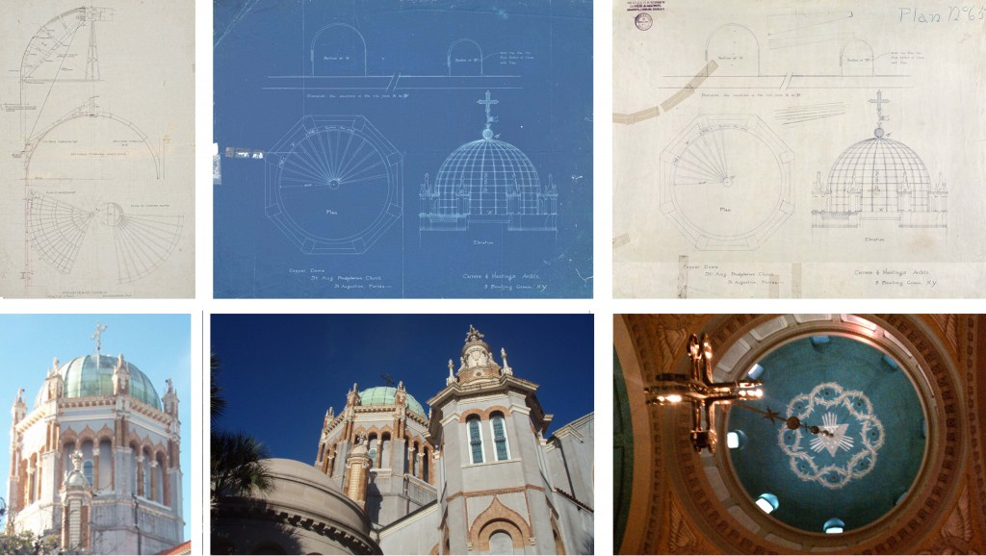
I can hear Carrere and Hastings debating what types of carvings should go on the doors, how high the dome should be, and where walls should be placed as to allow for a large, open space or several small intimate spaces. The previous repairs are interesting, too. I imagine Carrere and Hastings visiting the site, bringing along some of their drawings and blueprints so they can compare and make changes to what has already been built, and opps! one of them tears. An assistant scrambles for Scotch Tape, a stapler, or (in one instance) some paste and a brochure for the Hotel Ponce de Leon to serve as a Band-Aide.
Through this project, history is being preserved in both the content of the drawings and in the drawings themselves as historically significant objects.
Posted in arrangement & description, conservation, Flagler Memorial Presbyterian Church, UF Libraries Conservation Unit | Leave a comment

Conservation Treatment-Hotel Ponce de Leon Large Drawing
Posted on December 9, 2010 by kimtinnell
We have begun to work on some of the drawings in the worst condition. Yesterday, we completed the work on one of the largest floor plans for the Hotel Ponce de Leon. There are four drawings similar to this one that have all been kept in the same conditions.
These drawings are approximately eight feet wide and have been stored rolled up in tubes. Each drawing was originally three separate pieces of paper that were attached to one another. Due to the conditions in which they have been kept, they have started to separate from one another. For conservation and storage purposes, we are separating them into three sections. You can see where the three pieces have started to separate from one another in the photograph below.
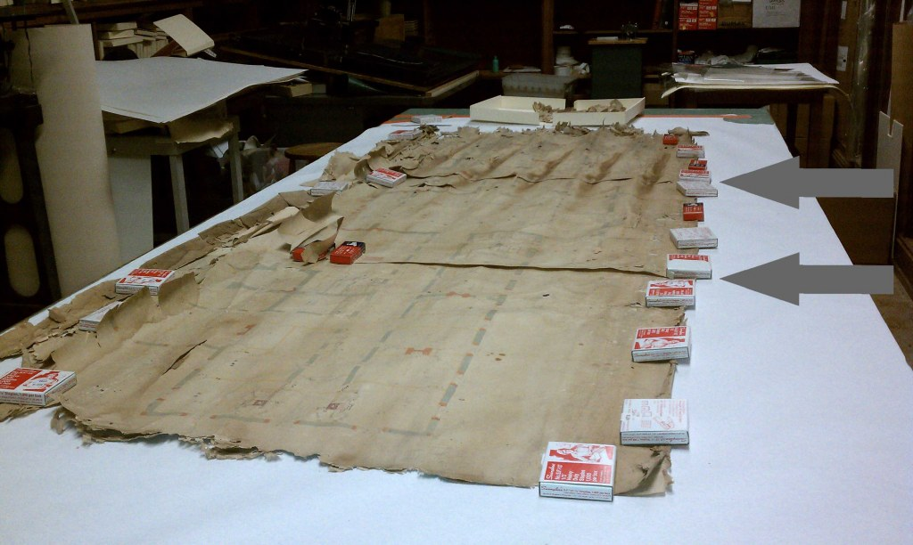
This drawing has a lot of rodent damage (particularly on the left side) and many pieces have come loose. We are setting aside any loose pieces, which can be matched up after the three sections have been separated and flattened.
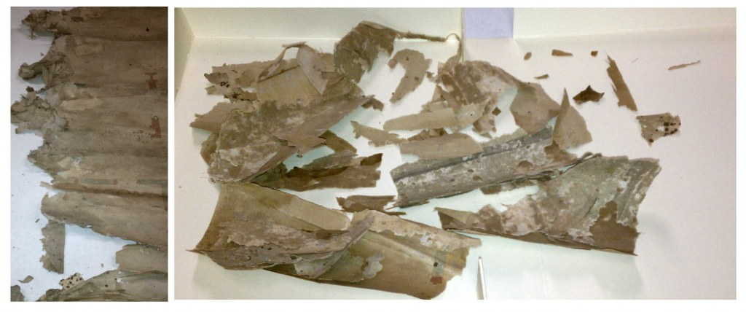
The first step in the conservation process of these drawings is to remove the cloth backing, which is extremely dirty and has mold as well as the remains of insects on it. Because of the previous exposure to humidity, the cloth backing is easily removed in strips.
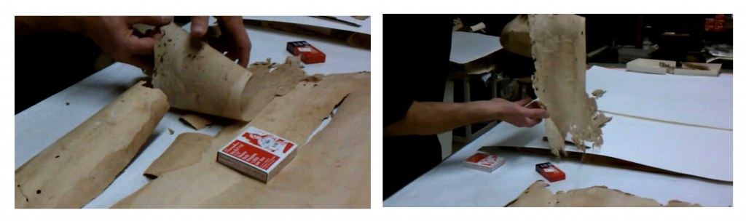
The paper is in fragile, brittle condition. Since it has been stored in a roll, the paper wants to continue to curl on its own. In order to prevent it from breaking as we tried to flatten it, we used a humidifier to help relax the paper. After removing dirt from the drawing’s surface using a low intensity vacuum cleaner and soft brush, we backed it temporarily with heat-set tissue. This makes handling the fragile drawing easier. Because the tissue sticks to the paper, it also allows us to attach the smaller, broken off pieces in the right places.
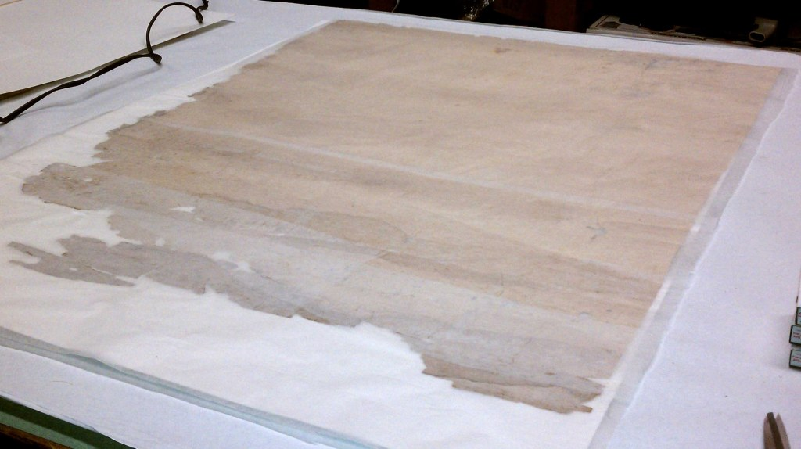
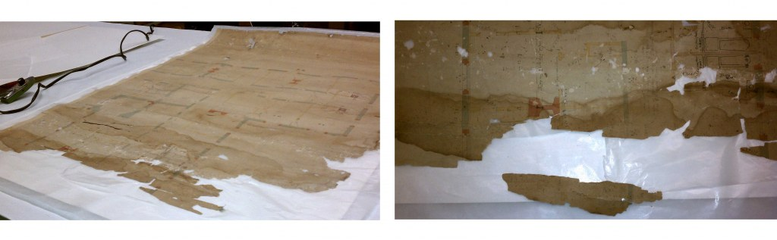
After digitization, we will remove the heat-set tissue and back the drawing with Japanese paper.
Posted in conservation, Flagler College, UF Libraries Conservation Unit | Leave a comment

Conservation Treatment-Encapsulation
Posted on October 27, 2010 by kimtinnell
We have begun encapsulating the blueprints and drawings from the Presbyterian Church. This is the final step in the conservation process. After they are all encapsulated, they will be stored in flat files in the library. While most people will use the digital images of these documents for research, the originals will be available upon request. Encapsulating them will allow for safer handling.
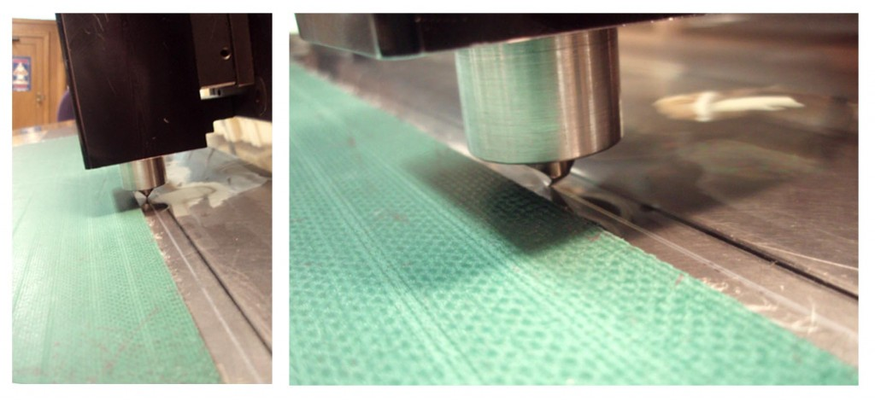
We are encapsulating the documents in Mylar using an ultrasonic encapsulator, which forms a seal using sound waves. Fluctuations in temperature and humidity levels in the environment and other environmental factors such as dust and insects are some of the major agents of deterioration for delicate materials such as these drawings and blueprints. Encapsulating them creates a stable microclimate for the drawing/blueprint to “live” in and keep unwanted intruders out. Because of the chemical processes used to make blueprints and diazotypes, we only seal three sides. Sealing the entire paper would result in creating a microclimate that was damaging to the print.
Posted in conservation, Flagler Memorial Presbyterian Church, UF Libraries Conservation Unit | Leave a comment

Digitizing the Document
Posted on October 26, 2010 by jrb74
Once conservation has finished evaluating and stabilizing the drawings they are sent to the large format queue in Digital Library Center. The DLC set up to digitize anything from film slides to three dimensional objects. For the Carrère and Hastings materials we employ the use of a large format scanner to get a large, detailed image.
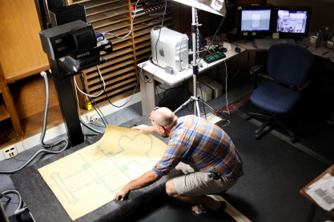
The large format scanner is used when flat work is too big for the Copibooks. It works in the same way a large format film camera works; the larger the surface area of the negative the more detailed the photograph will be. Think of it as a super megapixaled digital camera. The difference between this camera and your average digital camera is this camera employs a progressive scan like your normal desktop scanner. It scans one line at a time, 8000 lines for each image (http://betterlight.com/superModels.html). Because it is a progressive scan type of camera, the document cannot move otherwise streaks will appear in the image. To solve this problem the document is held down with a vacuum table. This also helps eliminate any wrinkles of folds that the document might have. Of course these documents have had, and have, a life of their own and are subject to folds and creases that need to be minimized while caring for the document. To remedy this, we use lighting and reflectors to eliminate wrinkles much like fashion photographers do. One problem we have run into is scanning drawings on tracing paper. The vacuum table is black as to absorb light and not put glare onto what we are scanning, but for many of these drawings the black shows through the tracing paper effectively eliminating the drawing from the scanned image. Our solution has been to first lay down some porous white vellum then place the document on top. We lose some of the vacuum’s power but the resulting image has been much more satisfactory.
Posted in digitization, Flagler Memorial Presbyterian Church, UF Libraries Digital Library Center | Leave a comment

Conservation Treatment-Deacidification
Posted on October 21, 2010 by kimtinnell
We received the Presbyterian Church drawings and blueprints back from the Digital Lab, so we are ready to complete the conservation treatment on these documents. This week we deacidified the original drawings using Bookkeeper Deacidification Spray. Next week we will encapsulate all of the Presbyterian Church drawings and blueprints in order to create microclimates. This will ensure continued preservation of the documents and aid in safe handling.
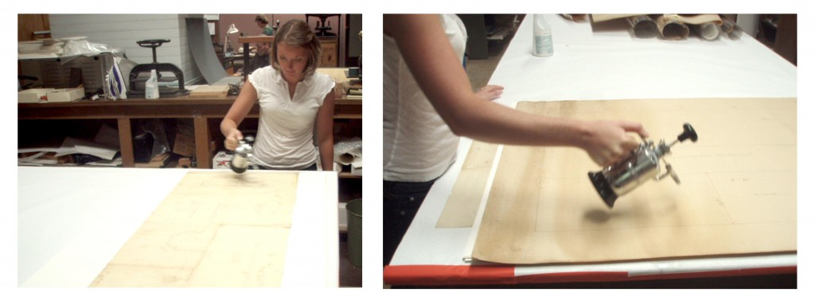
Posted in conservation, Flagler Memorial Presbyterian Church, UF Libraries Conservation Unit, Uncategorized | Leave a comment

Conservation Treatment
Posted on September 30, 2010 by kimtinnell
These architectural drawings have come a long way since their discovery in a basement boiler room in 2004 in the historic city of St. Augustine. Currently, they reside in the paper conservation lab at the University of Florida, where we are now working to preserve them. I began working on this project at the end of August and have already seen the condition of these papers improve greatly. Since August, we have done preliminary conservation work on all the drawings and plans from the Flagler Memorial Presbyterian Church and have sent them to the Digital Library Center to be digitized. Once they have been digitized, we will complete the conservation by deacidfying and encapsulating them.
Fortunately, many of the drawings and plans of the Flagler Memorial Presbyterian Church are in decent condition. (And by decent I mean not falling to brittle bits the second you try to touch them or missing large chunks.) Many of the diazotypes were previously backed with cloth, which has helped keep the paper from being too brittle to handle. In a few instances, a large fold through the middle of the plan rendered it necessary to remove the backing in order to flatten the paper so the digital lab could get a complete image. Once the cloth backing has been removed, you realize how fragile the paper actually is. Many of the hand drawings were not backed with cloth since they were done on thin paper. These have been much harder to handle since there are multiple folds and tears across the entire paper which has become incredibly brittle with age and stress from being previously exposed to poor conditions. We repaired the tears on the back using archival tape and backed two of the drawings using heat-set tissue. Small, tedious wrinkles are folded out using a small metal spatula, an alcohol solution, and a tacking iron. The alcohol solution relaxes the fibers of brittle paper and allows us to return it to its original flatness without breaking off pieces and risking loss of information. The photographs here show the process of removing folds and repairing a tear with tape.
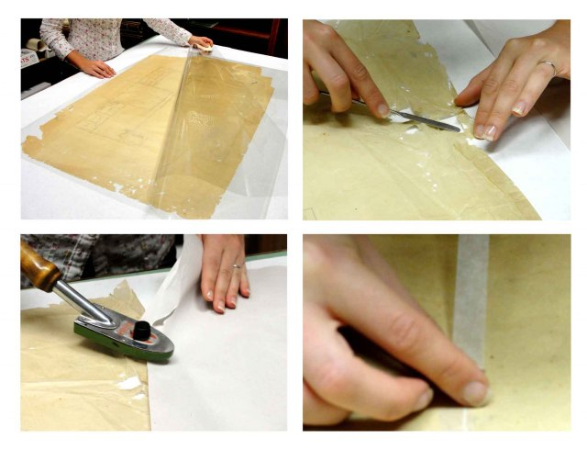
While we await the arrival of the Flagler Memorial Presbyterian Church plans and drawings back from the digital lab, we are beginning the preliminary conservation work of the Hotel Ponce de Leon papers. Unfortunately, these drawings and plans did not fare so well in the hot and humid boiler room and fell victim to hungry rodents with an appetite for irreplaceable materials. Some of the largest plans (measuring over eight feet wide) are rolled up, and when unrolled are revealed for the true puzzles that they are. It’s a good thing I grew up doing 2000 piece puzzles on my mom’s kitchen table. Sorry to say that this time there will be no box top to cheat off of! (But I am looking forward to the challenge.)
Posted in conservation, UF Libraries Conservation Unit | Leave a comment

Preserving the Past
Posted on August 19, 2010 by ufarchivist
We are starting a two-year project to conserve and digitize the earliest architectural drawings of John Carrère and Thomas Hastings, designers of the Hotel Ponce de Leon and the Flagler Memorial Presbyterian Church in St. Augustine, Florida. Future posts will document activities by project team members working at UF in Special Collections, Conservation, and the Digital Library Center.
Posted in project overview | Leave a comment

