Digital Library of the Caribbean (dLOC):
Guide to Adding a New Volume to a Serial

Step 1
Log in to myDLOC: http://www.dloc.com/my

Step 2
Find the serial in dLOC, often a page like this:
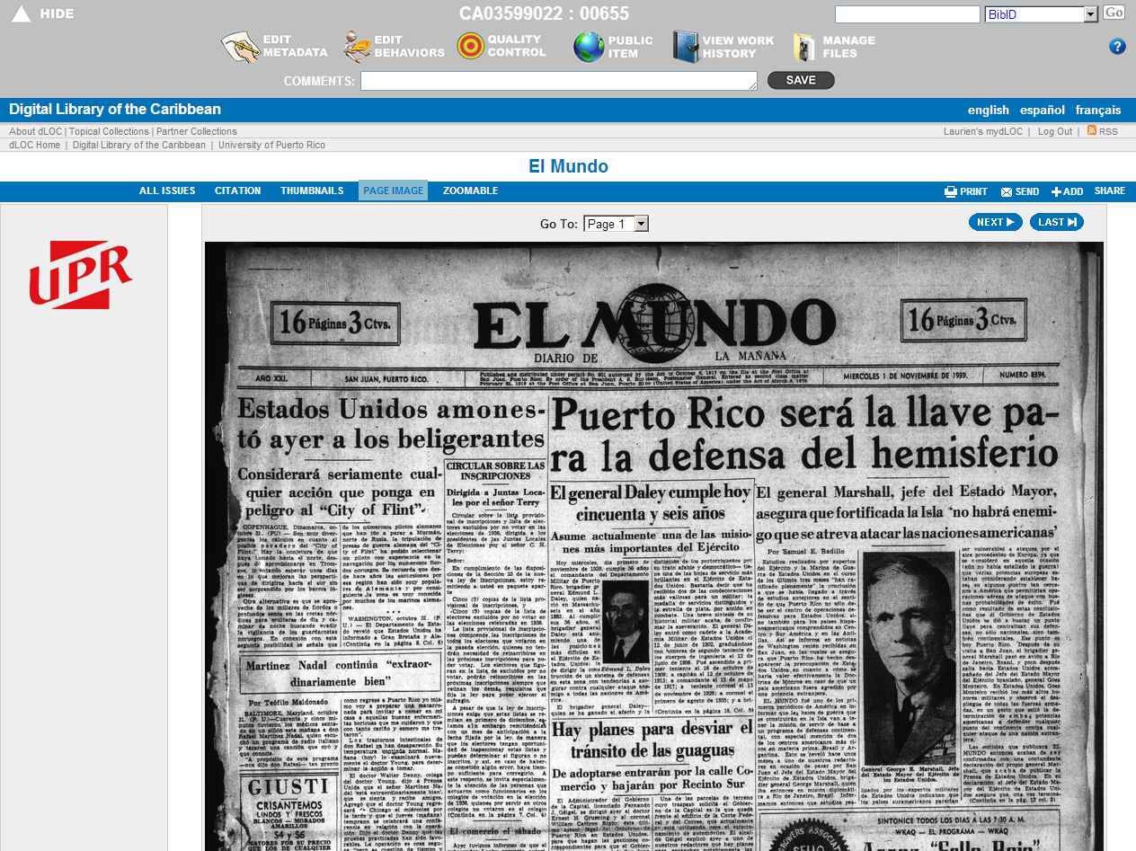

Step 3
Go to the “All Issues” page:
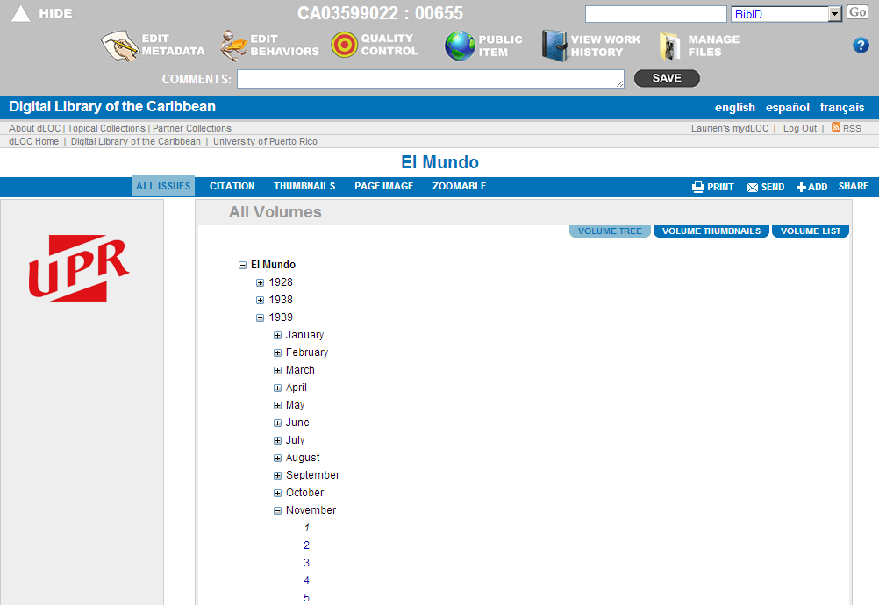

Step 3
When logged in, the “Volume List” link also appears. Click on it to see the page below. Here, scroll to the bottom to click on the last volume or VID.
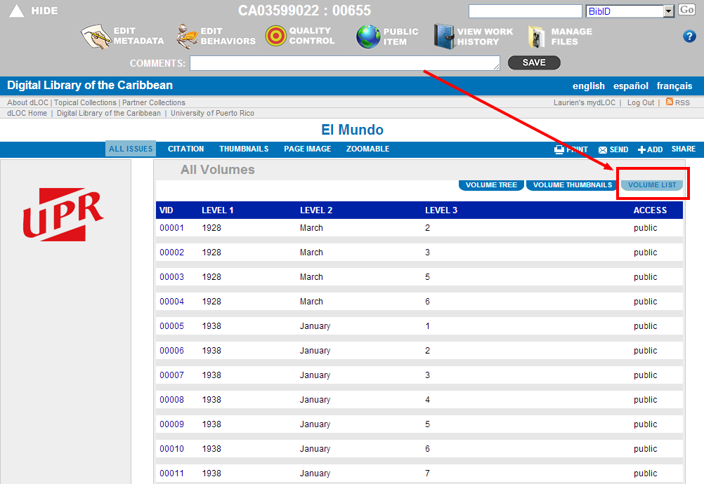
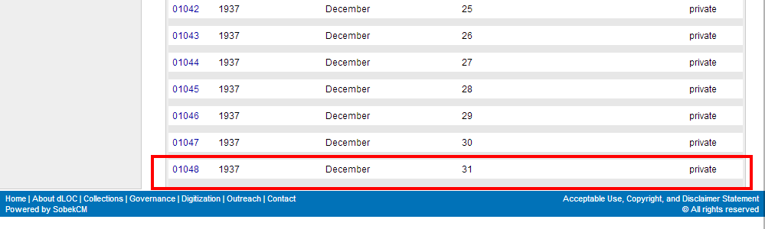

Step 4
Click on the last item to review the last volume metadata and behaviors.
When adding new volumes, the new volumes will inherit the metadata for the Holding and Source Institution, the Aggregations, Wordmarks, and Viewers. Best practices are to review this information before adding new volumes.
Below is a screenshot of the last volume entered at this time. Click on Edit Metadata to confirm the Holding and Source Institutions:
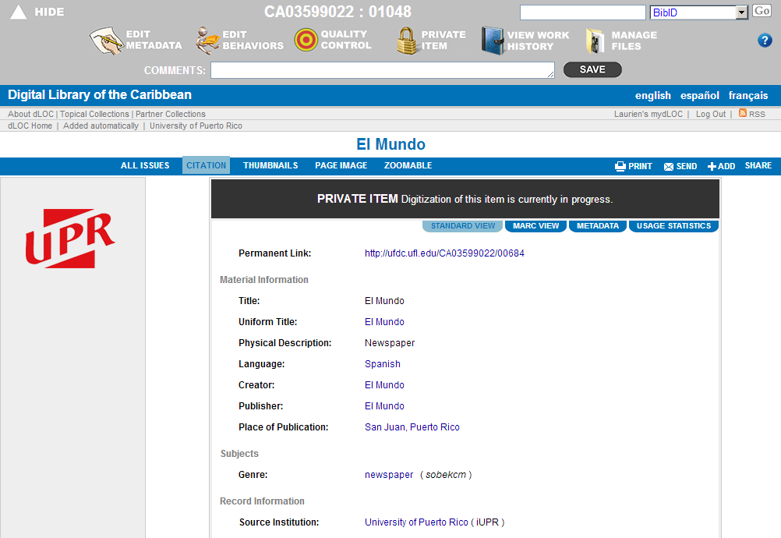

Step 5
In the Edit Metadata screens, click on the tab for “Record Information” to review the metadata for Holding and Source Institution, and to update these if needed. After reviewing these, click Save to save any changes.
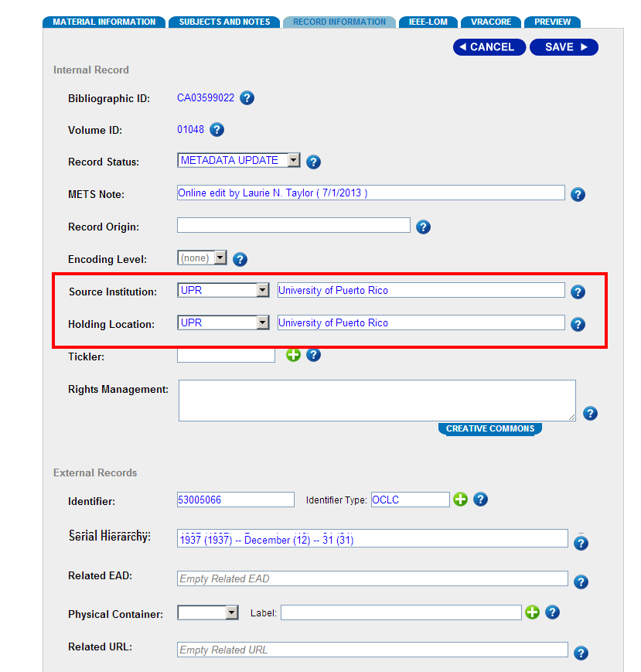

Step 6
Click on Edit Behaviors to review the behaviors.

Step 7
Review the behaviors for Aggregations, Wordmarks, and Viewers. Make any changes necessary, and click save.
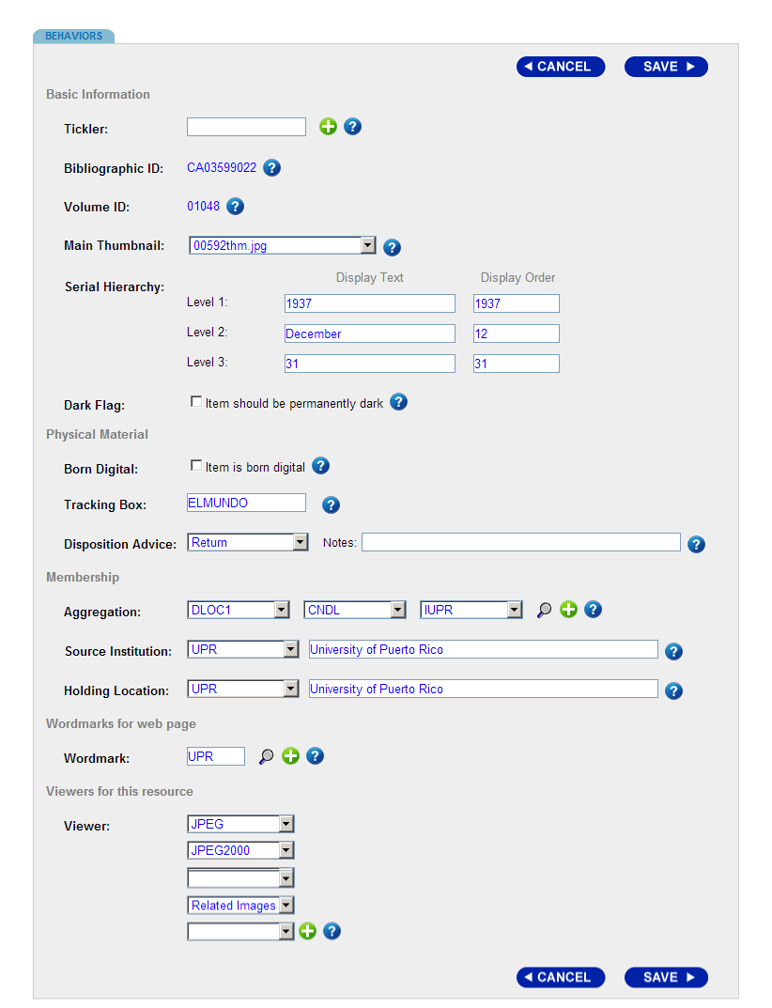

Step 8
After completing the review and verification process, click on the BIBID for the item to go to the main title-level screen.

Step 9
In the main BIBID screen, click “Add New Volume.”
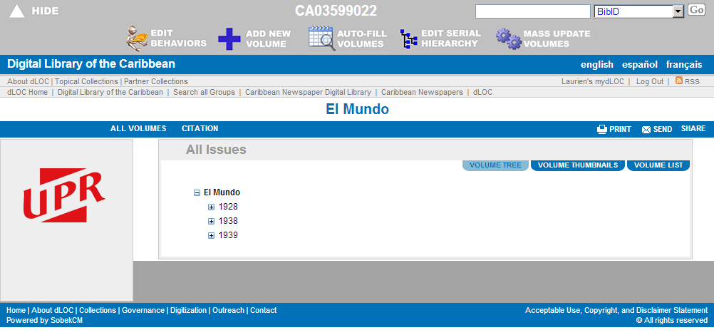

Step 10
Note: The add new volume screen begins with a note on “Import from existing volume” and this is the reason to review the most recent added item before adding new volumes.
To add a new serial, complete the “Serial Hierarchy” information and click one of the “Save” buttons.
See an existing volume or the example after this for the completed serial hierarchy information.
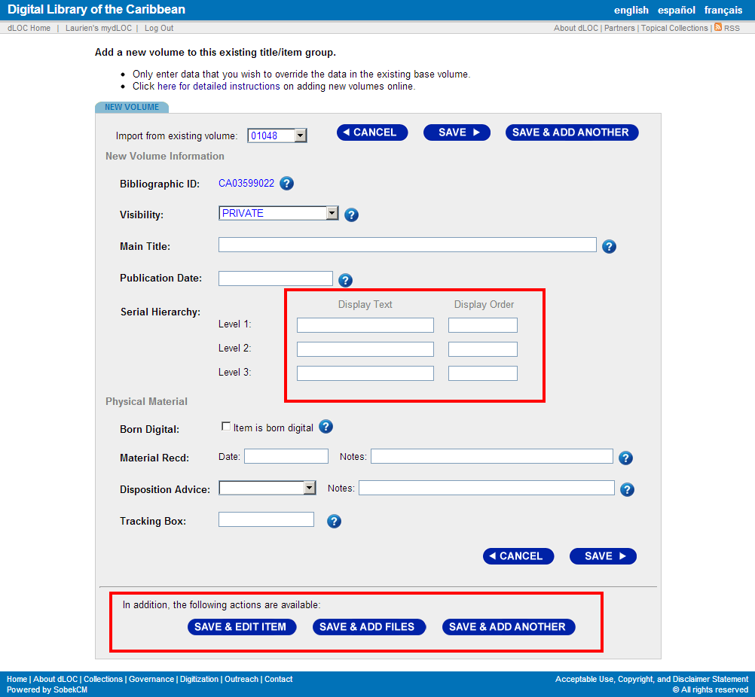

Example:
The example shows the year for the first level (with the text and numerical order, which is the “Display Order” being the same). Then, the second level in this example is January. For this to be computer-organized, January is listed as 1 for the display order. The issue is from January 1. Thus, the third level display text is 1 and the display order is also 1.
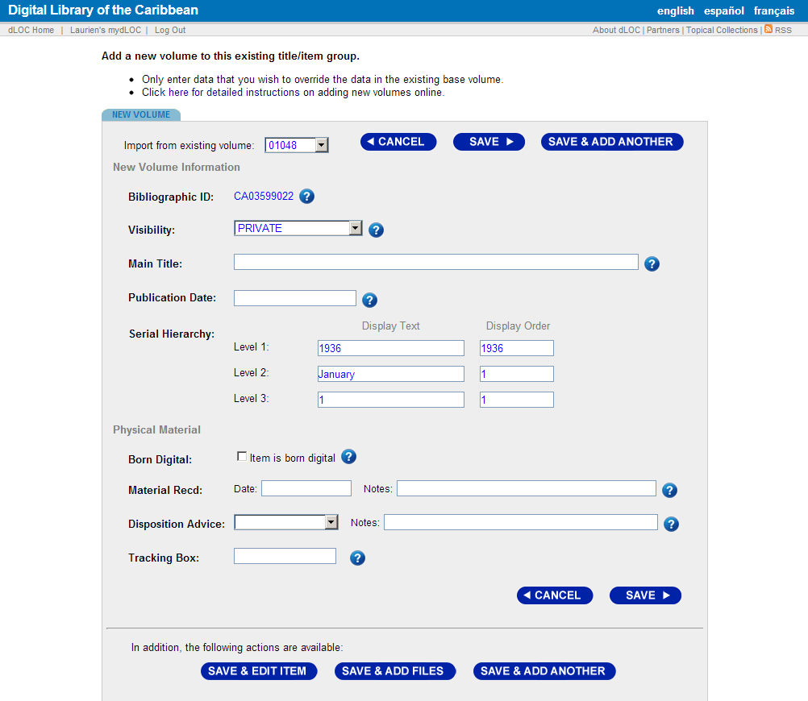

Step 11
After entering in the serial hierarchy, you have several options for “Save”. All of the “Save” buttons are great to use, and it may or may not matter for your workflows which you use.
- Save & Edit Item
  - Brings you to the Metadata Editor screen for the new item
- Save & Add Files
  - Brings you to the item in dLOC, which will only have a citation until files are loaded. From this screen, you can click “Manage Files” to load files.
- Save & Add Another
  - Will keep you on the same page. None of the information will change, except that a small note will be added at the top for “Saved new volume.”
- Clicking on Save brings you to the item in dLOC, which will only have a citation until files are loaded.
Depending on your local workflow, there may be a preference for one of these over the others. There also may not be a preference and all the save options allow you to easily get to the next part of the workflow.

Step 12: Upload Files
After saving the new volume, click on “Manage Files” to upload files for the item.

Step 13: Upload Files
In the “Manage Files” screen, select each file to upload, and click “Upload”. After uploading all items, click “Submit”. Here, you can also label different files as with adding page numbers, or this can be done in Quality Control.
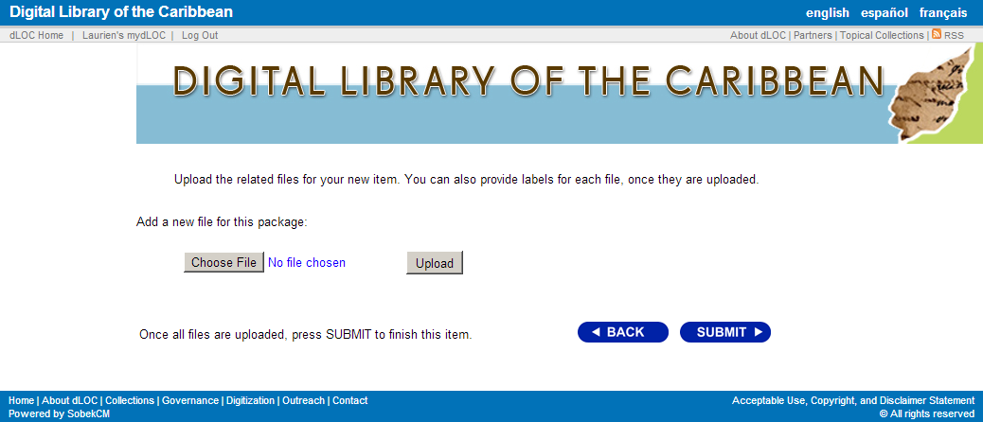
Step 14: Quality Control & Quality Assurance
After uploading all of the files, review the metadata and the files to ensure they all display properly.
For some items, this may include using the Quality Control functionality, which is shown below.
