Digitization with Canon EOS Camera

Manual for Training

Instruction manual by Mark V Sullivan ( 1/31/2012 )
Digitization with Canon EOS Camera
Two configurations:
- Negatives
  - Light table
  - No lights
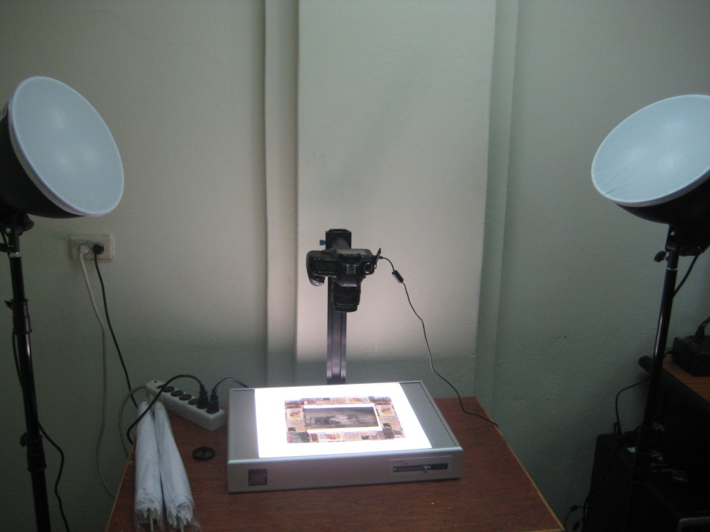
- Positives, Book covers, Postcards, Photographs
  - No light table
  - Lights – Always remove cover from the lights before using them
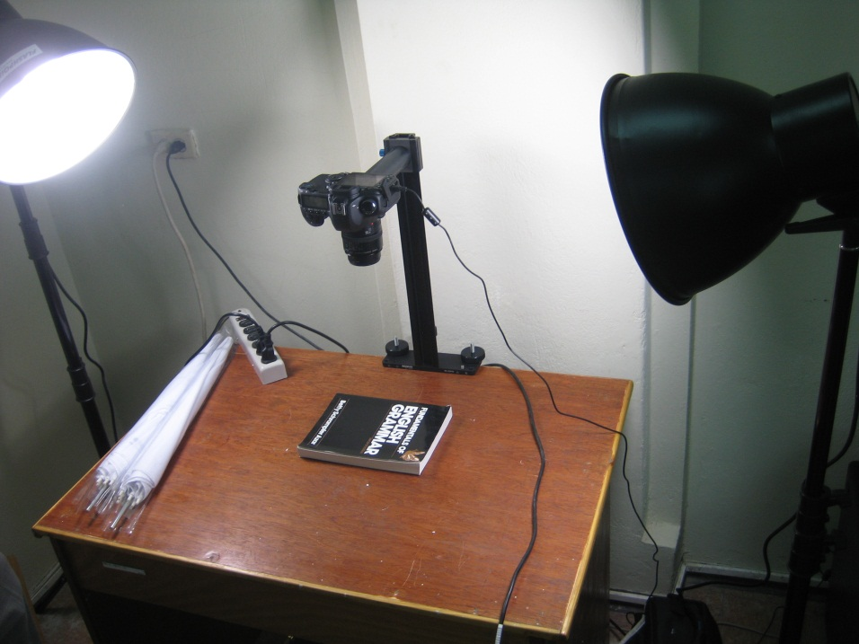

Negative Digitization with EOS Camera and Light table
- Image capture ( technology-specific )
  - Turn off the lights
  - Launch the EOS Utility from the Start Menu and select Camera Settings/Remote Shooting
  - Press the button to capture the image from the camera. Image will be captured as a JPEG

- Image adjustment and normalization
  - Open the image in Adobe Elements or Adobe Photoshop.
  - Rotate and crop
  - Invert the image from negative to positive
  - Image adjustment – Brightness/Contrast or Levels
  - Save document as a TIFF
  - Close Adobe Elements / Photoshop

- Create web derivatives
  - Put the new TIFF in its own folder.
  - Launch the SobekCM METS Editor, and select Create image derivatives for load.
  - Press CREATE and navigate to the folder you created.
  - After the image derivatives are created, folder will include JPEGs, JPEG2000s, and THUMBNAILS

- Create new item online and upload the images
  - Launch www.dloc.com and logon. After logging in, select Start a new item.
  - Accept the grant of permissions.
  - Enter the metadata about the image, from the bottom of the image. Include the date, title information, and any other information you may know about the subject of the image.
  - On the next screen, select each file to upload. Do NOT include the TIFF (due to bandwith). Include the JPEG, JP2, and THUMBNAIL images.
  - Press BROWSE to select each file and UPLOAD to send the image to the remote server.
  - Upload each file, one-by-one.
  - Press SUBMIT to finish this item when done uploading files.

Process complete!!

STEP 1: Image capture – Negatives on the light table
Turn off the lights.
Launch the EOS Utility from the Start Menu.
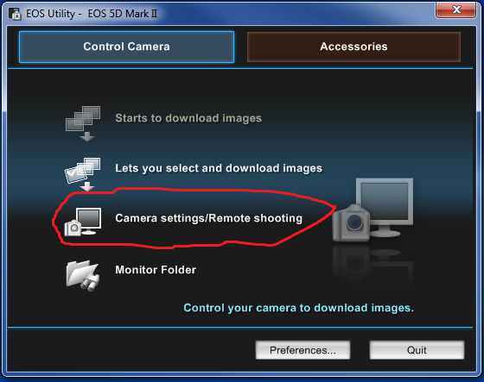

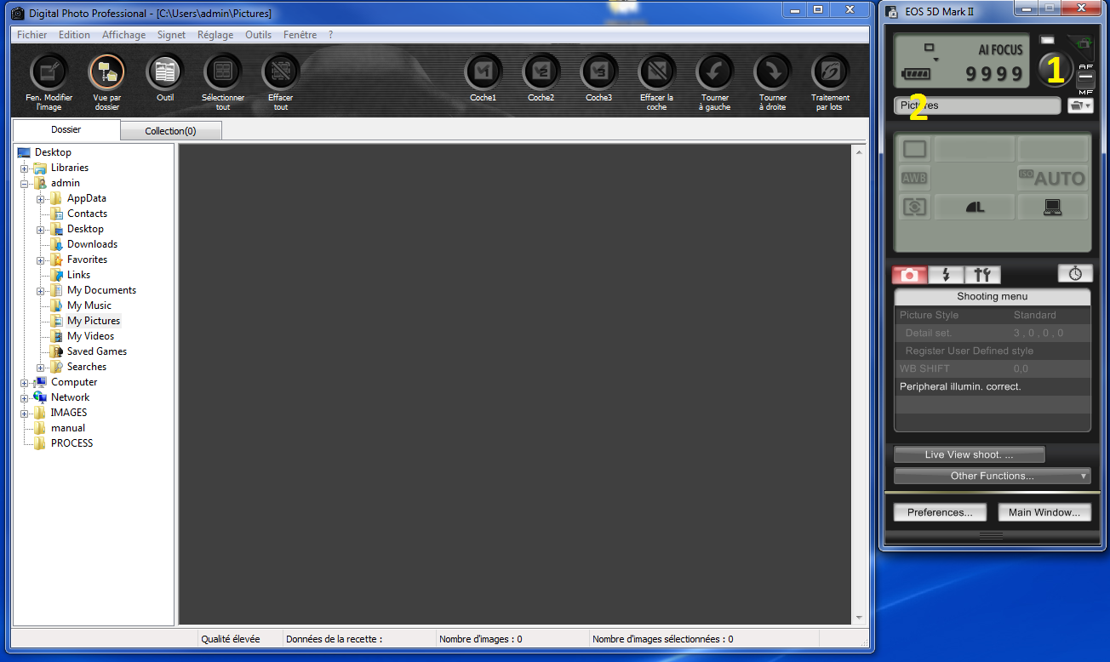
1 = Button to capture image 2 = Location the image will save

Press the button to capture the image from the camera. Image will be captured as a JPEG.
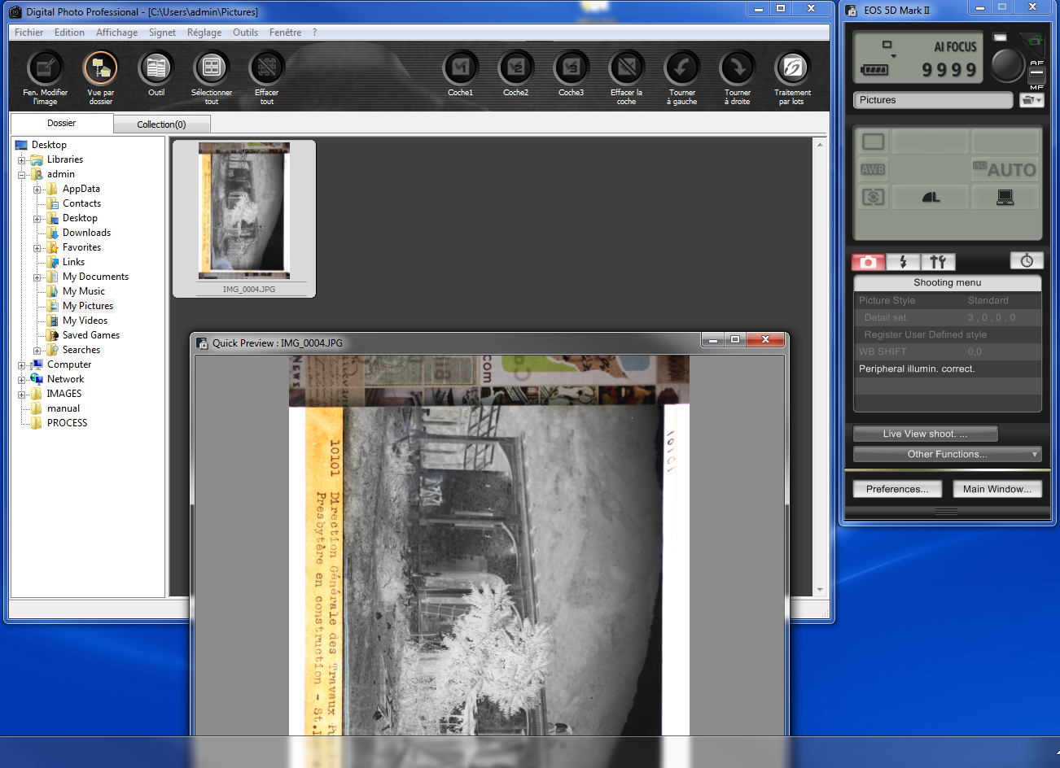

STEP 2: Image adjustment and normalization
Open the image in Adobe Elements or Adobe Photoshop. Rotate and crop.
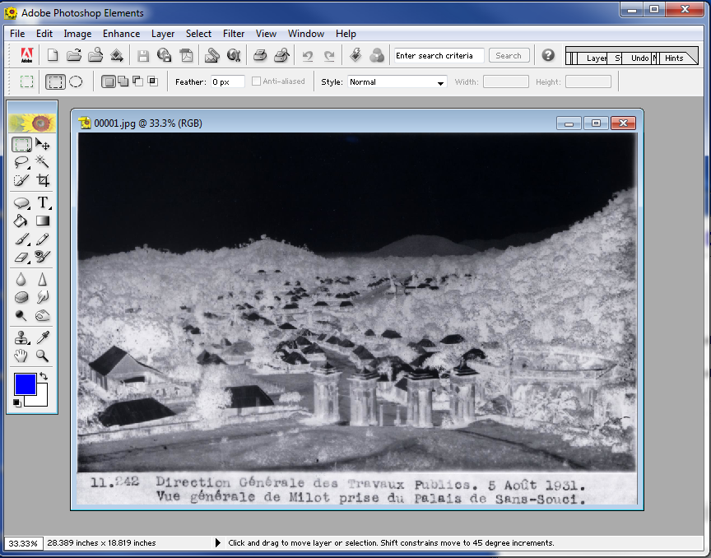
Invert the image from negative to positive.
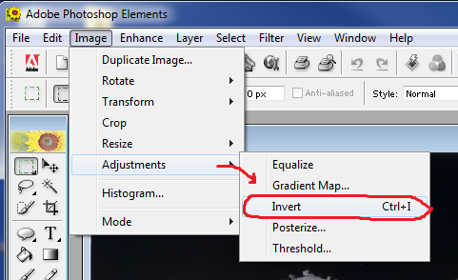
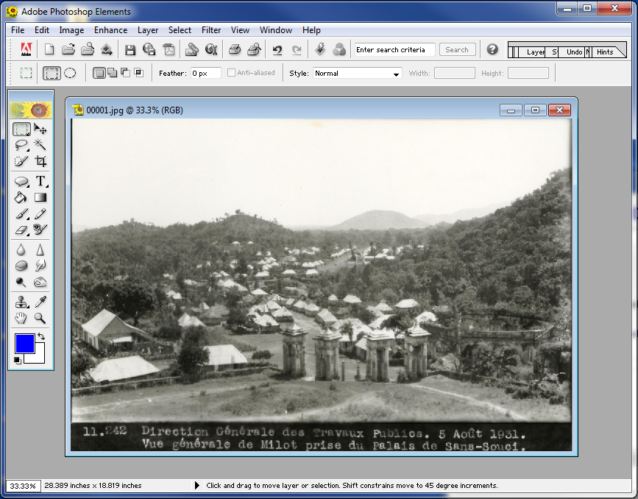

Image adjustment – Brightness/Contrast or Levels
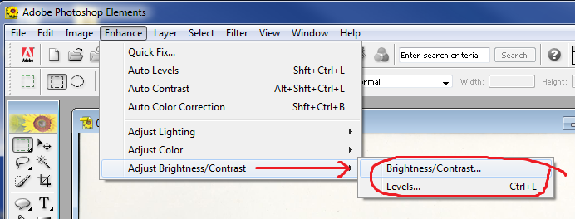

Brightness / Contrast …
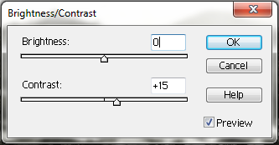
Levels …
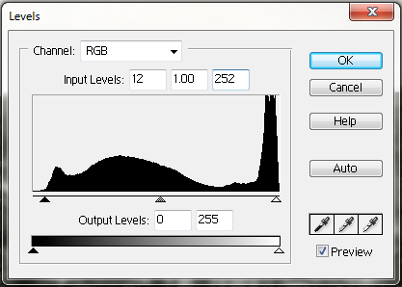

Save document as a TIFF.
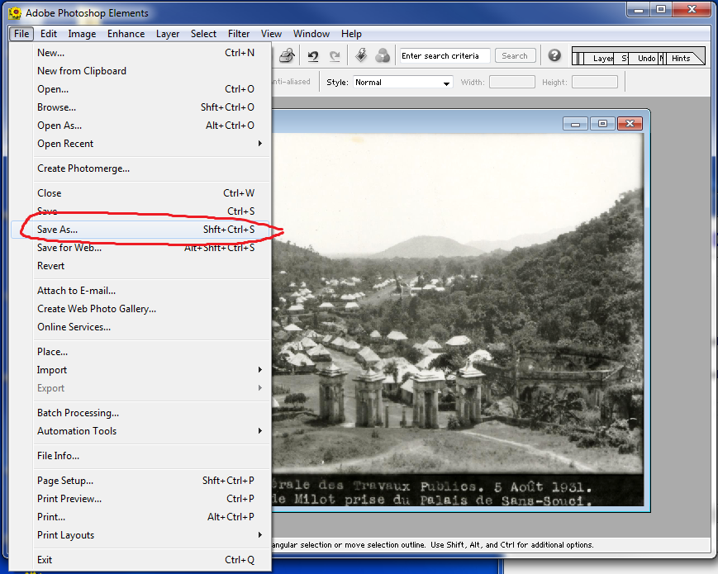

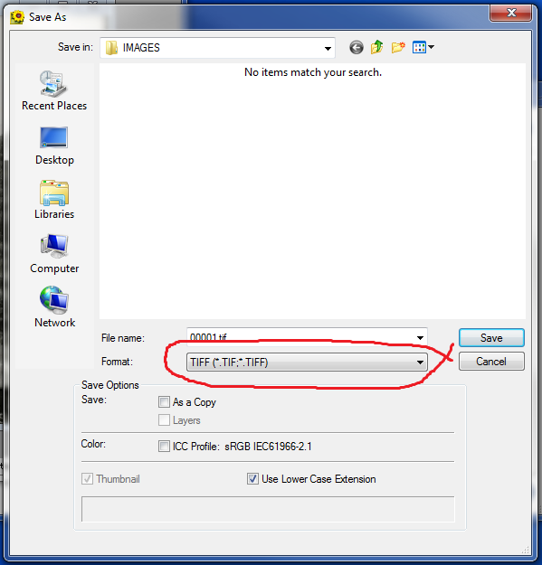

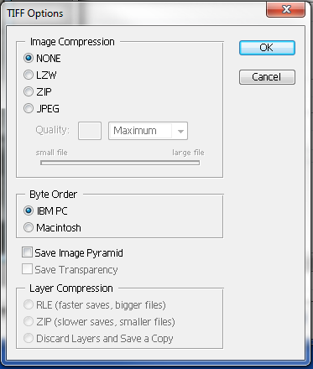
Close Adobe Elements / Photoshop.
STEP 3: Create web derivatives
Put the new TIFF in its own folder.
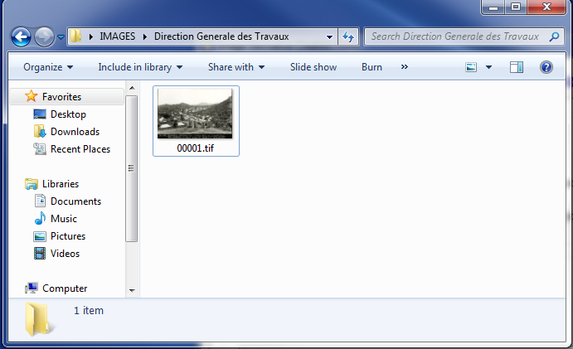

Launch the SobekCM METS Editor, and select Create image derivatives for load.
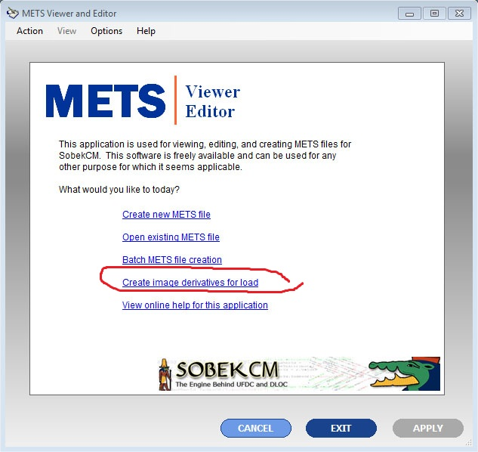
Press CREATE and navigate to the folder you created.
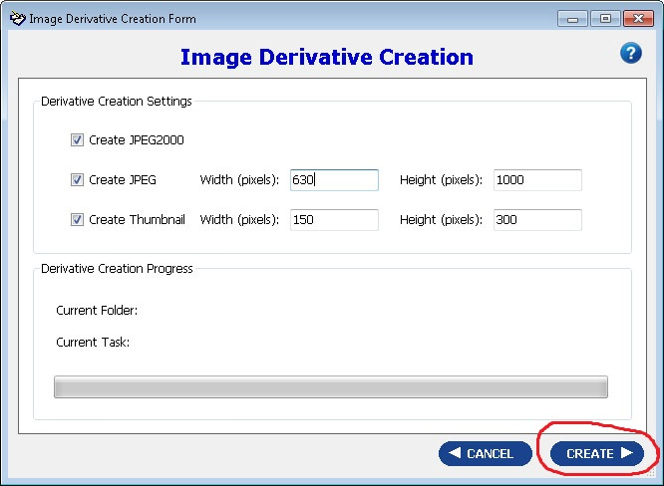

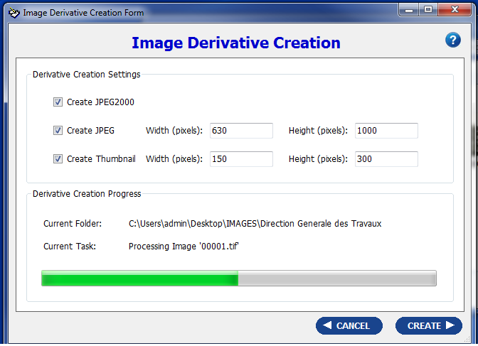

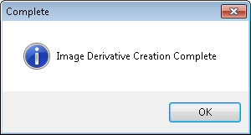

After the image derivatives are created, your folder should look something like this:
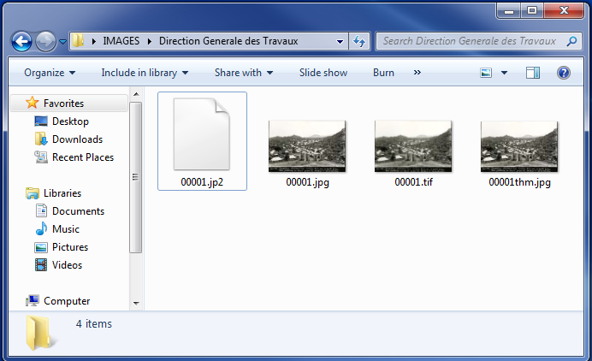

STEP 4: Create new item online and upload the images
Launch www.dloc.com and logon. After logging in, select Start a new item.
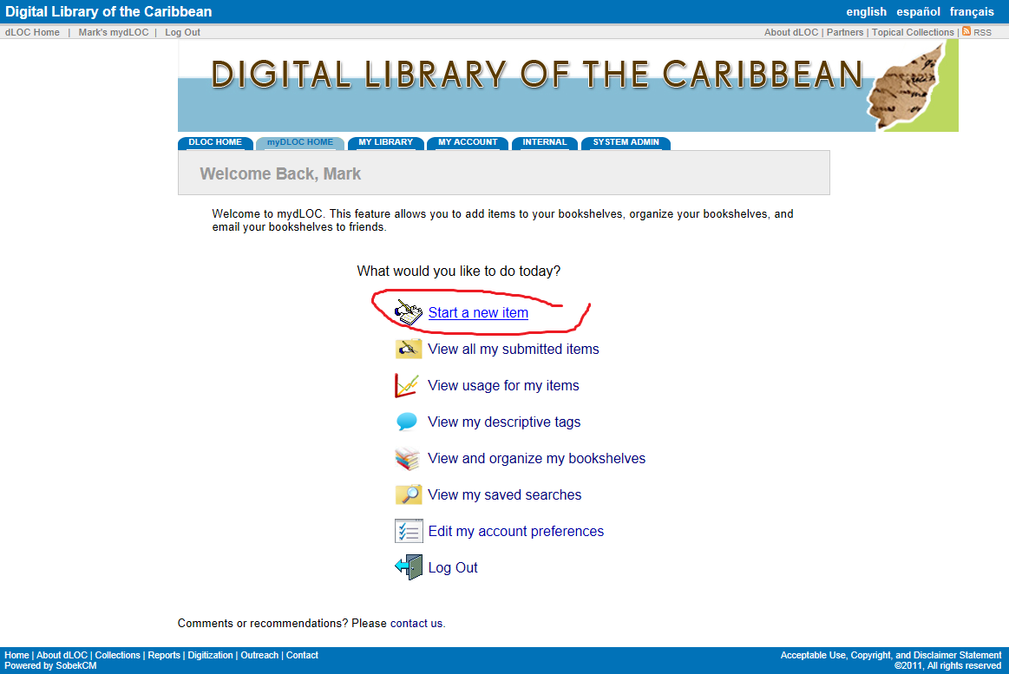

Accept the grant of permissions.
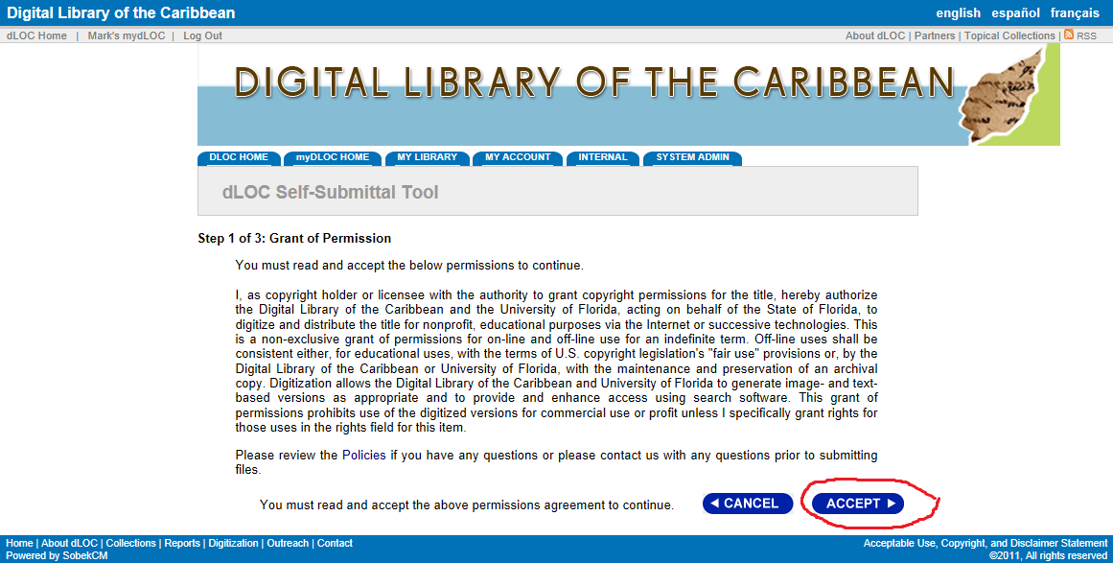

Enter the metadata about the image, from the bottom of the image. Include the date, title information, and any other information you may know about the subject of the image.
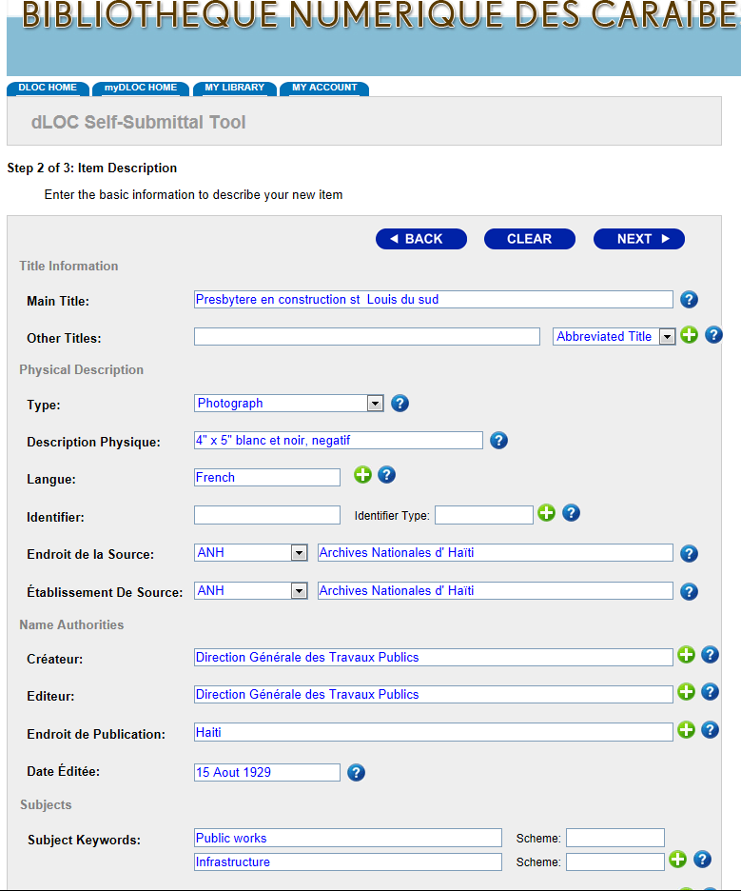

On the next screen, select each file to upload. Do NOT include the TIFF (due to bandwith). Include the
JPEG, JP2, and THUMBNAIL images.

- Press BROWSE to select each file and UPLOAD to send the image to the remote server.
You will see a progress bar as it uploads.
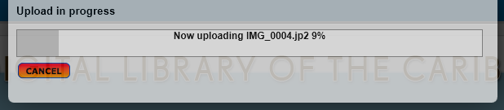

Upload each file, one-by-one.
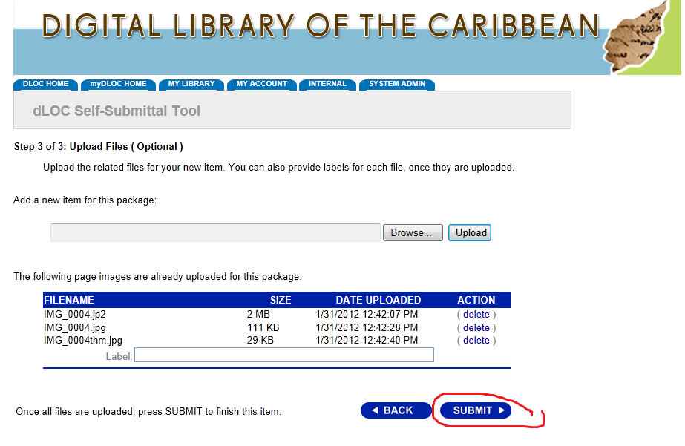
Press SUBMIT to finish this item when done uploading files.
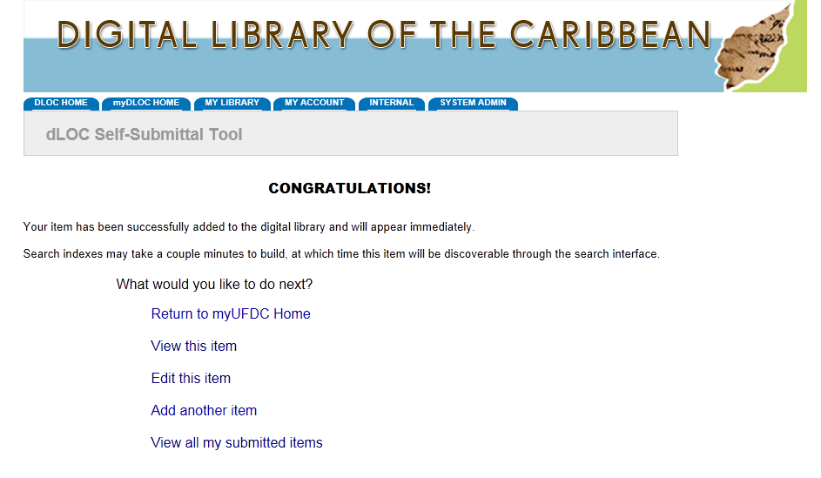

APPENDIX: Scanning with the Canon printer/scanner combo.
For this, only the first step really changes.
Launch Adobe Elements or Adobe Photoshop. Select File Import Canon MG1600 ser…

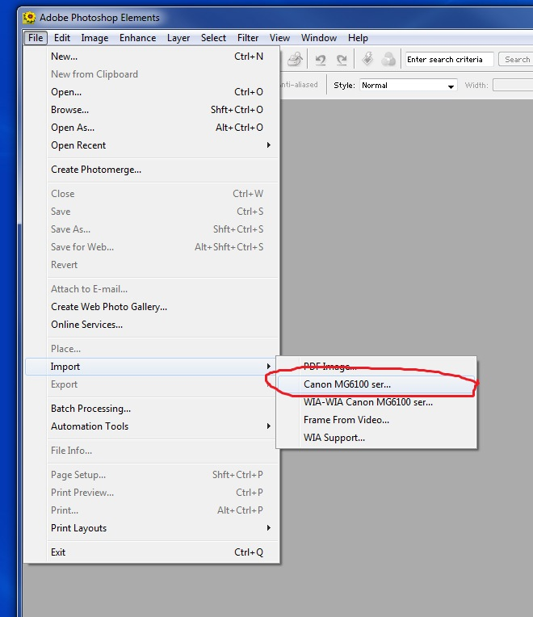

600 dpi for photographs, 300 dpi for full text items.

