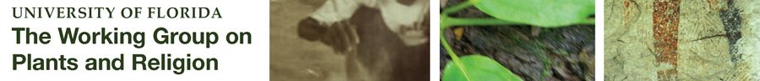

The Working Group on Plants and Religion Digital Collection contains materials from the Working Group on Plants and Religion, which was established to fill a gap in the current academic discourse, a systematic and holistic study of the ways in which Cultures uses plants for sacred purposes. The working group seeks to establish an academic framework in order to facilitate cooperative scholarship and research in the area of plants and religion. Drawing from a wide range of disciplines and perspectives, The Working Group on Plants and Religion presents a holistic and progressive schema for innovative research.

The Working Group on Plants and Religion Digital Collection is powered by the UF Digital Collections, a preservation and access repository. All items have permanent URLs that are ideal for referencing in CVs and annual activity reports. Usage statistics for all materials are maintained and available at the collection and item level.

To have your materials included in the Working Group on Plants and Religion Digital Collection, these methods are supported:
- Use the online self-submittal tool with your Gatorlink (http://ufdc.ufl.edu/my)
- Create a myUFDC account (http://ufdc.ufl.edu/my/preferences and self the checkbox for submitting materials online)
- Complete the permissions form (http://digital.uflib.ufl.edu/procedures/copyright/GrantofPermissions.doc) and send it and your files to ufdc@uflib.ufl.edu

