Digital Library of the Caribbean (dLOC) Software Toolkit
To aid partners with digitization and content submission, dLOC has created a software Toolkit to streamline local workflows and facilitate the creation of submission packages conformant to dLOC's technical and metadata specifications.
The toolkit is available online (http://dloc.com/toolk).
Screenshots of the dLOC Toolkit
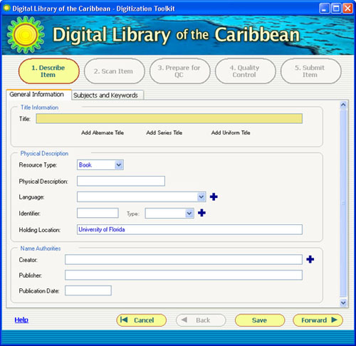 | 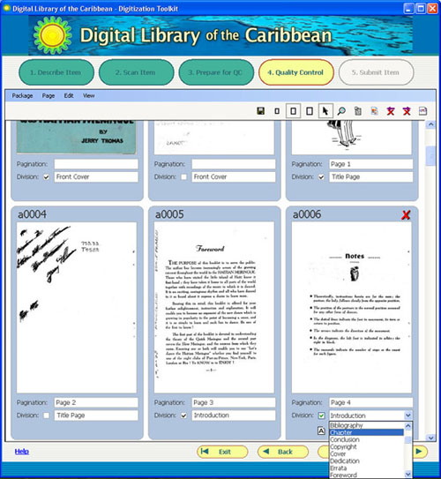
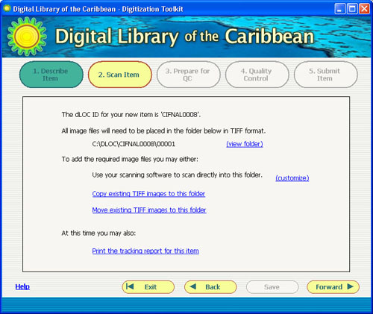 | 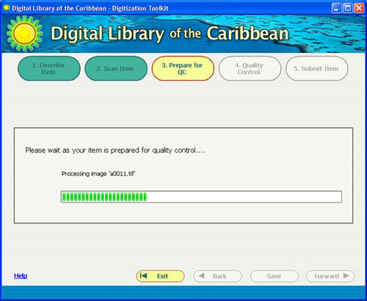

Please contact us with any questions: dLOC@fiu.edu

