

**THE ASIAN AMERICAN STUDENT UNION @ UF**

**NT UNION @ UF**



**2010-2011 AASU EXecutive board**



**President**  
Megan Vu  
[president.aasu@gmail.com](mailto:president.aasu@gmail.com)

**Internal Vice President**  
Alyssa Wang  
[ivp.aasu@gmail.com](mailto:ivp.aasu@gmail.com)

**External Vice President**  
Kevin Chiu  
[evp.aasu@gmail.com](mailto:evp.aasu@gmail.com)

**Vice President of Education**  
Vi Ho  
[vpe.aasu@gmail.com](mailto:vpe.aasu@gmail.com)

**Treasurer**  
Michael Satyapor  
[treasurer.aasu@gmail.com](mailto:treasurer.aasu@gmail.com)

**Secretary**  
Monica Tirtarahardja  
[secretary.aasu@gmail.com](mailto:secretary.aasu@gmail.com)

Enter Contact Information Here | 1127 Lombard Blvd. San Francisco, CA 59802 | phone 555.555.5555 | fax 555.555.5555

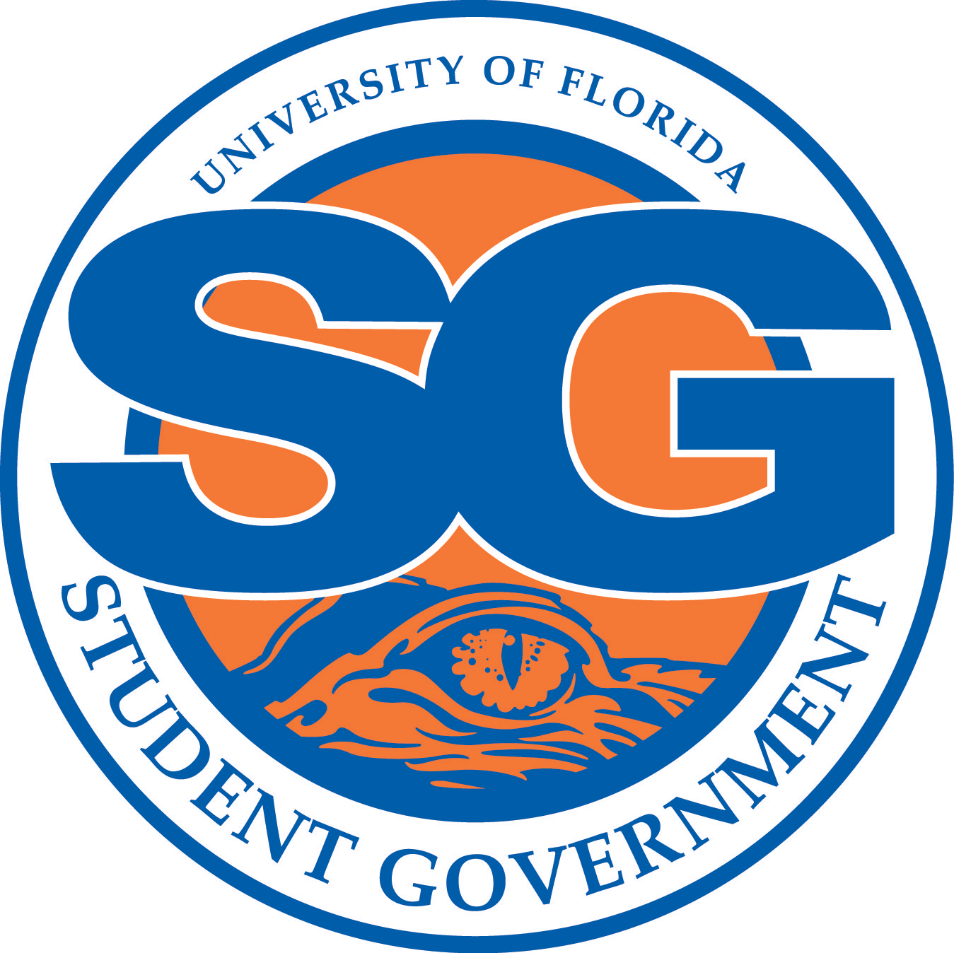

**“The Asian American Student Union seeks to promote Asian and Asian American Awareness at the University of Florida.”**

“We are dedicated to educating the campus about Asian American issues, history, and culture through creative and stimulating events.”

**Please visit our website for more details or feel free to contact any of the officers on the adjacent page.**

[**www.ufaasu.com**](http://www.ufaasu.com)

**Type in “Asian American Student Union at UF” to find us on Facebook!**

**Thank you and we hope that you can get involved and take part of our future events!**

**Feel free to ask any of the officers questions that you may have.**

**We are here for YOU!**

**Go Gators and Go AASU!**

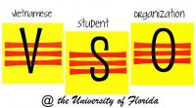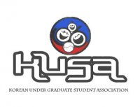

**AASU Week**

**SAVE THE DATE**

**March 21-25, 2011**

**AASU 18th Birthday Bash**

**AASU Showcase**

**Speakers, entertainers and more!**

*\*Put on by AASU FLP*

***The Korean Undergraduate Student Association (KUSA***) allows students to experience Korea's rich history and learn about the lifestyles different from mainstream America. This common interest of Korean culture allows students to divulge in enduring friendships through community service projects, competitive intramural sports, and exciting social events.

***The Filipino Student Association (FSA*)** is an organization that gives all students, Filipino or not, the opportunity to become part of a family. FSA is a home away from home where you will build friendships that will last for a lifetime. Dance in huge events such as Def Talent Jam, the biggest Asian party in the Southeast, in November; Barrio Fiesta in March; or VISA talent show in April.

***The Vietnamese Student Organization (VSO*)** is, first and foremost, a place where students can unite to meet people who share similar interests. As a family, we support, encourage, and motivate each other. We are each others anh's, chi's, and em's (or brothers and sisters). Together we not only organize events but we help each other grow and mature. College is the best time of our lives. Let’s experience it as a FAMILY! ♥

***Health Educated Asian Leaders (HEAL***) is an organization of students representing various health related fields at UF. We are here to bring together students pursuing a career in Medicine, Pharmacy, Dentistry, Veterinary Medicine, Nursing, and Physical and Occupational Therapy. We welcome all interested individuals to get involved.

***The Chinese American Student Association (CASA)*** is a "for student" and "by student" organization. The Chinese American organization strives to promote the Chinese and Chinese American heritage at the University of Florida campus and in the Gainesville community through social and community events.

**Sub-Organizations in AASU**

**Other Programs:**

**Freshman Leadership Program (FLP)**

Asian Kaleidoscope Month (during Fall)

Southeast Regional Conference of Asian American Leaders (SERCAAL)

AASU Week (during Spring)

KUSA

HEAl

CASA

VsO

**The Asian american**

**student union @ UF**

www.ufaasu.com