dLOC Training Program: Pre-Assessment for Module 3
Name: ________________________________________ Date: ______________
Please answer the following questions. This will help us to prepare the training and document the learning that happens this week. We do not expect you to know all the answers. Thank you.

Imaging (Module 3)
1. Would you scan this document in grey scale (8 bit) or color (24 bit)? _______
What resolution? ______dpi
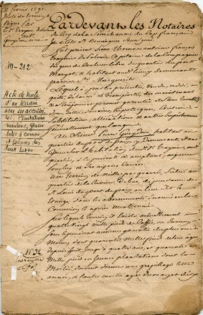

Why? ________________________________________________________________________
________________________________________________________________________
________________________________________________________________________
2. Would you scan this document in grey scale (8 bit) or color (24 bit)? _______
What resolution? ______dpi
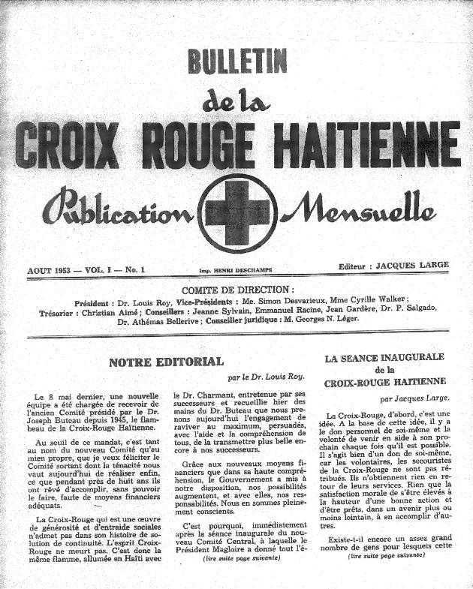
Why? ________________________________________________________________________
________________________________________________________________________
________________________________________________________________________

3. What is the generally recommended resolution for this photo (assume it is 4x6)? ______ dpi

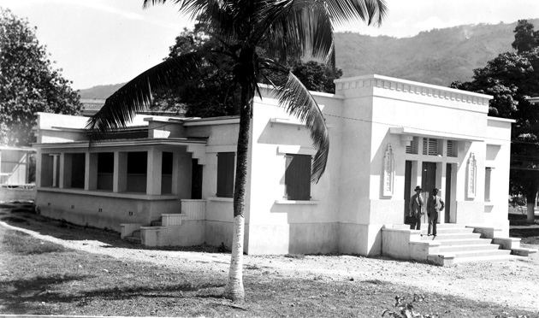

4. What is the archival file format most recommended for preservation of images?

a) TIFF b) JPEG c) PDF d) GIF

Why? ________________________________________________________________________
________________________________________________________________________
________________________________________________________________________

5. When correcting textual images, do you usually straighten or crop the image first? ________

Why? ________________________________________________________________________
________________________________________________________________________
________________________________________________________________________

