Module 3:
Imaging

Basic Theory and Specifications

dLOC Requirement for Digital Master Files.

8-bit Grayscale or 24-bit RGB Color (depending on whether original has significant color)
300 dpi for standard text or 600 dpi for stand-alone images (photographs, maps)
Save archival files as uncompressed TIFFs

Bits Depth & Color Space

In digitization three levels of Bit Depth are widely used: 1 Bit, 8 Bit, and 24 Bit images.

An 1 Bit image is referred to as “bi-tonal” or, less precisely, as “black-and-white”. Each point in the image is represented as a single bit, either ON or OFF.

An 8 Bit image is referred to as “grey-scale. The picture elements of an 8 Bit image are expressed with eight bits, for example: 00001111. 8 Bit images allow for as many as 255 shades or colors.

An 24 Bit image blends different channels of colors. The picture elements of a 24 Bit image are expressed in strings of twenty-four bits and allows for as more than sixteen million colors. The 24 bits are divided into three 8 Bit channels, one for each of three composite colors. Images with channels or Red, Green, and Blue utilize the standardized Red/Green/Blue (sRGB) color space.

Choosing the Appropriate Bit Depth and Color Space

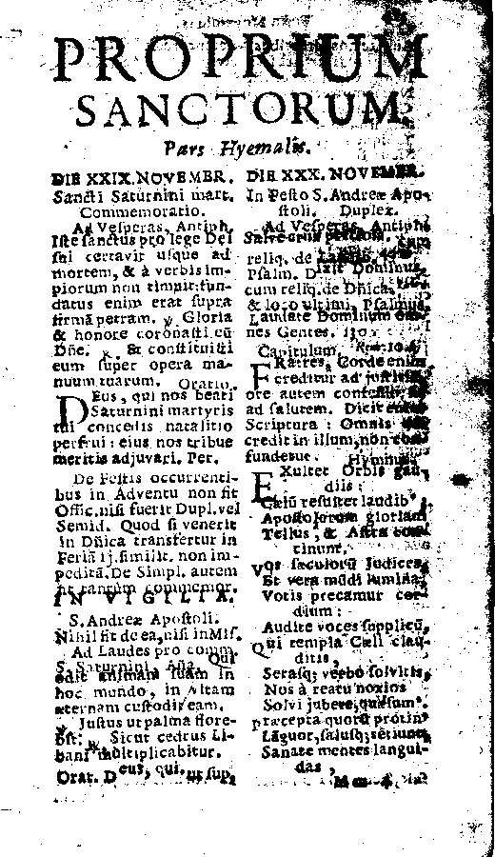 | 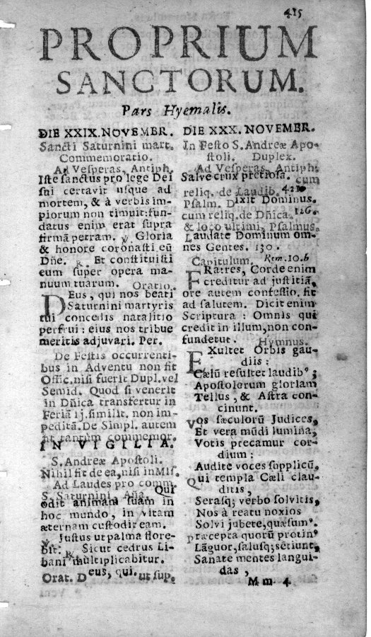 | 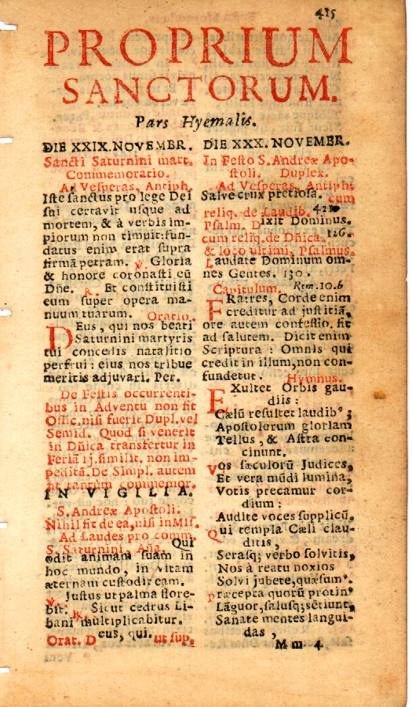

dLOC recommends that 1 Bit imaging should not be used. 1 Bit images tend to pixelate text. Imperfections on the page or artifacts of age may read as black, obscuring text in 1 Bit images.

The 8 Bit grayscale image above captures the textual information. And, the reader of the page can make sense of the text.

Readers of Latin religious texts, such as that seen above, will recognize the red text as instructions to the faithful, commentary on the spoken text of a religious service, or the narrative of the priest as opposed to that of the congregation’s response.

dLOC advocates preserving meaningful color. Meaningful color is color required to interpret the text. In the case of a newspaper with colored images, a color image accompanying an article demonstrates meaningful color, while a color advertisement may not.

It is true that “The greater the Bit Depth the greater the size of the digital image file”. But, digitization technicians are encouraged to produce images that meet the reader’s needs rather than the needs of the digitization technician to conserve space.

Resolution

The resolution of digital images is expressed in terms of pixels. A pixel is a picture element or, simply, a block of solid shade or color that, together with other picture elements comprises a digital image.

 | 
Trinidad and Tobago’s Coat of Arms (Zoom area in black box.)

 | Resolution | Use For
OR | 300 pixels per inch (ppi)  118 pixels per centimeter (ppc) | Printed text with normal sized fonts  Oversized documents and maps  Manuscripts with legible script
OR | 600 pixels per inch (ppi)  236 pixels per centimeter (ppc) | Photographs and select graphic arts  Printed text with very small fonts  Manuscripts with difficult scripts

The dLOC’s minimum digital resolution standard for printed text with normal sized fonts is 300 pixels per inch (ppi) or 118 pixels per centimeter (ppc). This threshold is based on both the characteristics of printed graphics and optical character recognition (OCR) tests.

300 ppi / 118 ppc

The Rationale for Printed Graphics

In general, the resolution of printed graphics does not exceed 300 dots per inch (dpi) or 118 dots per centimeter (dpc).

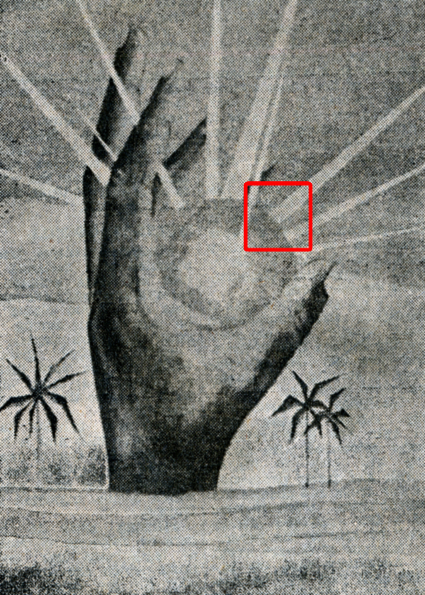 | 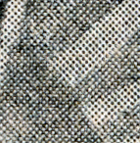
Carifesta ’72 logo printed in Guyana’s Sunday Post and Weekend Argosy (Zoom area in red box.)

Digitization of printed graphics at resolution greater than 300 ppi (118 ppc) would be excessive due to the low resolution of the original material.

Resolution and OCR Accuracy in high contrast images

75 ppi Image | 150 ppi Image | 300 ppi Image | 600 ppi Image
 | 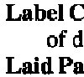 |  | 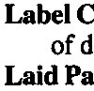
OCR results | OCR results | OCR results | OCR results
  L~iC
  ud
  L~ddPa
  Label C
  of d
  Laid Pa
  Label C
  of d
  Laid Pa
  Label C
  of d
  Laid Pa

The Importance of Bit-Depth on Text Recognition:
the Latin word Feltis = Goodness

 |  | 1 Bit Image  This letter may be any of the following: c – e – o - 0
 |  | 8 Bit Image  This letter may be any of the following: c – e – o – 0
 | 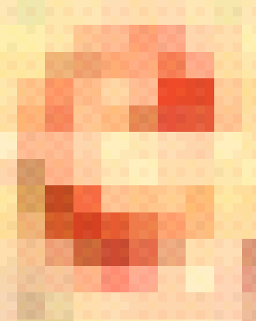 | 24 Bit Image  The letter e appears now to be more probable.

For printed texts with normal size fonts, whether plain (sans serif) or embellished (serif), tests demonstrate that the average modern printed document is accurately recognized at 200 ppi (80 ppc).

dLOC sets a slightly higher standard, 300 ppi (118 ppc), for printed texts with normal size fonts to compensate for occasional uses of small fonts and colored or blemished paper.

Digitization of normal printed texts at higher resolution (e.g., 600 ppi/236 ppc), in tests, generally showed no increase in text conversion accuracy.

600 ppi / 236 ppc

dLOC recommends digitizing at 600 ppi (236 ppc) when working with printed texts with very small fonts; photographs and other continuous-tone graphics.

Photographs

Photographs, unlike printed graphics, have continuous-tone. In the source document, one shade or color blends into adjacent shades and colors. Continuous-tone images may be digitized at any resolution. dLOC recommends 600 ppi (236 ppc) resolution to facilitate special uses of images and to provide ability to zoom into the image and see details.

Saving Files and Image Compression

Once the digital image is created, there remains the issue of saving or archiving the file. The digitization technician prefers not to loose a quality image to the imperfections of file saving and image compression routines.

TIFF | JPEG | GIF
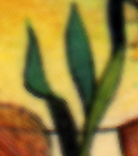 | 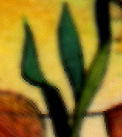 | 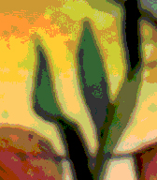
TIFF contains all image data. | JPEG compresses the image, seen here at leaf edges. | GIF also compresses the image, seen here in color patches.

Saving Files

Only the TIFF (sometimes: TIF; Tagged Image File Format) is considered archival within the international digital library community. It alone serves as a digital master. There are several reasons for this, primarily: image compression. The illustration above demonstrates image quality issues as a factor in file choice.

Other formats, such as JPEG and GIF, are often used created as derivative or secondary file formats from a digital master. These derivative formats are used just for online display.

Image Compression

When saving an image file, often regardless file type, the technician will be given the opportunity to compress the image. Compression saves file space but has produces other and unwelcome artifacts. Digital archival masters should be saved uncompressed.

Scanning

dLOC Requirement for Digital Master Files.

8-bit Grayscale or 24-bit RGB Color (depending on whether original has significant color)
300 dpi for standard text or 600 dpi for stand-alone images (photographs, maps)
Save archival files as uncompressed TIFFs

Flatbed Scanning: Epson Expression 10000 XL

The following screenprints are specific to the Epson Expression scanner, but the same settings apply to any flatbed scanner.

Scan Settings

Scan documents using Adobe Photoshop rather than using the scanner’s stand-alone image capture software and check the scanner settings with each new document.

Before opening Adobe Photoshop, turn on the scanner and make sure that the bed is clean and free of any dust, debris, etc. If necessary clean the glass with a lint free cloth and a very small amount of glass cleaning fluid.

- Launch Adobe Photoshop

- Select: File → Import → Epson Expression 10000 XL

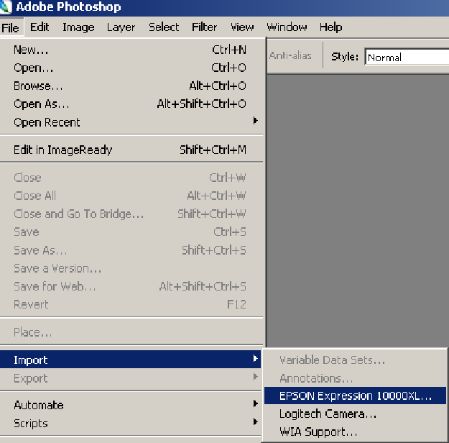

The scanning interface will then open two windows: a scan settings window and a preview window (as seen here)

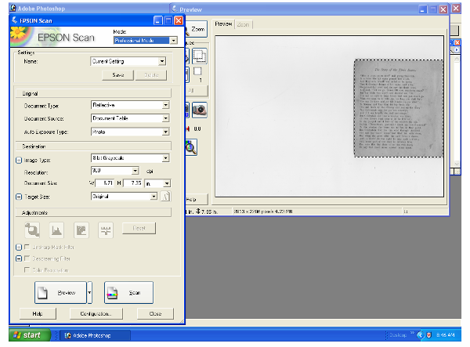

- Select the appropriate settings for your document
  - At the top of the scan settings windows select PROFESSIONAL MODE
  - Always select the following settings
    - Documents Type: REFLECTIVE
    - Document Source: DOCUMENT TABLE
    - Auto Exposure Type: PHOTO
    - Document Size: DO NOT ADJUST
    - Target Size: ORIGINAL
  - Select the appropriate color space and bit depth
    - 8-bit grayscale for items without significant color
    - 24-bit RGB color for all other items
  - Select the appropriate resolution
    - 300 dpi for mostly textual items
    - 600 dpi for stand-alone image items (photographs, maps, etc..)
  - Click the configuration button (below the Preview and Scan buttons)
    - Click the COLOR tab
    - Select NO COLOR CORRECTION
    - Click OK

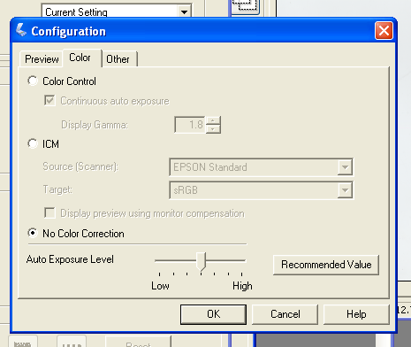

Scanning

- Place item, image down, on scanner glass. Be careful to place item as straight as possible in order to save time later. Close the scanner lid as much as item permits.

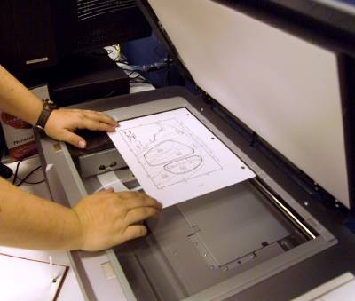

- Click the preview button in the Scan Settings window. A small preview of your image will appear in the preview window. Make sure the entire document is visible, if not reposition on glass and re-preview.

- Draw a bounding box around your entire image. If your original has 2 pages facing each other, draw a second box by selecting the dual marquee button . Arrange each box to completely include each side of the item. Once you are satisfied with the boxes positioning click the all button. DO NOT move the boxes or change settings after pressing this button!

- Click the scan button

Saving Files

- Save your image by selecting: File → Save

- Save all the files for a single resource within the same folder.

- Type in a sequential four digit file name, such as 0001, 0002, 0003, etc.

- Select TIFF from the file format drop down menu

- Always uncheck the ICC profile box

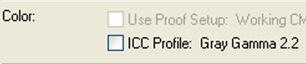

- Click Save

For TIFF Options select same as below

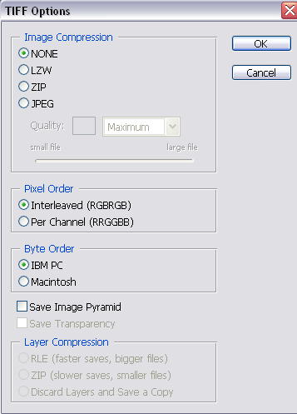

Image Correction

The intent of any digitization should be a faithful reproduction of the original document. Toward this goal, images will need to be deskewed and cropped to fit the in-hand original. In addition, it may be desirable to perform color correction either to reproduce the in-hand original, or the original state of the document. Applying these techniques is the topic of this section.

Image Correction in Adobe Photoshop or Elements

- Crop the image to remove any excess borders using the crop tool 

- If necessary (e.g., if the image is muddy), adjust the levels/histogram by selecting
Image → Adjustments → Levels

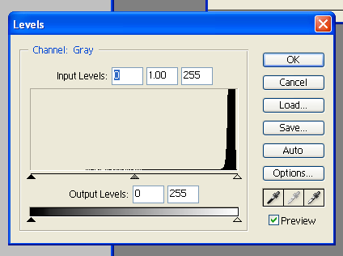

Adjust the black, white and midpoints to improve your image quality and contrast.

But, do not over correct and eliminate detail. A histogram shows the distribution of tones over a range. The image characterized by the histogram above is predominantly white. While the image contains shades of gray, deeper tones of black are almost entirely absent.

- Images with good, thick printed text can also be quickly corrected by selecting the document’s white point. This is done by opening the levels/histograms by selecting Image → Adjustments → Levels. In the levels window select the eyedropper furthest to the right and then select the point in your image that should be the brightest white. The images below show this effect before and after the white point selection.

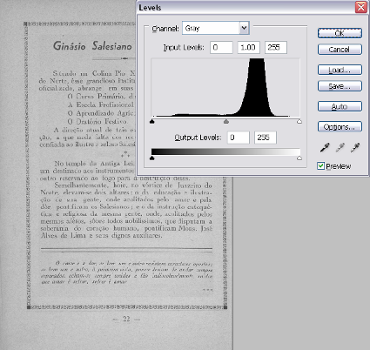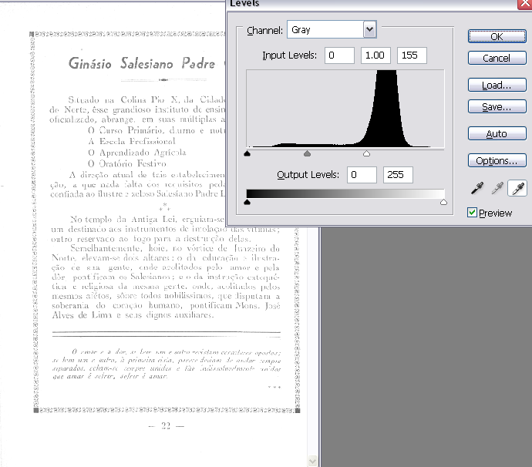

You will notice that the background becomes almost uniformly white, but the text is also lightened. Before selecting OK in the levels/histograms you will need to bring in the black point in order to improve the text. This is done by moving the arrow furthest to the left, in towards the right. You will notice that the numbers in the Input Levels boxes increase.

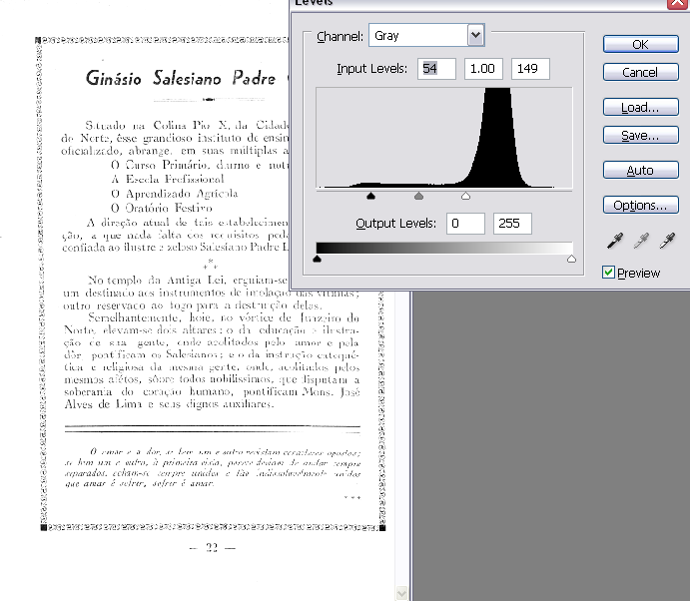

It is helpful to perform this correction while zoomed in to 100% on your image, as shown below.

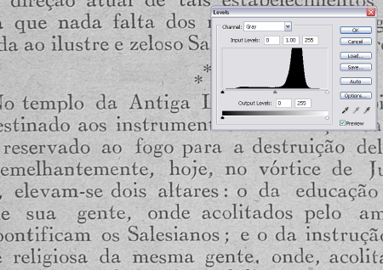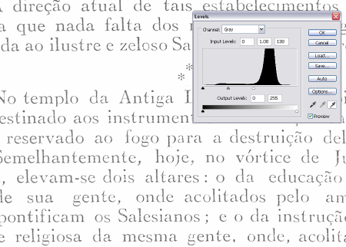

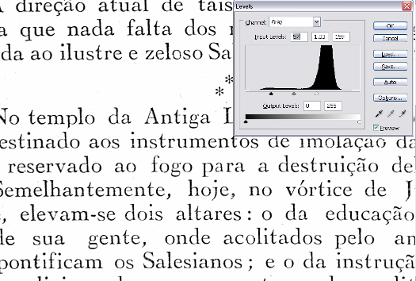

- If the image is extremely stained the document should be scanned in RGB and if possible, the stains could be lightened using Image → Adjustments → Replace Color
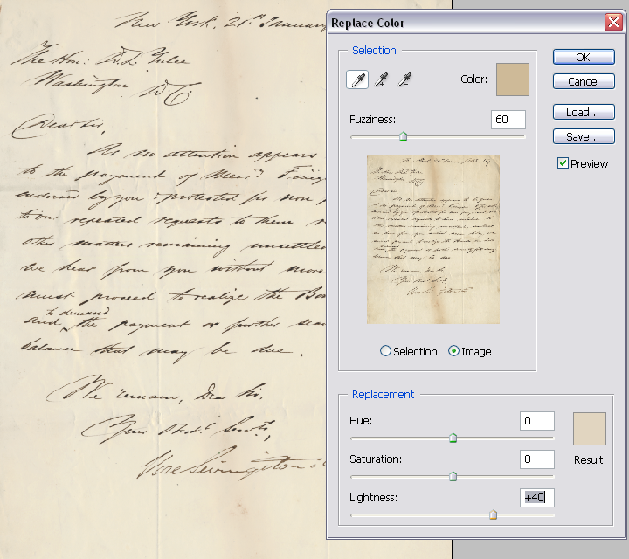

Select “Image” and not “Selection” in the Replace Color Window. Then using the eyedropper tool select the darker color of the stain. Adjust the Lightness, Saturation and Hue slider bars as needed to minimize the stains. The fuzziness meter indicates how closely a color must match the selected color to be replaced. Be aware that stains may be similar in color to text and therefore too much manipulation is undesirable in order to not lose information.

Often it is useful to zoom into one section of text while performing the color replacement. One must be careful not to make the text harder to read for the OCR engine.

- Remember that any adjustments done to images can be undone as long as the file remains open. Maintain your history window open by selecting Window → History in Photoshop, then simply select the previous step done. You can always go back several steps and re-correct your image.

