dLOC Training Program: Pre-Assessment (Modules 1-3)
Name: ________________________________________ Date: ______________
Please answer the following questions. This will help us to prepare the training and document the learning that happens this week. We do not expect you to know all the answers. Thank you.

About dLOC, Primary Contacts, Selection and Copyright (Module 1)
1. Who has access to the materials available in the Digital Library of the Caribbean?
________________________________________________________________________
________________________________________________________________________

2. What are some of the ways you can search for materials?
________________________________________________________________________
________________________________________________________________________
________________________________________________________________________
________________________________________________________________________

Imaging (Module 3)
3. Would you scan this document in grey scale (8 bit) or color (24 bit)? _______
What resolution? ______dpi
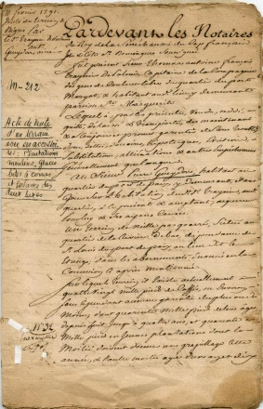

Why? ________________________________________________________________________
________________________________________________________________________
________________________________________________________________________
4. Would you scan this document in grey scale (8 bit) or color (24 bit)? _______
What resolution? ______dpi
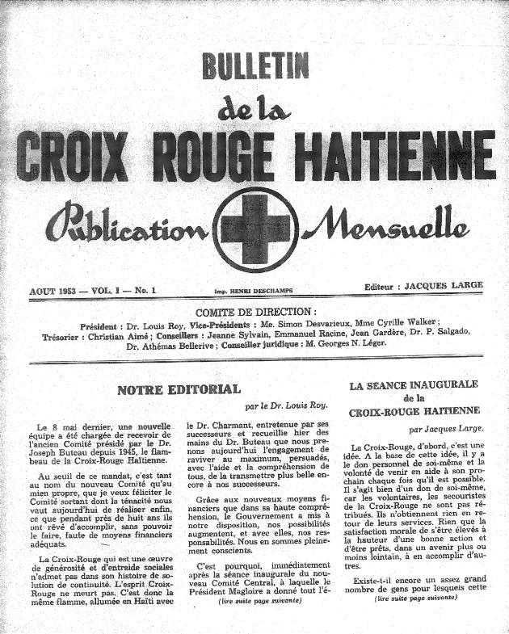
Why? ________________________________________________________________________
________________________________________________________________________
________________________________________________________________________

5. What is the generally recommended resolution for this photo (assume it is 4x6)? ______ dpi

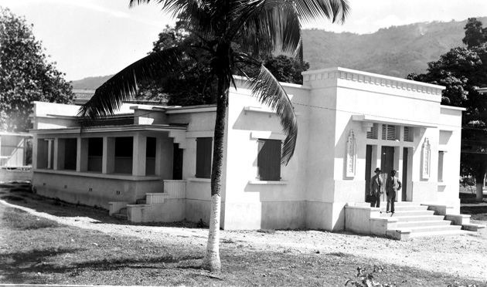

6. What is the archival file format most recommended for preservation of images?

a) TIFF b) JPEG c) PDF d) GIF

Why? ________________________________________________________________________
________________________________________________________________________
________________________________________________________________________

7. When correcting textual images, do you usually straighten or crop the image first? ________

Why? ________________________________________________________________________
________________________________________________________________________
________________________________________________________________________

Metadata (Module 2)
8. Please fill out the metadata practice sheet for the selected item.
Metadata Practice / Pratique Metadata
- Title / Titre
- Other Title / Autre Titre
- Type / Type
- Physical Description / Description Physique
- Language / Lange
- Identifier / Identifiant
- Holding Location / Endroit de la Source
- Source Institution / Établissement De Source
- Creator / Créateur
- Publisher / Editeur
- Place of Publication / Endroit de Publication
- Date of Publication / Date Éditée
- Subjects / Sujet
- Spatial Subject / Couverture Spatiale
- Coordinates / Coordonnées
- Abstract / Résumé
- Note / Note
